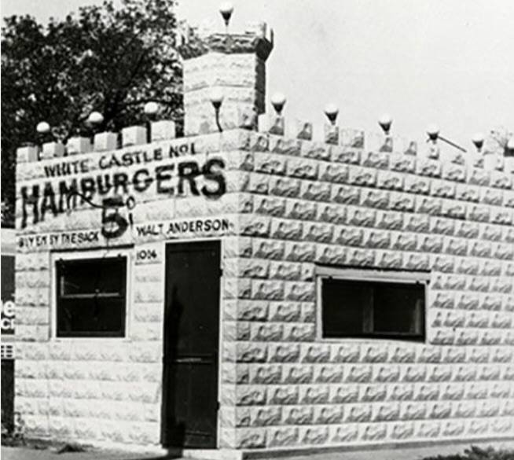

Thanks for your support!

Since these Kits have never been made or ever will, I decided to create my own and offer them for sale at a reasonable price.

You can see the cars and buildings I design and sell running on my layout on my YouTube Channel listed below, as I print and test them on my layout before I release them to the public.

Please go over the KIT, if anything arrives broken let me know and I will replace it free of charge, 100% Satisfaction and positive feedback is our goal.

www.flrailroaddog.com (Sign up for Newsletter & Receive 10% Discount) Reduced prices from ebay!!
Youtube - @FL Railroaddog
Etsy store - https://flrailroaddog.etsy.com

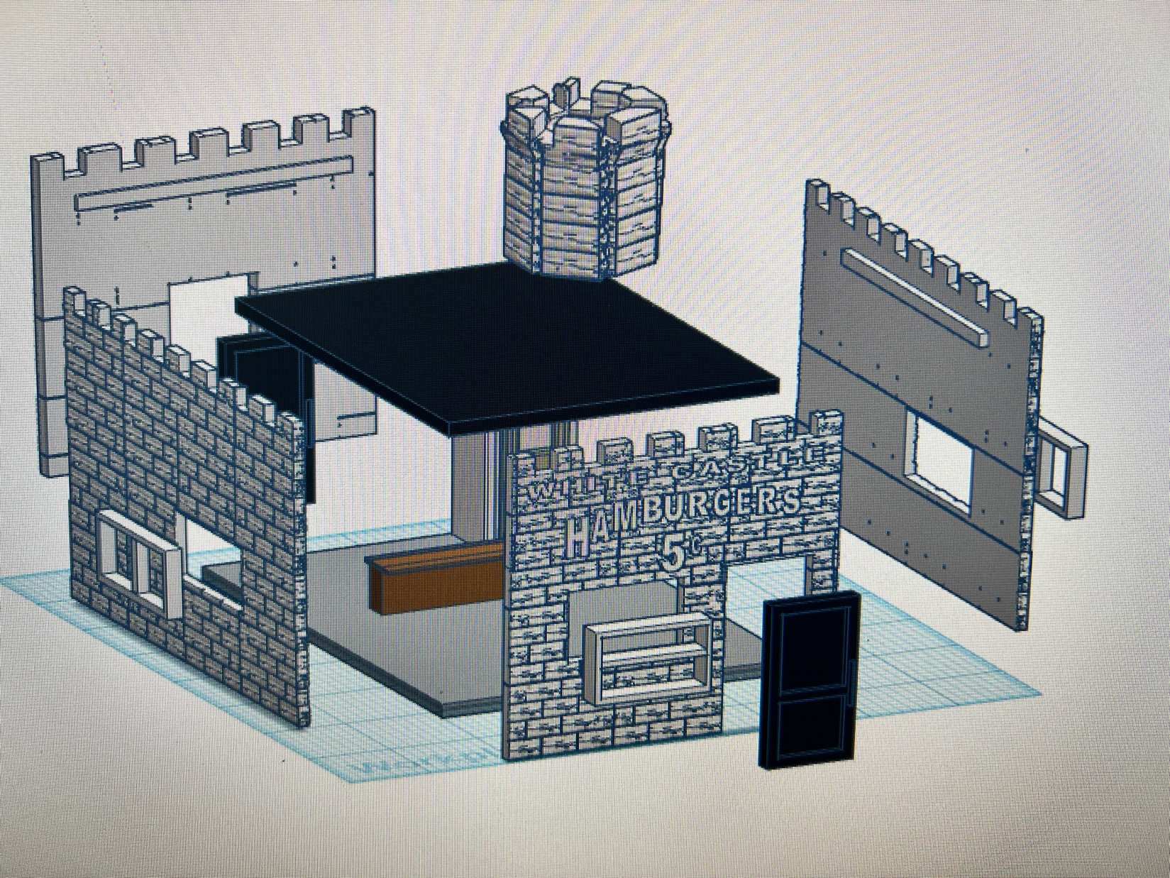

I clean the models before I ship them out, but I recommend going through the pieces to make sure all the fillers have been removed.

This KIT comes pre-painted in white, with the White Castle Logo already painted in black, saving the time used to fine paint them.

The doors and windows come separate and are designed to be glued / snap into place. I printed them in white if a different color is wanted. I recommend primer first, then paint. IF the windows or doors are a little tight, use a fine file to get them to snap in.

After the sides are built, glue the office/bathroom sides together and place in one corner of the building.

The counter can be placed or glued on to the base, keeping in mind that it is L-shaped.

Once all four walls are complete, glue on to the base, leaving the same amount of distance on all four sides. The roof will then fall in nicely and sit of the ledges on the inside of the sides and back wall.

Place or glue the tower on the roof and the model is complete.

I use a hot glue gun to glue my models, that way they are easy to take apart and store. A small amount at each corner should be just fine.

If you take your time, you can create a beautiful piece.

As always, your satisfaction is of outmost important, if anything arrives broken, let me know and I will ship out a replacement free of charge.

If you have any suggestions and or ideas to improve the KIT let me know.

Happy Railroading,

Jorge

