Freshman Lesson Plans
Letter | Color | Number | Shape

Monday | Tuesday | Wednesday | Thursday | Friday

Theme
Nursery Ryhme/song
ASL words
Book(s) to read
Sophomore Lesson Plans
Letter | Color | Number | Shape

Theme
Nursery Ryhme
ASL words
Sight word
Book(s) to read

 | Monday | Tuesday | Wednesday | Thursday | Friday
Math
Reading
Junior Lesson Plans
Letter | Color | Number | Shape | Bones | Senses | Opposites

Theme
Sight words
Book(s) to read

 | Monday | Tuesday | Wednesday | Thursday | Friday
Math
Reading
Games
Senior Lesson Plans
Letter | Color | Number | Shape | Bones | Organs

Reading Objectives
Sight words
Math Objectives
Book(s) to read

 | Monday | Tuesday | Wednesday | Thursday | Friday
Math
Reading
Writing
Other
Foreign Language Schedule
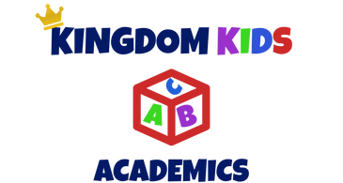
 | Monday | Tuesday | Wednesday | Thursday | Friday
Language | ASL | Japanese | French | Spanish | German
Opening
Activity
Close

Objective: To introduce the sophomores, juniors & seniors to various languages.
Goal: To see each child be able to recite numbers 1-10, basic shapes, colors, and a few greetings in the various languages.
Extra Curricular Lesson Plan
Music | Art | Social Studies | Science | Guidance

Date of Class __________________________
Opening
Song
Activity
Close

