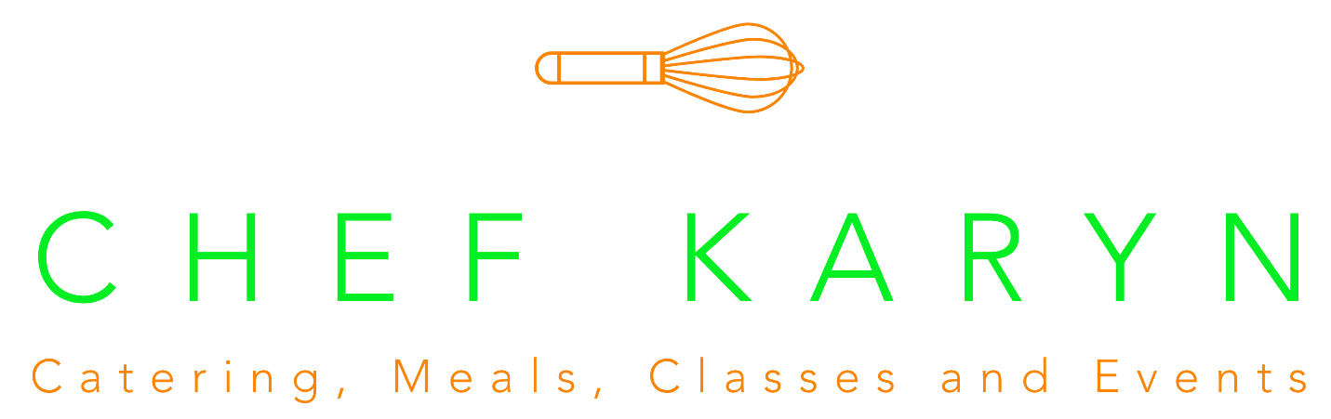

Chef Karyn Boxed Lunch Menu – All lunches $10
Each box lunch comes with a sandwich of your choice, a bag of plain potato chips, a Chef Karyn Famous Chocolate Chip Cookie, and a Bottle of Water. All Sandwiches are to be kept and served cold.
Minimum Order of 10 lunches. It is requested that 5 days’ notice is given prior to delivery/pick-up date. Delivery is available in Sheridan for no fee. Delivery is available in Westfield, Noblesville, and Carmel for a fee of $10. Delivery is available in Fishers and Zionsville for a fee of $15. Sales tax additional.

Sandwich options:
- The BEST Roast Beef Sandwich – Ciabatta Roll with roast beef, swiss, peach preserves, walnuts, and Dijon mayo.
- Peach Smoked Turkey Croissant – Croissant with smoked turkey, chive cream, peach preserves, rosemary, and pecans.
- Pesto Turkey Sandwich – Ciabatta Roll with pesto, smoked turkey, swiss, and a sundried tomato mayonnaise.
- Sweet Ham and Swiss – Ciabatta Roll with ham, chive cream, apple butter, and swiss cheese.
- Lemon Tarragon Chicken Salad – Croissant with Chef Karyn’s chicken salad – with lemon, tarragon, grapes, and pecans.
- Traditional Egg Salad – Croissant with traditional, creamy egg salad.
- Tuna Salad Croissant – Croissant with Chef Karyn’s Old Bay Tuna Salad.
- The Veggie – Ciabatta Roll with hummus, cucumber, tomato, lettuce, and feta.
- Build-your-own Sandwich – Choice of Croissant, Ciabatta Roll, or White Bread. Choice of meats – Roast Beef, Smoked Turkey, or Ham. Choice of Cheese – Swiss, Cheddar, or American. Choice of toppings – Lettuce, Tomato, Mayo, Yellow mustard, Dijon.

