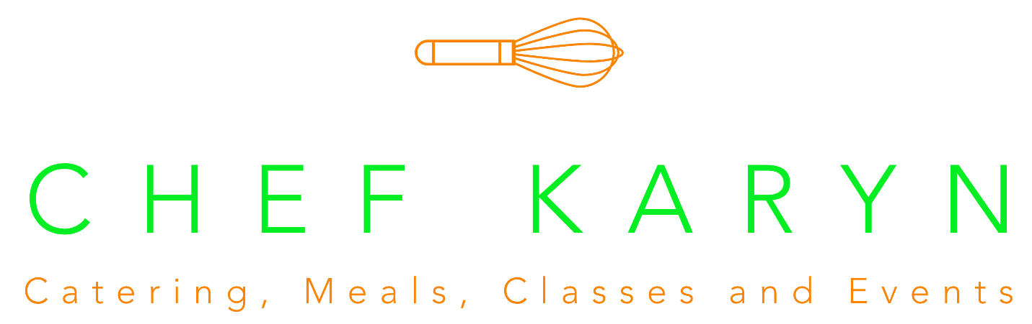

Chef Karyn Boxed Lunch Menu – All lunches $14
Each box lunch comes with a sandwich of your choice, a bag of plain potato chips, a Chef Karyn Famous Chocolate Chip Cookie, and a Bottle of Water. All Sandwiches are to be kept and served cold.
Minimum Order of 10 lunches. It is requested that 10 days notice is given prior to delivery/pick-up date. Delivery is available in Sheridan for no fee. Delivery is available in Westfield, Noblesville, and Carmel for a fee of $15. Delivery is available in Fishers and Zionsville for a fee of $20. Sales tax additional.

Sandwich options:
- The BEST Roast Beef Sandwich – Soft Roll with roast beef, swiss, peach preserves, walnuts, and Dijon mayo.
- Peach Smoked Turkey Croissant – Croissant with smoked turkey, chive cream, peach preserves, rosemary, and pecans.
- Pesto Turkey Sandwich – Soft Roll with pesto, smoked turkey, swiss, and a sundried tomato mayonnaise.
- Sweet Ham and Swiss – Soft Roll with ham, chive cream, apple butter, and swiss cheese.
- Lemon Tarragon Chicken Salad – Croissant with Chef Karyn’s chicken salad – with lemon, tarragon, grapes, and pecans.
- Traditional Egg Salad – Croissant with traditional, creamy egg salad.
- Tuna Salad Croissant – Croissant with Chef Karyn’s Old Bay Tuna Salad.
- The Veggie – Soft Roll with roasted vegetables and roasted red pepper mayo.
- Build-your-own Sandwich – Choice of Croissant Roll, or Soft Roll. Choice of meats – Roast Beef, Smoked Turkey, or Ham. Choice of Cheese – Swiss, Cheddar, or American. Choice of toppings – Lettuce, Tomato, Mayo, Yellow mustard, Dijon.

