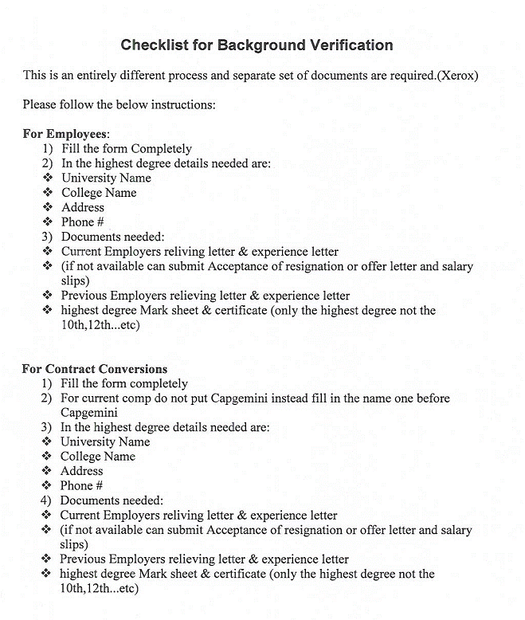

Background Verification Form

(Note: Please print this form clearly and complete and accurate information)

Name :_______________________________Date:_____/_____/_____

Date o Birth :_______/_______/________ Marital Status: Married /Single

Maiden / Former Name:_______________________ Gender: Female / Male

Email Id: ContactNo:
Address of Communication:

Employment Details

Sr. |  | Company 1  (Current Company) | Company 1  (Previous Company)
1 | Employer Name and full address
2 | Office Landline Numbers
3 | Dates Employed | From  Till | From  Till
4 | Job Title / Designation
5 | Gross Salary
6 | Supervisor Name & Contact Number
7 | Reason for Leaving
8 | Employee Code
9 | Agency Details  (For Contractual / Temporary Employees)

Education Qualification

Sr. |  | Institution 1 [Highest Degree Obtained]
1 | Exam Passed/Degree Obtained
2 | Institution/College Name and Address
3 | Institution/College Landline Numbers
4 | Year of Passing
5 | Seat Number
6 | Period : From / To
7 | Stream/ Main Subjects
8 | Percentage

Letter of Authorization

To whom it may concern

I understand that Real Check Verification Services Pvt Ltd (RCVS)may use an outside agency to verify and validate the information I have provided including my employment, my personal background, professional standing, work history and qualifications.

I understand that an outside background agency may obtain information it deems appropriate from various sources including, but not limited to, the following: current and past employers, criminal conviction records, College records and professional references.

I authorize, without reservation, any individual, corporation or other private or public entity to furnish Real Check Verification Services Pvt Ltd (RCVS)and the outside background agency all information about me.

I unconditionally release and hold harmless any individual, corporation, or private or public entity from any and all causes of action that might arise from furnishing to Real Check Verification Services Pvt Ltd (RCVS)and the outside agency information that they may request pursuant to this release.

This authorization and release, in original, faxed or photocopied form, shall be valid for this and any future reports and updates that may be requested.

Signed: ________________________

Name in Block Capitals: ________________________

Date of Birth: ________________________

Date: ________________________

