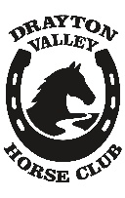
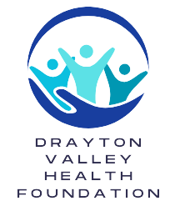
Rider Pledge Sheet Drayton Valley Horse Club
in support of

Drayton Valley Horse Club Annual “TRAIL RIDE AGAINST CANCER”
Instructions:
- Please make cheques payable to: Drayton Valley Health Foundation
- Please bring completed pledge sheet and collected pledges to the ride site.
To receive a tax receipt a legible name, address and postal code is necessary. (Receipts will be mailed within three months)
Receipts will be issued to those requesting them for donations of $20 or more. Receipts sent out by Drayton Valley Health Foundation. All pledges should be collected in advance.
Name | Mailing Adress | Phone | Cash or Cheque | Receipt  (Y/N)
Total This Page

Name | Mailing Adress | Phone | Cash or Cheque | Receipt  (Y/N)
Total This Page $ |  | Grand Total $
Charitable registration # 590-600-547-RR0001

