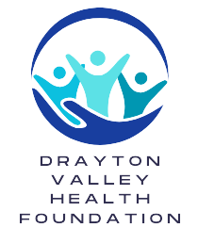
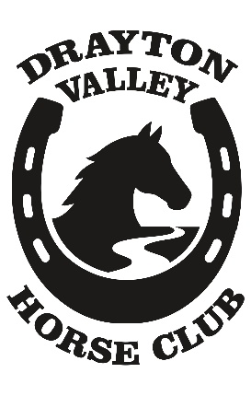
Drayton Valley Horse Club
Box 7645, Drayton Valley, AB, T7A1S7
Drayton Valley Horse Clubs
“TRAIL RIDE AGAINST CANCER”
Saturday, May 23, 2026

This is an invitation to participate in our exciting annual “Trail Ride Against Cancer.” Funds will be directed locally to the Drayton Valley Health Foundation. The ride will be held at the Drayton Valley horse club’s riverside trail’s (see map)
There will be two pleasure rides- one in the morning leaving at 10:00am and one in the afternoon leaving at 1:30pm.
Riders may arrive the evening before and camp overnight.
Please keep horses out of flagged area.
To qualify, a rider must have sponsors who make a specific financial contribution to the Drayton Valley Health Foundation. A MINIMUM of $15 total donations for riders 14 years and under and a MINIMUM $25 for all other riders is REQUIRED.
Coffee & doughnuts will be served at 8 AM.
Lunch will be served at 12 noon with presentation of prizes. Lunch will be available for purchase for riders and non-riders.
Prizes will be awarded for the individual top earner (Based on the money collected and turned in on the day of the ride.)
Be sure to have with you your complete entry form and sponsor sheets.
Official tax-deductible receipts will be mailed out to the sponsors after the ride.
“APRIL IS CANCER MONTH” Collect your donations early!!

Drayton Valley Horse Clubs
Trail ride against cancer

The safety and well-being of all horses and riders is of paramount importance, particularly in an event of this size we would appreciate your cooperation in the following:
• Please refrain from liquor or drugs while on the ride.
• Rifles and off-road vehicles are not permitted.
• No dogs allowed in picnic area or on the trails. Dogs must be always tied/leashed.
• Please refrain from horse play on the trails (Switching other horses, galloping by other riders, etc.
• No leaving the marked trails.
• Proper footwear should be worn.
• An adult on and off the ride must accompany children under 14.
• The minimum age for any horse entering the ride is three years of age and in good condition.
• Stallions are not encouraged.
• Horses, feed, and transportation are the responsibility of the riders. Water will be available. Please bring your own pail, tie horses to your trailer or the hitching rails do not tie horses to the trees.
• You are responsible for CLEANING up after yourself and horses!
We want to thank all this year’s participants for your support and making this years Trail Ride against cancer a success. Your cooperation in adhering to the rules will make our jobs easier. We hope that you will join us and enjoy the day.
We once again look forward to seeing you at this years Trail Ride Against Cancer, which we know will be an immense success with your continued support. Cancer attacks our young, our old, our mothers and fathers, the rich, the poor and even our horses.
TOGETHER WE CAN BEAT CANCER

