**Beaches Of Cape Sable**

**Island**

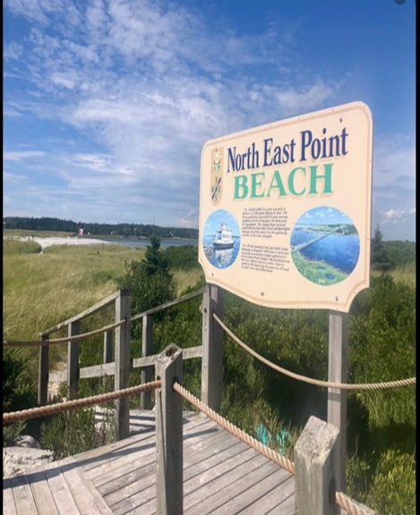It has been said that the beaches of the south shore of Nova Scotia rival those of the Caribbean and you will find some of the most beautiful ones on Cape Sable Island and area. Let’s first visit North East Point Beach.



**NorthEast Point Beach**

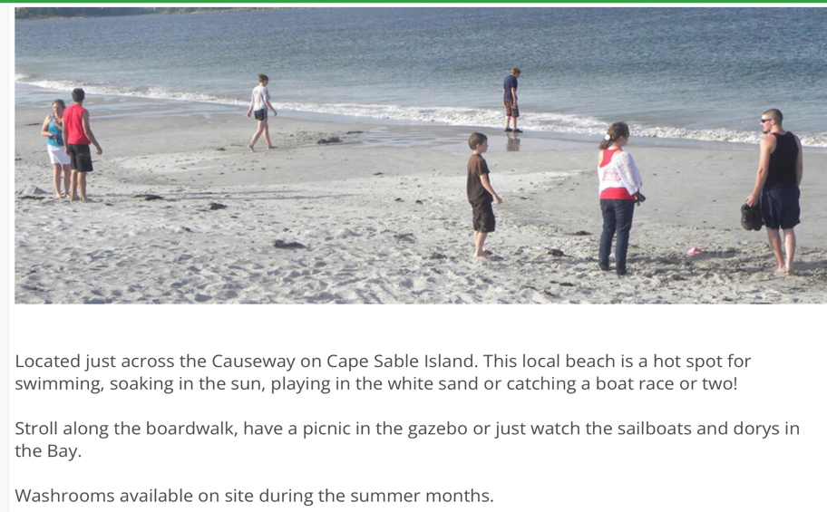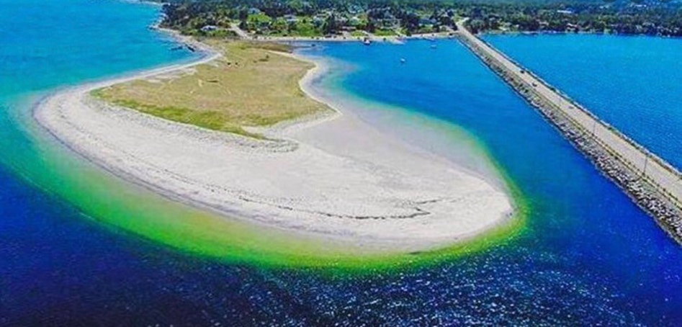When you first drive across the causeway to come onto Cape Sable Island you will see North East Point Beach to your left. You can stroll along the board walk which leads to a beautiful white sandy beach. This is one of the more popular beaches on the island and you will often find families playing in the sand, swimming or soaking up the sun. There are public washrooms available in the summer months. This beach is 6.9 km from Sandy Beach Hideaway.

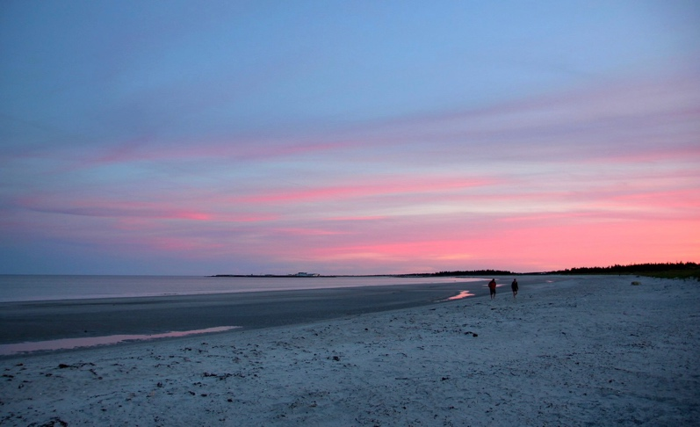 **StoneyIsland Beach**

**Our next stop is Stoney Island Beach. This beach is the closest to Sandy Beach Hideaway, within 1 km. We never get tired of searching for SeaGlass or enjoying a nice walk on this spectacular beach. When you see this beach you will know why!**

**South Side Beach…or Sometimes called Daniel’s Head Beach**

I have to say that this is my favourite beach on the island. There is something truly peaceful when the sky, sand and ocean all coming together as you stroll this beach. You can walk for miles and if you keep walking you can walk all the way to Hawk Beach which is just outside Clark’s Harbour. The fun part of this beach are the seals. Dozens of them sit on the large rocks sunny themselves and many of them are the size of a small car! The kids love going there running up and down the beach watching the seals.

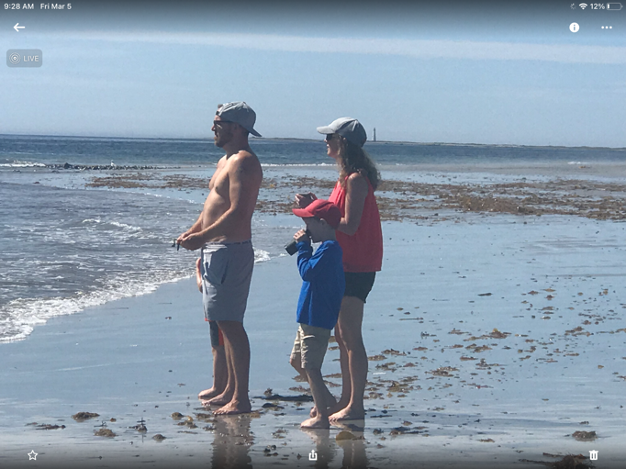

Here are a few of our family members watching the seals at South Side Beach. If you continue walking you can walk right to Hawk Beach. Another beautiful white sandy beach.

**Cripple Creek…. If you have a few days and like a hike go right out of the driveway and drive a few km down the road to Cripple Creek Road. There’s a small wharf there. Pull in to the left, park your car and start walking left. You will walk for about 35- 45 minutes along the coast and it will take you to a very secluded beach. It’s an awesome place to head with a picnic lunch.**

The yellow square is Sandy Beach Hideaway and can see off of Cripple Creek Road the blue sq. You can walk along the coast and enjoy a number of secluded beaches along the way. The best one is at the end! Lots of water and sun screen required.

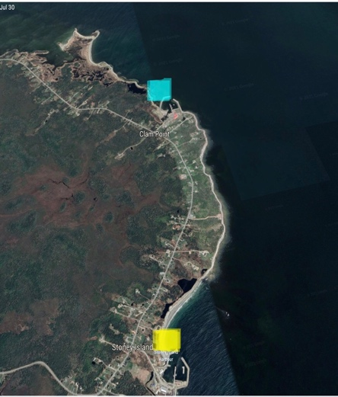

**Hawk Point Beach**

**This beach is at the far end of the island and you can reach it by walking the full length of South Side beach or driving to Clark’s Harbour and following the signs to Hawk Beach.**

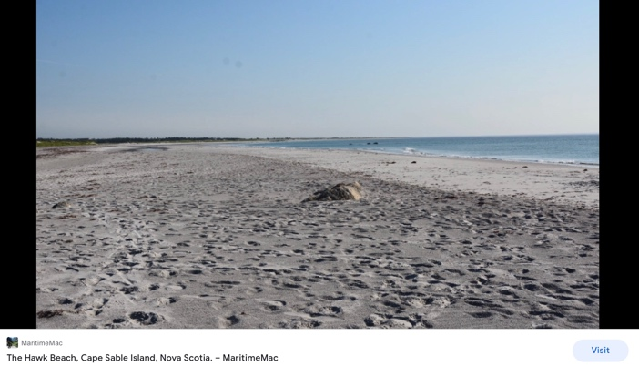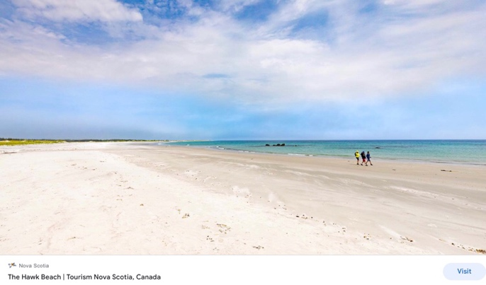**Here is another possibility for searching out SeaGlass. Sometimes you have to dig a bit in the loose gravel but it’s there.**

**Walking to to the left you can enjoy the beautiful white sand dunes but going left you will find one of nature’s oddities.**

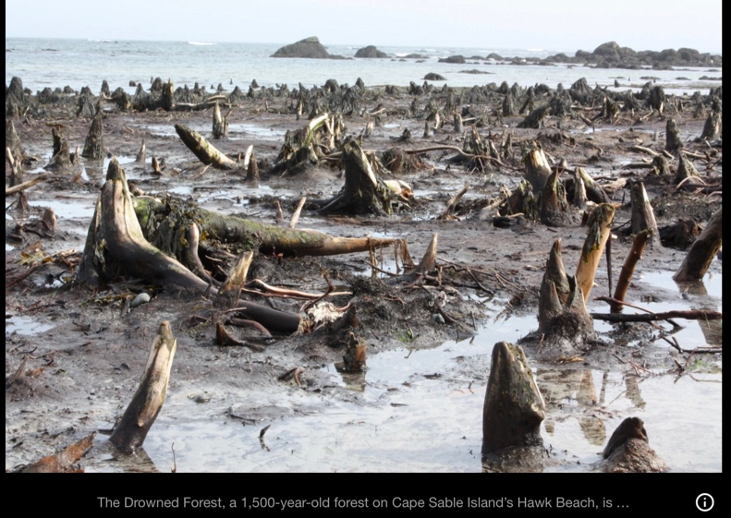**The Drowned Forest! This 1,500 year old forest is the remains of a forest that is still rooted in it’s original soil.**

**It’s one of the eeriest spots as the tree stumps jut out at all the wrong angles leaving you very puzzled as to what event in nature caused this occurrence.**

**“ The Cape”**

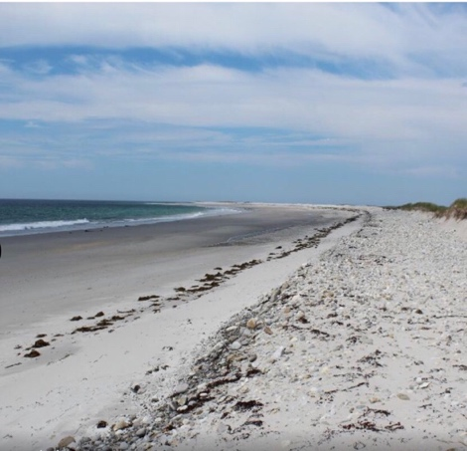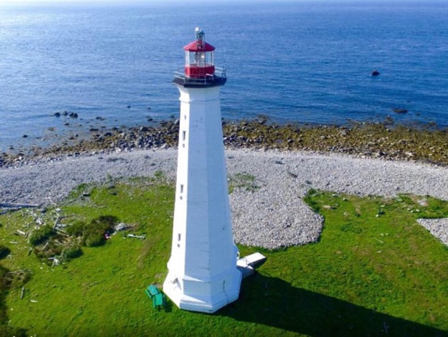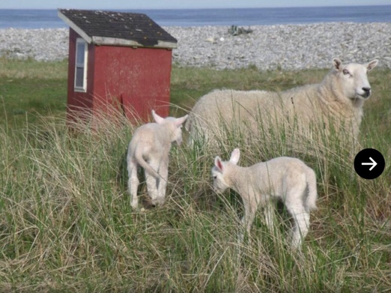**If you’re looking for something truly unique to do in the area then take a short boat ride with “ Johnny Hot Dog”! Of course that’s not the name his mother chose for him but around the island that’s who you will call to take you across the water to a very’ large sand**

**bar, known as The Cape. Not only will you find miles of a pristine white sandy beach but the island is also home for dozens of sheep, a number of shanties and one of the tallest lighthouses in Nova Scotia, standing at 101 ft. So pack yourself a generous picnic, sunscreen and a hat and set off for a day of exploring this very unique island. So, give Johnny Hot Dog ( Johnny Nickerson ) a call at 902-635-4466 to set up your time to visit.**

**Sandhills Beach, Villagedale. Crow’s Neck Beach, Smithsville**

**If you’re looking to travel a few more Km, then Sandhills Beach and Crow Neck Beach are definitely worth the trip. Sandhills Beach Park is a provincial park located in Villagedale just 21 minutes away. You’ll find 2.5 km of white-sand beach, sand flats that warm in the sun leaving the water nice for swimming when the tide comes in. You’ll will find public change/washrooms and lovely wooden walkways to the beach. A perfect day for the kids! This is also a great place for bird watching.**