League Rules

Last Updated
March 29th, 2026
League rules are subject to change for the betterment of the league and will be enforced after notification. However, in regard to suspensions, rules at the time of those players under suspension will remain under the previous policy until suspension is complete.

Non-Checking League
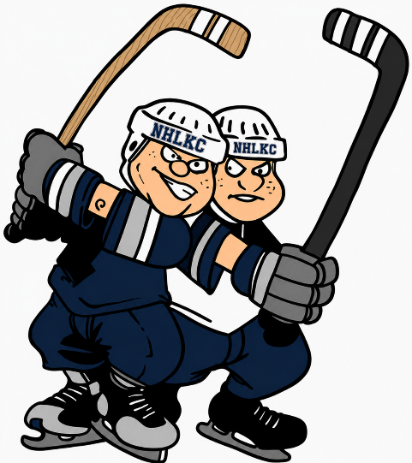
**This is a NON-CHECKING hockey league. However, CONTACT is bound to happen. Full equipment is highly recommended. Helmet, Gloves, Skates, Elbow Pads and Shin Pads are mandatory. You will be asked to address unsafe equipment. **
The Leagues Abide by The USA Hockey Rules and Regulations. However, In Addition to The USA Hockey Rules and Regulations the Following Policies Listed Also Apply. See On-Ice Game Play tab as well.

USA Hockey Membership Registration

USA Hockey Membership Registration
All League players are required to have USA Hockey membership. No Exceptions
2025-2026 open - register now and expiration is 8/31/26
- When registering choose "KANSAS" as the state.

Player Responsibilities
- Session fee is a team fee. See League fees for further breakdown of responsibility.
- Each participant is required to respect the rules and regulations of the Northland Hockey League Kansas City.
- Each participant is required to be courteous and respectful to all staff members and follow all facility regulations.
- Each player is required to sign waiver before stepping on the ice.
- Each team is responsible for keeping the bench and locker rooms clean.
- Only players that actively participate and properly registered are allowed on the bench.
- Participants must be 18 years of age. No persons on the bench under 18 years of age due to SafeSport protocols.
- It is the responsibility of every participant to know and understand league rules.

Fighting and Majors
- Absolutely NO Fighting!
- 1st offense: No additional sanctions beyond game officials’ assessments.
- 2nd offense: 2 Game Suspension in addition to game officials’ assessments / Possible Removal from League
- 3rd offense: League will impose further sanctions including removal from league.
- Threaten remarks during game activity will be subject to immediate removal from game and subject to further sanctions.
- Fighting - Rule 615 Know and understand
- Do not help break up any scuffles or fights… Odds are you will get penalized
- Instigating Penalties Will Be Strongly Enforced
- Off-Ice Offense (Example: Going in to Other Teams Locker Room or Penalty Box with Harmful Intent, Conduct Unbecoming): 10 Game Suspension / Possible Removal from League.
- 5+ Penalties In a game: 1 Game Suspension

Suspensions
- All Suspensions by KCOA are not subject to debate. Additional penalties can occur pending on the severity of the infraction. League reserves the right to remove any player from the league for conduct detrimental to their team/league.
- If a player is suspended, they are not allowed to play for any other team in any division until suspension has been served. Players playing on multiple teams cannot play with either team until suspension has been served in the division in which the suspension was issued. Not allowed to sub for any other team as well.
- Suspended Players are allowed to come and watch the games, but are not allowed on the player’s benches or in the locker rooms. They must conduct themselves in an appropriate manner. Any inappropriate behavior may result in additional game suspensions. Basically, make yourself invisible.
- No refunds will be provided to individuals who receive suspensions.

Verbal and Physical Abuse
Verbal and physical abuse of officials and arena personal will not be tolerated.
Abuse of any official (on/off ice) will not be tolerated by the league. You may not approach league officials or rink staff for any complaints during or immediately after the game. An automatic 1 game misconduct will be enforced. The league, in its sole discretion, reserves the right to suspend or terminate any player from the league for detrimental behavior. All reviews will be made on a case-by-case basis by the league and will consist of information from teams, referees, scorekeeper and arena personal.
The league reserves the right to block participation of players in any division.

League Fees

Payment Options
Captains -Payment options: Cash, Check, Venmo, or Debit/Credit Card(cash/check preferred)
Individual players pay their team captain and the captain pays the league is preferred method.
Individual payments can be made with the approval between League and Captain.
See important notices.

Lack of Fee Payments
League reserves the right to suspend players from games until payment has been made.

IMPORTANT NOTICES:
Session fee is a team fee.
$1000(TBD each session) must be paid prior to the start of each session with the remaining current session balance due by the 5th game of the session.
You are welcome to pay the balance any time before the 5th game. If you don’t have your balance paid by the 5th game the captain will be responsible for the balance and I will ask you to Venmo me the remaining balance or we will use a card of your choice. If teams are unpaid the potential to suspend games is a definite possibility until all teams are paid.
By agreeing to play you accept these terms.
(As it is a team fee, if members of team do not pay it is the responsibility of the remaining members to complete fee payments by end of the session.)
League reserves the right to charge late fees after the 5th game of the session.
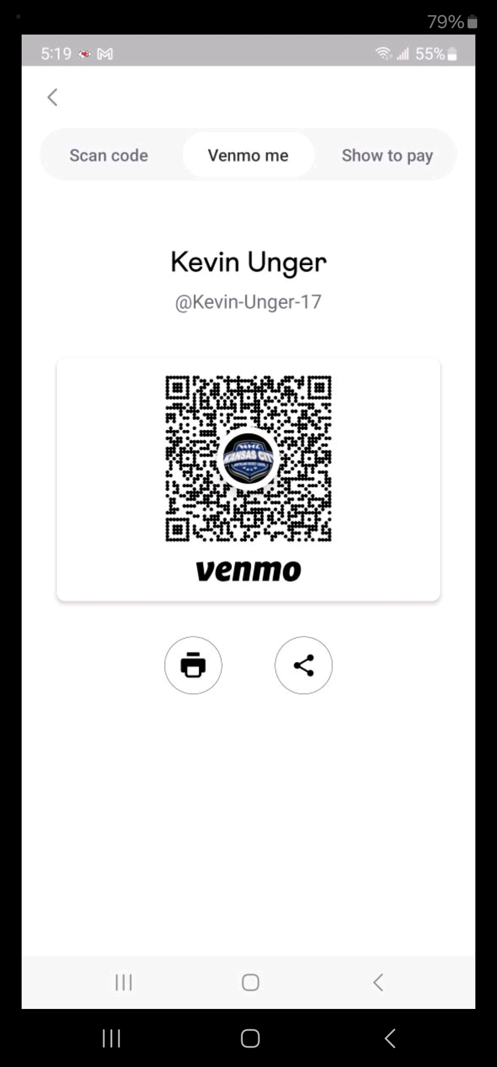

-Ice Rules, Game Play, Rosters

League Overviews
- USA HOCKEY Registration Required before eligible to play
- Valid Team rosters for division must be established prior to league play.
- Waiver required
- 3-minute warm-up starting when Zamboni doors shut, 14 minute (2 min pen) stop time periods A League and 12 minutes (1:30 min pen) stop time periods for B, C, and D Leagues, referees have been instructed to start game timely. The rink reserves the right to make 3rd period a running clock.
- Players are asked to help collect warmup pucks for scorekeepers.
- No tie games, if tied after regulation, 3-man shootout until winner
- 1 Time Out Per Game
- Win = 2 pts, Shootout Loss = 1 pt, Loss = 0 pts
- Game Times and Days, though rare, Are Subject to Change
- Games dates will only be changed for weather and rink issues.
- Communications - Captains must provide email and cell phone. You are required to use the GroupMe applications for communication purposes.
- Playoff Overtime - Championship Game only - 3 on 3 5-minute period, then 3-man shootout.

Rosters
- Roster Size – Maximum of 15 skaters and 1 goalie listed on template with valid USA hockey #’s. You will not need to list subs unless they are skaters from other rinks. It will be captain's responsibility to make sure players are USA Hockey eligible. Violations will be dealt with between captain and KCOA.
- All substitute players MUST BE rostered on another NHLKC team preferably from the same league.
- You may not use a player that is rostered at KCIC, IEC, Bluehawk, etc. unless they are on the sub list you submitted at the beginning of the season.
- No more than 15 skaters on the bench at any time including play-offs.
- Fee collections - Captains maybe required to provided credit card info if team is historically had issues with team collections.

Substitutions
- Amount of Substitutions - No team is allowed player subs if 10 or more of their rostered players are in attendance. In addition, you are not allowed to add more subs than the number of your opponent’s players in attendance for all leagues. If you must start a game with substitutes and your own players subsequently show up, your substitutes must leave the bench to remain in compliance of the rules.
- Current Understanding of Substitutes - Players can be from the same league or lower leagues to be eligible to sub. Sub players should be at or about the same ability level as the player they are replacing. Only exception is if you pick up a player from a team that has played prior to your game or plays subsequent to your game that plays in the same league. All subs (non-regular players must be registered with USA Hockey, must have signed waiver to be eligible. Captain’s responsibility to make this happen

Playoffs
- Absolutely no substitutions during the playoffs.
- Players not in League USA database and on scoresheets for playoffs are not eligible to play.
- League will always allow a review for all captains prior to playoffs for own team and opposing teams.
- During playoffs, protest must come prior to start of game and referees should be notified so non rostered players will be removed prior to game.
- Regarding double rostered player paying for both teams. If you meet during the playoffs, you must make a decision on which team you are declaring for at that time. If that team loses the players is also out for the remaining games of the playoffs.
- **PLAYOFF ROSTER: PLAYER MUST PLAY IN AT LEAST 50% REGULAR SEASON GAMES TO BE ELIGABLE FOR PLAYOFFS, IF NEW IN WINTER SESSION MUST PLAY HALF OF SESSION** The League will not monitor this it is up to captains to prove and protest prior to playoffs.

USA Hockey Membership Registration

USA Hockey Membership Registration
All League players are required to have USA Hockey membership. No Exceptions
2025-2026 open - register now and expiration is 8/31/26
- When registering choose "KANSAS" as the state.

League Divisions

NEED TO KNOW

The League would prefer even number of teams to avoid the dreaded BYE!
If you wish to add a team, please go to the Documents section and complete roster including highest level played, then submit the roster will be vetted especially at the D League level. The League reserves the right to remove players not appropriately skilled at the division level.

A League
No stipulations for participation. Player participation ranges from professionals, junior and travel players, and the more accomplished house level players.

B League
This division has a wide range of level of play and is highly competitive. Teams are typically made up of older A level players that no longer can compete at the speed required for A league play. B level players which consist of players that have had organized youth experience but typically limited to house level play and high-end C level players. C league players are allowed to play at this level if so inclined but must keep in mind that a sprinkling of A level players can compete and be rostered on B league teams to help raise the competitiveness and level of play of the lessor accomplished players.

C League
This is the division of most the pool of adult players. Typically, these players started their hockey careers as adults or are far removed from their youthful days of organized hockey. Range of level would be considered from players advancing from the D League to high C level players that may even try their hand at the B level.
Participation stipulations: Youth A & High School with all team captain's approval. B League with all team captain's approval, Youth House, C & D League

D League
New players to hockey and development of the novice skaters. Cooperation and communication between captains are key to the success of the league. Goal is to move players to the next level when possible.
Participation stipulations: C League with all team captain's approval, D League, Beginners, C League players rostered on a C League team for at least two sessions are not eligible for the playoffs.

