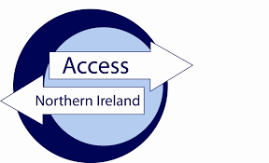
ACCESS NI
STEP BY STEP INSTRUCTIONS

- Volunteers/staff members who wish to have an ACCESS NI check done must fill in the PIN NOTIFICATION AND ID VALIDATION form. Only the new form from 1st May 2018 will be accepted.

- Applicants can go online and follow the instructions (on the form, which are more straight-forward than they look).

- Please ensure the following:

  - You give your full name. If you have two first names put them on the form.
  - You use Title Case. e.g. Sam Jones, not sam jones. This will come back on your certificate.
  - Organisation reference – please enter the name of the organisation you are getting checked for in there.
  - You will be asked if you want a postal copy of your certificate or a digital copy. If you choose digital, you will find it (when completed) where you check the status of your application by logging in to your Access NI account.

- Once the online process is completed, each person will be assigned a reference number to put on the form.

- The next step is to bring the Pin Notification & ID Validation form, the relevant identification and payment into Omagh Volunteer Centre. (£40 for a paid worker or £5 for a volunteer, cash or cheque made payable to Omagh Volunteer Centre)

- It can all be processed within a few days if all parts are completed and correct ID is shown.

- For volunteers only: we ask you to register with the Volunteer Centre to be kept up to date with training/other volunteering information. You will be added to our database/mailing list. This is not compulsory. Please speak to a member of staff.

- All Organisations using this service must have a Service Level Agreement dated since May 2018 in place.

