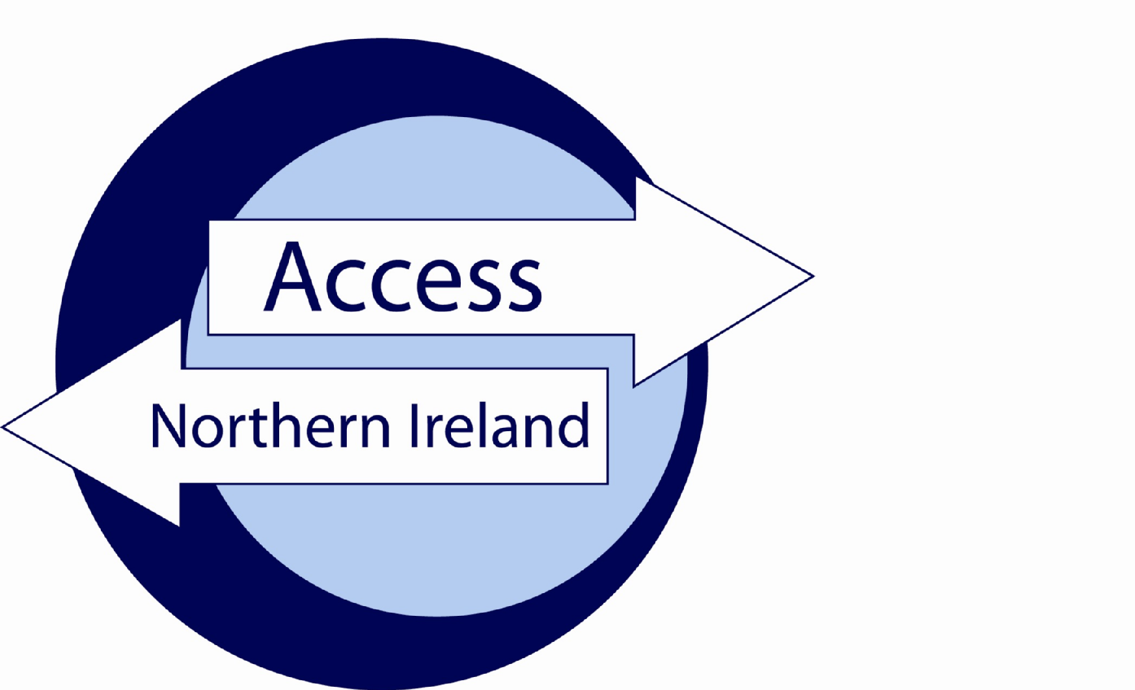

Service Level Agreement

Between

Omagh Volunteer Centre

and

3rd Party

May 2018

Index

Page

Section 1 – The Agreement 3
Introduction 3
Background 3
Scope 3
Assumptions 3
Section 2 – Roles & Responsibilities 5
Section 3 – Authorisation and Agreement 7

Section 1 – The Agreement

Introduction
The purpose of this agreement between Omagh Volunteer Centre and 3rd Party is to set out the terms under which both parties will agree to comply when handling personal information during the AccessNI disclosure process.

This agreement is made on insert date and will commence at the same time.

Unless the Agreement is specifically amended, altered or withdrawn it will be automatically agreed to have rolled over on the 1st April each year.

Background
Umbrella Bodies cannot take a recruitment decision on the basis of information contained on a Disclosure Certificate unless the applicant will be directly working for the Umbrella Body. This Agreement recognises that AccessNI provides one copy only of a Disclosure Certificate to the applicant. However, the on-line case tracking system enables Omagh Volunteer Centre to know when a Disclosure Certificate has been issued and whether there is any information in that Certificate. Omagh Volunteer Centre will provide relevant information to 3rd party. Omagh Volunteer Centre will record details that their part of the process is complete.

Scope
The terms of this agreement shall not be varied or amended unless agreed to and confirmed in writing by authorised representatives of Omagh Volunteer Centre and 3rd Party or AccessNI. AccessNI may, given appropriate notice, withdraw an organisations designation of Umbrella Body or request they do not offer their service to 3rd parties.

Assumptions
This agreement is based on the following assumptions:
- An employer / organisation has approached the Umbrella Body to assist with the processing of an AccessNI disclosure application;
- The employer / organisation requires Standard or Enhanced disclosures for individuals who they may seek to recruit (Basic checks are not carried out by Omagh Volunteer Centre);
- The Umbrella Body / employer has established that there is a legal entitlement to request Standard / Enhanced disclosures from AccessNI;
- A charge is applicable for the Disclosure, both parties to this SLA will have agreed the means by which payment will be made, prior to submitting a disclosure to AccessNI;
  - OVC Fees from January 2018 – Paid Worker £40 (£7+ £33 ACNI) & Volunteer £5 from non-profit organisations
- It is understood that AccessNI will only issue an invoice to the Umbrella Body;
- That the information supplied in Disclosure Application Forms is correct.

Section 2 – Roles & Responsibilities

Omagh Volunteer Centre will;

- make available the AccessNI Code of Practice (February 2016) to the employer;
  - https://www.nidirect.gov.uk/publications/accessni-code-practice
- ensure there is a legal entitlement for the type of disclosure requested by the applicant;
- assist 3rd Party through the AccessNI Disclosure process, including providing the appropriate PIN number for applicants to enable them to use the on-line application process;
- ensure Disclosure Applications are countersigned properly;
- verify the Identification of applicants per AccessNI guidance, or ensure the ID validation form is completed by 3rd Party and copies of ID is forwarded to OVC;
- retain the ID validation form and ID for a period of 90 days;
- be first point of contact with AccessNI on matters relating to Disclosure Applications submitted through them;
- gather any additional information AccessNI request by either directly contacting 3rd Party or the applicant;
- notify 3rd Party that
  - information has been disclosed on the Disclosure Certificate. Where information has been disclosed the Umbrella Body should advise the employer to ask the applicant to provide that employer with their copy of the Disclosure Certificate in order to view the information and take a recruitment decision;
- advise the employer to ensure that on sight of a Disclosure Certificate containing information they handle such information in line with the AccessNI Code of Practice and the Data Protection Act 1998 and the new General Data Protection Regulation (GDPR) from 25th May 2018;
  - https://www.nidirect.gov.uk/articles/employer-obligations-and-fair-treatment
- provide 3rd Party with guidance on secure handling and storage of information;
  - personal data must be stored according to new GDPR Regulations from 25th May 2018.
- monitor 3rd Party is complying with AccessNI Code of Practice.
  - https://www.nidirect.gov.uk/publications/accessni-code-practice

3rd Party will;

- provide any information requested by Omagh Volunteer Centre to provide assurance that the position applied for meets the necessary legal entitlements for the type of Disclosure requested;
- ensure that the PIN Notification and ID Validation Form and instructions are supplied to the applicant to complete the on-line application form;
- use the on-line application process to ensure that all mandatory fields are fully and accurately completed;
- undertake the appropriate identity checks on applicants, using the methodology in the PIN Notification and ID Validation Form supplied by Omagh Volunteer Centre and complete the PIN Notification and ID Validation Form;
- pass the PIN Notification and ID Validation form to Omagh Volunteer Centre along with the ID;
- agree that only staff authorised by Omagh Volunteer Centre will undertake the checking of Applicants identification documents;
- comply with provisions set out in AccessNI Code of Practice;
  - https://www.nidirect.gov.uk/publications/accessni-code-practice
- ensure the information on Disclosure Certificates provided by applicants is retained in a secure manner, accessible only by those with authority to see them. Details of non-court convictions, convictions, police information or barred list information should not be retained after the recruitment decision is made;
- If an employer uses AccessNI checks in the recruitment process, they must have a written policy on the recruitment of ex-offenders. Job applicants and volunteers can ask for a copy of the policy. AccessNI has produced the following sample policy statement, which can be downloaded below.
  - https://www.nidirect.gov.uk/publications/sample-policy-recruitment-ex-offenders
  - https://www.nidirect.gov.uk/articles/employer-obligations-and-fair-treatment
- ensure that Disclosure information is not passed to persons not authorised to receive it;
- comply with recommendations made by the Umbrella Body.

Section 3 – Authorisation and Agreement May 2018 Version

The Services detailed in this Agreement have been authorised and agreed by the following parties

PART A

For Omagh Volunteer Centre

Signed

Name

Position

Date

PART B

For 3rd Party

Signed Organisation Access NI Nominated Person

Name

Position

Contact Details
Telephone: Email:

Date
_____________________________________________________________________

Signed Organisation Access NI Nominated Person 2 (if applicable)

Name

Position

Contact Details
Telephone: Email:

Date

