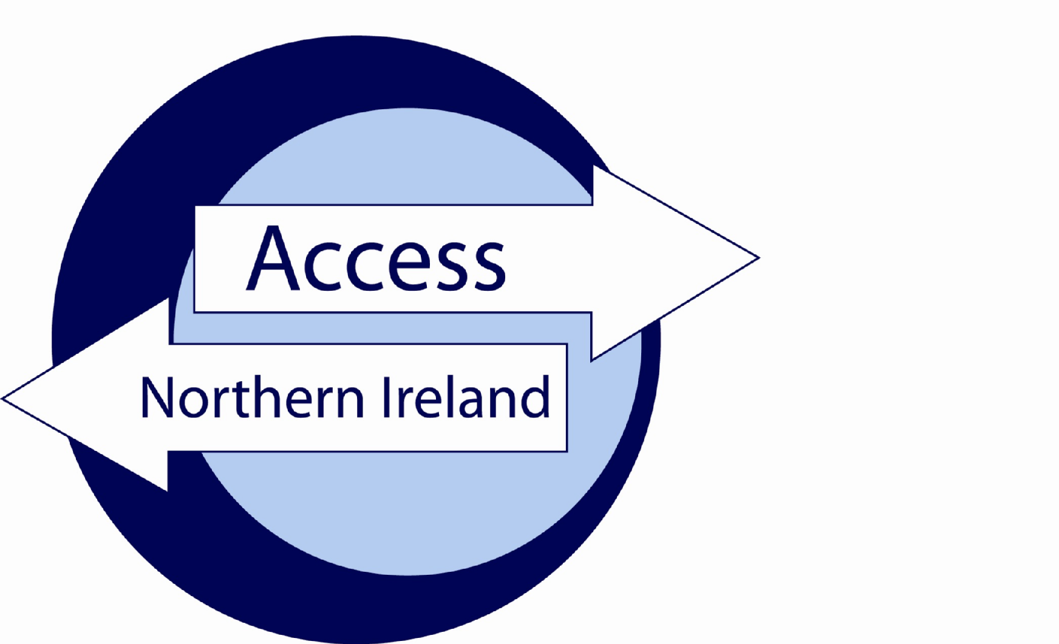

Service Level Agreement

Between

Omagh Volunteer Centre

and

*[3rd Party]*

Date [mm-yy]

**Index**

**Page**

Section 1 – The Agreement 3

Introduction 3

Background 3

Scope 3

Assumptions 3

Section 2 – Roles & Responsibilities 5

Section 3 – Authorisation and Agreement 7

Annex A……………………………………………………………………………………………….....8

Annex B……..…………………………………………………………………………………………...9

Annex C………………………………………………………………………………………………...10

# Section 1 – The Agreement

### Introduction

The purpose of this agreement between Omagh Volunteer Centre and [3rd Party Name] is to set out the terms under which both parties will agree to comply when handling personal information during the AccessNI disclosure process.

This agreement is made on *[insert date]* and will commence at the same time.

Unless the Agreement is specifically amended, altered or withdrawn it will be automatically agreed to have rolled over on the 1st April each year.

### Background

Umbrella Bodies cannot take a recruitment decision on the basis of information contained on a Disclosure Certificate unless the applicant will be directly working for the Umbrella Body. This Agreement recognises thatAccessNI provides one copy only of a Disclosure Certificate to the applicant. However, the on-line case tracking system enables Omagh Volunteer Centre to know when a Disclosure Certificate has been issued and whether there is any information in that Certificate. Omagh Volunteer Centre will provide relevant information to [3rd Party Name]. Omagh Volunteer Centre will record details that their part of the process is complete.

### Scope

The terms of this agreement shall not be varied or amended unless agreed to and confirmed in writing by authorised representatives of Omagh Volunteer Centre and [3rd Party Name] *or* AccessNI. AccessNI may, given appropriate notice, withdraw an organisations designation of Umbrella Body or request they do not offer their service to 3rd parties.

### Assumptions

This agreement is based on the following assumptions:

* An employer / organisation has approached the Umbrella Body to assist with the processing of an AccessNI disclosure application;
* The employer / organisation requires Standard or Enhanced disclosures for individuals who they may seek to recruit;
* The Umbrella Body / employer has established that there is a legal entitlement to request Standard / Enhanced disclosures from AccessNI;
* If a charge is applicable for the Disclosure, both parties to this SLA will have agreed the means by which payment will be made, prior to submitting a disclosure to AccessNI;
* It is understood that AccessNI will only issue an invoice to the Umbrella Body;
* All disclosure applications will be submitted to AccessNI via the NI Direct on-line portal;
* That the information supplied in Disclosure Application is correct.

# Section 2 – Roles & Responsibilities

**Umbrella Body Name** will;

● make available the AccessNI Code of Practice (October 2020) to the employer;

* ensure there is a legal entitlement for the type of disclosure requested by the applicant;
* assist [3rd Party Name] through the AccessNI Disclosure process, including providing the appropriate personal identification number (PIN) for applicants to enable them to use the on-line application process. The PIN form at Annex A can be used for this purpose;
* ensure Disclosure Applications are countersigned properly;
* ensure identity documents uploaded to the AccessNI application by the applicant are listed on the [AccessNI list of acceptable identity documents](https://www.nidirect.gov.uk/sites/default/files/2025-06/List%20of%20acceptable%20ID%20documents%20-%20June%202025%20%281%29.PDF);
* reject identity documents provided by the applicant which are not acceptable to AccessNI;
* verify the information provided on the AccessNI application accurately reflects details on identity documents to include the provision of all middle names and/or previous surnames;
* be first point of contact with AccessNI on matters relating to Disclosure Applications submitted through them;
* gather any additional information AccessNI request by either directly contacting [3rd Party Name] or the applicant;
* notify [3rd Party Name] that
  + a Disclosure Certificate has been issued by AccessNI; and
  + there is no information on the Disclosure Certificate; or
  + information has been disclosed on the Disclosure Certificate. Where information has been disclosed the Umbrella Body should advise the employer to ask the applicant to provide that employer with their copy of the Disclosure Certificate in order to view the information and progress to the next stage of the recruitment process.
* advise the employer to ensure that on sight of a Disclosure Certificate containing information they handle such information in line with the AccessNI Code of Practice and the Data Protection Act 2018;
* provide [3rd Party Name] with guidance on secure handling and storage of information;
* monitor [3rd Party name] is complying with AccessNI Code of Practice.

**[*3rd Party Name*]** will;

* provide any information requested by Omagh Volunteer Centre to provide assurance that the position applied for meets the necessary legal entitlements for the type of Disclosure requested;
* ensure that the appropriate personal identification number (PIN) is supplied to the applicant to complete the on-line application form;
* use the on-line application process on the NI Direct portal to submit applications to AccessNI;
* comply with provisions set out in AccessNI Code of Practice;
* ensure the information on Disclosure Certificates provided by applicants is retained in a secure manner, accessible only by those with authority to see them. Details of non-court convictions, convictions, police information or barred list information should not be retained after the recruitment decision is made;
* ensure that Disclosure information is not passed to persons not authorised to receive it;
* comply with recommendations made by the Umbrella Body;
* issue all applicants with a copy of the Applicant Information Leaflet (as appropriately amended) at Annex B;
* complete and return to the Umbrella Body the SLA checklist form (Annex C) along with a copy of your policy on

1. Recruitment of ex-offenders and
2. Secure handling, use, storage and retention of disclosure information.

# Section 3 – Authorisation and Agreement

The Services detailed in this Agreement have been authorised and agreed by the following parties

**PART A**

For Omagh Volunteer Centre

Signed

Name

Position

Date

**PART B**

For [Name of 3rd Party]

Signed

Name

Position

Date

|  |
| --- |
|  |

|  |  |  |  |
| --- | --- | --- | --- |
|  |  | |  |
| **Employee - PIN NOTIFICATION**  **DOCUMENTATION FORM** | |  | | |

**Applicant instructions**

1. Go to [www.nidirect.gov.uk/services/apply-online-enhanced-check-through-registered-body](http://www.nidirect.gov.uk/services/apply-online-enhanced-check-through-registered-body)
2. Select the green button to create a nidirect account and apply for an enhanced check. If you already have a nidirect account you should use this. You may be prompted to uplift this account to a higher level – instructions will appear on screen. [Guidance document to create a nidirect account](https://www.nidirect.gov.uk/sites/default/files/2025-03/Guidance-document-to-creat-%20NID-%20LOA2-accoun-%20for-AccessN-%20applications-.PDF)
3. You will need to retain your login credentials for future use.
4. A digital identity validation will be conducted when you create or uplift the nidirect account. Your current name, DoB and current address will be verified by nidirect. You will be asked to upload the required identity documentation and provide a selfie. Instructions will appear on screen. *If there are problems creating this account contact nidirect* ***on 0300 200 7868*** *or email* [*nida@nidirect.gov.uk*](mailto:nida@nidirect.gov.uk)*.*
5. Once you have successfully created/logged in, you will be taken to the on-line AccessNI application.

|  |  |  |  |  |  |
| --- | --- | --- | --- | --- | --- |
| **9** | **8** | **4** | **8** | **2** | **2** |

1. Enter the PIN number below at Step 1 of the form completion.
2. Complete the remainder of the application.
3. Upload the required identity documents to the AccessNI application form. You are required to upload **two** identity documents, chosen from the AccessNI list provided, to the AccessNI application form to allow the Signatory to verify that middle names and previous surnames have been provided. To help avoid delays, where possible the following documents should be uploaded with the application form: -

* Applicant’s birth certificate issued at time of birth or another suitable document that confirms the name(s) at birth and date of birth;
* A document that contains both the applicant’s current name and photograph.

1. Continue to complete the remaining fields on the application.
2. At STEP 12 you must confirm and date the declaration.
3. When you click on **confirm and proceed** the application will be automatically forwarded to the Signatory for approval.
4. Make a note of the 10-digit AccessNI reference number in the boxes below: -

|  |  |  |  |  |  |  |  |  |  |  |  |
| --- | --- | --- | --- | --- | --- | --- | --- | --- | --- | --- | --- |
| Application Reference |  |  |  |  |  |  |  |  |  |  |  |

*Return this form to the person who asked you to complete the AccessNI application*

|  |
| --- |
| **(Completed by Organisation)**  Please ask Employee the following questions:  **Is there any reason why you cannot work in Regulated Activity with children/adults? Yes  No**  **Full Name** *(including* ***ALL*** *middle names)***: _______________________________________________________**  **Any other Surnames** *(including maiden names)***: *_________________________________________________***  **Name known** *(by if applicable)***: _________________________Date of Birth: __________________________**  **Organisation Employed with: _____________________________________________________________**  **Job Role** *(summary of role to be used on AccessNI)***: ________________________________________**  **________________________________________________________________________________________**  *I confirm I have made the Employee aware of the level of disclosure being requested and advised when a check is being made against any of the barred lists.*  *Type of AccessNI requested (tick 1 box only)*  Enhanced Enhanced with Barred List Check  *(Please circle)* ***Children, Adult or Both***  **£10 admin charge included plus £32 Enhanced Check**  *or* **Please invoice our organisation**  **Completed by** *(Print Name)* **: ________________________________________________Date:___________** |

|  |  |
| --- | --- |
| **ACCESSNI LIST OF ACCEPTABLE IDENTITY DOCUMENTS** |  |

|  |  |
| --- | --- |
| Original Birth certificate **(issued within 12 months of birth)** | UK, Isle of Man and Channel Islands - including those issued by UK authorities overseas, eg Embassies, High Commissions and HM Forces |
| Certified copy of birth certificate **(issued more than 12 months after time of birth)** | UK, Isle of Man, Channel Islands or Ireland |
| Long form Irish birth certificate **(issued at time of registration of birth)** | Ireland |
| Adoption Certificate | UK, Channel Islands or Ireland |
| Passport | Any current and valid passport |
| Irish Passport Card | Cannot be used with an Irish passport, Current and Valid |
| Current driving licence photocard | Full or provision - UK, Isle of Man, Channel Islands or Ireland |
| Current driving licence photocard (full or provisional) | All countries outside the UK (excluding Isle of Man and Channel Islands) |
| Current driving licence (full or provisional) - paper version (if issued before March 2000) | UK, Isle of Man, Channel Islands and Ireland |
| eVisa – via weblink and share code | Current and valid |
| Immigration document, visa or work permit | Issued by a country outside the UK. Valid only for roles whereby the applicant is living and working outside of the UK. Visa/permit must relate to the country in which the role is based, Current and Valid |
| Electoral ID card | Northern Ireland only |
| Marriage / Civil Partnership certificate | UK, Channel Islands or Ireland |
| HM Forces ID card | UK |
| Firearms licence | UK, Channel Islands and Isle of Man, Current and Valid |
| Mortgage Statement | UK or Ireland, dated within 12 months |
| Financial statement, for example ISA, pension or endowment | UK or Ireland, dated within 12 months |
| P45 or P60 statement | UK or Channel Islands, dated within 12 months |
| Land and Property Services rates demand | Northern Ireland only, dated within 12 months |
| Council tax statement | UK or Channel Islands, dated within 12 months |
| Credit card statement | UK or Ireland, dated within 3 months |
| Bank or Building Society statement | UK, Channel Islands or Ireland, dated within 3 months |
| Utility bill **(not mobile phone)** | UK or Ireland, dated within 3 months |
| Benefit statement, for example Child Benefit, Pension etc | UK, dated within 3 months |
| Official Government/Council Document | Central or local government, government agency, or local council document giving entitlement, for example from the Department for Work and Pensions, the Employment Service, HMRC, UK and Channel Islands, dated within 3 months |
| EEA National ID card | Current and Valid |
| SmartPass issued by Translink | Northern Ireland |
| yLink card issued by Translink | Northern Ireland |
| Cards carrying the PASS accreditation logo | UK, Isle of Man and Channel Islands, Current and Valid |
| Letter from head teacher or further education college principal | UK - for 16 to 19 year olds in full time education - only used in exceptional circumstances if other documents cannot be provided |
| Letter of sponsorship from future employment provider or voluntary organisation | Non UK only - Valid only for applicants residing outside UK and Ireland at time of application |
| Exceptional circumstances – Document agreed with AccessNI | Cannot be used unless advised by AccessNI |

**lease do not send it to AccessNI**

**AnneAnnex B**



**AccessNI Disclosure – Applicant Information Leaflet**

As part of the recruitment process for a role in which you have expressed an interest, a criminal record check is required to be completed. In Northern Ireland this check is undertaken by AccessNI, upon receipt of a valid application. A disclosure certificate will be issued at the end of the process, including criminal record and other relevant information.

You can find out more about AccessNI on the nidirect website.

**Before the AccessNI process is commenced, and if you are applying for an Enhanced check (with a Barred List check), you are required to disclose if there is any reason why you cannot work in Regulated Activity.**

The AccessNI application must be made on-line through the nidirect website. You will be required to set up a nidirect account to complete your application. The application will be checked and authorised by an approved Umbrella Body before being transferred to AccessNI for processing. A link to the AccessNI Privacy Notice is available prior to commencing the e-application form.

You should note the following important information about the AccessNI application process: -

1. **Omagh Volunteer Centre** has been appointed to check and authorise your application.
2. The name of the authoriser is **Martin Cassidy**.
3. The PIN to be used on the on-line application can be found on the PIN Notification and Documentation Form given to you.
4. You will be requested to upload two relevant identity documents to the application; these will be destroyed 90 days after the date the disclosure certificate is issued, in line with AccessNI retention policy.
5. Your organisation/employer, and not Omagh Volunteer Centre, will be responsible for the decision whether or not to offer you a position.
6. Having a criminal record does not necessarily prevent you from obtaining a position.
7. A policy is in place that sets out the organisation’s approach to recruiting ex-offenders – a copy of this can be made available at your request.
8. The AccessNI Code of Practice (for Registered Bodies) and Service Level Agreement (for Responsible Bodies) is available on the NIDirect website and can also be viewed on <https://omaghvolunteercentre.org/>

If you have any questions in relation to this process you should, in the first instance, contact the person who asked you to complete the AccessNI application.

**Annex C**

**Service Level Agreement – Checklist**

In order to evidence compliance with the provisions within the Service Level Agreement, this form should be completed by [Name of Client Organisation] and returned to [Name of UB] along with the signed SLA and copy documentation as indicated below.

I confirm that [Name of Client Organisation] will:-

|  |  |  |  |
| --- | --- | --- | --- |
| **Requirement** | | **Yes** | **No** |
| 1 | Make all applicants (who require an AccessNI check) aware of the AccessNI Code of Practice and provide them with a copy of the CoP (upon request). |  |  |
| 2 | Comply with provisions in Data Protection Act 2018, and will not retain disclosure information for any longer than is required for the specific purpose. |  |  |
| 3 | Ensure that all applicants for relevant positions are notified in advance of the requirement for an AccessNI check. |  |  |
| 4 | Clarify with applicants if there is any reason why they cannot work in Regulated Activity prior to them commencing an application for an Enhanced check with a Barred List check. |  |  |
| 5 | Notify all potential applicants of the possible effect of a criminal record on the recruitment and selection process, and any recruitment decision. |  |  |
| 6 | Discuss any matters revealed in disclosure information with the person seeking the position before withdrawing an offer of employment. |  |  |

I further confirm that [Name of Client Organisation] has the following policy documents in place, and that copies of same have been provided to [Name of Umbrella Body]:-

|  |  |  |  |
| --- | --- | --- | --- |
| **Requirement** | | **Yes** | **No** |
| 1 | Policy on recruitment of ex-offenders. |  |  |
| 2 | Policy on secure handling, use, storage and retention of disclosure information |  |  |

**To be signed by representative of Client Organisation.**

|  |  |
| --- | --- |
| Signed: ……………………………...……………… | Date: …………………… |
| Print Name: ………………………………………… |  |