B.P.Ed.
Unit-1
KINESIOLOGY AND BIOMECHANICS

KINESIOLOGY

Meaning and Definition

Aristotle established the foundation for kinesiology and therefore known as the ‘Father of Kinesiology’. Aristotle is the first to analyze and describe the complex process of walking in which rotatory motion is transformed in the translatory motion.

Kinesiology is the study of human movement. Kinesiology is derived from the Greek terms ‘Kenine’ meaning ‘to move’ or ‘motion’ and ‘logos’ meaning ‘the science of’ or ‘word of knowledge’. Thus Kenesiology is defined as the “Scientific study of human motion”. Kinesiology is a science, an organized system of information related to motion. It is the study of scientific principles of movement in knowing motor performances. Improvements in muscular strength and development through kinesiological principles coupled with applications of physiology of exercise have resulted in improved physical performances. Without appropriated background knowledge of anatomy and physiology, we cannot understand kinesiology, though its applications are not necessarily limited to anatomy and physiology.

Importance of Kinesiology in Sports

In early days of physical education when few activities were taught other than gymnastics and dance, the content of a course in kinesiology was confined chiefly to functional anatomy. Gradually, as sports have assumed a more important place in the curriculum, the concept of kinesiology is broadened to include the study of mechanical principles which apply to sport techniques. The principles are applied not only to the movements of the body itself, but also the movements of the implements, balls and other equipment used for the sport.

Significant positive changes have been experienced in teaching physical education and coaching competitive sports all over the world. Teachers and coaches are better prepared today than ever before, they show greater concern for the welfare and happiness of their pupils in sports sciences and medicine. On e of the most important reasons for this unprecedented progress has been the ever increasing emphasis on the application of scientific principles to the preparatory programmes of physical education teachers and coaches. Some of the essential requirements in those preparatory programmes are successful academic and practical performance in such allied sciences as motor learning, exercise physiology, kinesiology and biomechanics.

The shift in professional preparation is a reflection of the current knowledge explosion in every field of human endeavor. The most marked feature of this explosion is the development of new ideas of knowledge and assessment of the traditional disciplines. The most dramatic progress in this continuous process of the development of new knowledge is being made in applied sciences. As new areas of knowledge are developed and recognised, they are given new names, whose scope is in close proximity with that of existing areas. The result has been the introduction of a variety of new terms, with varying degrees of emphasis of meaning. These terms are purported to define and describe most appropriately the subject matter within their respective areas.

The present trend of the application of the scientific principles to the analysis of human motion has been burdened by the problem of lack of consistency and clarity in the use of the terms for the different emerging areas of knowledge. There was a time when the term kinesiology (Kinesis=motion; Logos=science) was used to describe the knowledge concerned with the structure and function of the musculo-skeletal system of the body (Jensen et al 1983). Subsequently, the study of mechanical principles applicable to the analysis of human motion, became widely accepted as an inseparable and integral aspect of the field of kinesiology. This meaning has been expanded in 1970s to include all aspects of science that are related to human motion. These shifts in the emphasis of the meaning and content of kinesiology made it lose its usefulness as a term to describe specifically the science of motion concerned with either the musculo-skeletal system or the mechanical principles applicable to human motion. As a response to this flux, several new terms were generated as alternatives to bring sense and sanity to the bedeviled field of kinesiology. Some of these terms included bio-dynamics, bio-kinetics and kinanthropometry. The term that powerfully emerged from all these terms was Biomechanics, which gained much wider acceptance than any other term.

DEFINITION AND MEANING OF BIOMECHANICS

The term ‘Biomechanics’ has been described by different people with varying degrees of emphasis on different aspects of biomechanics. For example, Webster’s dictionary (1994) DEFINED Biomechanics as the “Study of the principles and relations involved in muscular activity. Similarly, Dorland’s medical dictionary (1991) defined biomechanics as “The science that examines the internal and external forces acting on a human body and effects produced by these forces”. However, the concept of biomechanics as the “Science, that studies external and internal forces acting on a biological system and the effects produced by these forces”, has been consistent in the scientific circles. On the basis of this widely accepted concept, biomechanics may be defined as “the field of study in which the principles of mechanics are applied to the structure and movement of animals and human beings”.

In the fields of physical education, sports and rehabilitation, the primary concern is the study of the effects of internal and external forces upon living bodies. Biomechanics of sport is therefore concerned with forces, movements, accelerations, velocities, energy, momentum and other mechanical aspects involved in the field of the application of Newton’s laws of motion.

Historical Highlights of the Development of Biomechanics:

With the advent of modern Olympics, interest in the improvement of techniques of sports grew dramatically reflecting an emerging need for the purposeful application of mechanical laws to movement in sport. Around the turn of the century, however, no serious attempts were made to develop a deeper understanding and insight into the objective laws (Duben Dofer, 1979). In individual athletic disciplines, athletes made attempts to learn intuitively the course of movement, which led to the greatest improvement in their performance. This course of movement has been regarded as the most advantageous. The comparison of performances in competitions (Hay 1973, Hocmuth, 1984) gave considerable support to this approach. New record breaking performances made the other athletes imitate the technique of those who broke the records. The techniques of Brumel and Fosbery in high jump and the training methods of Zatopek were similarly imitated.

However, this approach had limitations. Very often mistakes were committed because individual capacities for strength, speed and endurance were not taken into consideration. Therefore, it was realised that experience should be gained methodically and evaluated systematically, to ensure anticipated and continuous progress.

One could assume that different demands made by different sports disciplines could accelerate the development of biomechanics. In many countries, the biomechanics of sport developed in relation to the development of techniques of sports. This area came to be known as “Bewegungslehre” in Germany as “Kinesiology” in the U.S.A., and “Analysis of Movement” in France.

The nature and popularity of sport biomechanics have been changing as evidenced by the ever-increasing number of conferences, seminars and symposia being conducted. The continuous biannual International seminar on biomechanics since 1967 in Zurich provided a strong base for the continuous growth of biomechanics. In addition to these International biannual seminars, there have been other meetings with a focus on more specific topics, like theory of sport technique.

NEED AND IMPORTANCE OF KINESIOLOGY AND BIOMECHANICS

It is widely accepted in professional circles that knowledge of the anatomical and mechanical basis of human movement is essential to the professional preparation of coaches, teachers and trainers (Hay and Reid, 1982). Human motion is produced by the concentration of muscles and these are moderated by such environmental factors as gravity, force and friction. The resulting movements are thus influenced by two sets of factors, which include factors relating to muscular contraction and environmental factors. Because of this relationship between human motion and anatomy and mechanics, it is assumed that teachers, trainers and coaches can derive many benefits from the study of these disciplines.

Adequate background in kinesiology and biomechanics can help coaches to know their sports adequately, can enhance their confidence about their practice and can impr0ve their knowledge over and above the knowledge of the techniques in their sports to include the knowledge of the underlined reasons for performing a particular skill or technique in a given way.

The field of kinesiology and biomechanics can help teachers and coaches to answer the questions of students and athletes more objectively and more convincingly.

Physical education teachers and coaches are often confronted with problems related to the techniques they use in different sprinting activities they teach or coach. The problems become more serious when the pupils and athletes simply copy the techniques of champion athletes without regard to their merits and demerits. Under these circumstances, the professionals have to determine which features of the champion's technique contribute to the quality of his performance and which features limit the performance. This is possible only when they have a sound knowledge of kinesiology and biomechanics, which serves as a sound basis to evaluate the techniques imitated by pupils and athletes.

Very often the different international sports federations introduced new rules in their respective sports which produce changes in technique. For example, the introduction of rules governing turning in swimming stimulated the development of the new techniques of turning. Similarly, the development of new equipment and new surfaces produce changes in techniques. For example, the sponge faced table tennis bat the fiber glass pole in pole vault, and the wide bodied graphite rackets in tennis markedly affected the techniques in these sports. Adequate knowledge of kinesiology and biomechanics can help in the selection of best possible techniques to suite the new rules and the equipment.

A successful teacher or a coach is one who can, not only select the most appropriate technique but also can detect and correct the faults in the execution of a technique. Many coaches and teachers successfully detect the faults without giving much attention to the underlying causes of these faults. For a teacher or a coach to identify the causes of faults that he defects in the execution of techniques, he should have adequate knowledge of biomechanics, especially about the factors affecting the human movement. Thus, training in biomechanics helps professionals to evaluate existing techniques, to develop new techniques or modify the available techniques according to new rules, new equipment and new surface conditions. It also helps to identify faults in the execution of a technique, and pin point the causes responsible for such mistakes.

It also helps him to understand the causes of injuries in the chosen sport and also to take necessary precautions to prevent such injuries.

Objectives of Kinesiology and Biomechanics.

The most important prerequisite of effective and efficient technical training is that the pupil and the teacher, and the athlete and the trainer should be familiar with the most effective course of movement which can be evaluated objectively on the basis of movement related criteria. Objective information on the values obtained within these criteria is necessary for this purpose. Investigations in sports sciences provide such information base for technical training. Therefore, biomechanics as a separate discipline should achieve the following objectives.

1. It should find the most effective biomechanical resolution process to solve the existing problems of movements in sports. In other words, it should find out the most effective technique in sports.

- It should develop biomechanical principles that can be applied to develop the most effective technique in all sports in general from the knowledge gained on the most effective techniques in a specific sport discipline.

- It should continue to develop more sensitive methods of biomechanical investigations.

- It should also develop unique biomechanical methods of investigation to provide rapid information for use of technical training like comparison of obtained values in a particular movement parameter with the norms developed for that parameter.
- It should develop the principles required for regular training to develop the necessary physical, physiological and psychological pre-requisites for the achievement of performance targets, especially in relation t o force capacities.

The knowledge of Kinesioloy and Biomechanics helps in sports in many ways as follows:

- Analysis and Description of a skill
- Improvemet of a Technique
- Selection of a Technique
- Development of a New Technique
- Modification of an old Technique
- Invention of a New Technique
- Identification and Rectification of faults
- Copying the Technique
- Prevention of Injuries
- Helps to know the advantages and disadvantages of a technique
- Talent Identification

BASIC MECHANICAL PRINCIPLES

Gravity

Gravity is the force by which all bodies are attracted to the earth. The force of gravity acts continuously upon the human body and if unopposed, the latter will fall to the ground. The effects of gravity can be counterbalanced when a force equal and opposite to it is employed, such as the support of the plinth, the buoyancy of water, or an isometric muscular contraction. If, however, gravity is opposed by a force, which is greater, movement will occur in the direction of that force.

For example: a) From the standing position the heels can be raised from the ground by the contraction of the calf muscles, working in opposition to the resistance of gravity, provided the force of their contraction exceeds the force of gravity.

b) The heels will remain raised as long as the force of contraction of the muscles is equal to that of gravity.

c) The heels will be lowered to the ground by the action of gravity if the muscles relax.

Movement of joints may occur as the result of gravity or of muscular action, and each may control the effect of the other. In the erect position, balance is maintained by the integrated contraction of many muscles, call the anti-gravity muscles, while true relaxation can only occur under conditions in which the muscles are no longer required to work against the effects of gravity.

The Center of Gravity

The center of gravity of a rigid body is the point through which the earth’s attraction effectively acts whatever the position of the body, i.e. the point through which the line of action of the weight acts. A rigid body will balance when it is supported only at its centre of gravity.

- A uniform rod will balance at a point exactly half-way along its length.
- The center of gravity of an irregular piece of cardboard can be discovered by suspending it consecutively from at least two points at its margin and marking on it the line taken by a plumb line when the later is attached at the point of suspension in each position. The point of intersection of the two lines will be the C.G., which need not necessarily lie within the body.
- The center of gravity of a human body in the anatomical position is reputed to be in the vicinity of the body of the second sacral vertebra. Its position must may, however, according to the anatomical structure of the individual, being higher in men and children than in the average woman, because the greater amount of weight they carry in the upper half of the body, heavier pelvis and thighs and shorter legs.
- With all the other things equal, the higher the center of gravity, the less stable the equilibrium.
- The location of the center of gravity will vary with each of the many and varied postures the body assumes. This is where the physical educationist is more interested because of the varied posture in various techniques of different games and sports.
- Sometimes, C.G. can lie outside the body. This aroused some interest w.r.t. high jump and pole vault, where it has been centered that if an athlete got his body into a position similar to that of a boomerang.

A boomerang normally consists of a wooden piece, or a number of laminated pieces, of wood cut or bent into characteristic ‘V’ shape. To illustrate the above fact, imagine a special boomerang in which the angle between the arms can be adjusted. It can be seen from the figure that C.G. changes according to the position of arms. Initially, the C.G. lies within the substance of the body, then after moving outside it, as the angle between arms is increased, it returns to lie within the body as the angle approaches 180º. E.g. 1) The Fosbury Flop technique in high jumping affords the possibility of an athlete assign over the bar while his C.G. passes through it or beneath it. 2) A pole vaulter might also have his C.G. pass through or beneath the bar while he himself passes over it.

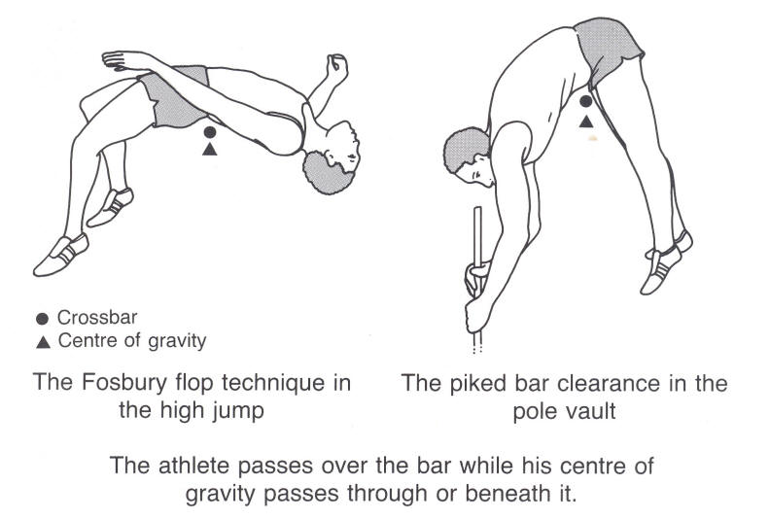
The location of the C.G. of a body whose parts are free to move depends on the orientation of these parts. As the parts move, so does the body’s C.G.

Basketball players in jump-ball situation or while shooting, volleyball players leaping to strike etc. all make good use this fact. Take for example the BB player. When he jumps for the ball, he swings both arms forward and upward to assist him in gaining height. Then once he has left the floor, he allows one arm to drop down by his side while he strives to get the maximum reach with the other. This dropping of one arm definitely adds to his advantage by gaining the reach.

In this way, some basketball and volleyball players can actually “Hang in air” during the execution of a shot. This is possible by raising the centre of gravity in air by flexing his knees and extending his arms.

Base
The base, as applied to a rigid body is the area by which it is supported. In the case of a cube, the face on which it rests is the base, whereas the effective base of a chair may be considered as the area bounded by the lines joining the legs. (Shown in he figure 6 a).

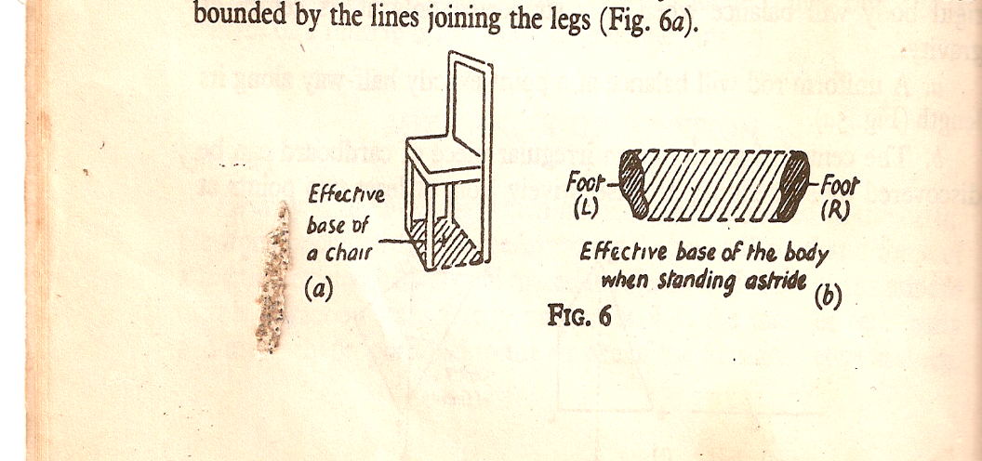

In the lying position, the posterior aspect of the whole body forms the base, and in stride standing it is an area as wide as the feet ( Fig. 6 b )and as long as the distance between their outer boundaries. .

In physical education, in many activities, the base is widened while coming to a sudden stop after movement of the body and while landing in gymnastics to maintain stability and balance of the body.

Factors that determine the degree of stability: The stability of a body in equilibrium (which is of course, what the terms stable, unstable, and neutral refer to) depends on the following factors.

- The position of the line of gravity relative to the limits of the base.
- The weight of the body (e.g. Wrestler)
- The height of the center of gravity relative to the base.
- Base of the body (e.g. Basketball, volleyball, hockey, etc.

Axes ane Planes

An axis is a line about which movement takes place and a plane is the surface which lies at right angles to it and in which the movement takes place. The terms are used to facilitate the description of movement or direction. As far as the axes and planes of joint movement are concerned, they are described with the body in the anatomical position.

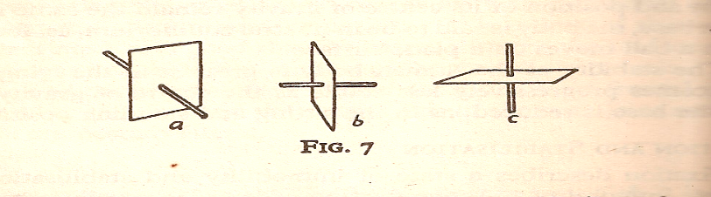

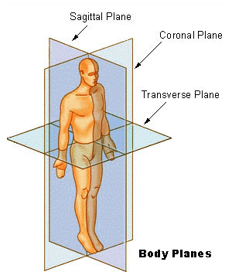

- A sagittal axis lies parallel to the sagittal suture of the skull i.e. in an antero-posterior direction, as an arrow might have pierced a yeoman in attack or in flight. Movement about this axis is in a frontal plane or coronal plane
- A frontal or transverse axis lies parallel to the transverse suture of the skull. It is also horizontal and at right angles to the sagittal axis. Movement around this frontal axis is in a sagittal plan or lateral plane.
- A vertical axis lies parallel to the line of gravity and movement about it is in a horizontal plane or transverse plane

A pencil thrust through a sheet of paper and turned to represent the three axes is a convenient example to demonstrate axes and planes.

Movements of the body occur at joints, therefore axes pass through joints and the part moved is in the lane which lies at right angles to the axis of the movement.
S.No. | PLANE | Plane Divides the body | AXIS at 90° to the plane | Direction of axis | Examples of Movement
1. | Sagittal Plane or  Lateral Plane | Into Sinister and Desture or left and right equal halves | Frontal Axis | From front to rear | Flexion and Extension
2. | Coronal Plane or Frontal Plane | Into dorsal and ventral or back and front | Sagittal Axis | From side to side | Abduction and  Adduction
3. | Transverse Plane  Or Horizontal Plane | Into cranial and caudal or upper and lower portions | Horizontal  Axis | From Head to foot | Inward and Outward rotation,  Horizontal Flexion

Abduction and adduction (except of the thumb) and side flexion movements are said to take place about a sagittal axis and in a frontal plane, flexion and extension (except of the thumb about a frontal axis and in a sagittal plane, and rotation occurs about a vertical axis and in a horizontal plane.

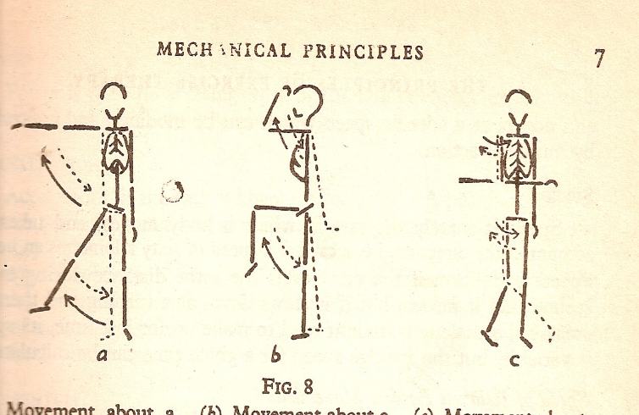

The above figure explains the following.

- Movement about a Sagittal axis and in a frontal plane
- Movement about a frontal axis and in a sagittal plane
- Movement about a vertical axis and in a horizontal plane.

Levers

The efficiency of the mechanical movement of the human body depends on the mechanical principles involved in it. A number of varieties of movements are made by bones around the joints in the human body. It is all possible by the combination of links and hinges, largely built on the in-built concepts of machines. The lever system plays a vital part in the functioning of the human body.

Lever—Definition: A lever is a rigid bar which is capable of movement about a fixed point called, fulcrum.

In the body a lever is represented by a bone, which is capable of movement about a fulcrum formed at the articulating surfaces of a joint; the effort which works the lever is supplied by the force of muscular contraction, applied at the point of insertion of the bone, while the weight may be either at the center of gravity of part moved or the object to be lifted.

Work is done when a force or effort (F) applied at one point on the lever, acts upon another force or weight (W) acting at a second point on the lever. The perpendicular distance from the fulcrum to the effort (E) may be called the Effort Arm/Force Arm and that from the fulcrum to the weight W as the Weight’s arm or Resistance Arm.

There are three orders/types/classes of levers, each of which is characterized by the relative positions of the fulcrum, effort and weight.

I Type/Order/Class Lever: The fulcrum is between the effort and weight; it may be situated centrally, or towards either of the effort or the weight, consequently the effort’s and the weight’s arms may be equal or one may exceed the other in length.

E F W E F W E F W

E.g. 1) A pair of scissors
2) Lifting the weight with a crow bar
3) See-Saw (Balancing rod with seats)
4) Forward and backward bends of the spinal column
5) Nodding movements of the head
6) V – sit
7) Mayurasan in Yoga
8) Tilting movements of the pelvis on femoral heads

II Type/Order/Class Lever: The weight is between the fulcrum and effort, and the effort arm must therefore, always exceed the weight (resistance arm)

F W E

Gaining the power at the cost of the speed is preferred in the levers of this type.

E.g. 1) Wheel barrow and nut cracker.
2) Raising the toes while bearing the weights.
3) Opening the Jaw
4) Push-ups.

III Type/Order/Class Lever: The effort is between the fulcrum and the eight and the weight’s arm must therefore exceed the effort’s arm.

F E W

Gain in the speed is of prime importance in this class of levers.

E.G. 1) Screen Doors and Forceps.
2) Flexion of the forearm by the biceps brachialis
3) Raising the arm sideward upward by the deltoid
4) Sit ups.

FORCE Force may be defined as a push or pull that alters or tries to alter the state of rest of a body or its uniform motion in a straight line. Or, simply it may be defined as a directed push or pull by one body acting upon another.

As force has got both magnitude and direction, it is classified as a vector quantity. Any change in motion is due to the action of some force. However, all the forces acting on a body cannot cause changes in the motion of the body. It is necessary that there be an unbalanced force, i.e., a force the magnitude of which is greater than that of the object to be moved. The study of he effects of forces is the realm of kinetics.

An unbalanced force, in addition to being able to push or pull can also cause distortion in an object. When the force tends to stretch the body, it is called tension force. When it squeezes an object it is called a compression force. When it causes one part of an object to slide relative to another part, it is called shear force. The force acting on a trampoline surface is a tension force. When a football is hit, it is slightly squeezed showing compression. Similarly tennis racket shows compressibility when it hits the ball. Skating involves shear force.

Application of the Force and the Effects if Force

Several factors determine whether an application of force can produce a desire motion or not, some of which are explained below.

- Magnitude of force: For motion to be caused, an unbalanced force should be applied. In other words a change in motion can be caused only if the magnitude of the applied force exceeds the magnitude of the resistance provided by the body.

- Direction of application of force: It is the direction of application of force on body that would determine whether the resulting motion is linear, angular or general. All the forces, for example, shown as vectors are identical in magnitude, but different in direction, so that when each force is applied separately, at the same point on the body, each will produce a different kind of motion

- Point of application of force: The point of application of force determines whether the body will move in a linear or angular manner.

In general all forces should be applied as directly as possible in line with the intended motion. Forces applied in other direction either retard motion in the desired direction or result in wasted energy. Point of application and direction of application are very important in sports and physical education to get the required direction of movement of the body.
4. Time of Application or Distance of Application of Force: The extent of any change in the velocity of a body is proportional to the magnitude of unbalanced force as well as to the length of time or distance over which the force is applied. The longer a force is applied, the more will be the acceleration of the body. In the initial stages of movement greater force should be applied within the shortest time possible to conserve energy using explosive strength because greater force is required to put the body in movement overcoming the inertia and gravity. Once the body gains its motion, to maintain motion, the time of application should be more with lesser magnitude of force application. For example, in 100m, during the start, the athlete uses his maximum strength to put the body in movement within the shortest possible time. To maintain the speed, lesser force is required but application of force should be till finish.

- Application of Several Forces: If several forces are to be applied successively in the same direction to a body, the sequence of application of these forces will affect the resulting movement. If the purpose is to give maximal velocity to a body, each new force should be applied at a point where the preceding force has made its greatest contribution to the increase in the velocity of the object. This is called the principle of summation of forces. The most important thing in this principle is the fine timing of different movements in the excution of a particular skill.

All the five principles of force application explained above are illustrated in the events such as shot put, discuss, javelin, etc.
The direction in which force is applied determines the angle of release and the initial velocity of the object. The final point of application of the force by the hand, wrist and fingers determines whether or not the object will rotate in flight and in which direction it will rotate. The longer the time the unbalanced force applied to the object, the greater it’s final velocity. Distance over which force is applied is reflected to the time. All the forces of the thrower should be summated right from the ground up.

Types of Force

Internal Forces: As the contracting muscles pull on the different body levers, they provide an internal force system in human motion. A muscle equally pulls both on its origin on one bone and insertion on the other. As one segment is stabilized either by its own mass or by the action of other fixator muscle, the other segment being acted upon is free to move. When a muscle shortens to cause a motion, it is called an agonist or mover. This muscle is said to undergo concentric contraction. If the muscle maintains tension while lengthening against some resistance, the contraction is called eccentric contraction.

External Forces: In addition to internal forces such as the muscular forces mentioned above, there are also external forces like force of gravity, wind and water resistance and friction which effect motion. While air born objects are pulled by gravity back to earth, friction, air resistance and buoyant forces oppose movements of objects.

EQUILIBRIUM
Equilibrium is a state when all parts of a body are either at rest or moving with the same constant velocity. If the some of two moments acting in opposite angular direction is zero, a state of equilibrium is said to exist. When a body is in equilibrium, there is an even adjustment among all forces and the body is in balance. The state of this balance may be secured or uncertain. When it is secured, the body is said to have a high degree of stability, which is firmness of balance or the ability to remit forces that may disturb balance. An object suspended from its center of gravity is said to be in rotational equilibrium. The term ‘equilibrium’ is used to identify any condition in which the sum of moments of forces acting equals zero. Therefore, this term can be applied to both static and dynamic condition of both linear and angular motion.

DEFINITIONS
“Equilibrium results when the forces acting upon a body are perfectly balanced and the body remains at its own state of rest or of motion”.
Or
“The object is said to be in equilibrium when the state of motion of the object remains unchanged even though two or more forces are acting upon it”.
Or
“When the sum of the forces and the sum of moments acting upon a body are both equal to zero, then the body is said to be in equilibrium.”

States of Equilibrium
Static Equilibrium: When the body is stationary when number of forces are acting on it, it is said to be in static equilibrium.
E.g. Hand stand in gymnastics, man standing still, no movement position in tug of war, etc.
Dynamic Equilibrium: When a body is moving with constant linear or angular velocity and if the sum of the forces and sum of the torques acting on it is zero, it is said to be in a state of dynamic equilibrium.
E.g. sky diver leaping from an airplane, a sled moving constant velocity, etc.
Examples of dynamic equilibrium are difficult to find in physical education and sports.
Types of Equilibrium
There are three types of equilibrium—unstable, stable and neutral.
Unstable Equilibrium: If a body is given an initial displacement and the forces acting upon it increase this initial displacement, however small the later may be, the body is said to be in unstable equilibrium.
E.g. toe stand, handstand, etc.
Stable Equilibrium: If the forces acting upon a body at rest tend to restore to its original position after it has been displaced, the body is said to be in stable equilibrium. This is more stable when the C.G. is low, the base is large and when the line of gravity falls at the center.
E.g. standing feet apart, hanging on a horizontal bar, boxer hitting the bag, etc.
Neutral Equilibrium: If in spite of displacement of a body, the height and position of its center of gravity remain the same in relation to the base, the body is said to be in neutral equilibrium.
E.g. A ball moving on a plain surface.
Suppose a ball is placed exactly at the crest of small hill (Point A). It may remain at rest there briefly, but if a light breeze moves it a bit, it will rapidly accelerate down the hillside. This is unstable equilibrium.
In the depression at B, the ball rolls back if disturbed. This is stable equilibrium. Finally, on the flat level area, near C, there is still no balanced force even if the ball is displaced slightly. This is neutral equilibrium.

Unit-2
FUNDAMENTAL CONCEPTS OF ANATOMY AND PHYSIOLLOGY

JOINTS

The joint is the Junction or Articulation at which two or more bones come together. Or, it is the place where two or more bones come together or the place where two or more bones come together and are able to produce movements around it.

Joints are classified into three types: 1) Fibrous joints or immovable joints, 2) Cartilaginous joints or partially movable joints and 3) Synovial joints or movable joints.

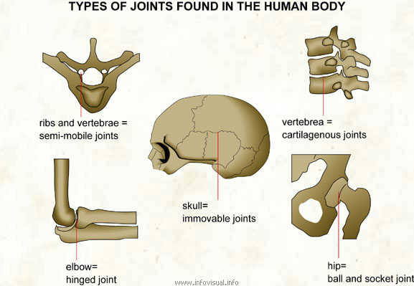

Fibrous joints or immovable joints: Fixed joints have seems (Suture like joints). These joints have a thin layer of connective tissue.

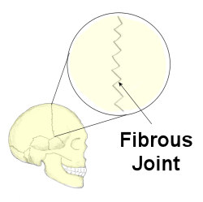

These joints absorb the shock and prevent the bones from breaking. The joints of the head (cranium) are fixed and they protect the brain.

Synovial or Movable Joints: Opposing bones are separated from one another by a space, lined by a special membrane called Synovial Membrane and are lubricated by the fluid called synovial fluid. Bones are joined together with a tough connective tissue fibres called the ligaments. Wide range of movements are possible. e.g. All joints of limbs. These joints absorb the shock and act as cushions at the joints.

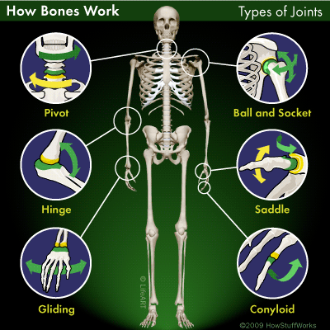
Movable joints
Types of movable Joints

There are six main types of moveable joints: 1. Hinge joints, 2. Pivot joints 3.Ball and socket joints 4. Gliding joints 5. Saddle joint and 6.Condyloid joints

- Hinge Joints: These joints will allow a forward and backward motion in only one plane. The joints at the knee, elbow and fingers are the examples of hinge joints.

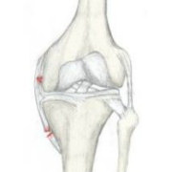 Knee Joint | 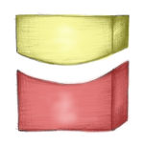  Hinge Joint

- Pivot Joints: This joint gives a rotating motion such as the movement of the head from side to side.

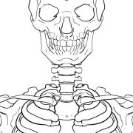 Neck Joints | 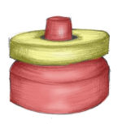 Pivot

3. Ball and Socket Joints: The structure of one end of the bone is in the shape of ball and the other end is in the shape of a socket. These joints permit the maximum freedom of movement. The shoulder and hip joints are the examples of ball and socket joints.

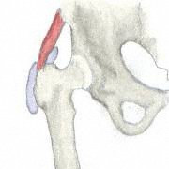 Hip Joint | 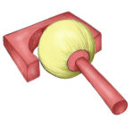 Ball and Socket

- Gliding joints: In gliding joints the articular surfaces glide over each other. Joints between the carpal bones and between tarsal bones are gliding joints.

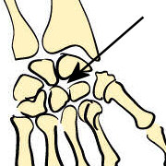 Joint between the carpal bones | 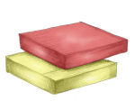 Two surfaces gliding over each other

- Saddle joint: It is Saddle Shaped (Convex & Concave), and so, it is called as saddle joint. Possible movements are, Flexion/Extension/Adduction/Abduction/Circumduction
e.g. Carpal and Metacarpal Joint of the Thumb.

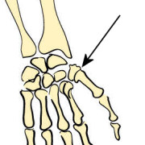 Carpal and Metacarpal Joint of the Thumb | 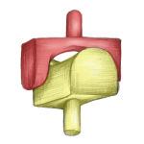 Saddle

- Condyloid Joint:In condyloid joint Movements in two planes at right angles to each other are possible.
The movements are Flexion/Extension/Adduction/Abduction/Circumduction
e.g. Wrist/Metatorsal and Metacarpal Joints.

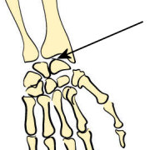 Wrist Joint | 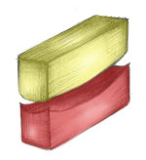 Saddle

Types of Muscle Contraction
Muscle Contractions can be divided into:
- Isotonic (meaning same tension)
- Isometric (meaning same distance or not moving)
- Isokinetic (meaning same speed)

Isotonic Contractions
Isotonic contractions are those which cause the muscle to change length as it contracts and causes movement of a body part. There are two types of Isotonic contraction:
Concentric
Concentric contractions are those which cause the muscle to shorten as it contracts. An example is bending the elbow from straight to fully flexed, causing a concentric contraction of the Biceps Brachii muscle. Concentric contractions are the most common type of muscle contraction and occur frequently in daily and sporting activities.
Eccentric
Eccentric contractions are the opposite of concentric and occur when the muscle lengthens as it contracts. This is less common and usually involves the control or deceleration of a movement being initiated by the eccentric muscles agonist.
For example, when kicking a football, the Quadriceps muscle contracts concentrically to straighten the knee and the Hamstrings contract eccentrically to decelerate the motion of the lower limb. This type on contraction puts a lot of strain through the muscle and is commonly involved in muscle injuries.

Isometric Contractions
Isometric contractions occur when there is no change in the length of the contracting muscle. This occurs when carrying an object in front of you as the weight of the object is pulling your arms down but your muscles are contracting to hold the object at the same level. Another example is when you grip something , such as a tennis racket. There is no movement in the joints of the hand, but the muscles are contracting to provide a force sufficient enough to keep a steady hold on the racket.
The amount of force a muscle is able to produce during an isometric contraction depends on the length of the muscle at the point of contraction. Each muscle has an optimum length at which the maximum isometric force can be produced.

Isokinetic Contractions
Isokinetic contractions are similar to isotonic in that the muscle changes length during the contraction, where they differ is that Isokinetic contractions produce movements of a constant speed. To measure this a special piece of equipment known as an Isokinetic Dynamometer is required. Examples of using isokinetic contractions in day-to-day and sporting activites are rare. The best example for this type of contraction is breast stroke in swimming, where the water provides a constant, even resistance to the movement of adduction.
POSTURE

Posture is unique to every individual and no two people have identical postures, although some are very similar. The determinants of a good posture are linked to the structure and size of bones, the position of body parts, injury and disease, static and dynamic living habits and the person’s psychological state.

Good posture, both static (Standing and sitting) and dynamic (duriang movement), is important for an attractive appearance, but more importantly, it is essential if the body is to function with an economy of effort. If posture is poor, it can lead to fatigue, muscular strain and poor muscle tone, the sagging of some parts of the body and low self esteem.

Posture is good when it allows the organic systems to function efficiently, when the body has god balance and alignment and results in a minimum muscular strain, and contributes to attractiveness.

  Good Posture | 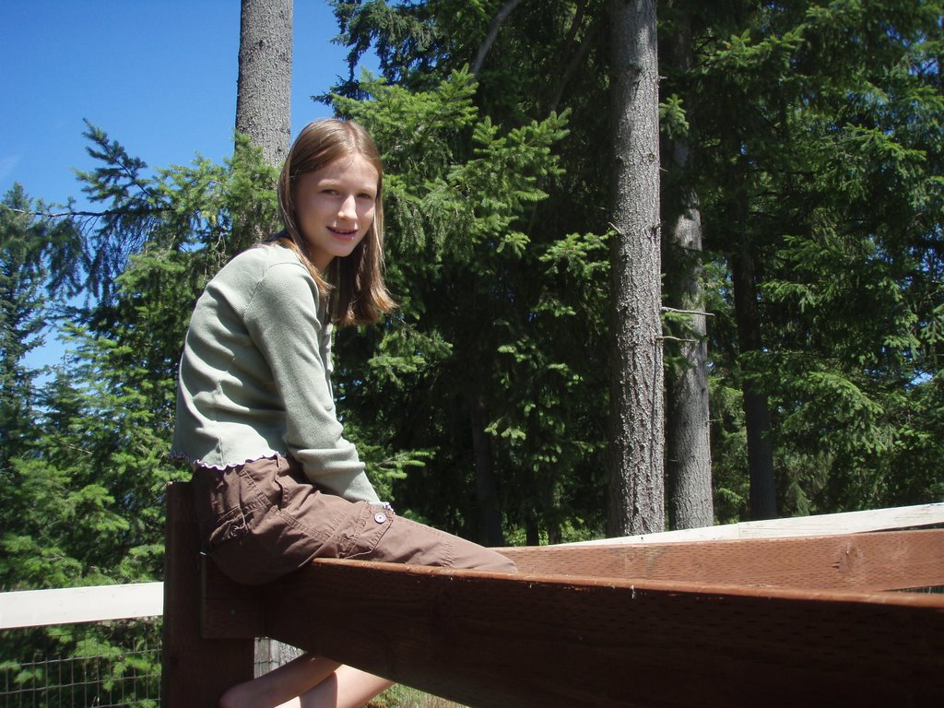  Bad Posture

Criteria for good posture

- It aids the functioning of the organic system.
- It reduces strain on muscles, ligaments and tendons.
- It increases the attractiveness of the persons.
- It may influence a person’s self concept.

Guidelines for good posture.

- The weight bearing segments should be correctly aligned, so that the line of gravity passes through them. This reduces unnecessary muscle strain and contributes to attractiveness.
- The weight bearing joints should be easy and should not be accompanied by strain, tension or excessive gravity.
- The feet should be placed far apart to from the base of support over which the body can be balanced easily without excessive muscle use.
- With respect to the inward and outward rotation of the legs, the correct position is the patella and feet pointed straight forward.
- Excessive forward tilt of the pelvis should be avoided because it contributes to a protruding abdomen and a swayed back, which in turn can contribute to permanent back problems.
- The spinal column, when viewed laterally, will naturally exhibit three curves, a convex cervical curve, a concave thoracic curve and a convex lumbar curve. When the spinal column is viewed from the rear, it should be straight.
- The abdominal wall, which is composed mostly of muscle tissue, should be kept in good tone and care should be taken to keep the wall straight and in proper support of internal organs.
- In good erect posture, the neck should be held straight but not rigid and the head should be aligned with the spinal column so the neck muscles are not under unnecessary stress.
- Good posture would seem to be a position which requires a minimum expenditure of energy for the maintenance of good alignment.
- Good posture—static and dynamic requires normal muscle tonus, good coordination, good neuromuscular control and well developed postural reflexes.

Causes of Bad Posture

- Injury
- Disease
- Habit
- Muscular or Nerves Weakness
- Mental attitude
- Heredity
- Improper clothing
- Training
- Nutrition

Postural Deformities

The following defects range from those which are only just visible to the trained eye, to those which are very extreme. Individuals with minor defects may not need a corrective program because their bodies have gradually adapted to them; however, those with moderate to severe postural deviations will need various levels of remediation and in extreme cases, surgery.

ANTEROPOSTERIOR DEFECTS

Pocked or Forward Head: This is a defect in which the neck is slightly flexed and the head is partially tilted forward. It is often associated with abducted scapulae (round shoulders). To correct this defect, the anterior muscles of the neck must be stretched and the posterior muscles strengthened.

Abducted Scapulae or Round Shoulders: This defect occurs when the scapulae assume an abducted position due to a weakened condition of the trapezius and rhomboid muscles. The medial borders protrude from the individual’s back. To correct this condition, the adductors of the scapulae need to be strengthened and the anterior thoracic muscles of the upper trunk stretched.

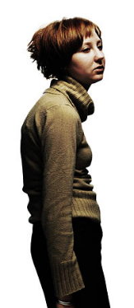  Round Shoulders | 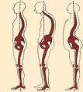  Development of Round Shoulders

Kyphosis (Round back or Sheuermann’s disease): This defect increases the convexity of the thoracic curve and is caused by wedging of the thoracic vertebrae. Treatment in mild
cases consists of exercises designed to stretch the upper anterior thoracic region and strengthen the muscles of the posterior thoracic area. If the condition is severe, a brace should be considered in order to produce extension of the thoracic spine and decreased lordosis in the lumbar spine.

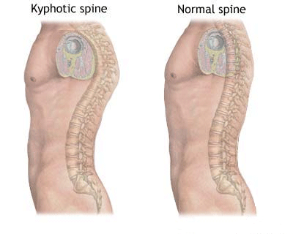
Lordosis (hollow back): Lordosis is characterized by an exaggerated lumbar curve, usually caused by the pelvis tilting too far forward (anterior pelvic tilt; APT). In this condition, the abdominal muscles become stretched and weakened and need to be strengthened along with the extensor muscles of the thigh, while the erector spine and the flexor muscles of the thigh should be stretched. | 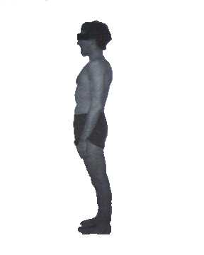

Protruding Abdomen: The condition is characterized by the sagging of the abdominal organs and often accompanies lordosis. The downward drag upon the mesenteries occurs when there is not sufficient tension in the abdominal wall to hold them in place. Exercises which strengthen the abdominal muscles are necessary to alleviate this condition.

Kypholordosis: This defect is a combination of kyphosis and lordosis and as a result places a great deal of stress on the trunk, because the anti-gravity muscles are forced to contract vigorously in order to balance the body segments. It is a condition where the individual is often in a state of chronic fatigue. Exercises which have been recommended for both kyphosis and lordosis should be carried out to alleviate this condition.

Leg Hyperextension: This defect is characterized by a backward curve of the legs which creates an unstable knee joint for agility sports. The causes of this condition are basically related to the structure of the femur, the tibia and the cruciate ligaments in the knee joint, and therefore only general strengthening exercises of the musculature surrounding the knee joint should be carried out. It is important keep the hamstring muscle group almost as strong as the quadriceps.

LATERAL DEFECTS

Scoliosis: This common defect manifests itself in a lateral curvature of the spine and in many severe cases is accompanied by a longitudinal rotation of the vertebrae. Scoliosis
Usually begins with a C-shaped curve (functional scoliosis) but over a period of time a righting reflex creates a reversal of the C at the upper spinal levels, producing an S-shaped curve (Structural scoliosis). This defect can be caused by uneven leg lengths, muscle imbalance and ligament lengthening.

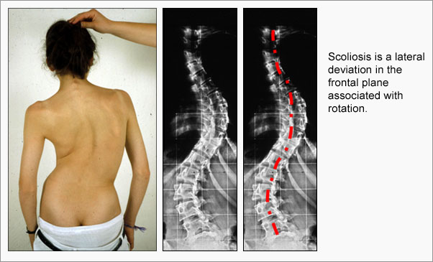

Bow Legs and Knock Knees: These conditions are genetic and individuals may need medical attention early in their life if they appear to be serious, as there are at times knee joint irregularities or partial deformities of the femur or tibia bones. Apart from general strengthening exercises for various muscle groups of the leg, the coach or a physical educationist can do little with these defects if they appear to be extreme.

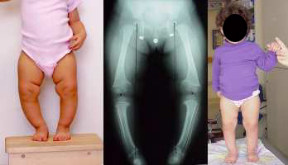
Bow legs

Pigeon Toes: Often referred to as ‘inverted feet’ this condition is characterized by internal rotation at the hip joints. This in turn causes the knees to inwardly rotate (‘crossed knees or squinting patellae’) so that the feet become inverted. Although it is structural defect, it can be alleviated by stretching the medial rotators of the hip joint and strengthening the lateral rotators.

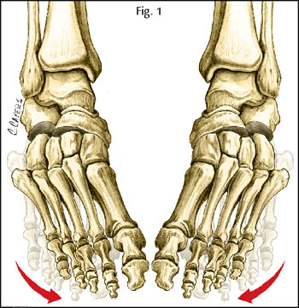  Pigeon Toes | 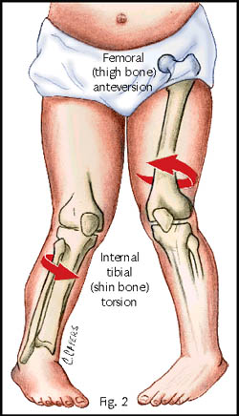  Development of Pigeon Toes
Duck Feet: This defect is also known as ‘everted feet’ and is characterized by a protruding medial malleolus and pseudo flat feet caused by the rolling inward of the ankles. The best treatment for this defect is the use of an orthotic device from an early age and a series of exercises involving toe flexion, foot planar flexion and supination.

Flat Feet: There are several classification of flat feet and these are as follows.

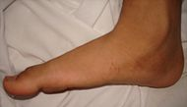  Flaf foot | 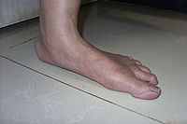  Adult flat foot

- True Flat Feet: This is the most serious of the foot defects in which the longitudinal arch is flat. The condition may be accompanied by discomfort and interference with the foot’s normal function. Medical treatment should be sought for this defect.
- Functional Flat Feet: This is a defect which is caused by weakened and stretched muscles, ligaments and fascia in the foot. If it is not corrected it can distort the mechanical relationships in the ankle, knee, the hip joints and the lumbar spine. Medical treatment should also be sought for this defect.
- Flexible Flat Feet: This condition is characterized by a loss of the arches of the feet during weight bearing, but when there is not weight on the feet, they appear normal. It is not regarded as pathological, unless it interferes with normal function or becomes painful.
- False Flat Feet: This is not postural defect but a condition with results from the presence of a fat pad on the plantar surface of the feet. From time to time one hears of elite athletes who have this condition, yet are able to function quite normally with it.

All or None Law

When muscle contracts, contraction occurs at the muscle fiber level within a particular motor unit. Motor unit Functions as a single unit and it is the single motor neuron & all muscle fibers it innervates. The muscle contraction is typical and the number of motor units responding (and number of muscle fibers contracting) within the muscle may vary significantly from relatively few to virtually all depending on the number of muscle fibers within each activated motor unit & the number of motor units. Regardless of number, individual muscle fibers within a given motor unit will either fire & contract maximally or not at all. This is what is called the All or None Law.

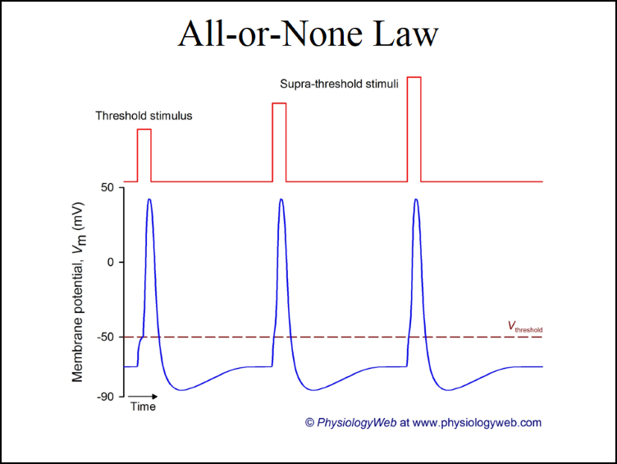

A stimulated muscle or nerve fiber contracts or propagates a nerve impulse either completely or not at all. In other words, a minimal stimulus causes the individual muscle fiber to contract to the same extent that a stronger stimulus does. This phenomenon is known as all-or-none law. Because a single neuron supplies many muscle fibers in the formation of the motor unit, it naturally follows that the motor unit will also function according to the all-or-none law. Although this law of physiology hold true for the individual muscle fibers and motor units, it does not apply to the muscle as a whole. It is possible, therefore, for the muscle to exert forces of graded strengths, ranging from a barely perceptible contraction to the most vigorous type of contraction. This voluntary capability is called muscle strength gradation.

Angle of Pull

The angle between the muscle insertion and the bone on which it pulls. This is the angle at which the muscle force acts relative to an axis or lever. Given the equation for torque:
τ = rF sin θ, and the angle of pull of the muscle being the angle θ, the larger the angle of pull, the larger the resultant torque produced by the muscle.
Definition of Angle of Pull: Angle between muscle insertion and bone on which it inserts.
Components of Force
  - Rotary component: force of a muscle contributing to bones movement around a joint axis; greatest when muscles angle of pull is perpendicular to bone (i.e. 90 degrees).
  - Stabilizing component: degree of parallel forces generated on the lever (bone and joint) when the muscles angle of pull is less than 90 degrees.
  - Dislocating component: degree of parallel forces generated on the lever (bone and joint) when the muscles angle of pull is greater than 90 degrees.
Components of force due to angle of pull
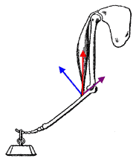 | 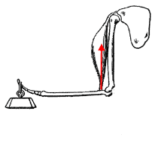 | 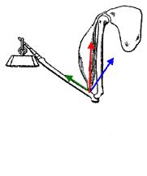
>90 degrees  includes stabilizing component | =90 degrees  100% rotary force | <90 degrees  includes dislocating component

Reciprocal Innervation
Reciprocal innervation describes skeletal muscles as existing in antagonistic pairs, with contraction of one muscle producing forces opposite to those generated by contraction of the other. For example, in the human arm, the triceps acts to extend the lower arm outward while the biceps acts to flex the lower arm inward. To reach optimum efficiency, contraction of opposing muscles must be inhibited while muscles with the desired action are excited. This reciprocal innervation occurs so that the contraction of a muscle results in the simultaneous relaxation of its corresponding antagonist.
A common example of reciprocal innervation, is the effect of the nociceptive (or nocifensive) reflex, or defensive response to pain, otherwise commonly known as the withdrawal reflex; a type of involuntary action of the body to remove the body part from the vicinity of an offending object by contracting the appropriate muscles (usually flexor muscles), while relaxing the extensor muscles.
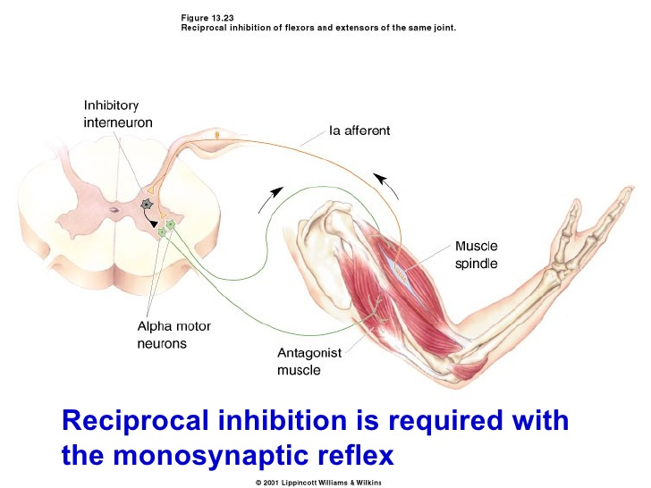

Unit 3
MECHANICAL CONCEPTS

FORCE :

Force has some relation to sports that breath has to the individual. Breath is required to maintain life. Since it takes force to create motion or prevent it, and since sports are activities of motion, there would not be any sport without force. Force, therefore, is essential to the life of sports and physical education

In the individual, the primary source of force is his strength. Strength is derived from a muscle or combination of muscles and related directly to the cross-sectional area of the muscle. Therefore, to have strength, one must build muscle. And, in sports, in order to have reserve to meet emergencies, it is desirable to acquire strength in excess of that required for chosen activity.

Force may be defined as a push or pull that alters or tries to alter the state of rest of a body or its uniform motion in a straight line. Or, simply it may be defined as a directed push or pull by one body acting upon another.

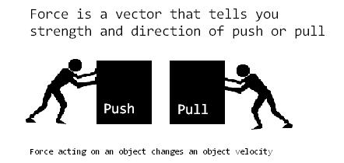

As force has got both magnitude and direction, it is classified as a vector quantity. Any change in motion is due to the action of some force. However, all the forces acting on a body cannot cause changes in the motion of the body. It is necessary that there be an unbalanced force, i.e., a force the magnitude of which is greater than that of the object to be moved. The study of he effects of forces is the realm of kinetics.

In volleyball service, the ball is put into flight by a force applied to it by the hand, which in turn receives its motion from various muscle forces acting to move server’s trunk, shoulders, arms and wrists. As soon as the ball is hit, it faces air resistance, which begins to reduce its velocity at the same time, the force of gravity acts to limit its ascent and to cause it to come down to earth.

An unbalanced force, in addition to being able to push or pull can also cause distortion in an object. When the force tends to stretch the body, it is called tension force. When it squeezes an object it is called a compression force. When it causes one part of an object to slide relative to another part, it is called shear force. The force acting on a trampoline surface is a tension force. When a football is hit, it is slightly squeezed showing compression. Similarly tennis racket shows compressibility when it hits the ball. Skating involves shear force.

Application of the Force and the Effects of Force:

Several factors determine whether an application of force can produce a desire motion or not, some of which are explained below.

- Magnitude of force: For motion to be caused, an unbalanced force should be applied. In other words a change in motion can be caused only if the magnitude of the applied force exceeds the magnitude of the resistance provided by the body. For example, if the body resists motion, with a force of 10 Kg. and the applied force is 12 kg., an unbalanced or net force of 2 kg. remains and therefore motion will be produced. Some of the most common resistances are friction and inertia. Friction is a force that always opposes the movement of one body over another. Inertia is a tendency of a body to resist any change in its motion. This is proportional to the weight or mass of the body.

- Direction of application of force: It is the direction of application of force on body that would determine whether the resulting motion is linear, angular or general. All the forces, for example, shown as vectors in figure-1 are identical in magnitude, but different in direction, so that when each force is applied separately, at the same point on the body, each will produce a different kind of motion. The effect of force F₁ when acting alone will be to move the body in a linear direction shown in figure-1 by the dotted line extension of the F₁ vector and to cause the body at the same time to rotate in a clockwise direction. This happens because the extended action line of F₁ vector passes below the center of gravity of the body. In fact, any such force that does not pass through the rotational axis of a body is called eccentric force. Thus F₁ and F₃ vectors in figure-1 are eccentric because their action lines pas below and above the center of gravity. On the other hand, force F₂ produces linear motion to the left because its action line passes through the mass center of the object.

- Point of application of force: The point of application of force determines whether the body will move in a linear or angular manner. The force vectors shown in fig.2 are identical in both magnitude and direction. However, they are applied at different points on the body. The unbalanced and eccentric force F₁ will cause counterclockwise as well as linear motion. Similarly, force F₃ being eccentric also causes linear motion of the object, but causes the body to rotate clockwise. As force F₂ passes through the mass center of the object, the object will be moved linearly to the left.

In general all forces should be applied as directly as possible in line with the intended motion. Forces applied in other direction either retard motion in the desired direction or result in wasted energy. Point of application and direction of application are very important in sports and physical education to get the required direction of movement of the body.
- Time of Application or Distance of Application of Force: The extent of any change in the velocity of a body is proportional to the magnitude of unbalanced force as well as to the length of time or distance over which the force is applied. The longer a force is applied, the more will be the acceleration of the body. In the initial stages of movement greater force should be applied within the shortest time possible to conserve energy using explosive strength because greater force is required to put the body in movement overcoming the inertia and gravity. Once the body gains its motion, to maintain motion, the time of application should be more with lesser magnitude of force application. For example, in 100m, during the start, the athlete uses his maximum strength to put the body in movement within the shortest possible time. To maintain the speed, lesser force is required but application of force should be till finish.

- Application of Several Forces: If several forces are to be applied successively in the same direction to a body, the sequence of application of these forces will affect the resulting movement. If the purpose is to give maximal velocity to a body, each new force should be applied at a point where the preceding force has made its greatest contribution to the increase in the velocity of the object. This is called the principle of summation of forces. The most important thing in this principle is the fine timing of different movements in the excution of a particular skill.

All the five principles of force application explained above are illustrated in the events such as shot put, discus, javelin, etc.
The direction in which force is applied determines the angle of release and the initial velocity of the object. The final point of application of the force by the hand, wrist and fingers determines whether or not the object will rotate in flight and in which direction it will rotate. The longer the time the unbalanced force applied to the object, the greater it’s final velocity. Distance over which force is applied is reflected to the time. All the forces of the thrower should be summated right from the ground up.

Sources of Force:

Internal Forces: As the contracting muscles pull on the different body levers, they provide an internal force system in human motion. A muscle equally pulls both on its origin on one bone and insertion on the other. As one segment is stabilized either by its own mass or by the action of other fixator muscle, the other segment being acted upon is free to move. When a muscle shortens to cause a motion, it is called an agonist or mover. This muscle is said to undergo concentric contraction. If the muscle maintains tension while lengthening against some resistance, the contraction is called eccentric contraction.

Eccentric contractions serve the purpose of controlling the descent of a body segment or external weight so that the movement becomes slower than it would be under the influence of gravitational acceleration of 9.81 mts /sec². This is very essential in such exercises as pull-up, in which the muscles lower the body slowly by eccentrically contracting to allow the extension of elbows. Without this eccentric contraction causing slow lengthening, elbows will come to fully extended position at a speed that can injure the joints and the supporting tissue.

Contractions involving change in the length of the muscles are called isotonic contractions, whereas contractions that produce no motion are called static or isometric contractions. Most movements in sports involve isotonic contractions.

External Forces: In addition to internal forces such as the muscular forces mentioned above, there are also external forces like force of gravity, wind and water resistance and friction which effect motion. While air born objects are pulled by gravity back to earth, friction, air resistance and buoyant forces oppose movements of objects.

LEVERS
There are six kinds of simple machines. The more complex machines are mere combinations of these six machines. The six simple machines are the lever, the pulley, the wheel and axis, the wedge, the screw, and the inclined plane. Lever is by far the most prevalent of these machines in the human body.
A lever may be defined as a rigid bar i.e. which revolves around a fixed point called axis, with a force to move it and resistance to be overcome by it. Sometimes force called is effort, the axis fulcrum and resistance, the weight.
The efficiency of the mechanical movement of the human body depends on the mechanical principles involved in it. The bones and joints make a number of varieties of movements in the human body. It is all possible by the combination of links and hinges largely built on the in-built concepts of mechanics. The lever system plays a vital part in the functioning of the human body.
Levers can be found either internally in the form of some bones of the extremities or externally in the form of sports implements like bats, rackets, and poles. It should be noted that the bar used in the definition of lever could be of any shape. The most important levers in the analysis of human motion are the internal levers. Whatever influence the body has on external levers, that influence is caused by the action of these internal levers.
Functions of Levers :
Levers perform two important functions. They increase the effect produced when force is exerted on a body. Generally one has to exert a force at least as large as the weight of a body if it is to be held or lifted, unless some mechanical aid is used. However, with the help of a lever, a body can be lifted or held by exerting much force than the weight of the body. Secondly, a lever can also help to increase the distance through which a body can be moved in a given time, i.e., the speed with which a body can move is increased. Which of these two functions a lever serves depends mainly on the distances from the lines of action of the force and the resistance to the fulcrum, also known as force and resistance arms.
Classes/Types of Levers :
There are three kinds or classes of levers that are determined by the relative arrangements of the fulcrum or axis (F), the point of force or effort (E) and the point of resistance (W). A first class lever has the arrangement of EFW, a second class lever FWE and a third class lever FEW as in the following figure.
As it is only the middle component that determines the class of lever, the outside components may be switched.
I Class Levers: The fulcrum (F) is between the effort or force (E) and weight or resistance (W). It may be situated centrally or towards either of the effort or the weight, consequently the effort’s and the weight’s arms may be equal or one may exceed the other in length.

E F W E F W E F W

E.g. 1) A pair of scissors
- Lifting the weight with a crow bar
- Seesaw: When two children balance on a seesaw, the heavier child must be closer to the fulcrum.
- Forward and backward bends of the spinal column: The vertebral joints in which vertebrae are separated by fluid filled discs form the fulcrum. While bending forward, the effort is of the abdomen muscles and while bending backward; the effort is of the back muscles.
- Nodding movements of the head: The skull represents the lever, the (atlanto-occipetal) joint forms the fulcrum. The weight is situated anteriorly in the face and the effort is supplied by the contraction of the posterior neck muscles.
- V- Sit
- Mayurasana
- Tilting movements of the pelvis on the femoral heads.

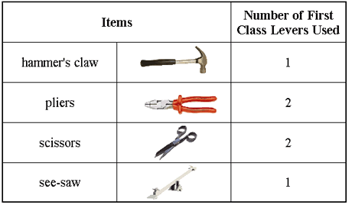

II Class Levers: The weight or resistance (W) is between the Fulcrum (F) and effort or force (E), and therefore the effort arm always exceeds the weight (resistance) arm.

E.g. 1) Wheel Barrow and the cracker
- Raising the toes in the weight bearing position. The fulcrum is said to be at the point of contact, the effort at the heel and the weight of the body transferred to the foot.
- Opening of the jaw
- Push-ups.

III Class Lever: The effort or force (E) is between the fulcrum (F) and the weight or resistance (W). The resistance arm always exceeds the force arm.

E.g. 1) Screen door and forceps
- Flexion of forearm by the biceps and brachialis. Fulcrum is at the elbow joint; weight concentrated at the end and the effort comes from the biceps.
- Raising the arm sideward upward by the deltoid muscle.
- Sit-ups.

Although all human motions involve levers, the following hints will help to understand them better.
- In the human body, a bone, or a combination of bones constitute a rigid bar called lever.
- The fulcrum or axis passes through a joint. It is the point around which the lever moves.
- Forces applied at the attachment of one or more muscles producing movement. Force is produced by the contraction of the muscles.
- The point of resistance is the center of gravity of the segment being moved, plus the center of gravity of any external weight or resistance. This resistance may be only the weight of the body segment, the weight of the segment plus the external weight or the application of an external force as in lifting an opponent.

Lever Arms :
Every lever, irrespective of its kind, has two separate arms called the force arm (FA) and the resistance arm (RA). The force arm is the perpendicular distance from the axis A to the line of pull of force (F). The resistance arm is the perpendicular distance from the axis A to the resistance (R). The exact ratio between these two arms changes with each class of lever and with different levers of the same kind. Moreover, this ration changes as the lever moves through its range of motion, because the line force changes.
In a first class lever, any of the two arms ( FA or RA ) may be longer than the other, depending on the axis of the lever. In the second class levers, the FA is always longer then the RA, where as in the third class levers, the RA is always longer.

MECHANICAL RATIO/MECHANICAL ADVANTAGE:

The ratio between the two arms of the lever determines the mechanical ratio of the lever. If, for example, the two arms were of the same length, as in a well-balanced teeter-totter, the mechanical ratio would be one to one without any mechanical advantage. If the force arm is three times longer than the resistance arm, the mechanical ratio would be 1 to 3 in favour of force. Conversely, if the resistance arm is three times longer as force arm, the mechanical ratio would be 1to 3 in favour of resistance.
Mechanical advantage is also the ratio of the weight to the effort.
Thus, M.A. = W/E, where M.A. = Mechanical advantage, W = Weight, and E= Effort.

Conversely, in cases in which the weight’s arm exceeds the effort’s arm, a condition of mechanical disadvantage occurs, as in levers of first order, when fulcrum is nearer to the effort than to the weight, and in all levers of the third order.
In the human body, the exact mechanical ratio varies with every movement at every joint. Moreover, it also varies at different points through the variance of motion. Therefore, the mechanical ratio varies not only from joint to joint but also within the same joint during the motion. This ratio can be purposely adjusted by changing the lever of resistance, or by reducing the lever. This knowledge is very helpful in such sports as gymnastics and wrestling, which can be used to one’s advantage.
Force Vs Speed :
With the force arm FA of a lever is longer than its resistance arm, the mechanical advantage contributes to the application of force at the cost of speed. This kind of lever is called a force lever. Conversely, if the resistance arm RA is longer than the force arm FA, the lever contributes to speed and range of motion at the cost of force. It is therefore, called a speed lever.
Figure….. involves two first class levers. In figure A, FA is longer than the RA. Suppose if this lever has a mechanical ratio of 1 to 3 in favour of force, 200 Newtons of force to balance 200 Newtons of resistance. If the point of force were moved one meter, the point of resistance would proportionately move 3 meters in the same period of time and therefore would move three times faster. It is therefore called a speed lever. The following hints will help understanding of the application of sped and force levers to human movements.
- Depending on the relative position of axis, first class levers may produce either kind of advantage. If A is closer to F than it is to R, FA will be shorter than RA and the lever will favour force. Most levers in the human body have their axes closer to the point of force and are therefore speed levers.
- In a second class lever, RA is always shorter than FA. Therefore, it is always a force lever.
- In a third class lever, FA is always shorter than RA. It is therefore a speed lever.
- Although, most levers in human body are first class or third class, third class levers are more common.
- Most levers in human body have the force arms shorter than the resistance arms and are therefore speed levers.
- The exact mechanical ratio, that is the amount of leverage, varies significantly from joint movement to joint movement and also in the same movement at different points through a range of motion.
- Correction of technique in different performances is a fundamental requirement to achieve optimum leverage.

Movement of Points on a Lever :
When a lever moves around its axis, all points on the lever move in an arc. The distance through which a point on the lever moves is directly proportional to its distance from the axis.
For example, point Y in the above figure is twice as far from the axis as point X and Z is three times as far as X. If point X moves a distance of 0.3 meters, point Y will move 0.6 meters and Z will move 0.9 meters. The points X, Y, and Z move through their arcs of 0.3, 0.6, 0.9 meters respectively in the same amount of time. This indicates that a point farther from the axis not only moves a proportionately greater distance but also with a proportionately increased speed.
Sports Implements as Levers :
When an implement such as a table tennis bat, a tennis racket, or a hockey stick is held in the hand, it becomes a lever. At the same time, the implement serves as a separate lever and in other cases it is simply an extension of a body lever. An implement extending beyond the hands moves faster than hands themselves. The farther the implement extends the greater its velocity. This means, that a point on a tennis racket head farther from the grip will move faster than a point closer to the grip. This tends to make one believe that a tennis racket should be struck near the end of the racket, where the velocity of the racket is the highest. Though it is true as far as the velocity is concerned, another factor must be considered. If the ball is struck faster away from the center of weight of the racket, the force of the ball will tend to rotate the racket and a part of the force will be dissipated. To make the most solid contact, the center of gravity of the ball, which should in fact contact the ‘sweet spot’.
As the idea of maximum velocity of the racket and the solid striking force are not in complete harmony, an adjustment between the two will produce the best result. In other words, the ball will travel the farthest, if it is struck solidly by the racket at a point slightly beyond its center of gravity (sweet spot). At this point on the racket, velocity is comparatively high and the impact is close to the center of gravity of the racket. In this example, full extension at the joint as opposed to partial extension will lengthen the total lever or combination of levers, producing a more speed at a particular point along the lever. In other words, if the angle of velocity at the joints remain constant, the racket head will move faster if the arm is fully extended at the moment of contact with the ball during service in tennis. Strengthening of the muscles involved in angular motion therefore ensures no loss in angular velocity as the lever is lengthened. Therefore, it is necessary to analyse the effect the each implement has on leverage in sports and utilise the implement in such a way that it will produce maximum results.
Application to Practical Situations in Sports :
The length of force arm in the human body cannot be changed. However, the proportional length of the force arm and the resistance arm can be changed by changing the resistance arm. The length of a lever can be either increased or decreased by extending or flexing the joints involved. Conversely, greater potential for force can be ensured if the lever is shortened by flexing the joints or by changing the point of grip.
If the purpose is to move the whole lever through the range of motion quickly, the resistance arm should be reduced so that it can be moved through a given range more quickly, provided equal force is employed. This can be easily accomplished by flexing the arms that shorten the lever.
The effectiveness of body levers can be improved by increasing strength because greater muscular force improves the force of movement and the speed at which a movement clan be produced against the resistance, irrespective of lever or amount of leverage. The point at which all the weight of a body is concentrated marks the intersection of three primary planes and their axes. In the case of an individual, standing in the anatomic position, the location of this point called the mass center for solid masses of uniform density is at the geometric center and remains constant irrespective of the position of the object. Though this point is ver obvious, the points through which the line of action of the resultant force acts are not so obvious.
The center of gravity is located at a point along the mid line, at about 55% of the height of a person. However, its exact point varies from individual to individual, depending on his or her body proportions. The following factors should be carefully analysed in order to have a clear-cut concept of center of gravity and its effects on performance.
- Because of structural differences between men and women in physique, the center of gravity is proportionately lower in women than in men. Though this gives a structural advantage to women in stability, it gives them a disadvantage when they are to raise their center of gravity in such events as high jumping.
- As one goes from childhood to adulthood, body proportions change, which makes center of gravity proportionally higher in children than in adults.
- The center of gravity is affected by such structured changes as amputations, because of which the body deviates from the normal.
- Specific body positions temporarily influence the center of gravity. In sprint start, for example, the center of gravity is shifted forward. Similarly, in diving it shits forward in the move from a layout to tuck position and moves away from the mid-line of the body when it is laterally flexed.
- The additional weights placed on the body, as in carrying a heavy sac will relocate the center of gravity.

The area of contact between the body and the supporting surface defines the base of support on which the human body rests. If this base of support and other factors remain unchanged, the stability of the body increases with the lowering of center of gravity.

NEWTON’S LAWS OF MOTION :

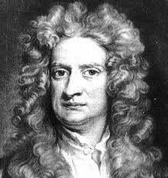  Sir Isaac Newton (1642-1727) | First Law (Law of Inertia): Every body continues to be in its state of rest or of uniform motion unless it is compelled by an external force to change that state.  Second law (Law of Acceleration): The rate of change of momentum of a body is directly proportional to the external force acting on it and the movement will be in the direction of force. (F= ma)  Third Law (Law of Reaction): For every action, there will be an equal and opposite reaction.
The motion of an aircraft through the air can be explained and described by physical principals discovered over 300 years ago by Sir Isaac Newton. Newton worked in many areas of mathematics and physics. He developed the theories of gravitation in 1666, when he was only 23 years old. Some twenty years later, in 1686, he presented his three laws of motion in the "Principia Mathematica Philosophiae Naturalis." The laws are shown above.
Newton's first law states that every object will remain at rest or in uniform motion in a straight line unless compelled to change its state by the action of an external force. This is normally taken as the definition of inertia. The key point here is that if there is no net force acting on an object (if all the external forces cancel each other out) then the object will maintain a constant velocity. If that velocity is zero, then the object remains at rest. If an external force is applied, the velocity will change because of the force.
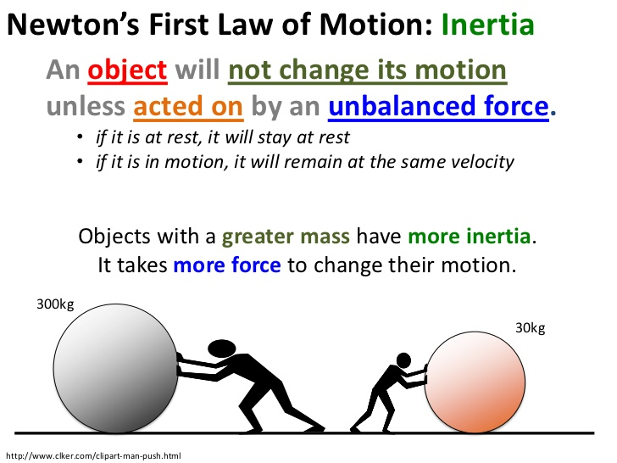
The second law explains how the velocity of an object changes when it is subjected to an external force. The law defines a force to be equal to change in momentum (mass times velocity) per change in time. Newton also developed the formula, and the "changes" expressed in the second law are most accurately defined in in it. For an object with a constant mass m, the second law states that the force F is the product of an object's mass and its acceleration a:
F = m * a
For an external applied force, the change in velocity depends on the mass of the object. A force will cause a change in velocity; and likewise, a change in velocity will generate a force. The equation works both ways.
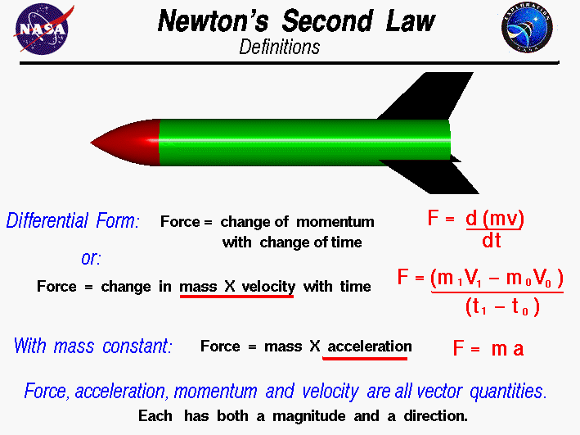
The third law states that for every action (force) in nature there is an equal and opposite reaction. In other words, if object A exerts a force on object B, then object B also exerts an equal force on object A. Notice that the forces are exerted on different objects. The third law can be used to explain the generation of lift by a wing and the production of thrust by a jet engine.

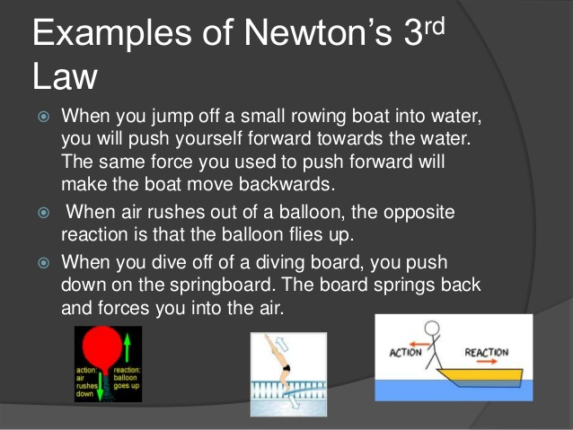

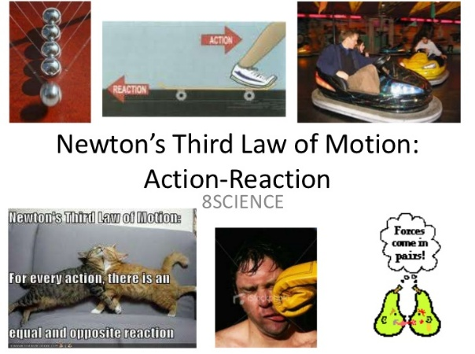

Application of Newton's Laws of Motion in Sports :
Newton's laws of motion form the basis for principles used in sport movements. Methods of training that depart from these laws would not make sense mechanically. Tips for efficient sport performances are built around these laws and principles.
First, it helps to know that there are two basic types of motion. These come into play in combination when applying mechanical principles to sport skills:
1. Linear motion occurs when an object or person travels in a straight line, as when sledding across a level surface.
2. Angular motion occurs when an object or person turns about a centre point, axis, or fulcrum and does not travel from place to place. It is common in diving and gymnastic skills when athletes rotate, twist, or spin.

The Law of Inertia
A body at rest tends to remain at rest. A body in motion tends to continue in motion with consistent speed and in the same direction unless acted upon by an outside force.
Basically, if an object is in motion, it keeps going unless something stops it. What are examples of outside forces that affect inertia? Most of these are--gravity, the surface of the playing field, a defensive player, or the braking action of an athlete's body to stop.

The Law of Acceleration:
The velocity of a body is changed only when acted upon by an additional force. The produced acceleration or deceleration is proportional to and in the same direction of the force.
If a baseball player hits a ball with double the force, the rate at which the ball will accelerate (speed up) will be doubled. Football players can slow down, stop, or reverse the direction of other players depending upon how much force they can generate and in which direction.
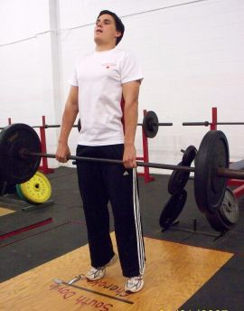
Newton's Laws of Motion apply to the pull phase of the power clean.

The Law of Counterforce :
The production of any force will create another force opposite and equal to the first force.
A swimmer propels herself through the water because the water offers enough counterforce to oppose the action of her hands pushing, allowing her to move. An athlete can jump higher off a solid surface because it opposes his body with as much force as he is able to generate, in contrast to sand or other unstable surface.

Mechanical Principles:

The Rules of Sport Skill Technique:
Mechanical principles applied to sports are rules that govern the efficient execution of skills. Using these rules as guides, athletes can build excellent technique and gain the greatest mechanical advantage. Newton's Laws of Motion are the foundation for these mechanical principles, which must be applied in concert with other sports training principles to achieve higher levels of sport performance.

Principles from the Law of Inertia :

1. To achieve skilled movements, athletes must effectively combine linear and angular motion. For example, a discus thrower's body must move in a straight path from the back to the front of the ring while rotating with increasing velocity.
2. When two or more motions are required, athletes must execute movements continuously in sequence. For example, if a javelin thrower hesitates or stops at the end of the approach just prior to the throw, the advantage of the the approach is lost.
3. Athletes can increase mass and/or velocity to realize proportional gains in momentum. For example, if a football player gains both weight and speed, it is more difficult for an opposing player to alter his path.
4. Transfer momentum efficiently from each segment to the whole body. For example, a sprinter coming out of the starting blocks uses the driving action of his or her arms to contribute to the total momentum and direction of the body.
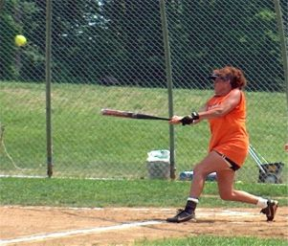

Principles from the Law of Acceleration :
5. Acceleration is proportional to force. For example, a sprinter increases acceleration by increasing the force that he applies against the track. Increasing force by 10% causes a 10% increase in acceleration. If he could lose fat weight but maintain the same level of force (power), acceleration would also increase.
6. Maximum acceleration is achieved when all body forces are coordinated in the intended direction. Body actions that do not contribute to a skill should be minimized to prevent wasted energy or detract from productive movements. For example, a swimmer coordinates the body actions to generate maximum force while minimizing unnecessary movements that cause excessive bobbing or lateral deviations.
7. When rotating, lengthening the radius slows the rotation and shortening the radius increases rotation. For example, a diver rotates faster when the tuck is tightened, creating a shorter body radius. A pike produces slower rotation because the radius is longer.
8. When jumping, the path in the air is set upon take off. Once a long jumper is in the air, his or her arms or legs may cause body rotation, but the flight path is not affected.

Principles from the Law of Counterforce:
9. Maximize counterforce with stable surfaces. If a surface is stable, it offers the same amount of force back as is generated against it. The less stable the surface, the less counterforce is returned. For example, sand does not offer a stable surface for running as compared to a concrete surface.
10. To achieve maximum jumping height, push directly downward upon take off. The direction of counterforce is directly opposite that of the applied force, and the applied force is most effective when it is perpendicular to the supporting surface because "give" is minimized.
11. Maximize total force. When batting (or for other striking skills), the total force at impact depends upon the both the momentum of the bat and the momentum of the ball.
12. Stay in contact with the ground. In activities involving throwing, pushing, pulling, or striking, one or both feet should be kept in firm contact with the ground until the force application is complete.
PROJECTILES

Any body that is thrown or projected into air is called a projectile. To be more specific, " A projectile is any body that is impelled by some force and then continues to move through the air by its own intertia".

Projectile motion - that is, the motion of the bodies that have been projected into the air- occurs with considerable frequency in physical education and sports. Shot putters and golfers, baseball, basketball and Volleyball players project a shot or a ball. Discuss and javelin throwers, archers and badminton players project variously shaped objects. All these types of projectiles are called inanimate projectiles. In diving, gymnastics and the jumping events, the projectile is an animate one -i.e., the performer himself.

The primary mechanical purposes, in sports for projecting the objects are: 1) to gain maximum horizontal distance, as in the case of all throws in athletics and long jump; 2) to reach maximum vertical distance, eg. High jump, basketball jamb ball etc. 3) to have maximum accuracy; eg. Basketball shooting, archery, shooting and 4) to have maximum accuracy when speed of the projectile enhances the projectiles efficiency e.g., volleyball service.

In all these cases, the outcome depends largely on the performers ability to control or (if control is not possible) to predict the result of projectile motion involved. It is therefore, important that physical education teachers and coaches have some fundamental knowledge of mechanical factors that govern such motion. Let us now discuss some of the important aspects involved in projectile motion.

Trajectory or path of projectile: If gravity did not act to change its motion, a projectile would continue to travel indefinitely with the same velocity and in the same angle it had at the moment of release - i.e., the moment it became a projectile. Consider for example, the case of a shot released with some velocity at certain angle to the horizontal. In the absence of external influences, the shot would travel the same distances horizontally and the same distances vertically during every second of its flight.

While shot putters might well wish that they could throw the shot out of sight in this fashion, in reality the described is only half correct. Because gravity acts in a vertical direction and thus has no influence on the horizontal motion of the shot, nothing acts to alter this horizontal motion. As a result, the horizontal velocity of the shot remains constant throughout its flight and the shot travels equal distances in equal intervals of time.

However, because the shot is subjected by gravity to a constant vertical acceleration of 9.82 m/s2, its vertical velocity changes from some positive value at release - i.e., assuming the upward direction is positive - to zero at the peak of the flight to some negative value before landing. The resulting flight path or trajectory is a smooth symmetrical curve known as parabola.

It is a type of curve resembling a mill. The steepness of a parabola varies with the angle of projection. The grater the angle of projectile the steeper, the parabola.

In all practical purposes, the movement of the human body is characterized by its movement of center of gravity (C.G). It is both interesting and important to note that once a person jumps or dives, the parabolic path of his or her C.G. is set and no movement of the torsoor limbs while in the air will change the path. Only external unbalanced forces can alter the direction of the body's masscentre. The athlete can, of course, rotate various body parts around the body's C.G. to accomplish certain stunt or to put the body into a particular position for landing, as in the long jump.
1
- Horizontal Motion: Suppose a soccer ball is released and projected into the air at angle O to the horizontal and with a velocity 'U'. As discussed earlier, it maintains the same horizontal velocity and it will be equal to U cos O.
We know that displacement is equal to the product of velocity and time. Hence,

dH = U Cos O x t

Where dH = horizontal displacement
U cos O = horizontal velocity and
T = time

This equation can be used to determine how far the ball has traveled horizontally after given intervals of time.

The total horizontal distance the ball travels while it is in the air, a distance known as the range of the projectile, can also be found using the above equation. It T = the total time of flight of the projectile and U Cos O = the horizontal velocity, as before, the range of the projectile R, is given by

U Sin 2O
R = U Cos O. T. = ----------------
g

From this equation it is apparent that if a soccer player making a goal kick (or any other performer who projects a body into the air) wishes to alter the range of the projectile, he can do only by altering the horizontal velocity of release and/or the time of flight.
2
- Vertical Motion and Time of Flight: The horizontal velocity of the soccer ball acts parallel to the ground and thus has no tendency to lift the ball into the air. The lifting of the ball is due to the vertical velocity imparted to it prior to release. The time of flight of the ball is also largely determined by the vertical velocity at release.
Logically, the time of flight is equal to the time it takes for the projectile to reach the peak of its flight (Tup) plus the time taken to return from this peak to the point of landing (T down). Usually Tup and Tdown both will be equal and can be found from the formula.

U sin O
T up = T down = --------------- = Total time taken T = T up + T down
g

2 U sin O
=------------------
g

Thus any performer who wishes to alter the time of flight of a projectile can do so only by altering the velocity parameter. The gymnast who needs more time in air to complete a stumbling stunt must increase the vertical velocity with which he leaves the ground and the basketball player who wishes to decrease the time the ball is in the air when making along pass must correspondingly decrease the vertical velocity with which the ball leaves the hands.
2
When the projectile lands at the level from which it is released, the vertical displacement can readily be found by the formula:

(U Sin O)
Dv = ---------------
2g

The projectile released at a height above or below the level at which it lands, down is given by

(V Sin O)
Ddown = dup + h =------------------ + h
2g

Thus, the total time taken in this case can be measured by the formula:

Sin O + (V Sin O ) + 2gh
T = ---------------------------------------
g

This equation indicates that where release and landing are not at the same level, the time of flight can be modified by altering the vertical velocity of release and/or the height of release. Thus shot putters who want to increase the time of flight of the shot and thereby enable it carry further have two means at their disposal:
- Increase the vertical velocity of the shot at the time of release, or
- Increase the height from which they release it.

Range of projectile:

The maximum horizontal distance traveled by the projectile from the point of projection during the time of flight is called its range.

The horizontal distance that a projectile travels during its flight is of interest not only to shot putters but to tennis players, football players, Golfers, long jumpers and many others.

The total distance that a cyclist travels obviously depends upon the average horizontal velocity and length of time spent riding. The horizontal distance that a shot travels - the range of throw similarly depends on the horizontal velocity of the shot and the time it spends traveling at that velocity, i.e., on the time of flight.

The range of projectile may thus be said to be determined by its velocity, angle of release and relative height of release.
The range, 'R' can be found by the formula

U Sin 2O
R=---------------
g

This applies only to situation in which release and landing are at the same level. Where the level from which the body is projected is above the level at which it lands (as in the case of shot put) the horizontal range is obtained by the formula:

U Sin O Cos O + U Cos O (U Sin O ) + 2 gh
R= ---------------------------------------------------------------------
G

3
- Angle of Projection: The angle at which the body is projected into the air is frequently discussed in Physical Education and athletics. This angle usually referred to as the angle of release or angle of projection in throwing and striking activities and the angle of take off in the jumping activities - is the acute angle between the velocity vector and the horizontal at the instant of release or take off. The size of the angle used varies considerably according to the purpose of the activity. For example, activities like shot put, long jump and ski jump in which the performer seeks a large horizontal range generally involve the use of smaller angles than do those like the high jump and most trampoline stunts, in which height is the objective.

The relatively small angles of release reported for some of the activities in which the performer attempts to obtain a large horizontal range raise the obvious question. “What is the optimum angle of release or take off in such cases? The answer to this question has three points.

- When the projectile lands at the same level as that from which it is released - as in a football kick the optimum angle is 45 degree.
- When the projectile lands at a level below that at which it was released - as in the shot put - the optimum angle is always less than 45 degree. The exact magnitude of optimum angle in such cases depends on the velocity and relative height of release.
- When a projectile lands at a level above that from which it was release - a rare occurrence in sport - as in the case of basketball shooting - the optimum angle is greater than 45 degree and again depends upon its velocity and relative height of release.

In general, the velocity of release exerts more influence on the range obtained
Than of either the angle or the relative of release.

