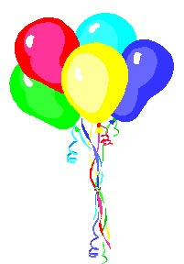
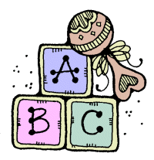

Pregnancy Education Classes

Classes | 2025 | Content
Healthy Pregnancy & Breast Feeding | May 10, Aug. 9,  Nov. 8 | Nutrition, exercise, avoiding risks/Breast or Bottle
Labor & Delivery | June 14, Sept. 13, Dec. 13 | Breathing & relaxation techniques
Caring for the New Baby | July 12, Oct. 11, Jan. 10 | Circumcision care, baby bath, crying, swaddling

All Classes are held on Saturdays from 10 AM "Sharp" to 12:00 PM

Classes are FREE -- Refreshments Served

Please Call to Register: (301) 423-0063
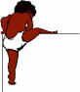

Classes are being held at:
Forestville Pregnancy Center
3611 Branch Ave. Suite 101
Temple Hills, MD 20748

