**\*\* Brethren, as per *Our* By-Laws \*\***

At Our April Stated Meeting,

We read the Names of **35 Members** that

had not paid Their Dues.

After attempting to contact these members,

I talked with 12, left messages with a few, no answer on some, had incomplete phone #s & e-mail info on others & discovered that 3 had passed.

We are now down to **17 unpaid Members**.

These will be **Summons** to pay by *Our* June Stated Meeting; if not, **YOU WILL BE SUSPENDED!**

--------------------

“May’s Stated Meeting”

**“Chair of Honor”**

**Bro. David Smith**

--------------------

We had 35 Members Present; (18 PMs).

“Congratulations”

***Bro. Henry Alfredo Vega*** on receiving His Fellow Craft Degree!

**Mr. Logan Tyler Elmore** has been elected to receive the 3o of Masonry.

--------------------

*******>>* ***UPCOMING EVENTS*** *<<*

***We Practice on***

***Tuesdays Nights***

except Stated Meetings

& Degree Nights

And *We* Eat @ 6 pm

--------------------

***Wednesday,* May 1st; *“Yom HaShoah”***

also known as ***Holocaust Remembrance Day***. It commemorates the lives and heroism of about six million Jewish people who were slaughtered by the Nazis between 1933 and 1945.



***“Loyalty Day”*** is on **May 1** each year. It is a special day for people to reaffirm their loyalty to the United States and to recognize the heritage of American freedom.

It was first observed in 1921 as

***"Americanization Day"***.

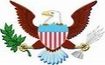On **May 1, 1865**; ***William McKinley***

(U.S. President 1898-1901) received his

1st degree in Hiram Lodge #21, Winchester, VA.

--------------------

***Thursday,* May 2nd** ***“National Day of Prayer”***

calls on all people of different faiths in the U S to pray for the nation and its leaders. In 1775 the Continental Congress allocated a time for prayer in forming a new nation.

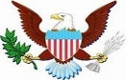--------------------

On **May 5, 1851**; ***Andrew Johnson***

(U.S. President 1865-1869) received his

1st degree in Greenville Lodge #119, Tennessee

--------------------

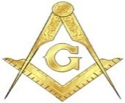 On **May 8, 1843**,

a national *Masonic Congress* was begun in Baltimore, *(Baltimore Convention)*, to attempt to establish a uniform ritual for U S Grand Lodges.

--------------------

***Friday,* May 12th**



On **May 12, 1932**

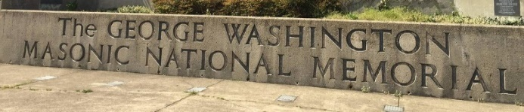 in Alexandria, Virginia, was dedicated in a very

large ceremony, attended by thousands, including the President of the United States.

--------------------

***Tuesday*, May 14th;*****“2 Master’s Degrees”***

For ***Bros. James Matthew “Matt” Walker & Henry Alfredo Vega***

Eat @ 6 PM & Degree @ 7 PM

--------------------

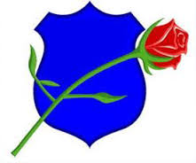***Wednesday,* May 15th**

***“Peace Officers Memorial Day”***

held annually in the U S on May 15 in honor of federal, state and local officers killed or disabled in the line of duty.

--------------------

On **May 18, 1959, *Harry S. Truman***

(U.S. President 1945-1953) received

His 50-year masonic award.

***Tuesday*, May 14th;*****“Master’s Degree”***

For ***Brother John Coy Isbell***

Eat @ 6 P & Degree @ 7 PM

--------------------

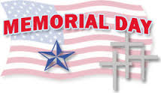***Monday,* May 27th**

--------------------

***Tuesday*, May 28th;**

***“Entered Apprentice’s Degrees”***

For ***Mr. Logan Tyler Elmore***

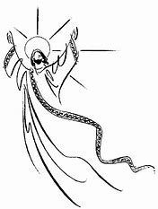Eat @ 6 PM & Degree @ 7 PM

--------------------

***Thursday,* May 30th; *“Ascension Day”***

Is observed on the 40th day of Easter. It

commemorates Jesus's ascension into heaven.

--------------------

Our next **STATED MEETING** will be

Tuesday, **"June 4th, 2019"** @ 7 pm

Dinner is at 6 pm by Our 5 Star Kitchen Crew!!

--------------------

Prayer Request

Charlie Bamman; Don Blackwell; John H. Carter; Dan Coleman; Wm. Albert Copen; Ronnie Davis; Louise Davis (Derek's Mom); Danny Dorsey; Gibson Duncan Jr. & Wife; Buck Gentry & Wife; Odie Gregory; Bill Henderson; Dewey Holt; Sterling Lankford; Will Lansdown & Family; Preston Marsh; Steve Murff; David Phillips & Family; David Pruitt; Randy Pryor; Paul Tomlin; Burton True; Thomas Williams; Randy Wilson;

Bobby Joe Vaughn said Thanks to Everyone!

--------------------

**\* * * * Celestial Lodge * * * \***

**Bro. Marvin Walter Wolfe** passed away 10/29/18

We received a card from His daughter, 4/9/19

**Bro. Kenneth Gordon Bush Sr** passed 3/31/19.

No Masonic Service was requested.

**Bro. Thomas Ray Blackwell Jr** passed 4/30/19.

No Masonic Service was requested.

--------------------

**Please Keep These Brothers & Families**

**IN YOUR PRAYER!**

***"OUR" OFFICERS FOR 2019!"***

**WM Gerald W. Graves - - - - - - - - - 615-339-6369**

**SW Larry C. Gauld Jr - - - - - - - - - 303-519-4476**

**JW Barry D. Kirby - - - - - - - - - - - 615-319-9720**

**Trea Guy C. Whitley - - - - - - - - - - - 615-416-3141**

**Sec Gary W. Pirtle - - - - - - - - - - - -615-838-1601**

**legzpirtle@yahoo.com**

**Chap Kenneth I. Wright - - - - - - - - -615-598-5181**

**SD John H. Rodriguez - - - - - - - - 615-459-3083**

**JD James W. Lackey - - - - - - - - - 585-734-2253**

**SS Ralph E. Ervin - - - - - - - - - - - 615-319-7352**

**JS Charles W. Bullard - - - - - - - - 615-525-3884**

**Tiler Steven T. Murff - - - - - - - - - - -615-330-3889**

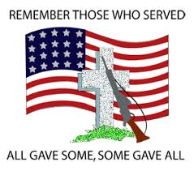

***"OUR" TRUSTEES FOR 2019!***

**Edward C. Mason II, PM - - - - - - - - - - 615-456-1072**

**Barry D. Knowles, PM - - - - - - - - - - - - 615-584-5094**

**Steven T. Murff, PM - - - - - - - - - - - - - 615-330-3889**

**Howard C. Rodriguez, PM - - - - - - - - - 717-398-9089**

**Amon D. Ringemann, PM - - - - - - - - - -615-228-2541**

IONIC Lodge No. 254 F&AM

P.O. Box 160383

Nashville, TN 37216

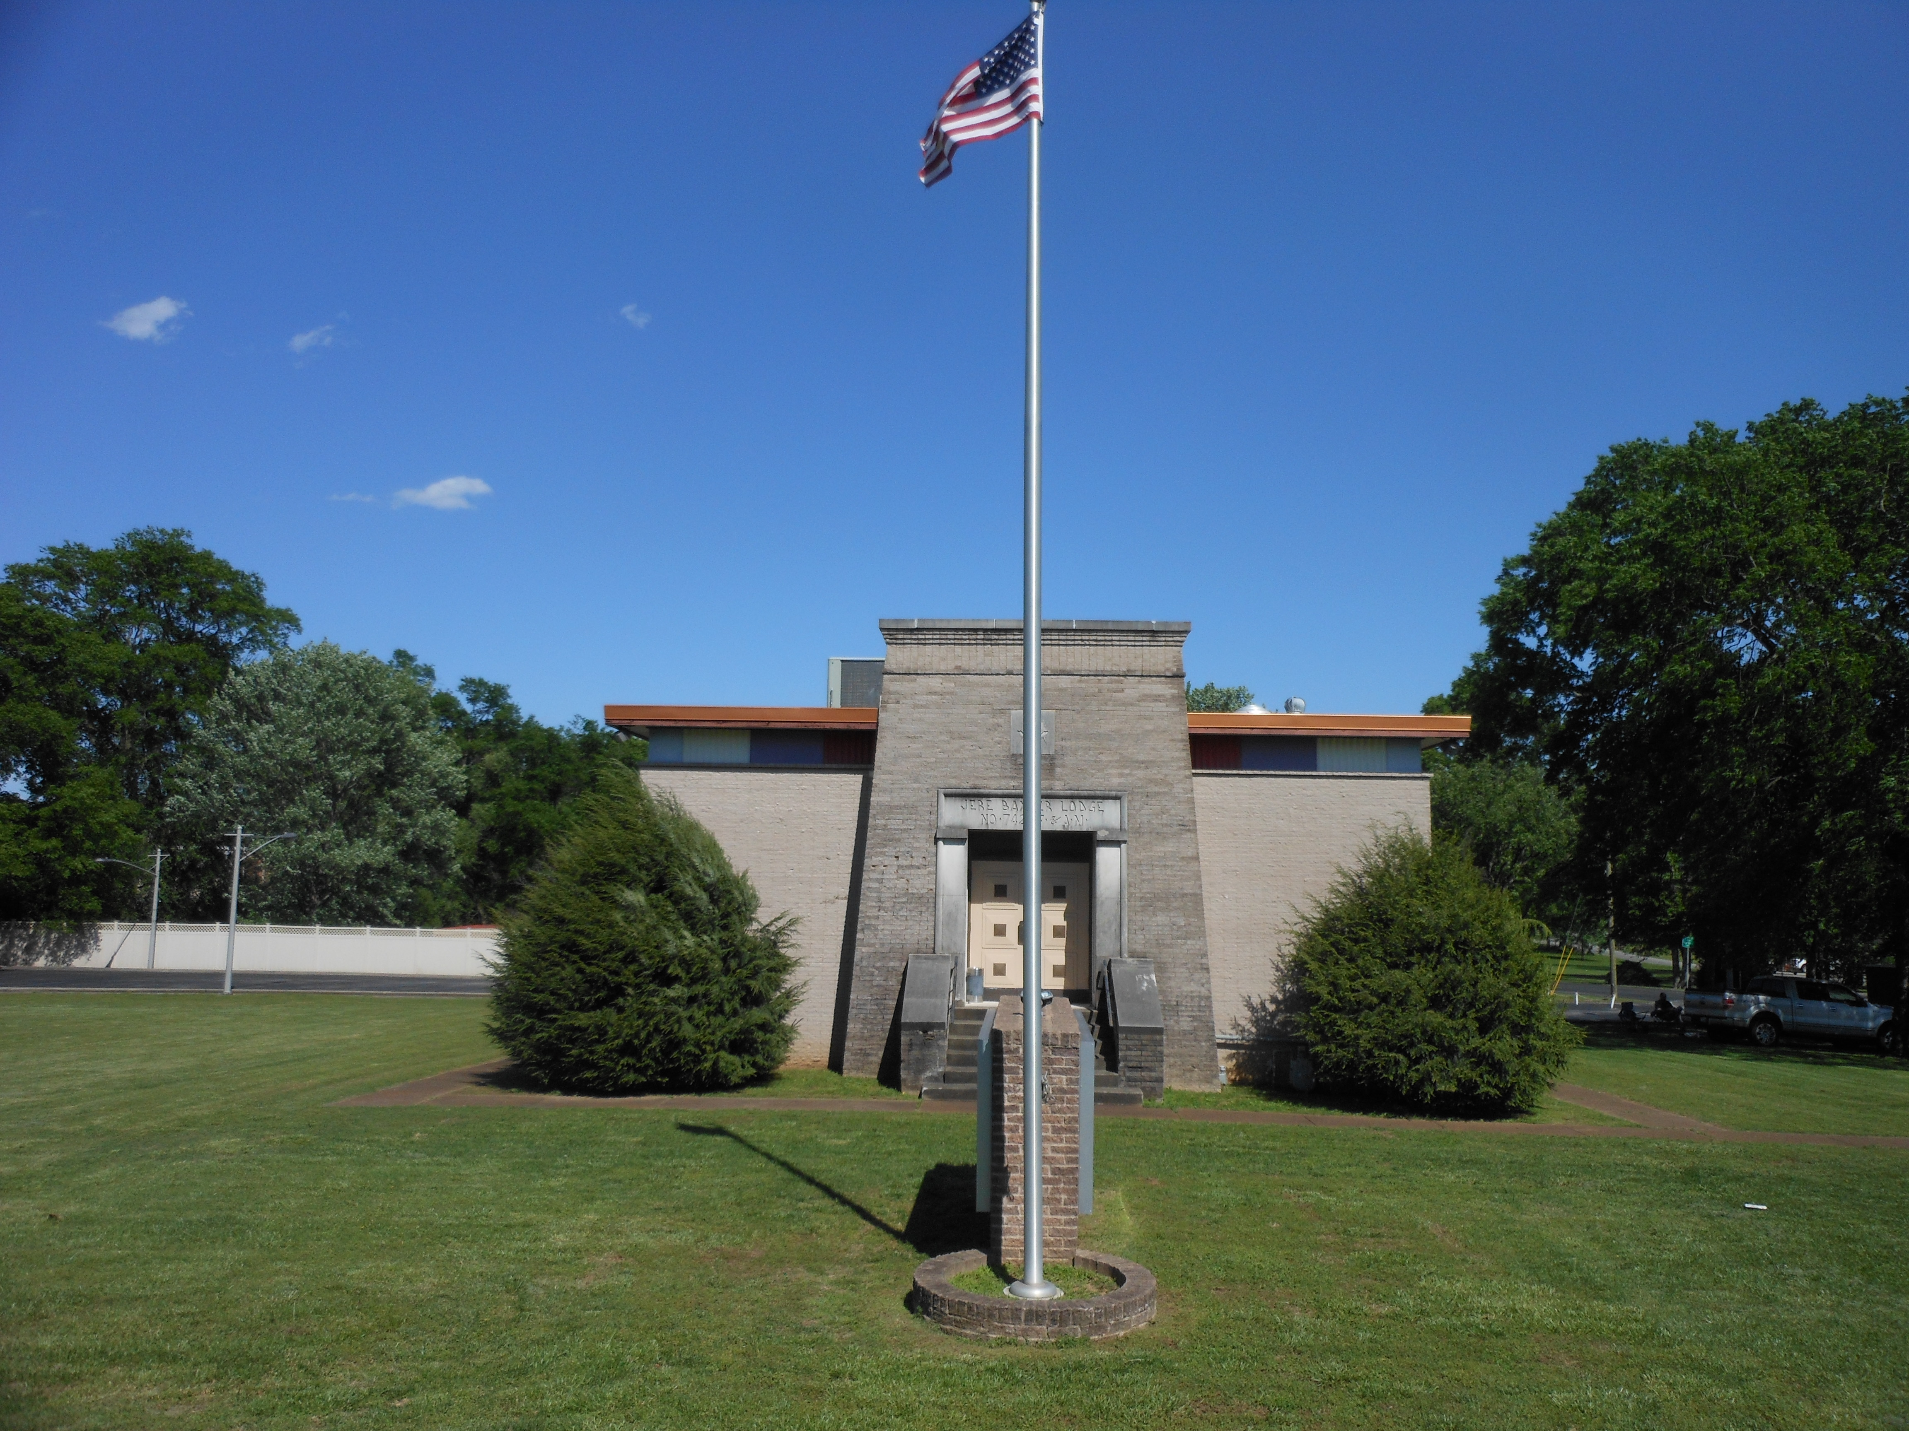

**One Nation Under GOD!**

ELECTRIC SERVICES REQUESTED

Non-Profit Org.

US Postage

PAID

37070

**Permit # 47**

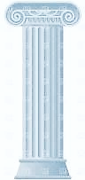

IONIC

lodge

no. 254

f & am

MONTHLY BULLETIN



**"2019"**

***Our Mailing Address is:***

IONIC Lodge #254

P.O. Box 160383

Nashville, TN

37216

***Lodge Location is:***

4400 Gallatin Pk. Nashville, TN 37216