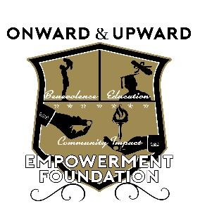

Onward & Upward Empowerment Foundation
2023 Mark Saunders Scholarship
APPLICATION

The purpose of this scholarship is to provide assistance for college students that may be experiencing challenges during their current semester. This scholarship is intended for student who are originally from the Dallas-Fort Worth metropolitan area. Student may also apply if there are currently attending college in the area. A short application is required to apply for this scholarship. Interested students can request and application at: OUEmpowerment@gmail.com. Access to the application can also be found at: oauef.org.

Part I: Educational and Personal Information
Section A. Student Information

Student’s Name _______________________________________________________________________
Please print Last First Middle

Sex____ Classification_____ Birth Date ___/___/___

Home Address_____________________________________________ Phone _____________________
Street

____________________________________________________________________________________
City State Zip

Page 2
Student’s e-mail (Please print)____________________________________________________________

Name of College_______________________________________ Phone__________________________

School Address____________________________________________County ______________________
Street
__________________________________________________________
City State Zip

Is the student a minority? Yes_____ No_____
This information is requested to help assure equal admission opportunity for all candidates.

Part III: Educational and Personal Information (continued)
Desired Degree___________________________________________________

Part II. Student Request
To be completed by Student:

Applicants are to submit a brief description of their current need. Please keep response to 400-500 words in length that (a) describes any challenges you may be encountering and (b) identifies what funds will be used for if approved. Please type your response on a separate sheet and attach it to this application

Page 3
Part III: School Information

Section A. School Record

- Student’s grade point average: ______________ (Use 4-point scale)

- Anticipated year and month of College graduation: Year__________ Month______________

Section B. Referral

Please advise how you learned about this Scholarship.

_______________________________________________

For more information, contact:
Chris Jones
Secretary
Onward & Upward Empowerment Foundation
504-256-7358
- e-mail: OUEmpowerment@gmail.com

