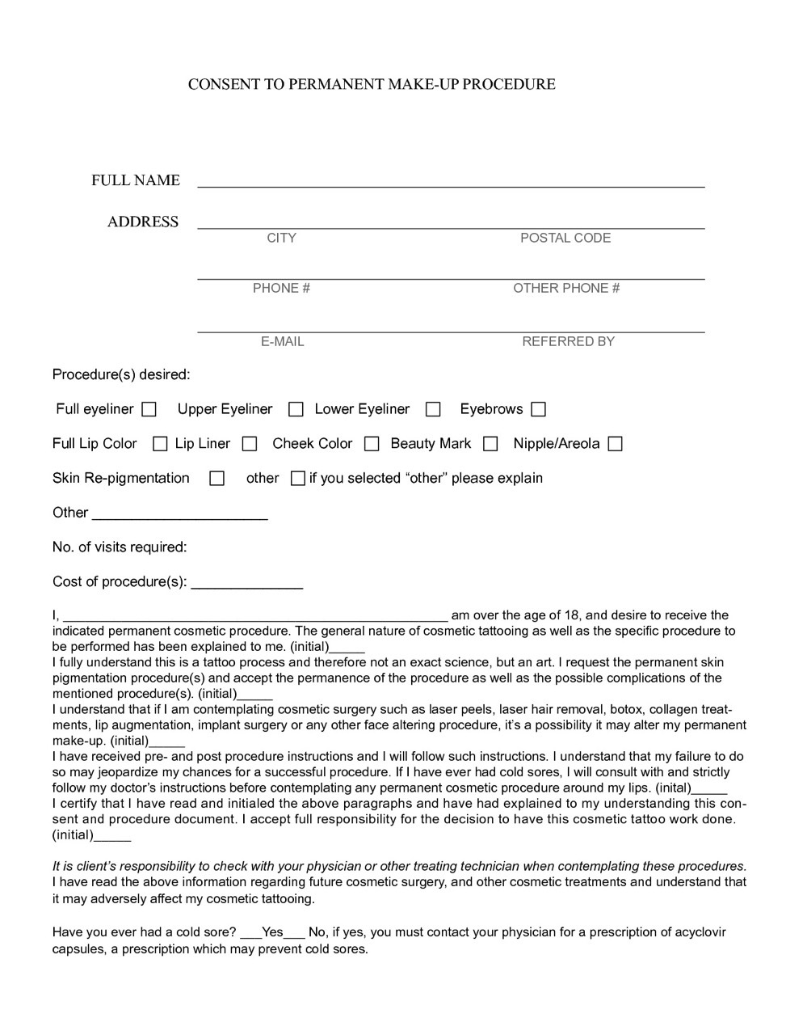

DATE OF BIRTH:

