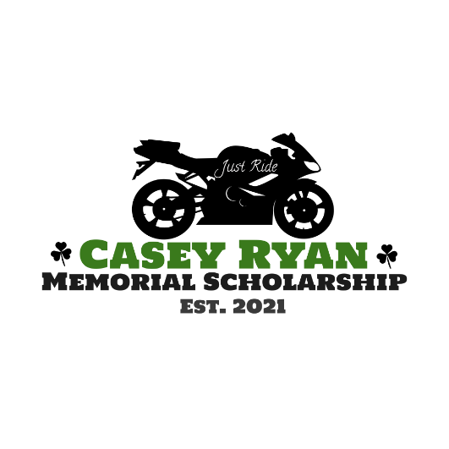
CBU PA STUDENT APPLICATION

Application Criteria:
- Graduating class of 2023 or 2024
- Letter from program verifying student status and GPA
- Student curriculum vitae (CV)
- At least 1 letter of recommendation from CBU faculty member
- Personal essay about career goals
- Brief essay outline on why this scholarship will help you pursue your goals in relation to the financial challenges in paying for PA school
- List of completed/expected clinical rotations

Name: __________________________________________________________________
Graduation year: ________________________________________________________
Date: ___________________________________________________________________
Mailing address: _________________________________________________________
_________________________________________________________
Email address: __________________________________________________________
Phone number: _________________________________________________________
May we post your name and photo on social media (if you are the winner)? ___Yes ___No

APPLICATION DEADLINE: March 31, 2023
Please submit all information (in one email if possible) to Whitney Gatewood at: caseyryanscholarship@gmail.com with your name in the subject line
Recipient will be announced at the White Coat Ceremony in May 2023.

