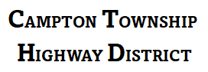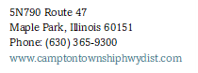

Job Application Form (non-CDL)
  - *Please complete all sections of this application form. Incomplete forms may not be considered.
  - Personal Information
Full Name
Date of Birth (MM/DD/YYYY)
Address
City
State
ZIP Code
Phone Number
Email Address

Employment Desired
Position Desired
Are you currently Employed?
If so, may we contact your current employer?

Drivers License
State | License No Type/Class Expiration Date

Education History
Name and Location of School. Did you graduate?
High School/GED | Yes No
College | Yes No
Trade, Business or Correspondence School | Yes No

Employment History
Please list your last three employers, starting with the most recent:
Company Name | Phone Number
Position Held | Responsibilities
Employment Dates | From To
Reason for Leaving

Company Name | Phone Number
Position Held | Responsibilities
Employment Dates | From To
Reason for Leaving

Company Name | Phone Number
Position Held | Responsibilities
Employment Dates | From To
Reason for Leaving

References
Please provide two professional references.
Name
Relationship
Phone Number
Email Address

Name
Relationship
Phone Number
Email Address

Certification and Signature
By signing below, I certify that the information provided on this application is true and complete to the best of my knowledge. I understand that any false information or omission may result in rejection of my application or termination of employment.
Signature
Date (MM/DD/YYYY)

