**Dealer Guide for Registering AL3RTGPS 2.0**

**Step 1: Go to dealer.al3rtgps.com and login to your account**

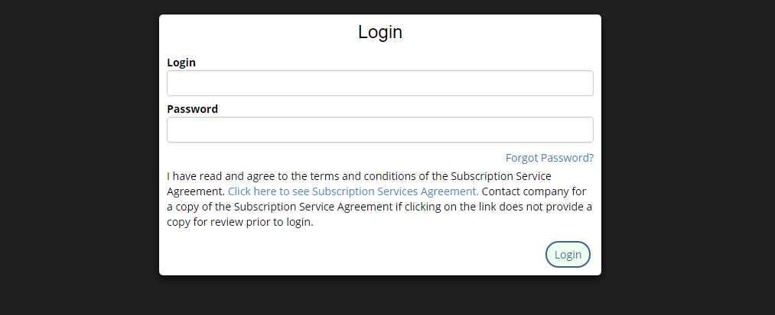

**Step 2: Find the serial number of the device you are selling the customer and hit the transfer button**

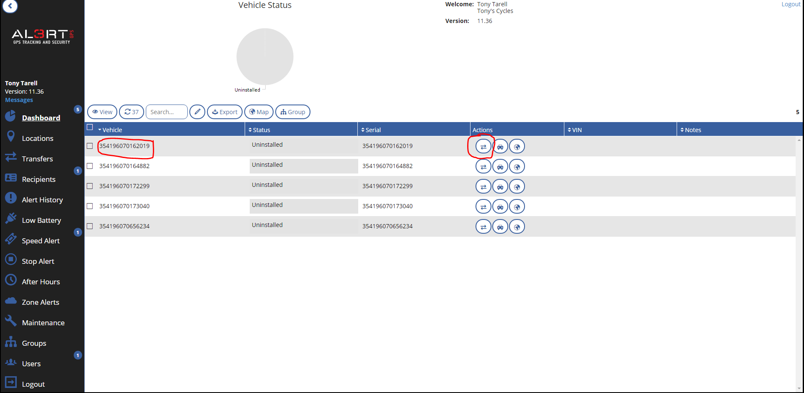

**Step 3: Enter the customer’s name and email address**

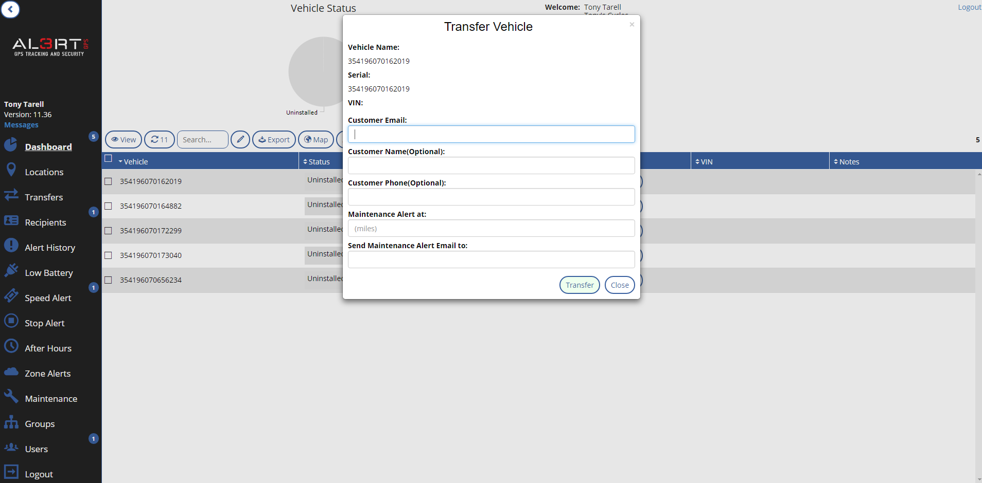

**Step 4: If you had the customer fill out the theft contract you can put in the mileage alert and your service managers email**

**Step 5: Tell your customer to check their email and follow the instructions.**

Consumer Site: trackit.al3rtgps.com

Support: [support@al3rtgps.com](mailto:support@al3rtgps.com) 855.687.4637