|  |
| --- |
| Carrot Puff A Kristen Hunt recipe. INGREDIENTS 1 lb. carrots, cut in 1 in pieces 3 T flour  1/2 cup margarine, melted 1 t baking powder  3 eggs 1 t vanilla extract  1 cup sugar DIRECTIONS  1. Grease 8 in square dish. 2. Cook carrots in saucepan; cover with salted water. Bring to a boil, then simmer for 20 minutes. Drain. 3. Put all ingredients, except carrots, in blender. Add carrots a little at a time. Puree. 4. Pour into dish. Bake at 350°for 45 minutes. |
|  |

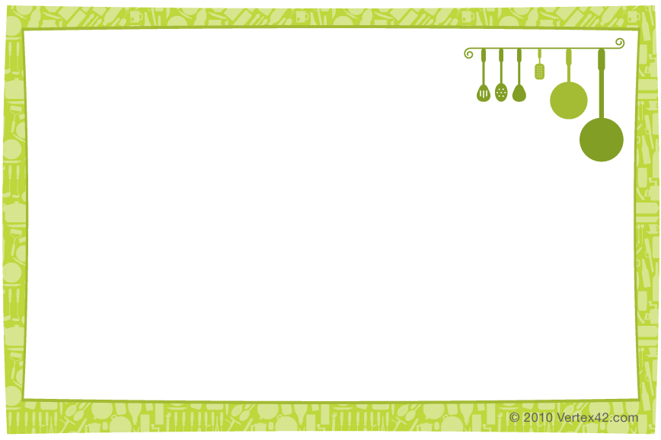

|  |
| --- |
| Carrot Puff A Kristen Hunt recipe. INGREDIENTS 1 lb. carrots, cut in 1 in pieces 3 T flour  1/2 cup margarine, melted 1 t baking powder  3 eggs 1 t vanilla extract  1 cup sugar DIRECTIONS  1. Grease 8 in square dish. 2. Cook carrots in saucepan; cover with salted water. Bring to a boil, then simmer for 20 minutes. Drain. 3. Put all ingredients, except carrots, in blender. Add carrots a little at a time. Puree. 4. Pour into dish. Bake at 350°for 45 minutes. |