|  |
| --- |
| Chicken Squares A Laura Wilkerson recipe. INGREDIENTS De-bone whole chicken (cooked and chopped)  8 ox cream cheese 2 tablespoons milk  2 tsp butter 2 pkg crescent rolls  2 tsp chopped onion DIRECTIONS  1. Mix together chicken, cream cheese, butter, onion and milk. 2. Open crescent roll package. Taken two triangles and pinch together to make one square. 3. Fill square with chicken mixture. Pull together four corners and pinch closed to make a closed pocket. 4. Bake at 350° for 20 minutes or until crescent rolls are golden brown. (Note: some brands may only take 11-15 minutes of bake time). |

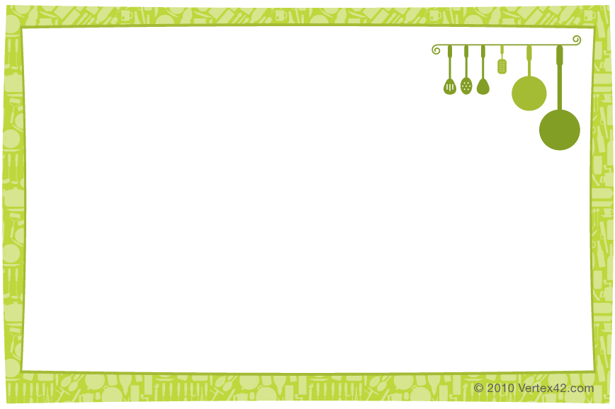

|  |
| --- |
| Chicken Squares A Laura Wilkerson recipe. INGREDIENTS De-bone whole chicken (cooked and chopped)  8 ox cream cheese 2 tablespoons milk  2 tsp butter 2 pkg crescent rolls  2 tsp chopped onion DIRECTIONS  1. Mix together chicken, cream cheese, butter, onion and milk. 2. Open crescent roll package. Taken two triangles and pinch together to make one square. 3. Fill square with chicken mixture. Pull together four corners and pinch closed to make a closed pocket. 4. Bake at 350° for 20 minutes or until crescent rolls are golden brown. (Note: some brands may only take 11-15 minutes of bake time). |