|  |
| --- |
| Flavor Craver Dip A Judy Hunt recipe INGREDIENTS ½ Heinz Chili Sauce 2 teaspoons horseradish  1 pkg (8oz.) cream cheese, softened 4 ½ oz. tiny shrimp, rinsed and drained  ½ cup mayonnaise or salad dressing  ¼ cup chopped onion Potato chips with ridges DIRECTIONS  1. Blend chili sauce gradually into cream cheese. 2. Mix in mayonnaise, onion, and horseradish. 3. Fold in shrimp. 4. Cover and chill at least 1 hour. |
|  |

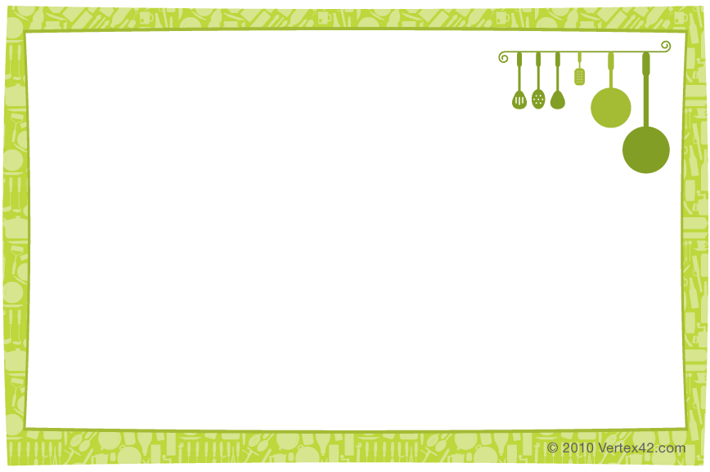

|  |
| --- |
| Flavor Craver Dip A Judy Hunt recipe INGREDIENTS ½ Heinz Chili Sauce 2 teaspoons horseradish  1 pkg (8oz.) cream cheese, softened 4 ½ oz. tiny shrimp, rinsed and drained  ½ cup mayonnaise or salad dressing  ¼ cup chopped onion Potato chips with ridges DIRECTIONS  1. Blend chili sauce gradually into cream cheese. 2. Mix in mayonnaise, onion, and horseradish. 3. Fold in shrimp. 4. Cover and chill at least 1 hour. |