|  |
| --- |
| Italian Grilled Cheese Sandwich Laura Wilkerson. INGREDIENTS 3 eggs 2 tablespoons grated Parmesan cheese  2 tablespoons milk 6-12 slices American cheese  2 teaspoons garlic powder 12 slices bread  2 tablespoons Italian seasoning DIRECTIONS  1. Whisk eggs, milk, garlic power, Italian seasoning and Parmesan cheese. 2. Assemble sandwiches (American cheese in between bread. Dip both sides of each sandwich in egg mixture. 3. Heat a non-stick frying pan over medium heat. 4. Place dipped sandwich in the hot frying pan; cook until golden brown and cheese is melted, about 3 minutes per side. |

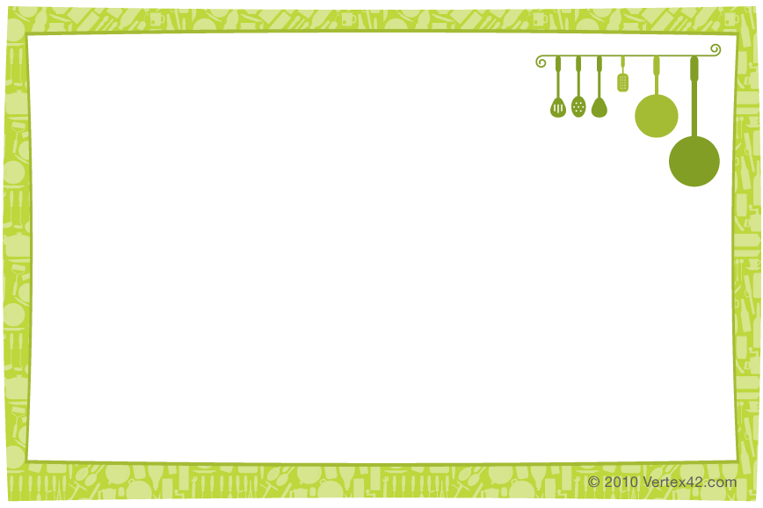

|  |
| --- |
| Italian Grilled Cheese Sandwich Laura Wilkerson. INGREDIENTS 3 eggs 2 tablespoons grated Parmesan cheese  2 tablespoons milk 6-12 slices American cheese  2 teaspoons garlic powder 12 slices bread  2 tablespoons Italian seasoning DIRECTIONS  1. Whisk eggs, milk, garlic power, Italian seasoning and Parmesan cheese. 2. Assemble sandwiches (American cheese in between bread. Dip both sides of each sandwich in egg mixture. 3. Heat a non-stick frying pan over medium heat. 4. Place dipped sandwich in the hot frying pan; cook until golden brown and cheese is melted, about 3 minutes per side. |