|  |
| --- |
| Layer Garden Salad Laura Wilkerson INGREDIENTS SALAD DRESSING  4 cups torn iceberg lettuce (or other) 1/3 cup mayonnaise  1 cup seedless rep grapes, halved 1/3 cup sour cream  1 ½ cup fresh broccoli florets 2 Tablespoons orange marmalade  1 ½ cup fresh cauliflower florets 2 oz. (1/2 cup) crumbled feta cheese  ¼ cup sliced green onions 1 Tablespoon chopped fresh basil DIRECTIONS  1. In 3-quart serving bowl, layer all salad ingredients 2. In small bowl, combine mayonnaise, sour cream, and marmalade, blend well. 3. Spread dressing evenly over salad. Spring with cheese and basil. 4. Cover; refrigerate at least 2 hours or overnight. Just before serving, toss gently to mix.   6 carbs |
|  |

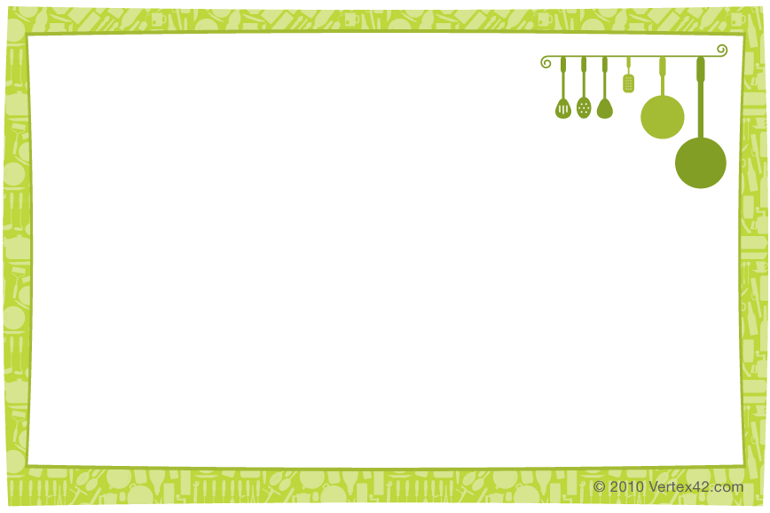

|  |
| --- |
| Layer Garden Salad Laura Wilkerson INGREDIENTS SALAD DRESSING  4 cups torn iceberg lettuce (or other) 1/3 cup mayonnaise  1 cup seedless rep grapes, halved 1/3 cup sour cream  1 ½ cup fresh broccoli florets 2 Tablespoons orange marmalade  1 ½ cup fresh cauliflower florets 2 oz. (1/2 cup) crumbled feta cheese  ¼ cup sliced green onions 1 Tablespoon chopped fresh basil DIRECTIONS  1. In 3-quart serving bowl, layer all salad ingredients 2. In small bowl, combine mayonnaise, sour cream, and marmalade, blend well. 3. Spread dressing evenly over salad. Spring with cheese and basil. 4. Cover; refrigerate at least 2 hours or overnight. Just before serving, toss gently to mix.   6 carbs |