|  |
| --- |
| Fudge A Judy Hunt recipe. INGREDIENTS 2 ¼ cups sugar 6 oz. chocolate chips (semi-sweet)  ¾ cup evaporated milk 5 oz. marshmallow creme  ½ stick margarine DIRECTIONS  1. Bring sugar, milk and butter to a boil. 2. Cook 5 minutes, stirring constantly. 3. Remove from heat. 4. Add chocolate chips and marshmallow. Pour into greased pan and chill. |

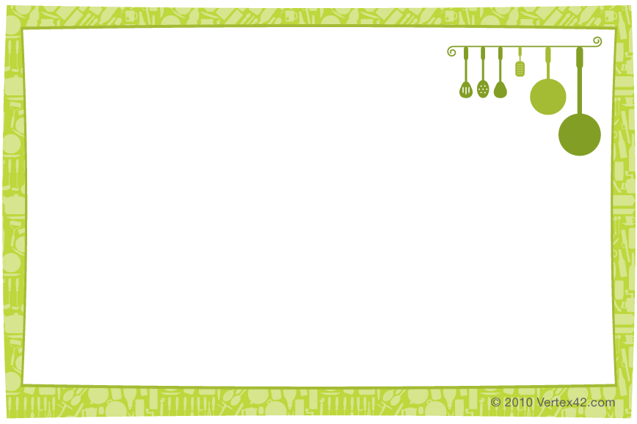

|  |
| --- |
| Fudge A Judy Hunt recipe. INGREDIENTS 2 ¼ cups sugar 6 oz. chocolate chips (semi-sweet)  ¾ cup evaporated milk 5 oz. marshmallow creme  ½ stick margarine DIRECTIONS  1. Bring sugar, milk and butter to a boil. 2. Cook 5 minutes, stirring constantly. 3. Remove from heat. 4. Add chocolate chips and marshmallow. Pour into greased pan and chill. |