|  |
| --- |
| Nashville House Cole Slaw A Nashville House recipe. Now a Laura Wilkerson tradition. INGREDIENTS SALAD HERB INGREDIENTS Cabbage (2 bags angel hair shredded) Basil  Onion Thyme  Mayonnaise Marjoram  Salt and pepper Tarragon  Salad herbs Fennel  Celery  Dill DIRECTIONS  1. Prepare cabbage and onion in food processor or blender. 2. Fold in mayonnaise and herbs. Salt and pepper to taste. Let chill at least an hour.   Note: Nashville House store used to sell herb packages with secret proportions of herbs. |
|  |

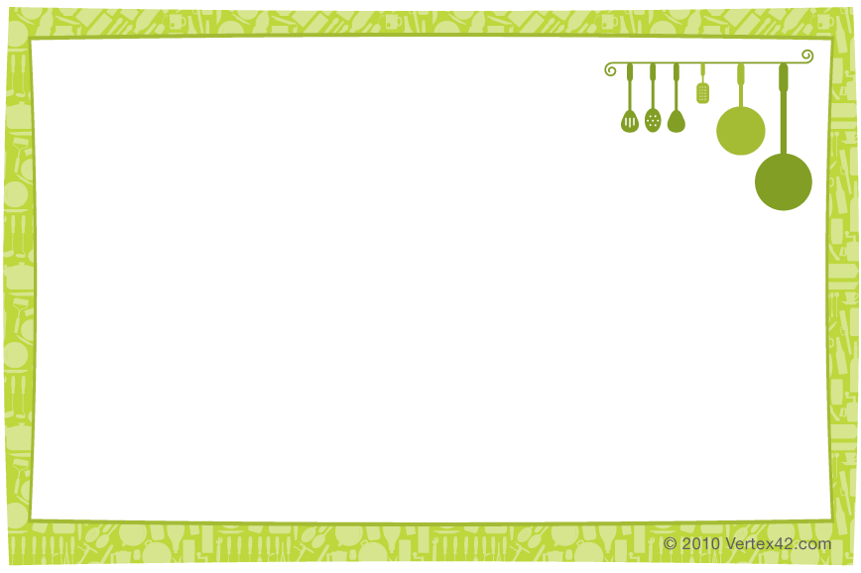

|  |
| --- |
| Nashville House Cole Slaw A Nashville House recipe. Now a Laura Wilkerson tradition. INGREDIENTS SALAD HERB INGREDIENTS Cabbage (2 bags angel hair shredded) Basil  Onion Thyme  Mayonnaise Marjoram  Salt and pepper Tarragon  Salad herbs Fennel  Celery  Dill DIRECTIONS  1. Prepare cabbage and onion in food processor or blender. 2. Fold in mayonnaise and herbs. Salt and pepper to taste. Let chill at least an hour.   Note: Nashville House store used to sell herb packages with secret proportions of herbs. |