|  |
| --- |
| Spaetzle A Laura Wilkerson recipe INGREDIENTS 2 cups flour  1½ tsp salt (plus more for salted water)  2/3 cups milk  Butter DIRECTIONS  1. Combine flour, salt, milk, and eggs. Stir until mixture is blended. 2. Boil water in 4-quart saucepan. Add additional salt to the water. 3. Drop spoonful of batter into boiling water. Or “slice” off batter as Nan did. 4. Boil for 8 minutes. Add butter to taste. |
|  |

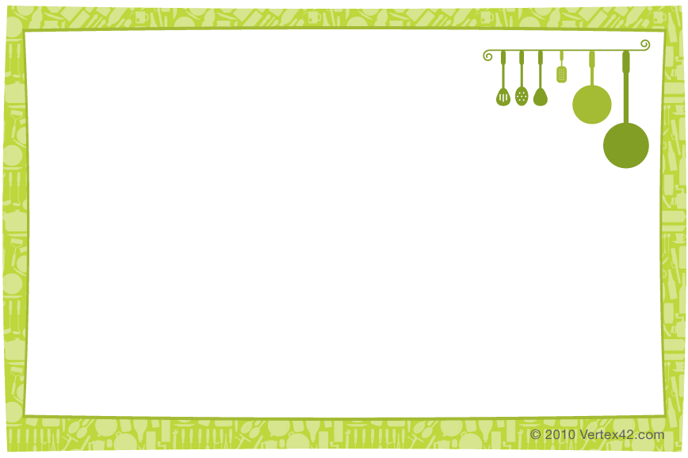

|  |
| --- |
| Spaetzle A Laura Wilkerson recipe INGREDIENTS 2 cups flour  1½ tsp salt (plus more for salted water)  2/3 cups milk  Butter DIRECTIONS  1. Combine flour, salt, milk, and eggs. Stir until mixture is blended. 2. Boil water in 4-quart saucepan. Add additional salt to the water. 3. Drop spoonful of batter into boiling water. Or “slice” off batter as Nan did. 4. Boil for 8 minutes. Add butter to taste. |