|  |
| --- |
| Tarragon Green Peas Easy and very tasty side dish. Laura INGREDIENTS 1 pkg. (1-lb.) frozen sweet peas 3 tablespoons zesty Italian dressing  3 tablespoons butter (optional)  2 green onions, sliced  1/8 teaspoon dried tarragon leaves DIRECTIONS  1. Cook peas to desired doneness as directed on package. Drain. 2. Meanwhile, melt butter in small saucepan over medium heat. 3. Add onions; cook 2 – 3 minutes or until onions are tender, stirring occasionally. 4. Stir in tarragon. Optionally add Italian dressing. |
|  |

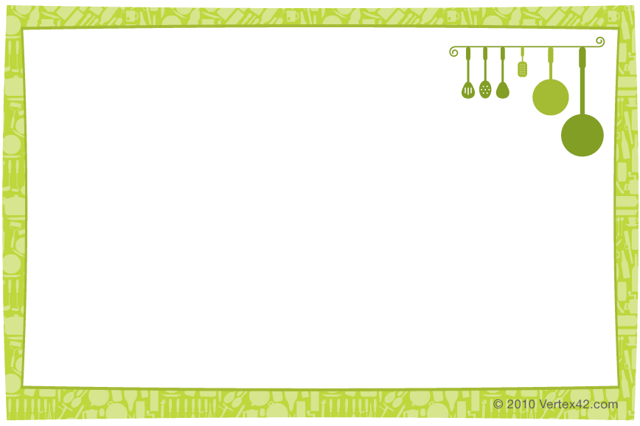

|  |
| --- |
| Tarragon Green Peas Easy and very tasty side dish. Laura INGREDIENTS 1 pkg. (1-lb.) frozen sweet peas 3 tablespoons zesty Italian dressing  3 tablespoons butter (optional)  2 green onions, sliced  1/8 teaspoon dried tarragon leaves DIRECTIONS  1. Cook peas to desired doneness as directed on package. Drain. 2. Meanwhile, melt butter in small saucepan over medium heat. 3. Add onions; cook 2 – 3 minutes or until onions are tender, stirring occasionally. 4. Stir in tarragon. Optionally add Italian dressing. |