2020-2021
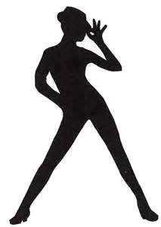
KNK Dance Creations Enrichment & Performance Studio
Mission Statement
KNK Dance Creations is a dance program committed to creative dance and performance. We work hard to introduce and instill self-expression, discipline, and passion in each of our students. We are not your average dance studio, as we are called to assist and mentor each of our students that participate each season. Although DANCE is one of the main focuses of the program, we also want to be the Protege for each of our students and build great leaders to continue a Legacy created by GOD. Whether a student is dancing for fun or planning to enter the wonderful world of dance on a professional level, we are here to provide guidance along the journey
Polices & Procedures

Joining the Team- Students interested in Joining the team must be Highly Motivated to dance. The Age requirement for joining is ages 6-18 OR Grades 1st -12th. No student will be turned away unless not eligible due to age requirements if we are unable to meet the needs of your child and if we are full to compacity.
Polices- Can be updated at any time during the season, parents will be provided with the updated changes.
Commitment: Dancers are required to participate from September through June & Summer July through August (if participating in summer.) This is a commitment of which participants are expected to fulfill. All parents will be required to sign a parent/guardian agreement, medical waiver and provide a copy of Drivers license or Picture ID, and dancers birth certificates.
Birth Certifies-Birth certificates are required to provide the proof of each dancer’s age for classes and competitions. Any students who participated last season will not need to provide a birth certificate because we have it on file, unless otherwise not on file.
KNKDC Movement & Financial Commitment: KNK Dance Creations has minimize the program to fit the needs of all our students, although Participation in our program requires a level of financial commitment. We have organized a KNKDC Movement Action Plan that will be set to reduce the annual tuition fees for the program. To be eligible for the KNKDC Movement Action Program all you must do is SUPPORT! Support the program where we need the help, such as fundraising, selling tickets for our showcases or other KNKDC Events. Even providing goodies and waters for our dancers is greatly appreciated to help with the process of the program. Those who withdraw in participation from the Movement of actions that are set, will be charged the fees that are due.
Communication: We will send reminders through emails and group messages to remind you of payments, schedules and to keep you posted on what is to come for the dancers. There should not be any excuses for lack of knowledge of anything going on in the Studio. (we will invite all parents/guardians to download and join the GroupMe OR BAND APP (see your app store) (Parent meetings TBA) Note: Band OR GroupMe apps are only used for communication in providing upcoming information such as schedules etc. there is to be NO personal conversation in our team apps, if you have any questions, please contact the studio or email us.
Open House- KNK Dance Creations will schedule a few open house gatherings, this will be a day were our teammates and parents/guardians come to meet and greet, ask questions about the program, purchase dance attire, get student measurements, turn in signed medical release forms, agreement forms etc. (Note only students that are registered can attend open house along with /parent/guardians).
Tuition Payment: Monthly Tuition is due September-June & July/August if participating in Summer incentive. (see payment review)
Payment methods: KNKDC ACCEPTS: Cash, Credit, AND Money Order payable to: KNK Dance Creations Enrichment and performance studio There is also a $3.00 services charge or more for Credit Cards payments depending on the total amount. / CASH APP payments send to $knkdancecreations. Visit our website to make online payments OR paypal.me/KNKdanceCreations (NO CHECKS) www.knkdancecreations.com
Drop Box-All cash or money orders must be placed in our studios drop box please make sure payment is placed in an envelope and labeled with dancers name (KNK Dance Creations is not responsible for payments not received or not correctly labeled.

Receipts- will be emailed upon request to the email address provided on the dancer’s registration or if paying with cash or money orders. Receipts will no longer be sent home with your dancer or in hand. if you need an immediate receipt please use a payment method that provides a confirmation receipt.
*Payment Arrangement Policy: KNKDC will do our best to assist with payment arrangements, please speak with our Administrative Staff for Arrangements, keep in mind that it is not required for KNKDC to give arrangements and it will be totally our discretion to provide an arrangement. Dancer (s) cannot attend class until fees are paid or arrangements are approved.
Late Fee: There will be a $15.00 fee for late tuition
Attendance: is mandatory for all dance classes. KNKDC is very accommodating and flexible as it regards to school functions, Senior Students, summer vacations and for personal illness. However, by accepting placement in this program, you agree that your commitment to KNKDC is a priority in your schedule. Missed classes for any other reason must be approved by Krystle Galloway (owner/Chorographer OR KNKDC Administrative Staff). Student absences will be recorded. Excessive absences or tardiness will result in penalties up to dismissal from the program. The attendance and commitment of each dancer has a direct affect on the overall performance and ability to perfect each routine. While KNKDC fully supports students pursuing extra circular activities to becoming a well-rounded individual, dancers must understand when it comes to participation on a performance team, skills are constantly being taught and absenteeism hinders the overall success. KNKDC will not hold any parts for dancers who are absent, this means if we get to far in the routine the dancer will be excused off stage or withdrawn from the performance, unless otherwise.
TEAM Moms/DADS: KNKDC invites interested supporters who would like to serve their dancer’s team for the year! More Information is forthcoming. We will be forming Committees to help assist the program TBA.
Class Description Classes will be grouped by age/ grade or by coach’s discretion, our students will be taught creative choreography using moderate Techniques and genres in Modern and Contemporary Ballet, Jazz & Hip-Hop, we also will introduce a few elective genres to our students with coach’s discretion in ,Fun Tap, Pom-Pom,Creative Pointe, Praise dance, Musical Theater, Majorette, Tumbling & &Acro. (see class Schedule)
Spectator Attendance - Unfortunately KNKDC does not allow the parents, friends, or family member to attend rehearsals due to limited space, and major detractions for the instructor and students. KNKDC will post classes on the parent band from time to time so that you can see the progress of your dancer.
Note: *Parents/Guardians due to covid-19 we will still take precautions to keep our dancers safe. To keep the amount of traffic going in and out of the studio we ask that parents/guest to remain in the lobby until dismissal for questions please call (757) 224-3332 or email us knkdancecreations@yahoo.com unless otherwise.

Parking/Door- Designated parking is on both sides of the building and the parking garage. The doors will lock at certain times for safety reasons if using the back door and it is locked please walk around to the main entrance. We apologize for any inconvenience. Call the studio if doors are locked (757-224-3332)
Base Dance Classes will prepare our dancers for Performance! All Dancers will be eligible to participate in Showcase, selected Performances, our Move 2 the beat of Dance competition, feature in Local Parades that we participate in and Selected team building functions. (with coaches’ discretion)
“Legacy” is an Advanced Dance Squad formed from selected dancers in each base dance group through Tryouts. Dancers Ages 10-18 will be eligible to compete in competitions and a variety of performances based on the selected style of dance. Please note: We would love for all our students to have the opportunity to participate in Legacy performances and Competitions but will not allow any dancer to participate if they are not ready to compete or perform. (Dancers must Try out for each routine and meet the required age level)
“Legacy Competition and Tryout- Note: if dancers do not make ANY tryouts for the season, a $50.00 fee will be credited to dancers account. (no refunds under any circumstances unless dancer did not make any tryouts or performances for the season.)
Legacy Summer incentive program-is held in the month of July-august more information forthcoming.
Solo’s Duets & Trios- Selected Dancers Only (TBA)
Young Adult/Parent Dance Squad- Parents come hit the stage with KNK Dance Creations More information TBA.
Youth Coaches-Every studio can use Help! And it is not always in the hands of an Adult! K.N.K Dance Creations gives our students the opportunity to takes on some responsibilities of a Coach and administrative staff! Students who express great leadership skills will be highly recommended to participate in assisting each season that they are enrolled in our program and will be given great incentives for a job well done!

Student Responsibly: All Dancers should be responsible!!! Leaving their dance shoes and misplacing items is not tolerated. No cell phones during class time’s students need to charge their phones at home and if parents need to contact them please call the studio.

Student Check- all students will be checked in, we believe in enforcing responsibly, as students arrive to class they will sign in (younger dancers will be assisted ) coaches/staff will check dancers bags (bags must be kept nice and neat, we don’t want to see trash dirty clothing etc. in their dance bags) dance attire must be worn at all times and dance shoes are to stay in dancers cubbies at the studio. If dancers come to class with inappropriate attire they will sit out of class or be sent home unless otherwise.
Student Withdraw- If you must withdraw your dancer for any reason please let us know in advance and pay any fees owed to the program to keep from penalty.
NOTE: If your child is removed from the program permanently or temporarily due to injury that has happened in our program/Studio or Other, a Doctor’s note must be provided to KNK Dance Creations.
Competitions & Showcase - Our Dancer’s will be preparing for dance competitions, Exhibitions, (Parades if we attend) and our annual Dance Showcase Extravaganzas. Please keep in mind that events can and may be CANCELLED at any time. We may travel out of state for competitions but most if not ALL our competitions are local. If we travel parents will be responsible for the transportation and travel expenses. Keep in mind that some dancers may not attend every competition or every competition performance this is depending on their dance eligibility (Must be a part of Legacy to compete).
NOTE: DANCERS MUST ATTEND PRACTICE PRIOR TO COMPETITION OR SHOWCASE! Failure to do so will result in their inability to compete in competition or perform in showcase. Also we may not know the times or entry numbers until 1-2 weeks before competition so please be patient and understand that parents have the right to go on the competition websites and get the available schedule but will not have access to teacher’s information because of confidentiality to studio rights. (Please be aware that the competition companies will report to the studio)
Extra Rehearsals -KNKDC will have extra back to back dance rehearsals on non-scheduled days such as Mondays, Wednesdays Friday’s, Saturday’s, and possibly even Sundays (but not likely on Fridays or Sundays! We also will have extended dance times, especially when we are getting close to competition, & showcase. We do apologize in advance for any inconvenience this may cause, and we ask for total cooperation in this matter.

Late Pickup: for students who are picked up after studio hours please give the studio a call if you are running late. Fees @ $1.00 per min will be added if being late becomes a habit. After 15 min and no call back, we will contact emergency contact.

NO Pick-Up OR Take-Home Zone: KNK Dance Creations Staff & Krystle Galloway Owner will no longer be responsible for drop offs and pick-ups, please designate someone if you need those services for your dancer to get to and from class. Unless its and extreme emergency KNKDC is not responsible.

Contact Information: If parents/guardians have any questions or concerns, please direct your concerns to our administrative staff during business hours only or email us at knkdancecreations@yahoo.com Parents are not allowed to pull the owner to the side for personal conversations or questions about the program or about payment arrangements etc. (especially during class hours) If in the event a meeting can be set up and concerns can be addressed at the appropriate time. “Please no personal phone calls to the owner or staff if not authorized” Unless otherwise we will provide contact instructions.
Competition Fee: Each Legacy dancer will be charged a competition fee of $150.00 (KNK Dance Creations Movement Action plan will not cover any competitions fees. If competition fees are not paid dancers will not attend any competitions and will be removed from the Legacy Squad. (see page 13)
Costume/Accessories: Parents will be responsible for any loss, stolen or damaged costumes at the cost of $2.00 OR M ORE per item depending on the item.
Added Addition: Parents will be asked to provide small added touches for dancer’s costume attire, such as providing leggings, tops, shoes etc. and sewing or adding decor to the costumes if needed.
Measurements: will be taken in the beginning of the dance season and during open house unless otherwise.
Team Jackets- All dancers will have access to a studio jacket when needed NOTE: If pervious dancers have jackets and they are damaged or worn out its required for students to use our Studio Jackets. Studio jackets are not personalized and belong to the studio. (If students damage or loose our studio jackets there will be a $50 replacement fee.
Team Dance Bag- All Dancers are required to purchase a Team Duffle bag that will be personalized with dancer’s name.

Make Up & Caboodles- All students are required to wear make-up and create a make-up kit or caboodle (please include the following items: *Foundation, Red & Hot pink Lip stick etc., * Mascara, *Blush, Black eye liner or liquid eye liner. *All colors of eye shadow, eyelashes (eyelashes are optional for my younger dancer’s), make-up remover wipes, and anything else such as glitter, face rhinestones or other makeup of your choice, also reminder please purchase make up brushes. (See help you pack dancers’ caboodles. “)
Photo shoot- Date TBA dancers must wear appropriate bra (if needed), (underwear, black or nude), suntan dance tights, make-up and hair should be neat. there is to be no picture taking during photo shoot and No extra guest, after the photo shoot please make sure you have packed all items. Parents can purchase pictures, More information TBA
Videoing/Recital DVD- DVD’s Can be purchased for showcases and other events. More information TBA
Showcase Information- Showcases are normally in the month of December March & June. Date and location TBA NOTE: Every dancer is required to participate!

Showcase/Events Tickets- All tickets Price TBA NOTE: Every dancer is required to sell 10 or more tickets per dancer per ratio of students (more information forthcoming)

Team Souvenir Booklet - this is a great token of remembrance for our dancer’s family and friends. More information forthcoming. NOTE: Every dancer is required to participate!
T-shirts Information- purchase our showcase OR Team T-shirt! More Information TBA

Miss KNK- is an Award presented to dancers in each class and an overall dancer for the season KNK dance creations looks for the dancer who is completely passionate loves to entertain, is respectful, a good role model and has a supportive family that supports the program. All dancers awarded Miss KNK must dance for the next full following season or they would have to return the award as stated in the contract. Miss KNK will be rewarded at our Team Banquet or End of the Season Showcase More Information Forthcoming.

Team Trip- KNKDC Enjoys Hosting a Day of Fun with Our Dancers Family and Friends, Trips must be paid by the expected due date. We will do our best to provide Fundraisers to help cut the cost out of pocket. Dancers are not required to participate in the trip, but we really encourage all our dancers to be a part. More information on our upcoming Team Trip TBA. Note: Team Trip will be held in April May June or July (TBA)

Showcase/Performances/ Competition Policies_
- The last week of Rehearsal is mandatory. Dates and times are forthcoming.
- All Dancers must wear their Team-Out Wear, for competition /boots or sneakers, dance tights and appropriate bra. Bras must be black or nude (strapless or clear straps if needed. Panties are only permissible during monthly cycles at which time dancers should wear plain nude seamless underwear or trunk bottom briefs in nude. (TBA)
- All hair should be neat! No hair adornments, hair balls, or beads. Hair styles are at the discretion of the parents. We only ask that hair is pulled away from the face. There may be times when specific directives for hair styles are implemented by the dance instructor.
- Competition Dancers will have different hair styles pending routine and costume which may include hair pieces or wigs.
- All dancers should have their Dance Bag and make-up caboodle.
- All Dance Shoes should be labeled with dancer’s name
- Pack all your required dance shoes
- Shave under arms (if needed)
- Use clear deodorant
- False LONG nails are not permitted during competition or performances. Polishes on fingers and toes should be of natural tones or French.
- Only stud earrings are allowed. No other jewelry is allowed during practice, performance, or competition.
- Students should arrive to showcases and competitions wearing make-up unless otherwise instructed.
- Students who must wear glasses should make sure they are tight and secure with a sport strap.
- All valuable items to include electronics, cell phones, laptops or purses are not to be backstage during showcases or competition.
- Parents are asked to pack dancer's child’s showcase and competition bag according to the student's needs.
- Team moms/Dads will work together to supply a light snack for competitions & showcase.
- Students should have a light well balanced meal before all performances.
- Guests are not allowed in the dressing area. Students are to be dropped off and picked up at the designated area.
- KNKDC requires female assistance for dancer’s backstage for the Showcase and competitions

Class Dance Attire
All Dancers are required to wear our appropriate class attire (Black unitard Black or purple sports bra if top heavy please wear black bra with the sports or camisole bra) tan tights and Black personalized Dance Bag with all required dance shoes. For safety reasons, no jewelry will be allowed (stud earrings only) (if there is any jewelry that cannot be removed please wear a covering or bandage. Hair should always be neatly pulled from the face. Students are not to wear hair rags, bandannas etc. must practice good hygiene (no hair under arms coming to class) no socks during class, etc. (No TAKY ZONE)!! If students come to class inappropriate, they may be asked to sit out or be sent home for the night or day.
NOTE: SUMMER classes ANY black or purple KNK dance attire, jazz shoes and sneakers required.
* All Legacy students must purchase a K girl Face Mask during season
* ALL Dancers must have black non-lace jazz Shoes & A basic Black Tap 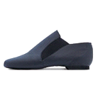jazz-shoe 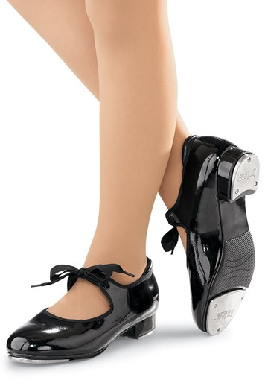 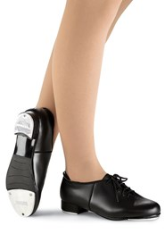 Tap shoe

*All Students must have black and white high-top sneaker (Airwalk)
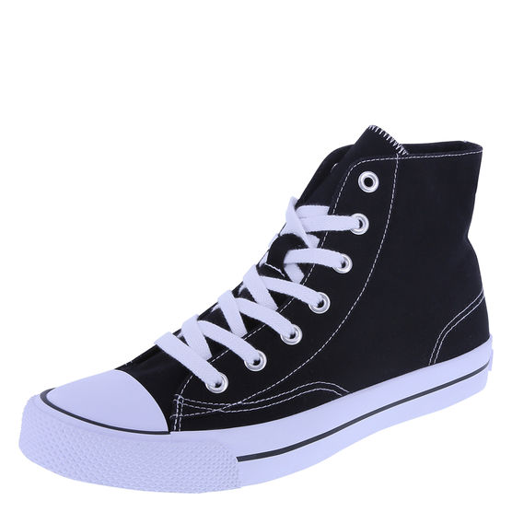

*All Students must have an all-black combat boot
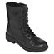

Most items can be purchased at the studio visit our website to shop dance attire
www.knkdancecreations.com

Class Schedule
September-June 2020-2021
Class | Days | Grade/Age | Times
Legacy | Mondays | Selected Dancers Will be notified | 6:30PM-8:30PM
Royalty Dolls MINI/YOUTH SQUAD | Thursdays | Elementary grade Level | 6:00PM-7:15PM
B-Dazzled JUNIOR SQUAD | Thursday’s | Middle School Grade Level | 6:00PM-7:15PM
Purple Diamonds SENIOR SQUAD | Thursday’s | High School Grade Level | 7:15PM-8:30PM
Selected Dancers or Entire Team | Saturdays  Dates TBA | TBA | 9:00AM-1:00PM or sometimes 3PM

Payment Review & Schedule

Registration - $25.00 per Dancer
TUITION FEE 2020-2021
Tuition is $75 per month (per dancer)
Legacy one-time Competition Fee $150.00 (split in 2 payments)

Payment Schedule
September 7th-11th Tuition Due
October 5th-9th Tuition Due
November 9th-13th Tuition Due
December 7th -11th Tuition Due
YEAR 2021
January 4th–8th Tuition Due
February 1^{s} -5th Tuition Due & Competition Fee Due $75.00
March 1st -5th Tuition Due & Competition Fee Due $75.00
April 1st-2nd Tuition Due
May 3rd-7th Tuition Due
June -1st-4th Tuition Due

Before attending Class

PLEASE EMIAL US THE FOLLOWING:
* copy of Driver’s License or ID (parent/guardian)
* Copy of Dancers Birth certificate

PARENTS PLEASE PRINT, FILL OUT AND BRING THE FOLLWING:
* Medical Wavier form
*Sign Agreement
ALL FORMS ARE ON OUR WEBSITE

DANCERS CAN EXPECT TO:
*Get Sized for Dance shoes (if needed)
* Get measured for costumes

OTHER INFORMATION:
*Purchase Dance Attire (IF NEEDED can purchase on our website)
*Make tuition payments (if needed)
* WE WILL ANSWER ANY QUESTIONS OR CONCERNS

NOTE: Due to COVID-19, For the safety of ours Studio Staff, Dancers & Parent/ Guardians, Mask will be required when entering the Studio. And we would like to keep our guest visits to 15 minutes or less

www.knkdancecreations.com

What to pack in your Dancers caboodles?

Parents dancers will not need all these items please use your discretion😊

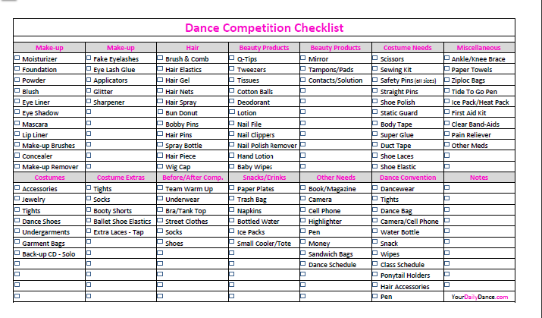

Parent / Guardian Roles
KNK Dance Creations endorses a harmonious environment. Parents are expected to be supportive, respectful, and courteous to all team members and their families always. KNKDC will not tolerate rudeness, jealousy, resentment, and disrespect to another team member, their family, or directed at the KNKDC staff. This applies at all dancers regardless of age or talent. You are not permitted to bring into this facility anything that will cause dissension and create negativity with the children and families. The role of the parent is to lift and support each child and encourage your child to persevere despite the challenge. Teach your child to be happy for others, give a hand to those who may be behind or struggling, stand firmly behind the teaching staff, work with the teaching staff, showing your child that you support their dance teacher. The most successful children are those whose parents support their teachers and coaches 100%. These are the ones who do not bad-mouth or question a teacher or coach in front of their children, and they are certainly the ones who are realistic about their children and their place on a team. We all want our children to succeed, but success is not measured by the trophy a child brought home, or by the row in which they stand on stage, or by how many pirouettes they can do. Instead, it is measured by the effort that they put forth. All we ask is that they give their all. If you every have questions or concerns, please see Administrative Staff.
Note from Coach K: Teaching is my utmost passion! Thank you for trusting me and my staff by giving us the opportunity to work with your children. We take our job very seriously and your child and their success in this program is priority. Making decisions regarding placement in the KNKDC Competition dances and in the many routines that we produce is a long, difficult, and well thought out process. No child is ever “held back,” but instead, encouraged to develop their skills to their fullest.
Krystle Galloway
Owner, Choreographer
in have to

