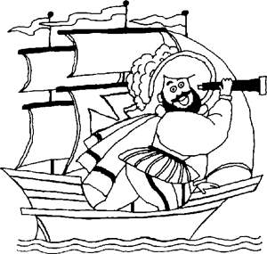 The Council of Italian American Societies of

Greater Bridgeport, Inc.

P.O. Box 5087

Bridgeport, Connecticut 06610-0087

(203) 362-9413

**2024 Vincent Vizzo Columbus Day Concerts Program Book**

**To Support the 116th Greater Bridgeport Columbus**

**Day Parade & Italian Hertiage Celebration**

Dear Community Member and Supporter:

**"Land ho! Land ho!,** was the cry as Christopher Columbus set sight on what was to be the New World, and the rest as they say is history.

In recognition of Columbus' exploration and navigational achievements, the Council will hold its 116th Greater Bridgeport Columbus Day Parade on Sunday, October 13, 2024. The parade will feature the 2nd Marine Aircraft Wing Band hailing from Cherry Point, North Carolina. In addition, senior drum and bugle corps, area high school bands, various ethnic groups, scouts along with the popular Pyramid Shriners, local dignitaries, police and fire departments, clowns and a variety of floats. In addition to the Parade, the visiting Marine Band will perform at two free Vincent Vizzo Columbus Day Concerts.

**But of course, no celebration is complete without the community's participation. In anticipation of your support, we’re asking you and your business to help** by purchasing an ad in our 5.5" x 8.5" Columbus Program Book which will be distributed at the Vincent Vizzo Columbus Day Concerts on October 11 and 12, 2024 at Bridgeport's Klein Memorial. Through your financial support, you'll make possible the 116th Greater Bridgeport Columbus Day Parade and Italian Heritage Celebration. For your convenience, please find attached or enclosed an advertisement order form.

Thank you for your consideration and support and Happy Columbus Day!

**Christopher Caruso Elaine K. Ficarra**

Program Book Chairperson 2024 Grand Marshal