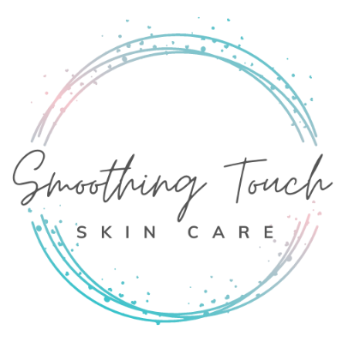
Name ________________________________________________ Phone ______________ Date_________________
Address ______________________________________________ City_________________ State _____ Zip ________
Emergency Contact _________________________________________________ Phone ________________________
e-mail____________________________________________________________ Birthday Month/Day ______ /______
Would you like to receive emails from Smoothing Touch Skin Care about promotions and specials? Y N

1. What are your main skin care concerns?

2. If you could wave a magic wand, how would your skin look in one month?

3. Any special requests for today’s visit? (extractions, skin soothing, skin clearing, hydration, relaxation, waxing)

4. Medical, Health, Bodily Conditions: Is there anything I need to know before we get started? The more I know, the better your results. (Please list any: allergies, sensitivities, pregnant, nursing, health issues, diabetic, medications, metal plates, cold sores, Retin A use or any topical product that might cause skin sensitivity).

5. What did you LOVE about your last facial, and what could you have lived without?

6. Knowing that home care is a big part of achieving beautiful skin, would you like to chat about how to maintain today’s results at the end of your facial?
___ Yes, give me the scoop on how to look and feel beautiful
___ No, just here to relax

7. Is there anything else you want to share? I love learning about my clients as it helps me provide superior customer service.

Please read carefully and initial the following:

___ I understand that Smoothing Touch Skin Care LLC services including facial and body treatments given at Smoothing Touch Skin Care, are for the sole purpose of skin cleansing, body and mind relaxation and rejuvenation.

___ I understand that it is imperative to tell my aesthetician about any oral or topical medication prior to every facial, waxing or other body treatment services.

___ I understand that Smoothing Touch Skin Care and staff do no diagnose illness, disease or any other physical or mental disorder. I accept full responsibility of the use of Smoothing Touch Skin Care at my own risk, and do not hold Smoothing Touch Skin Care or staff liable for loss, damage, or injury.

___ I understand that results are personable and not guaranteed.

___ I confirm that to the best of my knowledge that the answers given on client consultation form are correct and that I have not withheld any information that may be relevant to my treatment at Smoothing Touch Skin Care.

___ I understand that I must provide at least 24 hours of advance notice for the cancellation of an appointment.

___ I understand that Smoothing Touch Skin Care has a strict 24-hour cancellation policy. In the event of a late cancellation/no show the fee is $25. An invoice will be sent via Square. If we can replace the appointment with a client on the wait list, we are happy to waive the fee.

___ I understand that there are risks associated with skincare treatments. Such as: redness, sensitivity, peeling, inflammation, etc. Any additional concerns I will discuss with my practitioner.

*Please note any additional information that may be of importance to your licensed aesthetician regarding the spa treatment you will be receiving:

Client Signature _________________________________________________________ Date _________________
Service Provider’s Signature _______________________________________________ Date _________________

