Collaboration models within Fintech

Collaboration is a critical aspect of the evolving fintech field, and in this chapter we will examine how this collaboration is unfolding. While there are several possible types of collaboration occurring within the fintech space, we will be looking at four particularly important examples.

1. Banks – Fintech

This is one of the most obvious areas of collaboration in the fintech industry, with the existing financial architecture keen to get on board with this hugely profitable niche. An ever increasing number of traditional banks are now collaborating with fintech firms, and we can expect to see this expand further still in the years to come.

Indeed, the report 'Top-10 Technology Trends in Retail Banking: 2018' from the financial services analyst Capgemini indicated that 91% of bank executives would like to work with fintech companies in some capacity. The high regard that traditional financial institutions have for fintechs is reflected in the fact that the same report suggested that 86% of bank executives believe that a lack collaboration with fintechs will hurt their overall business.

So its not just those with a vested interest in fintech that recognize its importance. But before going any further, we should note that while collaboration is valuable, the type and nature of this collaboration ultimately defines its effectiveness. Collaboration in fintech must be designed to meet the specific needs of all stakeholders, tessellating with existing business models and the goals of each participant.

With this in mind, collaboration in fintech is built on models that include bank acquisition, investments, and partnerships with fintech companies. Engagement in this arena can assume the form of incubators / accelerators, hackathons, or use of APIs to open systems to third parties.

It should also be noted that collaboraton with fintechs offers data sharing advantages to traditional banking institutions. New regulations, such as Europe’s Revised Payment Service Directive (PSD2) and Open Banking Standards in the UK, are encouraging partnerships between banks and fintechs. Considering that nearly half of bank executives also believe that working with fintech can help reduce their operating costs, and it's clear that there are a raft of incentives for these partnerships.

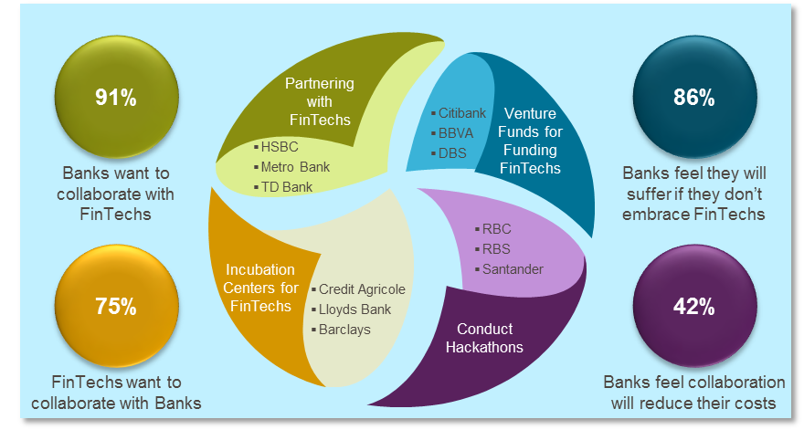

Source: Capgemini Financial Services Analysis, 2018, Capgemini Top-10 Technology Trends in Retail Banking: 2018

Another challenge for banks going forward which has implications for the fintech field is platformification. This rather unwieldy word simply refers to an entirely new business model for banks, in which both providers and consumers connect with platforms, interact, create and exchange value. It can be seen as a much more reciprocal relationship than has been the case traditionally.

While platformification is an exciting prospect for both banks and customers, it also poses significant challenges. Curating an ecosystem that can deliver innovations as quickly as possible certainly poses logistical issues. But the benefits for both banks and fintechs are quite clear.

Working closely with fintechs means that banks can deliver new and attractive innovations more rapidly. Fintechs offers banks creative solutions, which when blended with the core functionality that banks have cemented over the years, can really help produce killer apps and solutions.

This was reflected in a recent white paper produced by the research and advisory firm Celent. The document outlined the extent to which matchmaking between fintech and banks is accelerating. Researchers discovered that 36% of banks are already utilizing fintechs, with a slightly larger number stating that access to the fintech sphere is a critical plank of platformification.

And nearly two-thirds of those who responded concluded that building and testing technologies in an agile way is, and will be, a central priority with platformification, and more than 6 in 10 stated that they will require new technologies to be integrated into their existing technology stack.

This suggests that fintech will play a major role in delivering platformification, as it is precisely in these fields where this emerging technology excels. Banks struggle to innovate via their own initiative alone, with over one-third of respondents stating that internal constraints were restricting the speed of innovation, or that there were challenges with upgrading or tweaking internal technology. From these figures, it can be inferred that most banks will wish to embrace fintech sooner rather than later.

Banking Accelerator Programs for Fintech

Considering the imminent and contemporary importance of fintech for a wide variety of financial sector companies, many have already invested in the fintech sphere. Below you can see a summary table of the major banking fintech accelerator programs, intended to ensure that big banks are ready to go with fintech.

Banks’ Acquisitions of Fintechs

Equally, banks are already purchasing fintech startups, with the intention of breaking into this critical field. While this process of acquisition began slowly, it is already accelerating noticeably. Research by CB Insights demonstrates that banks are already strongly investing in fintech. CB found that while 18 fintech startups have been purchased by 10 top US banks, 8 of these acquisitions took place in 2017; more than in any previous year.

However, further investigation suggests that this impression is not entirely correct. You can see in the table below a full record of the acquisition of fintechs by banks:

And it should be noted that as of September 2018, global banks had acquired 28 fintech startups. Clearly the big players in the financial sector are already significantly invested in fintech, and we can expect this process to expand in the years to come.

Banks Partnering with Fintechs for Go-To-Market or to Launch new Products

Another area of collaboration between traditional banks and fintechs is in straight partnerships. Banks enter into such arrangements with fintech companies with the intention of pushing ambitious new products into the marketplace, or for crafting go-to-market strategies (these are action plans that outline and formalize the way that companies will attract customers and seek market edge over competitors).

While fintech is big news anyway, this particular aspect of this burgeoning industry has garnered a good deal of media coverage. This means that partnerships between banks and fintechs are somewhat more overground than some other aspects of their collaboration. Thus, it has already been established that top European banks have on average between 50-150 fintech partners, with the most prominent actors in this space having already acquired over 300 fintech company partners.

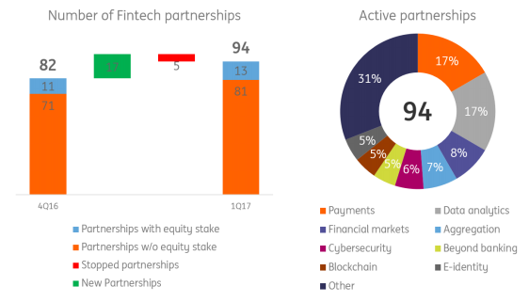

The figures above from the esteemed financial services company ING indicate the main areas of cooperation between fintechs and banks being:

- Payment
- Data analytics and aggregation
- Trading
- Cybersecurity
- E-identity (KYC/AML)

There is such a vast array of partnerships between financial institutions and fintechs that it becomes impossible to account for all of them, or indeed even the majority of them. But we can look at the particular areas in which these collaborations are taking place, and examine a snapshot of illustrative examples.

Simon-Kucher provides a North American perspective of bank-fintech partnerships in the image below:

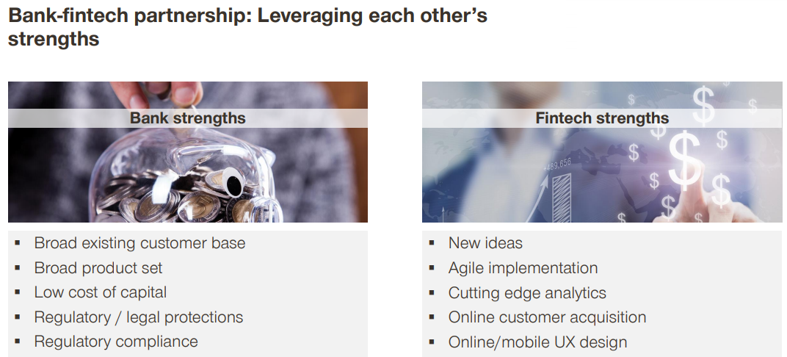

This could be summarized by saying that fintechs benefits from partnerships with banks by drawing on their established processes, procedures, and foothold in the financial markets. While banks gain from their relationships with fintechs by gaining access to a knowledge base that would otherwise be outside of their capabilities, along with innovative new technologies, insightful analysis, and what could be summarized as a breath of fresh air that will help enliven their existing business model.

And Simon-Kucher also outlines why such massive financial sector organizations as Chase Bank have been enticed into partnering with fintechs over the last couple of years.

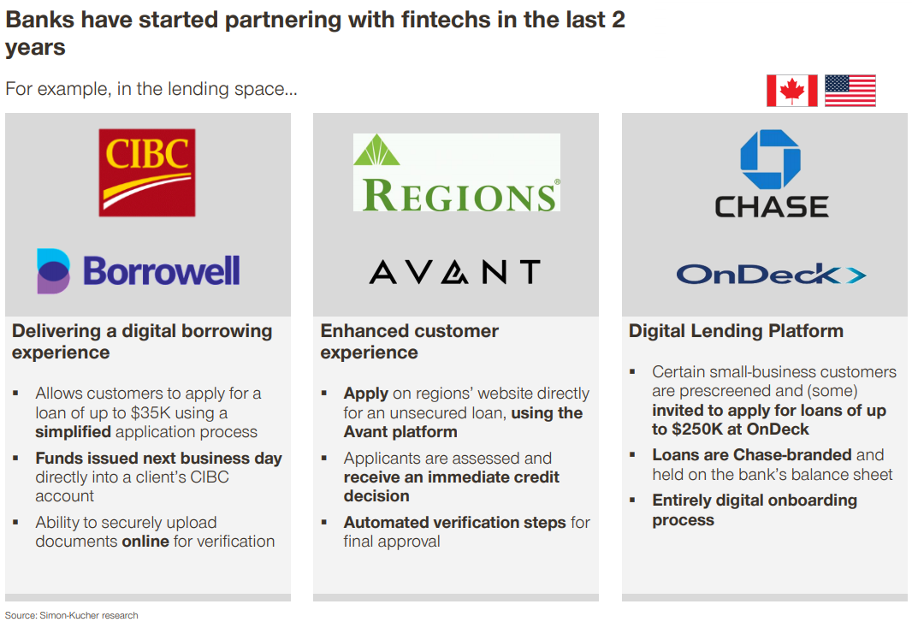

While the image below indicates the areas in which fintech has been particularly impactful.

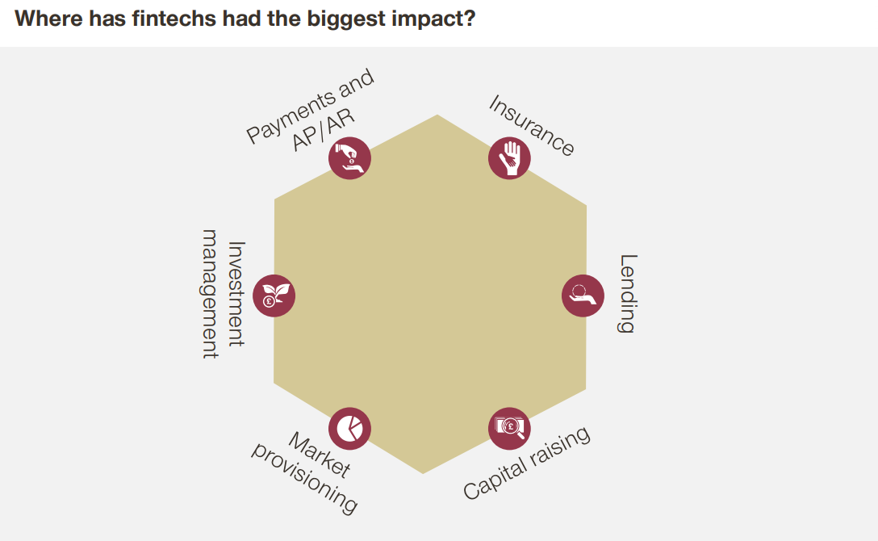

While fintech may seem to be naturally suited to payment and AP systems, there are several other areas in which the emerging tech is having significant influence. It is interesting to note that fintech is also making an impact in terms of lending and capital raising, meaning that the tech is being adopted in areas that would have been seen as the reserve of the traditional banking elite.

Looking at specific case studies of bank-fintech collaborations, Simon-Kucher notes the partnership between the Citizens bank and Fundation. The consultancy firm notes that there is a clear division of labor between the two organizations in this burgeoning partnership.

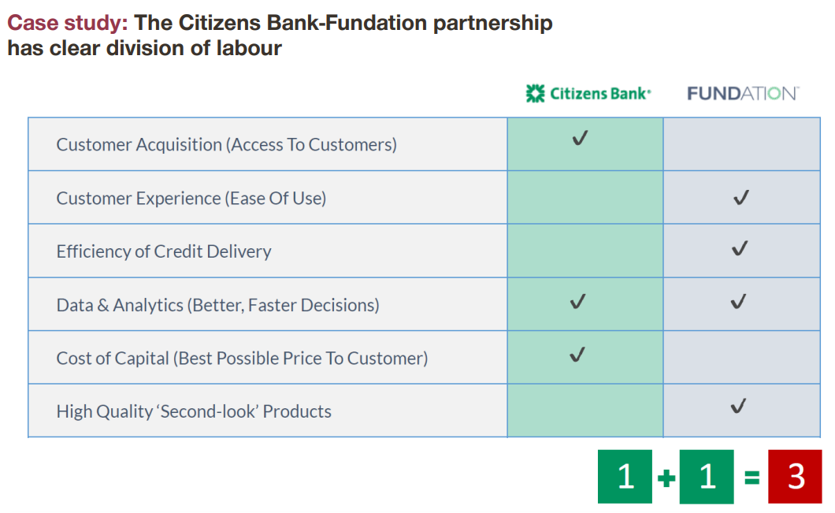
The Citizens-Fundation setup is based around the sort of user-friendly and intuitive digital application that defines the fintech experience. Customers have the option of linking their online banking information to the application, providing convenience and instant access for clients. Information can also be fed back to customers, as it is collected by the Fundation platform, from a variety of third-party sources.

Fundation's platform is also able to perform credit checks and enact other related policies. However, what has been achieved thus far is only a stepping stone to what Simon-Kucher envisages will be possible in the future. The early stages of fintech and banking collaboration will delvier a relatively crude online platform, but this will soon evolve into an omni-channel optimized experience, delivering what the customer needs, when they need it, and at virtually any customer touch point. It is this sort of vision which helps explain why banks are investing in the fintech revolution.

Another further interesting example of collaboration in the fintech space involves Idnow and Commerzbank. This still relatively young partnership was launched as the latter intended to produce an immersive and powerful mobile app for its banking services, yet lacked the expertise and experience required to deliver it.

Commerzbank came to the fintech with a problem related to EU regulations. European Union laws currently require bank customers to verify their identities to banks in person. This effectively makes signing up outside branches to be impossible, at least for the majority of banks.

Addressing this, IDnow produced a solution for Commerzbank which enabled the institution to verify customer identity via video. This system could then be used with computers and mobile devices in order to confirm identity, without requiring customers to come into branches. Clearly this offers massive convenience for customers, and this was reflected in a 50% upward surge in conversion for Commerzbank customers.

A third interesting case study involves the partnership between Eurobits and Bankia. The latter is not a big name all over the world, but is nonetheless one of Spain's major banks, formed by the consolidation of seven banks based in the Iberian nation back in 2010. Responsible for managing the accounts of 33,000 SMEs, Bankia had faced huge difficulties with invoicing and billing costs, often resulting in payments to suppliers being delayed.

In an attempt to address this issue, Eurobits provided an invoicing platform which enables the creation of supplier portals to operate with the bank, and which also have the capability of integrating with other ERPs. And this innovative solution delivered real results for Bankia.

Having implemented this new approach, Bankia was able to go virtually paperless, and move all invoicing to its new electronic system. As a result of this, nearly all invoicing takes place in the electronic realm, which has made massive savings for the company.

Bankia notes that the new system has resulted in a savin of €2.50 per invoice sent, which equates to millions of euros when projected across thousands of accounts. Furthermore, Bankia has been able to reduce the payment period associated with invoices to ten days, ensuring that the payment process is smoother for everyone involved.

The takeaway from this partnership is simply that fintech can save both time and money when implemented successfully, and which organization would be opposed to that?

There are numerous other prominent bank and fintech partnerships emerging. For example, HSBC believes its collaboration with Tradeshift will represent a massive financial opportunity, due to the $46 trillion tied up in accounts receivable worldwide.

And the Dutch Development Bank FMO and African fintech Above & Beyond program offers innovation, while aiming to foster financial inclusion in some of Africa's poorest nations. In July, 2017, a joint report from the Center for Financial Inclusion at Accion and the Institute of International Finance examined how financial institutions and fintechs are partnering for inclusion. The report concluded that “if financial institutions can continue to learn from fintechs, and if the relationships can continue to be mutually beneficial, we see a bright future for partnerships enabling financial inclusion”.

API Portals

A final particularly viable aspect of the collaboration between fintechs and banks will be the utilization of API portals. Several banks are already involved with developing these, with the hope of better understanding their clients and the customer journey, while also providing an enhanced user interface for bank customers.

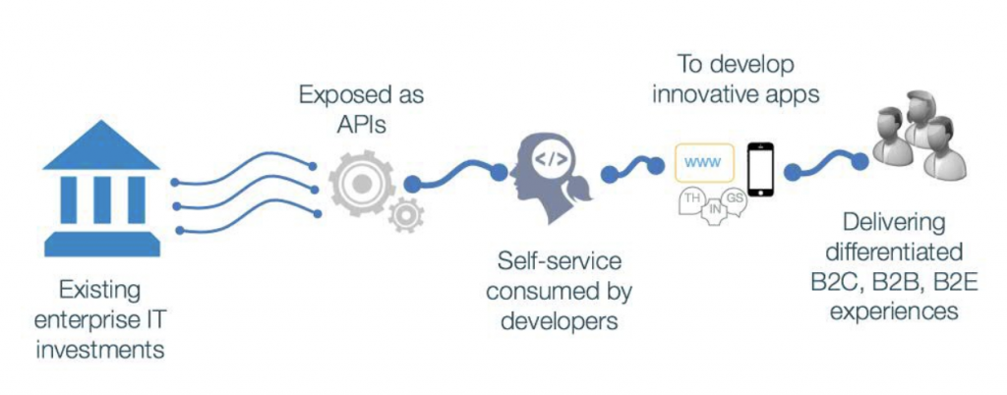

API portals will support the interconnection of third-party applications with bank systems, and thus providing new and improved experiences for customers. The ability to deliver distinct B2B, B2C and B2E experiences will be valuable for banks and its clients alike. This new fintech approach will ultimately deliver user experiences that are driven by autonomy, mutal gains and self-service, helping to transform the entire banking industry, particularly at the retail and customer level.

This new ecosystem of applications with multiple capabilities, and its implications for the banking sphere, led Goldman Sachs CEO Lloyd Blankfein to describe the bank as a “technology company”. This is indicative of the general direction of banking in the wake of the fintech revolution.

2. Fintechs-Fintechs

The second area of collaboration in the fintech space will involve fintechs partnering up with other fintech firms. On reflection, this seems like an entirely natural development, as the specialized nature of the technology field means that different companies have vastly different areas of expertise. Yet the obvious common ground and ethos shared by fintechs makes them obvious candidates for collaboration.

While it should also be noted that fintechs will also compete with one another for a slice of the banking pie, there is also huge potential for businesses in this space to collaborate in order to enhance one another's effectiveness and competitiveness. By engaging in well-founded collaboration, sharing skillsets and knowledge, fintechs will be better placed to go-to-market, produce superior products, tap into wider marketplaces, develop API partnerships, and generally enhance their overall operation and commercial viability.

This could be vital in the development of the fintech space in the short-term. But, conversely, it is difficult to believe that this will be a significant trend in the longer term. As mentioned previously, all fintech companies are effectively competitors, and while they could work together in some capacity, they will always have overlapping goals, which will make deep-rooted partnership less than ideal.

Despite this obvious reality for fintech firms, we have still seen some collaboration in this space, and we can reasonably expect this to develop somewhat in the coming years. There are examples of fintech partnerships, and these are playing a role in this developing technological niche.

One example of such collaboration is BaaS (Bank-as-a-Service) or BaaP (Bank-as-a-Platform) firms (such as SolarisBank or Starling Bank) facilitating go-to-market options for startups. BaaS is defined by VentureSkies as an “end-to-end process, ensuring the comprehensive completion of a financial service, provided via the Internet on demand and managed within a specified timeframe.”

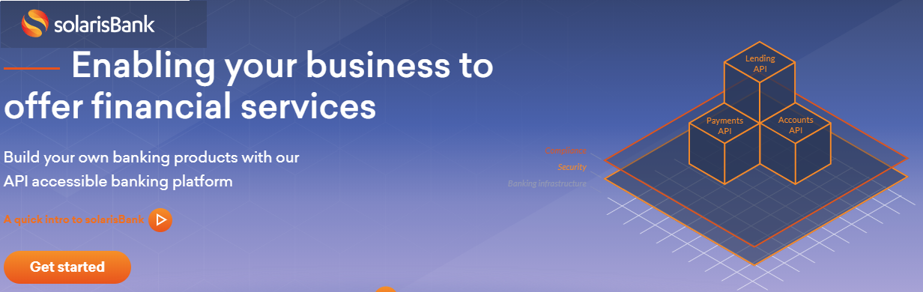

Clearly there is a huge amount of overlap with fintech here, and SolarisBank is already acknowledged as a major innovator in this area. The aforementioned VentureSkies notes that not only does Solaris have the expertise to deliver a Bank-as-a-Service solution, but also the regulative framework to operate as a regulated bank.

This obviously means that the company has no need of the underlying support and infrastructure offered by a traditional bank. This hints at an independence that will come to define an increasingly competitive marketplace, with the German Federal Financial Supervisory Authority (BaFin) having already granted SolarisBank a full banking license.

StarlingBank in Britain is another startup looking to deliver similar solutions to SolarisBank. This is another firm tapping into the platformification zeitgeist, by delivering a plug-and-play Bank-as-a-Platform system that is set to disrupt the UK market.

Some analysts already suggest that the sort of marketplace banking that such systems help create could be a panacea for other challengers in the space. This remains to be seen, but the ability of these startups to deliver their own technology, and operate as an independent financial institution, is certainly a game-changer.

Other interesting players in this niche include financial data aggregations solutions, such as the partnership between Salt Edge and Yolt. This smart money app and API combo enables users to connect to more than 3,000 banks worldwide. And there are also some interesting B2B Marketplace solutions emerging. Mambu is probably the prominent example of this, offering a variety of both localized and globalized solutions that can be integrated with an SaaS engine.

Payment Integration

CurrencyCloud is another startup that has achieved substantial market penetration in its young life, also entering into partnerships with several online banks. Its collaboration with FidorBank resulted in a huge reduction in Forex costs for customers, while FidorBank was able to increase its client base by nearly 60%.

The mobile-only bank Monese also partnered with CurrencyCloud, achieving a ten-fold decrease in forex costs and a massive reduction in payment fees. And CurrencyCloud also teamed up with Revolut, attracting 160,000 new customers to the app, thanks to the ability to save around 40 euros per foreign transaction. Clearly CurrencyCloud is having a significant impact on the banking industry.

Another field for fintech-fintech collaboration is digital identity, with one such example being the work of Avoka and Trulioo. This partnership has delivered a digital identity verification solution that enables the bank to meet compliance requirements in a more nimble and flexible way. This is definitely one field in which a longer term fintech-fintech partnership is feasible, but competing firms will also be scrambling to become the industry standard.

As the fintech field develops, government bodies will increasingly invest in the technology. One such example is the Industry Clusters, which were fostered by investment from Finance Innovation France in 2007. This initiative is intended to help develop innovation in the French financial sector, and encompasses over 140 corporates and banks, 300+ fintechs and SMEs, along with 30 academic institutions.

This has resulted in over 2,000 innovative projects being launched in France over the 11-year period, with 600 of these being fintech certified. Between 2005 and 2016, 1681 collaborative R&D projects received public financing of €6.8 billion. This sort of partnership is helping fintech reach its potential in a complex and fast-moving world.

Other territories have a different approach. In Scandinavia, Nets fosters fintech alliances in the region, providing financial infrastructure for developments in the industry. Nets represents a major network of 240 major Nordic banks, 300,000 Nordic merchants and e-commerce merchants, and 240,000 private and public sector companies.

Nets' support for fintech startups has enabled widespread collaboration, resulting in a wide range of strategic partnerships. The organization has also built alliances with other similar initiatives across the Nordic region, resulting in partnerships with Copenhagen Fintech, IT-Branchen, IKT Norge, Copenhagen Fintech, and Fintech Factory.

And such partnerships are not limited to developed economies. In Africa, fintech collaboration is being used to help facilitate cross-border payments, in a part of the world in which the financial infrastructure is still relatively embryonic.

One such example is Finserve Africa - a wholly owned subsidiary of Kenya’s biggest lender. Finserve Africa has already signed up the Chinese third-party payment platform Alipay, along with WeChat, a a social media and mobile payments app by Tencent Holdings. Having closed these deals, Fintech Africa then set up the acquired technology on a merchant aggregation platform, which is providing valuable functionality to this area of the third world.
Indeed, official figures indicate just how valuable cross-border payments are in an African context. For example, Ethiopians working abroad sent back around $4.6 billion last year, which represents about a quarter of the nation’s annual foreign-exchange earnings. As African economies mature, so they are seeking to widen their economic links with other nations. Thus, China was sub-Saharan Africa’s biggest trading partner last year, accruing around $120 billion. This was more than double the 2007 total.

Just recently, in August of this year, Fintech Africa announced its intention to expand its existing operations, by working with six major banks in order to facilitate cross-border transactions, as well as e-commerce. As fintech in Africa continues to develop, more similar initiatives are inevitable.

So the overall picture of fintech-fintech collaboration is one of co-operation currently. However, we shouldn't necessarily expect this pattern to continue, as the industry becomes more cemented in the overarching financial infrastructure. But there were probably always be off-shoots of fintech companies working together, and there will certainly also be numerous mergers in this fertile sector.

3. Regulator-Fintech

While fintech is undoubtedly an exciting field with huge potential, it is also still pretty new, and will therefore require a lot of financial regulation in the coming years. As regulators begin to understand the fintech space, we can expect to see a good deal of collaboration between these two stakeholders, while regulators will also have to take a legislative lead in many cases as well.

Fintech Sandboxes Launched by Regulators Around the World

There are already a raft of commingled trends which indicate the willingness of authorities to work closely with fintechs, rather than looming over them threateningly. The first of these is the decision of the UK’s Financial Conduct Authority (FCA) to help provide a fertile environment to help fintechs develop.

The FCA provided a 'sandbox', intended to provide fintech firms with the ability to test new products and services in a controlled environment. This has enabled the UK to lead the world in terms of fintech regulatory initiatives, while 95 firms have already participated in the four sandbox experiments. 90% of these firms have already progressed towards a wider market launch, while over 40% received investment funding during the sandbox process; illustrating the success of this policy.

On top to this, there have been three further important occurrences in the last 12 months. Firstly, the FCA is looking to export its sandbox model to overseas territories, announcing on 7th August, 2018 a major partnership with 11 overseas financial regulators, Together, these 12 bodies will form the Global Financial Innovation Network (GFIN), and have already published a consultation document on the matter.

The GFIN members are as follows:

- Abu Dhabi Global Market (ADGM)
- Autorité des marchés financiers (AMF, Quebec)
- Australian Securities & Investments Commission (ASIC)
- Central Bank of Bahrain (CBB)
- Bureau of Consumer Financial Protection (BCFP, USA)
- Dubai Financial Services Authority (DFSA)
- Financial Conduct Authority (FCA, UK)
- Guernsey Financial Services Commission (GFSC)
- Hong Kong Monetary Authority (HKMA)
- Monetary Authority of Singapore (MAS
- Ontario Securities Commission (OSC, Canada)
- Consultative Group to Assist the Poor (CGAP)

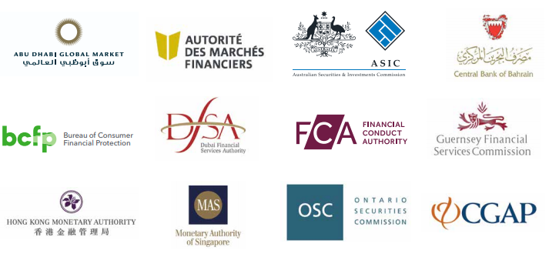

In launching the GFIN, the FCA hopes to achieve the following functions:

1. Act as a network of regulators to collaborate and share experience of innovation in respective markets, including emerging technologies and business models;

2. Provide a forum for joint policy work and discussions;

3. Provide firms with an environment in which to trial cross-border solutions.

The FCA has arguably been the most active of regulatory bodies, having several projects currently under operation. The FCA is also implementing the integration of search and tagging features in its regulatory handbook, building an AI-based intelligent front-end advisor, intended to handhold applicants through its handbook via automated guidance, and ensuring programmability of regulations to enable financial institutions to map their regulatory requirements directly to the data that they hold. This will then create the potential for automated and straightforward processing of regulatory returns.

With Arizona having become the first state to adopt a regulatory sandbox in the US in August, this concept is moving forward on an international basis. This is quite a significant event, as the world's largest economy has surprisingly lagged behind in terms of fintech regulatory innovation and adoption.

Indeed, the head of the Department of Financial Services (DFS) of New York - the state’s financial regulatory body - Maria T. Vullo has spoken against the US Treasury’s support for fintech sandboxes, as well the notion as allowing fintechs to acquire bank charters (banking licences). Vullo was quite dimissive of the sanbox concept, notoriously stating that “toddlers play in sandboxes. Adults play by the rules”.

Vullo continued her opposition, stating: “The idea that innovation will flourish only by allowing companies to evade laws that protect consumers, and which also safeguard markets and mitigate risk for the financial services industry, is preposterous.” She also strongly opposed the decision of the Office of the Comptroller of the Currency to enable fintechs to obtain charters as ““lawless, ill-conceived, and destabilizing of financial markets.”

In this climate, it is perhaps not surprising that the DFS ultimately sued the federal government over its decision to award national bank charters to online lenders and payment companies (Vullo v. Office of the Comptroller of the Currency et al, U.S. District Court, Southern District of New York, No. 18-08377). Reuters described the level of litigation against fintech licensing as a “slew”, and clearly the US regulatory environment remains divided on the subject.

Nonetheless, despite some opposition from within the United States, private-public sandboxes are emerging in Europe. Fidor Solutions recently signed an agreement with AFIN, together in a consortium with Virtusa and Percipient. This will create an API-based marketplace and sandbox environment, open to both banks and fintechs, with the aim of creating a collaborative ecosystem, fast-tracking the delivery of innovation, and empowering new technology developments.

Regulators Working Directly with Fintechs

Aside from the sandbox environment, regulators are also beginning to work directly with fintechs. This has led to the term SupTech being coined, which refers to supervisory technology in the fintech space. Such solutions are intended to help tackle problems faced by regulatory agencies, and to automate and streamline administrative and operational procedures.

SupTech involves the application of digital technology, and enables the scope of financial supervision to be widened. Implementing such technology makes it easier for regulators to capture, process, store, manage, analyze, distribute and act to meet their risk and conduct goals. SupTech is currently involved primarily with data collection and analytics, and enables financial regulators to transform supervisory data in rapid fashion.

Singapore has been a pioneer in this area, with Mr. Ravi Menon of the Managing Director, Monetary Authority of Singapore having spoken on the matter at Singapore FinTech Festival on 14th November 2017. Menon is effusive about the potential of fintech, indicating the desire of the Singaporean authorities to “make pervasive a culture of innovation in [its] financial sector.”

Menon thus predicted that the active integration of technology into the supervisory process will dramatically enhance supervisory effectiveness by the mid-point of the next decade. By this time, he expected the following trends to have surfaced:

- Data analytics finally solves the long-standing challenge that banks have had in aggregating credit and market exposures across various businesses and geographies;
- This will enable banks to derive a consolidated risk profile in real-time;
- And the integration of RegTech and SupTech will allow data from financial institutions to flow directly into regulators’ databases in machine-readable formats through Application Programming Interfaces or APIs.

In his Keynote Address to the Symposium on Asian Banking and Finance, Federal Reserve Bank of San Francisco on 25th June 2018, Menon suggested that automated surveillance dashboards will have a huge impact on the industry, negating the need for supervisory officers to spend hours scrutinizing spreadsheets. Menon asserted that “compared to just ten years ago, technology has enabled supervision to become much sharper and surveillance of systemic stability more rigorous”.

The fact that this speech took place in San Francisco indicates that the opposition to fintech within the US is by no means blanket in nature. But the enthusiasm of Singapore's authorities, and the measures that the country has already put in place, indicate that developing economies may be more likely to be major innovators and pioneers in this field for the foreseeable future.

Certainly it could be argued that the traditional financial behemoths have a vested interest in maintaining the status quo, and could see fintech as something of a veild threat to this hegemony. No doubt this will change steadily as fintech becomes more inculcated in the world economic and financial system.

Aside from Singapore, there are several other examples of Suptech / Regtech / Fintech co-operation. Firstly, the National Bank of Rwanda has partnered with Sunoida Solutions with the intention of developing an electronic data warehouse. This will pull together data from 600 supervised financial institutions.

And the Central Bank of the Republic of Austria has instigated a new data-input approach to regulatory reporting, partnering with the Austrian Reporting Services GmbH (AuRep). This report platform is helping to bridge the gap between IT systems of supervised entities, and the supervisory agency.

AuRep is co-owned by seven of the largest Austrian banking groups, and this is helping to lend legitimacy to this process. As European authorities adopt similar regulation mechanisms, it is expected that highly quality and more timely granular bank data wull be produced.

The Netherlands Bank has also recently launched a Data Science Hub initiative, as part of its system-wide data governance program. This is intended to enable data to be handled more efficiently, and also to investigate several key areas of analytics and data storage. The project also encompasses creating a community of data scientists, ensuring that there is a 'brains trust' of credentialed individuals for the Netherlands to call upon.

Efforts are not limited to Europe either, with the Australian Securities and Investments Commission (ASIC) having unveiled the Market Analysis and Intelligence (MAI) system. The MAI is a suptech platform, which enables all equities and equity derivatives products and transactions to be monitored in real-time. With big data and machine-learning tie-ins, this is deemed to be a highly sophisticated system, which will have a big impact on identifying trading anomalies in Australia.

To conclude this part of the chapter, in July, 2018, the Bank for International Settlements published a paper on the topic of fintech and regulatory bodies. The report divulged a wide range of innovative suptech technologies that are currently either implemented by supervisory agencies, or otherwise under development.

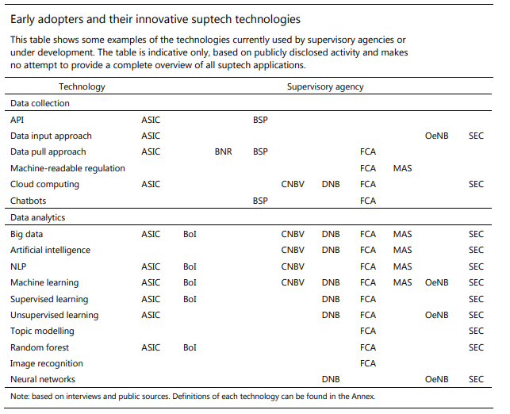

And the report also provided some interesting indication of where suptech applications are currently being utilized:

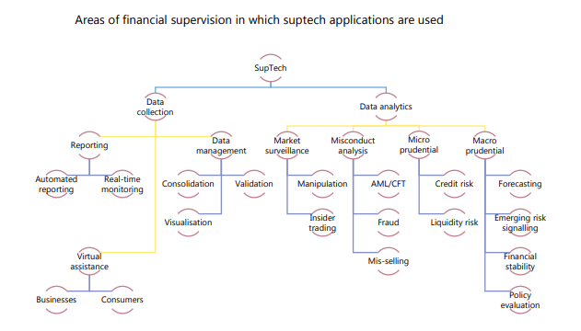

Information on the specific regtech and fintech firms involved in SupTech projects is still pretty thin on the ground. But FutureFlow is one such overground solution. This London-based company has developed an innovative solution that enables banks to identify and access the possibly fraudulent transfer of funds. Advanced analytics allows FutureFlow to assiduously monitor the movement of electronics funds, often between hundreds of parties.

It is clear that such advanced SuperTech solutions will be requisite in the highly complex and technologically advanced marketplace ushered in by the emerging prominence of fintech.

4. Regulator-Regulator or Government-Government

One final area of collaboration in this niche relates to either regulator-regulator or government-government partnerships. We already touched upon this subject in the previous section with GFIN, but there are several initiatives in other parts of the world that are also unfolding.

For example, in March 2016, FCA and ASIC signed an agreement to support fintech startups. As a result of this agreement, the two regulators will essentially refer to each other innovative companies seeking to enter one another's markets. The two bodies will also share information, as they oversee a fintech industry that has grown to be worth around $12.5bn (£6.6bn) and $1.3bn (£0.7bn) in Britain and Australia respectively.

Another influential initiative in this area in the so-called 'Fintech Bridge'. This term refers to collaborative programs between two nations that facilitate the entry of start-ups into regulatory sandboxes resident in the two nations. Fintech Bridges are also intended to enable processing to take place more rapidly, with regard to licensing businesses that have previously been authorized in the opposite jurisdiction.

Again, the FCA has been particularly active in this area, with the body having established the first ever Fintech Bridge between Britain and Singapore in May 2016. Since then, the UK has fostered further agreements in this field with Canada, China, Hong Kong, Japan, South Korea and Australia.

Since this initial agreement was penned, 41 bilateral co-operation agreements have been established in various diverse locations:

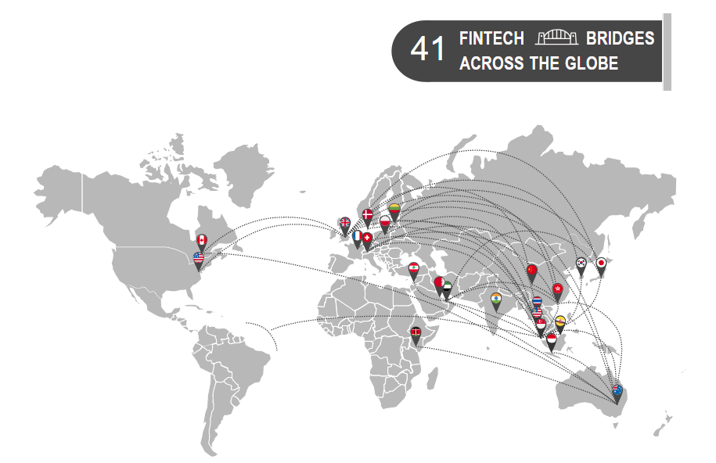

Some of the most prominent of these include:

- The February, 2018 agreement between the FCA and the US Commodity Futures Trading Commission (CFTC) which formalizes a relationship between the two regulatory agencies in the fintech niche. As a regult of this arrangement, the innovation initiatives, LabCFTC and FCA Innovate, will also collaborate on supporting firms in both nations.

- In June, 2018, India's Department of Economic Affairs (DEA) and MAS announced an agreement expanding their existing partnership in fintech.

- And in September, 2018, the FCA and MAS revealed that they will work closely together on a variety of fintech avenues, including supervisory tech, cybersecurity, and cryptocurrencies.

Reasons why Regulators are Collaborating with Each Other

So why are regulators so keen to enter into fintech-related partnerships? Well, firstly, by doing so they help circumnavigate any risk related to regulatory standards suffering. This could conceivably occur as different jurisdictions compete for business.

The second reason is to help ensure that fintechs can be scaled adequately. In particular, fintech companies face challenges with expansion into new locations, while also scaling operations suitably. Each country presents different market conditions for fintechs, while the regulatory environment from nation to nation also varies quite significantly. This can actually pose major financial problems for fintech firms.

And there are several advantages of collaboration fundamentally related to the cooperation itself. Sharing experience in respected markets is certainly helpful, while creating a mechanism to aid discussion on various hot topics is also undoubtedly useful. And the ability for those regulating the fintech industry to coordinate their efforts in the implementation of proposed measures will certainly benefit from such cross-border arrangements.

Summary

As the fintech sphere develops, various forms of collaboration are developing. These partnerships are sprouting among different nations and geographical regions, and also among different stakeholders in the industry. The nature of these arrangements is still evolving, as the fintech industry finds it feet in the global financial architecture, but it can be anticipated that the roots that have been planted are only the beginning of this ongoing trend.

Tables and diagrams:
One table showing what banks have invested into startups in 2016-2017 (please include acquisitions also)
All acquisitions are already inserted in separate table above (and included in Excel doc)
Find below summary table of banks’ 2016-17 investments in fintechs

Within 15h time limit I added only Citi fintech investments, all other are:

0ut if scope of current budget since could take additional 7-10h

- Update above table with numbers for 2016-2017

When the table will be ready calculation of 2016/2017 investments will be easy, except one hurdle- it is IMPOSSIBLE to FIGURE OUT what EXACT amount was INVESTED since most funding rounds were with participation of VC firms or VC arms if other banks.
So, numbers will be rough estimates

- One table with list of all accelerator programs launched by banks
Done (see above and in Excel)
- Startups in each program/year
- Year
- Category
0ut if scope of current budget since could take additional 5-8h

