What is Competitiveness?
The term 'competitiveness' is a familiar one in our daily lives, and one that tends to define human society. When we hear the word, it is intrinsically associated with competition, or the ability of someone to compete with their peers. When a company beats rivals, captures market share, or gains comparative advantage, we consider it to be 'competitive.' The way that the term was later extended to also assess the success of a country is difficult to track, but I suspect that it all started in 1990 with the publication Michael Porter’s 'The Competitiveness of Nations'. In his book, Porter borrows the term from the corporate world to stress that the success or failure of nations is relative, and therefore countries 'compete' with one another in order to be more prosperous.
Note that the analogy does not imply that when Switzerland successfully competes with Austria, Switzerland is better off and Austria is worse off; only that Switzerland is more successful than Austria. This is important because when I meet government officials, they often misunderstand the concept, and consider themselves to be uncompetitive because their neighbour is a powerful economy. The danger of such confusion is to consider that, in order to be successful, a nation needs to beat others (instead of cooperating with them through trade), and particularly to be involved in more successful export. Spain had a Minister of the Economy and Competitiveness for quite a long time, yet official publications often conveyed the wrong impression on how to indeed become competitive: “the concept of competitiveness for an economy is associated with achieving larger advantages from international trade through by improving terms of trade”. Along the same lines from the same publication: “national competitiveness is related to the ability of a country to export”
Porter also introduced what is the main ingredient in the competitiveness equation: productivity. The term 'productivity' here is related strongly to production activity, which is aligned with the ability of a particular country to produce goods and services. In subsequent research reports, Porter suggested that it is mostly appropriate for competitiveness to be measured by productivity, and that productivity is the factor that most readily determines economic prosperity. Other international institutions followed suit: the Competitiveness Advisory Group (1995) defines competitiveness as “the elements of productivity, efficiency, and profitability.” In a similar tone, the World Economic Forum (WEF) also associates national competitiveness with productivity, and defines competitiveness as “the set of institutions, policies, and factors that determine the level of productivity of an economy, which in turn sets the standard of prosperity that the economy can achieve.”
So what can we understand as 'productivity'? Simply put, at the national level, productivity is the power and ability that a country has to produce goods and services. However, although productivity is strongly related to the national production ability, it is not necessarily equivalent to economic growth. To differentiate between productivity and economic growth, let us turn our attention to simple equations. In macroeconomics, there are three variables frequently attached to production (Y), namely capital (K), labor (L) and technology (A). Let's suppose the ability of a country to convert capital and labor to final goods and services is conducted through a production function. Let us use the most straightforward production function, which is in a period t is given by...(note: SOMETHING NEEDS ADDING HERE – CM).

Capital is the set of assets (physical and intangible) required to produce goods and services, such as land, machinery, oil, factories, and so on. On the other hand, Labor is simply employees who actively contribute their time and effort to convert capital into final goods and services. Finally, technology refers to the ability of producers to multiply goods or services based on a certain level of capital and labor. Technology also reflects the effectiveness and efficiency of a production process; usually referred to as total factor productivity (TFP), which also reflects the nation's competitiveness. So if we want to put this in the simplest terms possible, total factor productivity can be approximated as...(note: SOMETHING NEEDS ADDING HERE – CM).

If we are suggesting that TFP is a proxy for technology, and vice-versa, then rhe term A in the expressions above must then be understood as the ability of a country to transform inputs into outputs:
“A nation’s standard of living depends on the capacity of its companies to achieve high levels of productivity—and to increase productivity over time. Sustained productivity growth requires that an economy continually upgrade itself. A nation’s companies must relentlessly improve productivity in existing industries by raising product quality, adding desirable features, improving product technology, or boosting production efficiency”.
Comparative advantage is one requirement needed to ensure that production activity can turn into competitiveness. The idea raised here is that countries can be more competitive if they produce and trade specific goods or services which they are naturally well placed to do better than others. In other words, countries which have endowments of specific resources will be able to produce goods and services more efficiently than ones that aren't fortunate to possess them. For example, countries blessed with abundant gold deposits can be more competitive in the production of gold-related products, or countries with significant oil reserves are obviously better placed to produce oil-related goods or services. It should also be noted that endowed capital can help the country to minimize production costs, and sell products at lower prices. By achieving this specialization, nations can become more competitive as a result.
It is important to understand that a nation’s success is also primarily dependent on the objectives and direction of government (more about this later). Although comparative advantage is essential, it is not sufficient to achieve national competitiveness in the long run. In 1994, Nobel-laureate Paul Krugman wrote an article with the suggestive title “Competitiveness: A Dangerous Obsession”, in which he contended that successful competitiveness requires a continuous dynamic process of comparative advantage over a period of time, rather than only being comparatively advantaged on the factor of endowments. The obsession that Krugman speaks about derives, in my opinion, from confusing competitiveness with competition. For Krugman, the fact that countries focus on competing in international markets is not only wrong, but also dangerous, because it derails governments from their true objective of ensuring that people are materially better off.
Indeed, competitiveness does not neglect citizens. A country cannot be competitive if it is unable to create prosperity for its people. One of the major indicators for welfare is that citizens can expect to enjoy a healthy level of income, and one that progresses over time. As suggested by the Organization for Economic Cooperation and Development (OECD), competitiveness is “the degree to which a nation can, under free trade and market conditions, produce goods and services which meet the test of international markets, while simultaneously maintaining and expanding the real income for its people over the long term. Such understanding brings to the core a proposition that competitiveness is embedded in the type of economic system, in this case, a free market economy.”
The IMD World Competitiveness Center is a pioneering organization in the study and measurement of competitiveness. We define it as “the ability of a country to facilitate an environment in which enterprises can generate sustainable value,” in order to stress the difference between the public and private sectors. The public sector sets the conditions for the economy, while the private sector creates jobs. This does not contradict the idea that productivity drives competitiveness, rather it complements this notion by adding the requirement that for a country to be competitive, it must generate prosperity for its citizens.
Productivity is therefore the result of an optimal combination of inputs: natural resources, geographical position, political choices, the enforcement of good regulation, and satisfactory health and education systems.
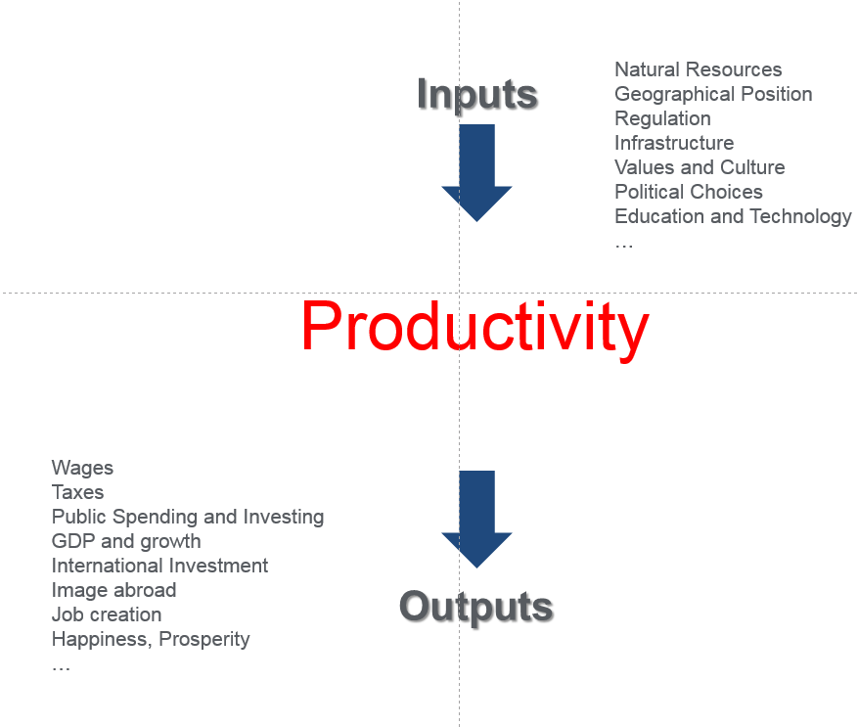

However, productivity should not be considered the end of the competitiveness equation. Productivity is particularly related to prosperity and value created by enterprises, because productivity is the main determiner of salaries. People earn their productivity, and that is why football players (who are effectively marketing machines to sell t-shirts) earn so much, and lumberjacks so little. In the long run, labor wages are equal to labor productivity. Wages, in turn, determine tax revenues for a government, its ability to invest in roads, hospitals, and schools, and thereby the correlation between skills and the needs of the labor market. When an economy is productive it attracts foreign investment, it creates jobs, it generates output, and therefore economic growth is also created. With economic growth, the image of the country abroad improves, and ultimately talent is attracted to the country, creating a virtuous circle in which infrastructure, healthcare, and the country’s education system can again improve, thus driving productivity once more.
Natural resources are not necessary conditional to productivity. Switzerland is competitive despite its lack of natural resources and its unfavorable geographical position (landlocked, without access to the sea, mountainous orography) because it has developed a good regulatory environment, and because its education system is excellent, among other reasons. Institutions can sometimes replace the natural endowments of a country, but not the reverse. Indeed, institutional quality is a mandatory requirement for prosperity. Struggling countries such as Argentina, Venezuela, Philippines, and South Africa prove that a privileged geographical position, and an ample supply of natural resources, does not guarantee competitiveness.
However, natural conditions and good institutions also require a minimum quality of life, in terms of health and education standards, be preserved. The genocidal colonization and posterior abandonment of India by the British Empire may be a much maligned act historically, but the empire at least left impressive economic and social institutions behind, along with an efficient judiciary that had copied that of the metropoli, rule of law (more to come later in Chapter XXX). The history of India is well known. A sequence of post-colonial governments, poor choices in economic policy, and unfavorable international environment prevented the development of a satisfactory education system and suitable infrastructure in the country, with largely disastrous consequences. Indeed, India is only recovering from these tribulations in the modern era.
The virtuous circle of competitiveness can break at any point throughout the history of a nation. Obviously, political choices (or impositions) are not exogenous by their very nature, and the competitive fate of a country is massively shaped by its political leaders.

Competitiveness Success: The Netherlands
(note: SOMETHING NEEDS ADDING HERE – CM).

When a Country is not Competitive: The Case of North Korea
The other side of the coin is the Democratic People's Republic of Korea (DPRK), which I had the chance to visit in 2016. Having spent the last ten years in Switzerland, I have enjoyed the experience of residing in a competitive, modern, innovative country, with a superb quality of life. Even in the poorest countries in the world one sees a potentially bright future, although it is sure to be found at the end of a very dark, long tunnel of poverty, and lack of institutions. Without a doubt, I have seen the ugliest side of world competitiveness in a country that has little more than a mere sliver of hope.
The DPKR enjoys a privileged geographical position. It has access to trading routes through its eastern (Sea of Japan) and western coastlines (Yellow Sea). It shares borders with two of the world superpowers - China and Russia. Indeed, through its Russian border it can access Vladivostok, a major port city, which is only 684 kilometers away from Pyongyang. Of course, its limits to the south border South Korea, a country that is 80 percent smaller, but with double the population. North Korea is rich in mineral reserves, and in particular coal, iron ore, limestone, magnesite, graphite, copper, zinc, lead, and precious metals. And DPKR also has excellent agrarian resources. Despite being a mountainous country, 19.5% of its territory is arable land and 46% forest.
However, DPKR is first and foremost a failed economy. Remarkably, one of the very few low-income countries which is not in Africa, it is still recovering from a famine in the 1990s following the collapse of the Soviet Union, which resulted in the death of approximately two million people. Internal tourist brochures and the press will paint a positive picture of life in the country. But even on my trip - which was meticulously controlled by the Korea International Travel Company, during which I could only see what they wanted me to see - there were glaring examples of depravity. Agricultural laborers still use tools and systems that were created before the industrial revolution. There is no mechanization; all tasks are performed by hand. Furthermore, there is a lack of long-term planning and product diversification, and certainly low productivity. The DPRK is a deserted landscape with no trees and vegetation, and a primary sector which seems far from being self-sufficient. I had the opportunity to visit a cooperative farm in Chonsam-ri which operates under the same premises as the ones in Mao Zedong's disastrous Great Leap Forward in China: the government imposes a production quota (usually of basic products such as rice and cabbage), and the cooperative farmers keep the surplus. Since the government controls both the quota as well as the price paid, the prosperity of the cooperative members is completely in the hands of the government.
Industrial equipment is also obsolete. During a visit to a water-bottling plant in Kangso, I could see that the machinery used there had been manufactured in Italy in 2002, even though the plant was inaugurated in 2012. In the Kaesong Koryo Museum, I was presented with a display of 'North Korean' technology, which included mining equipment by Caterpillar and robots with the Siemens logo. Buses and planes are Russian; cars are Chinese and Japanese, in addition to the Mercedes and Audis driven by party officials (which can be easily identified by the 02 and 216 plate numbers); trains are German, telephones are Chinese, coffee is Swiss. I visited a training center so that I could experience the North Korean technological revolution, and students were working with Dell computers, whose branding was carefully covered with a North Korean logo. However, all these items were ridiculously old and close to their breaking point, so one has the impression of being in an eastern European city in the 1950s.
When governments care about prosperity, physical infrastructure must be addressed first and foremost. Excluding the residential area of Pyongyang, the rest of DPRK is in perilous ruins. It was a nightmare to drive the 180 kilometers that separate Pyongyang from Panmunjom and the De-Militarized Zone (DMZ). This contrasted significantly with my drive from Seoul to the DMZ in 2004 via an impeccably smooth highway. There has been no infrastructural development in the last 20 years, ever since Soviet money stopped flowing into the country. My guide explained very proudly how the road on which we were driving on our way to Mount Myohyang had been built by students who volunteered during the 'Arduous March' of the 1990s. While I had reason to believe that the students had not volunteered in the strict sense of the word, it was clear that the construction had been undertaken by amateurs, who had little or no experience constructing roads.
And the people of DPRK suffer. I was not allowed to see it, and I was never told so. However, the signs of malnutrition and low quality of life, as well as a lack of culture, recreation, and leisure are all too evident. I attended a concert given by the North Korea National Orchestra, and saw the magnificent National Theater. However, instruments were clearly old, un-tuned and low-quality, overshadowing the players' skill. Supermarkets (if the dark and standardized establishments where the locals buy food can be called that) offer only the basics - rice, tomatoes, onions, potatoes, bread, tea and coffee. In the countryside, most of the houses had no electricity or running water, so I had to shower with icy water in my 'luxurious' hotel in Chongchun. In most of the public buildings (museums, exhibition centers, government departments), however luxurious they may have appeared from the outside, interiors proved to be decrepit, with no running water or heating. I also endured a few power cuts during my stay, which are a daily occurrence for people of North Korea.
What is the root of such a colossal failure? Certainly the political system. The country is one of the, if not the most, grim dictatorships in the world. The population of 24 million lives under the complete control of the Worker's Party, the centralized government, and its President Kim Jong Un.
After spending time in the country, it is clear that the dictatorship’s reputation as fundamentalist, communist, kleptomaniacal, nepotistic and megalomaniacal is well-deserved. Private initiative does not exist, and the Party dictates which school you will attend, whether you will grow up with your parents or not, where you will work and live, and whether you can move from one place to another. Police are everywhere and the army can be seen performing any number of tasks outside of their usual roles including construction, street cleaning, traffic control, and farming. Prices are fixed across the country and of course there are no banks, internet, social networks, trade unions, proper political parties, or places of worship. The Juche idea (Kim Il-sung’s philosophy based on the proposition that men control and decide everything, so people are fully responsible for their destiny) directs every single policy and decision. The regime has instigated and instituted fear and irrationality, and people are forced to do the most ludicrous things. For example, in anticipation of the 7th Congress of the Worker's Party, the government enforced a 70-day campaign of increased productivity and extra working hours for all North Koreans. This meant that bureaucrats have to stay a few hours longer every day, that industries have to multiply output, and that people in the countryside need to show, by working for the community, commitment to their leader and the country. As a result of this imposition, I saw hundreds of people lining up along the roads fixing patches, picking weeds, planting trees in the middle of nowhere, or simply sweeping the road; all of these activities being undertaken with their bare hands and rudimentary tools.
After three generations of iron-fisted control, North Korean people have grown massively ignorant and indoctrinated. Kim Il Sung (the "Great Leader") is adored as a god; his son and successor Kim Jong Il (the "General") is considered a visionary and a genius. The examples of irrational devotion to their leaders were sometimes so absurd that they made me crack up with laughter. During my visit to the Songnam Caverns, the guide started by saying that her explanations should be listened to very attentively because the General said so during his visit 30 years earlier. Pictures and statues of both the Leader and the General are everywhere, always smiling — however they are the only ones who smile in the DPRK.
There is not a large display of Kim Jong Un's ‘visionary’ ideas yet, but of course he has been in power for a short period, and there is still plenty of time for him to become a ‘legendary’ figure. So far his appearances on local TV are usually associated with the country's nuclear weapons arsenal, and his ability to ‘wipe out’ both the Blue House (South Korea’s government headquarters) and the White House. He is referred to as ‘the Marshall’, due to his 'Songun' policy, which prioritizes the military over anything else.
It was frustrating to see that North Koreans know much less about North Korea than we as outsiders know. Neither my guide nor any of the locals I talked to knew that Kim Jong Un had attended a Swiss boarding school, that his father was born in the Soviet Union (interestingly, one of the tourist attractions in the northern part of the country is Kim Jong Il's mythical birthplace...), or that he has a five-year-old son. It goes without saying that they also had no idea what either Google or a 'selfie' is. North Koreans think that the DPRK won the Korean War in 1953 (they call it the ‘Fatherland Liberation’ War). They have grown up believing that the regime is the result of Kim Il Sung's divine intervention, and not affiliated in any way with the USSR, which is not mentioned in any history books. The United States is their eternal imperialistic enemy. North Koreans pride themselves on inflicting violence, suffering and humiliation on Americans, which was on display in the Fatherland Liberation War Museum, with 20 depictions of dead American soldiers. North Koreans ignore the mysterious circumstances surrounding the deaths of Kim Jong Un's uncle Jang Song-Thaek and Kim Jong Il's first mistress Song Hye-rim. The willingness of the Party to rewrite history explains why the country is airtight to foreigners, and why we are seen as a dangerous threat to the country’s cult-like mindset. My movement was strictly limited. I had a guide everywhere I went including during my jogging sessions in Pyongyang when my annoyed escort was doing his best to keep up in his official uniform. I think that only with the distance of time will I be able to make sense of the irrational fear, the nonsense, the lack of freedom that I experienced (although at a level that probably pales in comparison to what North Koreans go through) and the locals’ blind belief that their country is paradise.
The problem with political failures is that there are sometimes very difficult to resolve. My impression is that the current regime is going to last for a considerable period of time, even in the absence of its current, tyrannical dictator. The North Korean population is not only prepared to go to war now, but they are also willing and prepared to suffer continued hardship and starvation. As my guide said, "we are not afraid of War; if provoked, we will go to war”. The consequences of the famine in the 90s has been corruption, and a certain tolerance towards black markets by authorities, but indeed the lesson that North Koreans have learned is that they can survive (or, at least, most of them can) if the situation were to repeat itself. Besides, they are absolutely behind their political leaders, whose propaganda is extremely effective. Changing the mindset of the population won’t happen in a matter of days, especially by using outside force.
Therefore, the current embargo is insufficient, and economic sanctions will only make people suffer, while doing nothing to weaken the political system. Perhaps closing the borders to stop foreign products and equipment, especially oil, from entering would make the average North Korean more inclined to revolt against their leaders, but that would be impossible, not to mention cruel and inhumane.

Does it Matter? Competitiveness and Stock Markets
It is when I joined IMD 14 years ago that I heard for the first time the acronym “BRICS.” These countries—Brazil, Russia, India, China, South Africa—are the future of the world economy, I was told, and any company that wants to succeed in the next decades needs to operate in these countries. They have large economies and domestic markets, growing populations, natural resources, and uncovered potential. The term is attributed to then Goldman Sachs Chief Economist, Jim O’Neill, who would later become Chairman of Goldman Sachs' Asset Management division.
As O’Neill would comment later, “I got two out of four countries right” (South Africa would be added to the BRIC countries later), in reference to China and India, the two countries that, his opinion, delivered to expectations. Alas, Table 1Error: Reference source not found shows that, in terms of overall competitiveness, China has definitely improved, but India has not. The privilege of being the most improved BRICS nation goes to Russia; despite being among the 20 least competitive countries in the IMD rankings, it has improved four positions between 2011 and 2018.

Table 1. BRICS Position in the IMD World Competitiveness Rankings
In reality, even the Goldman Sachs’ Chief Economist got it wrong. If what he wanted to predict was the
'countries of the future' as of 2011, Error: Reference source not found shows that USD100 invested in an equally-weighted portfolio (a portfolio with 20%of the money invested in each of the five countries) would have generated USD146 by the end of 2018, or equivalently 4.9% per year. By contrast, the world portfolio has generated an average return of 11.35%. Not even the best-performing countries (China, South Africa, and India) outperformed the world portfolio, despite what we may have suspected, given that China has been considered the most successful economy of recent decades.
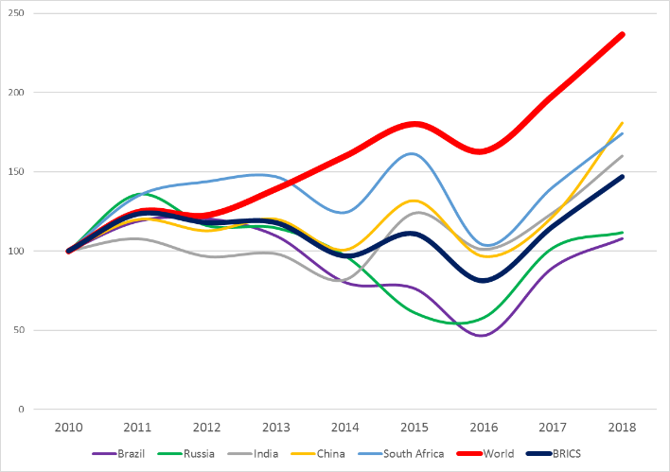 If we claim that competitiveness is the right tool to measure the success of a country, then competitiveness should be correlated with stock market returns; at least as long as stock returns track the performance of the overall economy. The problem with stock markets is that returns are primarily commensurate with risk, therefore riskier markets (countries) should be also yield higher stock returns. Let us try to assess both, using the 2000 IMD World Competitiveness Rankings. I have classified countries in three groups: most competitive (ranking 1-16), average (ranking 17-33), and least competitive (ranking 34-47). For each country, and using the Datastream country index (which tracks the stock price performance of the largest publicly traded companies in the country) I have computed annual returns and volatilities, where the volatility is measured as the annual volatility of monthly stock returns of the 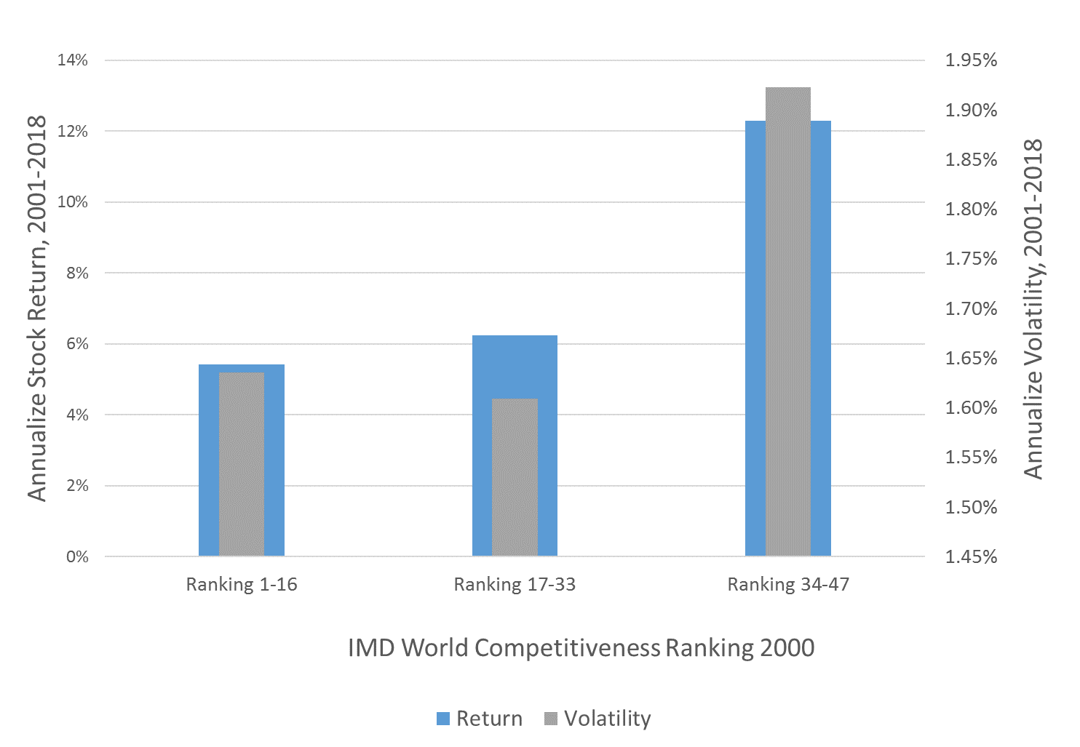country index.

Can we predict stock market returns and risk (volatility) using competitiveness rankings? The answer is in Error: Reference source not found. Countries are classified in the horizontal scale by their competitive ranking. The vertical scales measure, respectively, annual returns and annual volatilities for the groups of countries. Surprisingly, the more competitive a country is ranked, the lower the stock market returns. For the most competitive economies in 2000, annual market returns were 5.4% on average over the period 2001-2018; for the least competitive, this figure is 12.3%. So what is going on?! Obviously, less competitive economies are also riskier. While the most competitive economies display an annual volatility of 1.6% (meaning that returns are confidently within a band of 3.8% to 7%, that is 5.4%±1.6%), volatility is 1.9% (with returns that vary between 10.4% and 13.2%). Volatility differences are not dramatic at the index level, but they are much greater at the individual stock level.
Overall, the best risk-return trade-off is provided by the countries in the middle, those that Parag Khanna has called “The Second World”. Intuitively, investing in competitive economies is a safe bet: they are “value” economies ready to generate returns, but because the market already incorporates that information, they are highly priced and also low risk. Indeed, less competitive economies are 'growth' economies with development potential, but also with high risk. Surprisingly, the BRICS countries are neither of these. Over the period, they have displayed low(er) returns with high volatilities, possibly because they were declared so publicly as the “successful countries of the future.”

Summary
In summary — productivity is the result of endowments, good institutions, and reliable infrastructure. But despite the fact that productivity is the main anchor of competitiveness, its presence within a particular country is not a guarantee of success. Sometimes productive economies fail to generate prosperity because of government malfunctioning. In democracies, very often the political cycle is an obstacle for long term policies—an issue that we will discuss extensively in the next chapter – because politicians favor short-term and easily acceptable reforms that guarantee re-election, at the expense of necessary and painful reforms that only pay off in the long-term. In dictatorships, the North Korea example above demonstrates that people depend to a great extent on luck when it comes to been ruled by the right dictator. In both democracies and dictatorships, corruption, bureaucracy, sub-optimal decentralization, and the excessive influence of exclusive institutions (like the military) in politics result in economies that are not competitive.
Fiscal rules need to prioritize people’s quality of life and job creation. Sometimes tax rules are implemented in order to attract capital and investment, but they subsequently give advantage to a few. In other cases, the economic structure of the country is such that, despite being productive, tax revenues have to be diverted to government spending that is not necessarily value-creating. An example of the former is the UAE, with no income taxes, and yet an amazing ability to attract foreign business, but also with non-existing public education and healthcare systems. An example of the latter is Japan, where public finances are held captive thanks to a demographic structure dominated by an aging population that needs to be supported by the government pension system.
In order for productivity improvements to result in more competitiveness, it is also paramount that salaries guarantee a decent standard of living for workers. As we will discuss in the section Productivity and Wages, in some industrialized countries there is an increasing wedge between productivity and salaries, with detrimental impact on prosperity, as well as lower tax revenues. Meanwhile, salaries for the public sector are usually pretty low in such countries. Ultimately, health and education systems, infrastructure, and the quality of human capital typically deteriorate in such societies, and competitiveness suffers as a result.
Finally, external conditions do matter a lot as well. These can be geopolitical conflicts (Ukraine, Palestine), the hostility of neighbors (Russia, Israel, Taiwan), or the global economic context, when the country is extremely open to foreign trade (Mexico). In those cases, even a productive economy will fail to deliver prosperity to its citizens, and competitiveness will also be conspicuous by its absence.
Why is competitiveness our choice? Why is it the best measure of a country’s success? In the next section, we look back at history, and analyze how economists and policymakers assessed the performance of countries, and the metrics that were used.

Looking back to History

Early economists believed that economic development was mainly dependent on a nation’s natural resources and extracted wealth. Wealth used to be expressed in two main forms - capital and labor. The most populated nations had more human capital than less populated ones, and nations waged wars to obtain additional human capital in the form of slaves and war prisoners. Hence, this doctrine stipulated capital and labor as being the main source of wealth for nations.
But if natural and human resources determine wealth, a corollary follows that, in order to develop, countries need to generate and increase the supply of both. Therefore, early economic growth theories were focused on the extraction of natural resources. As an economy grows, it depletes the availability of minerals, fisheries and forests. And, at the same time, it increases the quality of human capital, gains access to unexplored sources of materials, and drives innovation to create new ones. This conflicting and contrasting process is described by what economists refer to as 'endogenous growth models.' However, the main limitation of economic growth theories is that they are limited by the amount of natural resources and the environmental issues caused by intensive manufacturing, and the sustainability of resources extraction.
Commenting on this process, Robert Solow - currently Emeritus Institute Professor of Economics at the Massachusetts Institute of Technology, and the 1987 winner of the Nobel Prize in Economics - formulated in the 1970s an exogenous-growth framework (the so-called Solow Growth Model), in which sustainable economy is possible so long as non-renewable natural resources can be substituted with another factor of production such as physical capital; consequentially balancing the economic growth path.
The availability of natural resources partly explain why the United States, Canada, and Australia report higher-than-average levels of income per capita. However, this phenomenon fails to explain why India, Venezuela and the Democratic Republic of Congo are underdeveloped. India has the fourth largest coal reserves on earth and significant reserves of limestone, petroleum, diamonds, natural gas, chromite, titanium ore, and bauxite. Over 12% of the world’s thorium production and over 60% of global mica production come from India, which is also the leading producer of manganese ore. At the end of 2017, Venezuela possesses 24.9% of the world’s reserves of crude oil, more than those of the United States, Canada and Mexico combined. It is also the leading exporter of bauxite, coal, gold, and iron ore. The Democratic Republic of Congo has the world’s largest reserves of cobalt and significant quantities of the world’s diamonds, gold and copper. This makes it potentially one of the richest country in the world. Yet despite this apparent wealth of natural resources, poverty ratios in these three countries are particularly high, suggesting that rich endowments do not guarantee economic development. Economic development models in these cases fail to acknowledge the impact of openness and globalization in the domestic access to these resources.
Of course, some countries are lucky enough to sit on top of a massive source of wealth, and rightfully exploit it. From the 16th century, and until the 1930s, Dubai and Abu Dhabi were the leading ports and pearling centers of the Middle East. In fact, peals provided the foundation for the region’s growing prosperity during that period. Most of these pearl exports were directed to the West, but India and Turkey were also frequent recipients. The demise of the pearl industry was caused by the First World War, the Great Depression, and primarily by the Japanese invention of the cultivated pearl, and the slump in prices that this caused. In any case, the attractiveness of the pearl sector for a society that had been mostly rural and poor for centuries was disrupted by the discovery of oil in 1958, after a 30-year search that had started in 1936 when the first British geologists arrived in Abu Dhabi. From this point, until the creation of the United Arab Emirates in 1971, the wealth of the region increased massively. By 1980, the country’s GDP per capita was $113,000 (constant 2010 USD), compared to $28,700 for the United States, and $54,800 for Switzerland in the same year. Alas, between 1980 and 2017, the UAE’s GDP per capita has fallen 61%. Natural resources do not last forever, but even with the fall in oil prices, Abu Dhabi’s GDP per capita was $71,600 in 2017, while Dubai’s was $40,700. Such a difference exists because, while Abu Dhabi produces oil, while Dubai does not.
But the UAE, and Dubai in particular, also tell a different story on how to succeed through trade, independently or at least in parallel to abundant natural resources. In 2006, Sheikh Mohammed bin Rashid Al Maktoum took over as leader of Dubai. Through a parallel strategy designed to attract talent and capital, Sheikh Mohammed successfully turned Dubai into the global business hub of the Middle East. He did so by eliminating corporate and income taxes to begin with. Dubai is funded primarily with the profits of state-owned enterprises and consumption taxes, and its economy relies primarily on logistics and services — depending heavily on foreign trade.
Originally, those economists who defended trade as the key to economic development were called Mercantilists — and their doctrine Mercantilism. The Mercantilists viewed trade as the main source of wealth generation, and eventually economic development. David Ricardo (1772-1823) developed an international trade theory based on comparative advantage and specialization. The theory was first introduced in his book On the Principles of Political Economy and Taxation in 1817. The main argument proposed by Ricardo is summarized as follows - countries should specialize in the production of goods in which they not only have an absolute advantage, but also a relative advantage over other countries, in order to gain the benefit of international trade. Since China is specialized in labor-intensive products, and the US is specialized in capital-intensive products, China should export wheat to the US, and the US should export cars to China.
Mercantilism was dictated by the economic environment of that age, at a time in which the primary factors of production (capital and labor) did not interact through technology. Trading nations are no longer necessarily the wealthiest countries. In fact, free trade has hardly ever been the factor behind the success of the great powers of the past:
“The shocking truth, however, is that every economically successful society has been guilty, in its formative stages, of protectionism. Outside the anomalous offshore port financial havens such as Hong Kong and Singapore, there are no economies in the world that have developed to the first rank through policies of free trade.”
The intensive trade doctrine has been eclipsed with the industrial revolution, allied with the rising importance of technology. Early in the twentieth century nations raced in technological advancement and qualitative economic development. Modern theories of economic development are no longer dependent only on the accumulation of capital, either physical or human. Academics now argue that there is a third form of capital which is equally important to the performance of production – a favorable institutional environment.
The importance of institutional quality rose in popularity with Dorn Acemoglu and James A. Robinson’s (from MIT and the University of Chicago, respectively) 2012 book “Why Nations Fail: The Origins of Power, Prosperity and Poverty.” The authors form their main hypothesis around the fact that economic institutions are the key determinants to a country’s success; hence, economic growth and development. In this framework, wealth creation can only be achieved through political freedom. The political environment in a country formulates economic institutions, and the quality of those institutions are the key elements that will determine the success or failure of nations. Their work is extensive and extremely relevant, as they test the hypothesis that institutional development determines success, at the expense of two other alternatives. These two alternatives are that the geographical position of the country is of primary importance — so that rough climate areas and exposure to diseases hinder economic development, or that cultural aspects, such as the business orientation of a nation, its creativity and hard work, determine success. In the end, they conclude, the quality of a nation’s ruling elite, and whether they form and apply relevant policies, are the keys to fighting poverty and securing economic development.
Institutional quality explains why Singapore and Argentina differ so much in their degrees of prosperity, being ranked 59th and 3rd respectively. Obviously, Argentina is quite a rich country with significant natural deposits, extensive territory and a population of around 44 million. In contrast, Singapore is a small island-country with limited natural resources, land and population. Argentina was a highly developed nation at the turn of the 20th century, but has since experienced a raft of major crises, announcing defaults eight times over the next hundred years. We have touched upon some of Argentina's more recent problems elsewhere in this book. Singapore, upon gaining independence from Malaysia in 1965, was already viewed as the “Monaco of the East”, securing a steady economic growth and development. The main driving force of Singapore economic progress has been the policies of Singaporean first prime minister, Lee Kuan Yew, particularly since the 1970s.
Firstly, Singapore curtailed corruption and established equal business rights, attracting foreign investments by offering a competitive tax policy, and securing investors by instigating property protection regulations. These astute development policies led businesses to growth, prompting an increase in foreign direct investment’s portfolio, which eventually resulted in capital stock rising by thirty-three times (note: does this mean it rose on 33 occasions, or rose 33-fold? It's not entirely clear - CM) by 1992. Ultimately, this helped the nation in constructing a world-class airport, and establishing modern business districts, which have also boasted both its physical and intangible infrastructures.
Thus, natural endowments, trade openness and institutional quality combine in different ways to drive a nation’s success. But none of them can be considered either entirely necessary nor sufficient. Institutions (see the next chapter) require economic foundations, since stock markets, trade unions, political parties and business associations are the result of, not the reason for, a productive economy. Trade openness is partly to blame for the emergence of new powers in the last decades (China and the European Union for instance), but protectionism has helped most big countries in the early stages of development. Natural resources are usually a distraction from effective policies, and in most cases those countries with massive access to natural resources have failed to develop welfare-enhancing economic and social institutions. Prosperity is therefore the combination of different approaches and policies, the interaction of the public and private sector, and the ultimate choice of a country’s rulers, taking into account each nation unique historical and social background.

A detailed look at Productivity data

World Data
We live amazing times. At the end of 2017, the difference between the richest country in the world (Luxembourg: 107,000 in constant 2010 USD per person) and the poorest (Burundi: 212 USD per person) is more than 500 times. That is way more than in 1960, when the difference between the richest and the poorest was 176 times (Bermuda: 27,800 USD; Myanmar: 158 USD). Countries are more disparate, but both the richest and the poorest countries are today richer than they were 58 years ago. Indeed, Myanmar's per capita GDP has multiplied 9 times between 1960 and 2017, and Luxembourg’s has grown four-fold. For the average country in the world, the increase is 2.87 times.
Angus Maddison from the University of Groningen has calculated the performance of the world economy in a colossal book. When measured in 1990 international USD, the average output of a world citizen has grown from 450 in the year 1000 to 6,516 in 2003, or else 14 times. However, most of the prosperity that we enjoyed today has been generated over the last decades: world GDP per capita has grown after 1950 at the same rate as it did between 1000 and 1913.
In the period 1500-1820, the world’s per capita output grew 0.14% per year on average, but it grew 3.92% per year in 1950-1973, 1.77% in 1973-2003, and 1.5% between 2003 and 2017. Today, we grow in ten years as much as we did in a century before 1900. Low-income countries enjoy the same living standards today as Norwegians in 1820.
As a result of our economic development, and above all the consequences of the industrial revolution, more people work, and therefore output is higher. In the United States alone, Maddison reports that, while only 1/3 of the population was employed in 1820, almost 50% was working by 2003. And because output has grown much more than employment, the world population is also significantly more productive.
The best source of information for productivity figures is the Total Productivity Database provided by the Conference Board. Productivity is measured as output (in 2017 US$) divided by employed persons, and adjusted based on a 2011 price index. To gain a feel regarding the performance of this indicator at the world level, Figure 2 illustrates the average of labor productivity across countries in the world (left side), and how this has changed every year (right side) in the period 1985-2018. 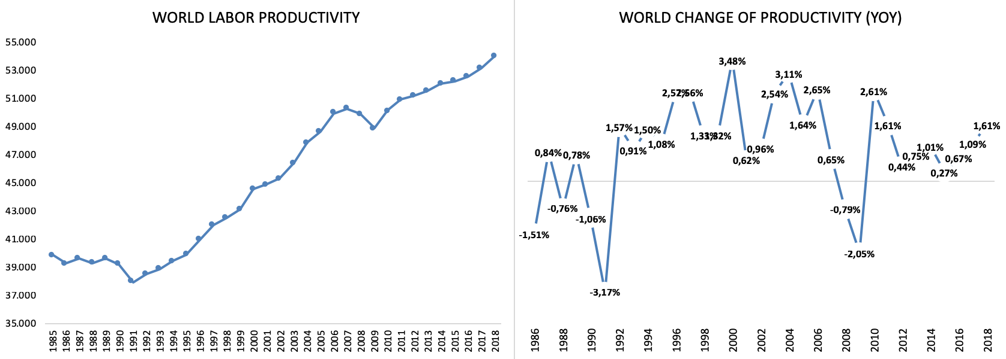
Figure 1. Productivity of Labor. The Average Labor Productivity Across All Countries and its percentage annual change (Source: Total Productivity Database, Conference Board)

Overall, the average of the world’s labor productivity is expanding, but its changes (in percentage terms) are fluctuating. Specifically, labor productivity has decreased since the period 1985-1990, and has then increased in an upward curve. The banking crisis in the US and political conflicts in some developing countries, could be the reason for the weakening of productivity in the 80s. Furthermore, the US subprime mortgage crisis also affected productivity from 2007-2009, which caused productivity to decline and rebound onwards.
However, the positive trend of productivity does not necessarily reflect the progressiveness of its growth. The annual percentage change of the world’s labor productivity seems to have increased since 1985, but, in fact, turns to have been weakening since year 2000. Similarly, the growth of productivity plummeted in the early 90s - which was primarily due to the US recession - and again in 2008 due to the global financial crisis. At those two points, labor productivity fell by 3.17% and 2.05%, respectively, relative to the previous year. In comparison to the year 2017, the world’s labor productivity in 2018 has increased by 1.61%, which is higher than the previous year’s increase, which was 1.09%.
The average measure of labor productivity at the world level can provide us with valuable insight regarding global productivity. Unfortunately, there are also some concerns about these conclusions. Firstly, the average index is calculated using equal weights, which therefore implies that more productive countries can shift their production to the less productive nations, which is not logical. Secondly, every country is treated equally, which should not be the case. Thirdly, the 'average' also implies that the impact of economic shocks in one country can always spread to all other nations, while this is not always true. Thus, in the following section, we would like to narrow our observation of labor productivity to smaller country samples. We will present the countries in two groups, namely the G8 nations and other developing countries.

G8 Countries
Established in 1975, the group of eight (G8 countries) refers to the group of the eight most industrialized nations. They are the United States, France, Germany, Canada, Japan, Russian federation, Italy and the United Kingdom. According to World Bank data, the total GDP of the eight countries in 2017 accounts for 47.48% of the world’s total GDP. Figure 1 below illustrates the movement of labor productivity in the eight countries in the nominal value (US$) during period 1950 – 2018.

Figure 2 Labor productivity in G8 countries in nominal value (2018 US$) (data processed, the Conference Board)
Overall, except for Italy, the path of labor productivity in the G8 countries is one of continuous increase. In 2018, the United States is leading the rest of the countries regarding labor productivity level, while the Russian Federation has the least labor productivity in the group. Russia experienced the lowest labor productivity in 1998, when the financial crisis occurred, and caused the country to default on its debt. The Asian financial crisis, and the decline on metal and crude oil demand, were two external shocks triggering the Russian financial crisis at that time, which then subsequently turned into a political mess. However, Russian productivity gradually rebound to its initial path as the country’s financial institutions started to diversify their assets.
In what is a significantly different case than Russia, Italy is currently under prolonged distress, and still unable to wake up from its weakening productivity. Fiscal management is the greatest challenge for Italy in 1998, which was also the start year of a persistent slump in labor productivity. Subsequently, its high ratio of public debt to GDP makes Italy one of the most vulnerable countries in Europe to any form of external shock.
Let us look at the data in a different fashion. We will now measure the percentage growth in labor productivity every decade since 1950. Figure 3 illustrates the productivity growth for the eight countries in the group. Surprisingly, unlike the positive movement on its nominal value, the productivity growth across countries in the group are all decreasing.
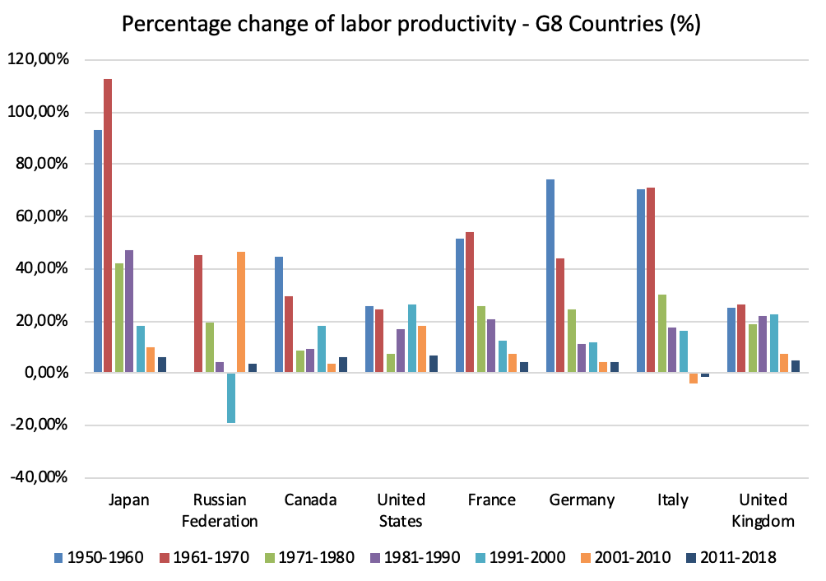
Figure 3 Percentage changes of labor productivity every 10 years in G8 countries
Every decade, labor productivity growth is showing a downturn, with the smallest growth experienced in the year 2011-2018. Even for Italy, productivity growth fell below 0% in the period 2011-2018. How can the increasing welfare gained by industrialized countries correspond to the fall of productivity growth? This phenomenon is known as the “productivity puzzle”; associated with a number of possible causes. We will get more deeply into this issue in the next section.

Other Countries
To have a better understanding of labor productivity across the globe, let us take examine a simple form of analysis, as we did with regard to comparing the G8 countries with other nations. In order for the comparison to be fair, a similar analysis will be implemented in some leading developing countries, namely China, India, Brazil, South Korea, Switzerland, and Saudi Arabia. According to World Bank data, in 2017 the GDP of these six countries made up 24.52% of total GDP in the world. China, in particular, is the world’s second largest economy after the United States, which alone constitutes 15.16% of the world’s GDP.
Figure 4 illustrates labor productivity in nominal level (US$) for the six countries. In comparison to figure 3, we can see that the level of labor productivity in developing countries is below that of industrialized nations, except for Saudi Arabia and Switzerland. Remember that labor productivity is measured as output per employed person; thus, in the case of China, although its economy is rapidly growing, its labor productivity is still below the U.S., as more of its population are employed as labor than in the U.S. Some economic issues, such as excess inventory, asset bubbles, or trade war with the US, could also have the potential impact of pressurising Chinese productivity in the coming years.

Figure 4 Labor productivity in non-G8 countries in nominal value (US$) (data processed, the Conference Board)
Labor productivity in Saudi Arabia, in particular, is known to behave quite differently in comparison with other countries. With oil resources and smaller number of employed persons, Saudi Arabia reached its peak labor productivity up to US$250,000 per employed person in the 1970s, which is superior to any other country. However, the productivity plummeted in the mid 80s, as an oil price crisis hit the economy. Currently, the labor productivity in this country is hovering at $150,000 per employed person, which is still way above the average of world’s labor productivity. Furthermore, Switzerland has reached the similar level of productivity of its peers i.e. France, Germany, the UK and Italy. Finally, Brazil and India are currently hovering at around the similar level of labor productivity, except that economic turbulence is more common in Brazil, and its recent isseus have ensured that its labor productivity has been decreasing during the current decade.
Interestingly, the phenomenon of productivity puzzle is also a conundrum in some developing countries, particularly those with a high productivity slope. Figure 5 below illustrates the percentage change of the labor productivity index, the so-called 'productivity growth', measured every ten years.
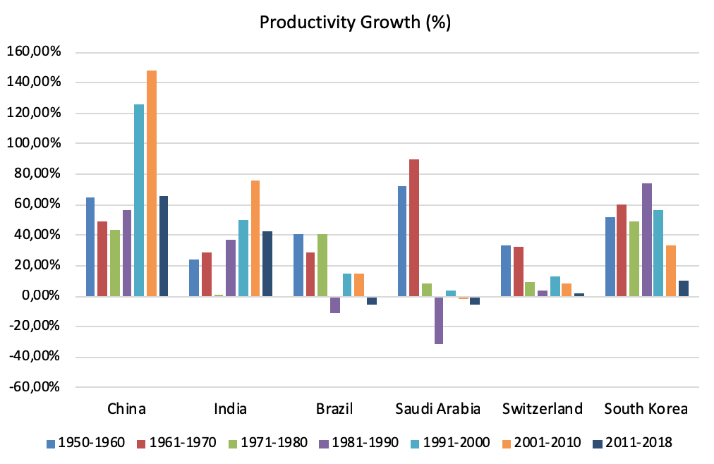
Figure 5 Percentage changes of labor productivity every 10 years in some developing countries
As shown above, weakening productivity growth is obviously observable in South Korea, Switzerland, Saudi Arabia, and Brazil, where the first three countries are placed at the top three on table 3 (note: not quite sure what the second half of this sentence means - CM). In China and India, the trend of labor productivity is an upturning curve. However, even when China and India are considered, the labor productivity growth in all countries during 2011-2018 is found plummeting compared to previous decades.
Overall, as we have established thus far, several results stand out. Firstly, diving into productivity issues in individual countries can give us a better insight regarding the competitiveness of a particular nation, as opposed to relying solely on aggregate measures, such as the IMD World Competitiveness ranking, or the world’s average ratio. Using the labor productivity index, defined as output per employed person, can give us more information regarding the level of productivity, its speed, and how it grows over time. Secondly, the level and growth of productivity in industrialized countries still outperforms those in some leading developing countries. Thirdly, although the level and growth of productivity between industrialized and developing countries is different, the phenomenon of the productivity puzzle continues to exist in both groups. This offers us an indication that the slowdown of productivity growth might be caused by a systematic pattern or similar economic factors across countries, regardless of various economic issues that every country is facing.
So in the following section, we are going to delve more deeply into productivity puzzle. What is it, and what factors are actually affecting this phenomenon?

The Productivity Puzzle
In March 2016, the Bank of International Settlements (BIS), based in Basel (Switzerland), proclaimed the productivity puzzle to be one of the biggest risks to the world economy. This is a well-known phenomenon - the puzzle comes from the fact that the productivity growth of a country tends to decline while technology is developing rapidly. Figure 3 and Figure 5 give us a clearer view regarding the downturn trend of productivity growth in G8 and other developing countries; except for China and India, labor productivity growth declines during the period 1950 – 2018. Between 2008 and 2018, labor productivity in Germany, Switzerland, the United States, the United Kingdom, and most other developed economies has stagnated.

The irony is that while in the last decade the world has enjoyed the fastest technological revolution ever seen, our economies have not become more efficient. This seems like a paradox; automated production and services should be able to produce more with less people. If we took this to its natural conclusion, full automation implies infinite productivity. While we're obviously not at this level, major progress has been made. For example, car manufacturing in Germany has achieved levels of automation whereby 80% of the jobs can be made redundant. Intuitively, this should imply that the industry has become extraordinarily productive, because very few hands produce many cars, with the help of machines. But such a phenomenon has not happened.
Why is it that, in the most technologically advanced decade of our history (between 2000 and 2010), in the years when we saw the explosion of Google and Apple, robotics, the industrial internet, automation and big data, the world economy has not been able to improve the productivity of labor? Labor productivity is a simple equation — output is the numerator, number of employees is the denominator. If technology allows us to produce more with fewer people, why is it instead that countries like Germany, Switzerland and the US are as productive today as they were in 2010? Answering this question is extremely important because we are effectively saying that the world economy (with the exception of a handful of countries) is less competitive today than it was ten years ago.
Let me venture some potential explanations:
- Credit crunch - One of the popular ideas regarding the reason behind this puzzle is the impact of the economic crisis. For instance, economists Carmen Reinhart and Ken Rogoff from Harvard University have taught us that financial crises affecting economies can create a permanent scar on productivity. This logic is similar to an incident in which footballer breaks his / her leg; (s)he may not be able to perform at the same level afterwards, as before the accident. During its lifecycle, the global economy has experienced economic turbulence of various kinds, such as oil price shocks, financial crises, and geopolitical turmoils. One similarity across the crises mentioned is the constraint of credit activity, which is due to the excessive risk aversion of the financial sector. This fear affects the way that banks are able, and choose, to channel their funds. Consequently, the more constrained and prudent credit provided by banks narrows the room for economic agents to expand their businesses. A recent study by the Bank of England suggests that this credit constraint is a major factor that has hampered the growth of labor productivity. Unfortunately, the financial channel does not fully explain why, even when credit activity has been stabilized, and countries have implemented exit policies from their crises, that the productivity puzzle continues unanswered.
- Misallocation of capital and labor across sectors - This is a very interesting avenue, since it suggests that in most countries skills and resources are not matched to jobs, so both the public and private sector invest inefficiently in sectors that do not necessarily create added value. A research piece written by Gita Gopinath, currently Chief Economist at the International Monetary Fund, and various co-authors has shown in the context of the recent European crisis that the decline in real interest rates in the period 1999-2012 led to a significant decline in sectoral total factor productivity. This was due to the fact that capital inflows were misallocated toward firms that had higher net worth, but that were not necessarily more productive. The UK National Institute of Economic and Social Research and the Bank of England have also provided evidence showing that resource misallocation between capital and labor during the crisis was the factor that weakened productivity in the UK.
- Data is wrong - One can obviously argue that output, measured by GDP, does not take into account all productive activities of an economy (more below), nor the quality of its output. The first mobile phone ever launched, the Motorola StarTac, cost about USD1,000 in 1996, which is, in real terms, much more than consumers pay today for the market-leading iPhone X. However, of course, the features of the latter are stellar compared to the former. While this is true, the fact that productivity is not higher today than it used to be, and consequently salaries have not increased, remains. Therefore, today we are less able to enjoy our technology than before, because our productivity, and hence our salaries and purchasing power, are lower.
- Even though we produce higher quality products, what we produce is cheaper - This argument unfortunately does not stand up to scrutiny, because the data in the previous graphs and tables is in inflation-adjusted dollars.
- The McKinsey Global Institute released a study in 2018 assessing the role of demand on the productivity puzzle. They suggested that the momentum of the productivity boom during the 90s has faded. If you were employed during the 90s, you might still remember how tremendous the impact of the use of PCs, software, and information technology was on the way people worked at that time. Unfortunately, that type of euphoria has faded. This thinking explains why the high productivity boom in the past occurred, as the way that people worked changed dramatically, from manual to automation, which resulted in high productivity growth. But today, technology has become widespread in every type of work, in all companies, of all sizes. So, we cannot expect similar productivity jumps as occurred in the past.
- It takes time for technology to impact productivity - That is, today’s innovations need a lag effect actually to materialize and impact on labor productivity. Regarding innovation, the study from McKinsey releases similar statements to those of Gordon (2012) and Cowen (2011) who asserted that the type of technological progress in the past may not continue as progressively in the future. However, Gordon (2012) claimed that current innovation may not be as substantial as in the past, which is understood, as ongoing innovation is more focused on internet technology rather than the physical machine. Decker et al. (2016) even argued that current innovation is sufficiently mature that marginal productivity emanating from future innovation may not be as high as it was in the past. However, this latter point is quite debatable.
- Technology does not make us more productive - Some economists contend that current innovation disentangles labor further from productivity. For instance, the invention of Twitter or Facebook is found to make people less productive. Furthermore, some also argue that the development of technology today is based more on market orientation rather than pushing users to be more productive. Nevertheless, McKinsey (2018) believes that it is only a matter of time before modern innovation has a significant impact on labor productivity.
- Lack of investment - Without investment, job creation deteriorates and productivity suffers. In the post-crisis period, and especially in western economies, there has been a lack of investment in tangible capital, less research and development, less capital replacement by companies, and consequently a smaller stock of capital. The recognition of intangible assets such as patent and R&D should be measured in the same way as physical capital in GDP, yet it is not. This thinking leads many to believe that the lack of recognition for this type of asset hinders innovation to grow even more, which eventually decreases labor productivity.
- The slow diffusion of innovation to firms has also been blamed for the slowdown of productivity. The slow penetration or diffusion process of innovation to companies is the reason for slowing productivity, not the slower rate of innovation itself. However, this slow diffusion can also be triggered by other factors. For instance, less skilled workers in a company can ensure that any innovation is effectively useless. Or, less innovative company’s leaders unwillingness to innovate can also ensure that innovation stalls. Finally, besides the slow diffusion process, some studies also blame governments who help to ensure that productivity is seriously slowed. The blame for this is based on the argument that government policy stabilization, such as fiscal policy or monetary policy, is executed inappropriately, which subsequently destroys productivity itself. For instance, a tight fiscal policy can impose a tax rate that is too high, and this then disincentivizes business to grow, labor to work, or even individuals to save their money. Furthermore, over-tightening monetary policy to prevent economic overheating is also believed to have a persistent impact on weakening credit activity, which subsequently restrains credit offered to firms, and causes labor productivity to fall.
There are two final explanations that are worth considering. Our productivity data is reported as output per capita, not output per hour. It could well be that, if we work fewer and fewer hours as our economies develop, that we would end up living in a more efficient world (higher productivity per hour) but with less productive employees as they work less. Unfortunately, when one looks at productivity per hour, the results are the same as those reported here.
Besides, the explanation could simply be that we work in less productive jobs. If this is the case, then the productivity puzzle is almost a red herring. But this is at odds with the observation that, during recent decades, the world economy has moved from farming to manufacturing, and then to services. And services is more productive than manufacturing, which is in turn more productive than farming — irrespective of technology.
In conclusion, as argued above, many factors impact on the productivity puzzle, ranging from crisis-related causes, to technology, human capital, diffusion dynamics, and many others. However, although the theories mentioned earlier are sufficiently logical, no single answer can actually explain the puzzle. The best guess among all alternatives is that the productivity puzzle is a dynamic phenomenon, which has an equilibrium that is prone to various shocks. By the same logic, if this is a dynamic phenomenon, then a cure to accelerate the productivity in an upward curve should also be identifiable. More importantly, when economic shocks - such as crises, technology, lack of human capital - infiltrate the economy and dislocate productivity from its equilibrium, government policies are of critical importance. For instance, from the fiscal policy side, more budget can be allocated to support education and training, so that human capital can be strengthened. Equally, the government can also assign more budget to prioritize investment in productive sectors, according to the country's endowments and profile, in order to advance its dynamic comparative advantage. Beyond that, other supporting factors to productivity must also be promoted, such as employees’ incentives, innovations, and other aspects that can tend to result in a better quality of life.

Productivity and Wages
Productivity matters because, in an economic equilibrium, individuals should be paid according to how productive they are. If I generate USD20 per hour of work because I am a lumberjack, while my neighbour is a soccer star who sells in an hour USD1,000 in official club t-shirts, he should be paid 50 times more than me. Besides, if technology makes me more productive, or I simply work harder, so next year I generate USD30 per hour in output, my wage should increase by 50%. Certainly, I am not entitled to all the proceeds from my job, because there are production costs incurred, and my company will need to invest in technology and advertising. But it should be the case that, over a long period of time, productivity increases should be approximately equal to salary increases.
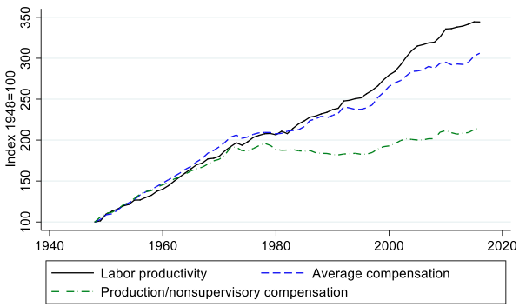
Figure 6. The Gap bewteen Productivity and Salaries. Source: Stansbury and Summers (2018)
In Figure 6, I show the dynamics of labor productivity and average compensation in the United States in the period 1948-2016. The data is collected by economists Anna Stansbury and Larry Summers from Harvard University. Between 1948 and the 1973 oil crisis, productivity and wages grew in parallel, and in 25 years there was an impressive doubling in the average prosperity of American workers. However, the wedge between productivity and pay began in 1973, and grew systematically until today. In their analysis of the most recent period, Stansbury and Summers show that, while productivity grows 1.16%, 2.33%, and 1.15% in the periods 1973-1996, 1996-2003, and 2003-2014, the wage share of such increases is -0.26%, 0.32%, and -0.34% respectively. In other words, we can even see that in the last decade, productivity increases are accompanied by reductions in real wages. There is also a big difference between what the US Bureau of Labor Statistics calls “Production/nonsupervisory compensation” which essentially corresponds to blue-collar workers, and the average worker who represents industry and services employees. For the former, the wedge between productivity and salaries has widened even more.
What has happened? The good news is that while there is an increasing gap between productivity and average pay, there is still a substantial linkage between productivity and median compensation in the 1973-2016 period. To understand what this means, note that as income inequality increases because the top 5% becomes richer and richer, average compensation increases, but median compensation does not. In a hypothetical country with 100 workers where all earn USD30,000 per year, both the average and the median salaries are USD30,000. If instead, 5 out of 100 workers get a pay raise to USD300,000, the median salary remains at USD30,000, but the average salary has now increased to USD43,500.
Interestingly then, what Stansbury and Summers find is that “even as productivity growth has been acting to push workers’ pay up, other factors not associated with productivity growth have acted to push workers’ pay down. So while it may appear on first glance that productivity growth has not benefited typical workers much, [their] findings imply that if productivity growth had been lower, typical workers would have likely done substantially worse.”
All in all, these results suggest two important features of our economies in the recent years: productivity increases have been enjoyed by only a few, and labor has lost in favor of capital (i.e. machines). Few reasonable people would doubt this conclusion, so it is important to discuss the reasons behind it. Non-technological explanations would attribute the gulf to the increasing lack of skills of employees faced with technological innovation, immigration and globalization, and a decline in the power of unions. As for technology, obviously automation and digitalization have reduced the relevance of manual labor, and human skills now require investments in new technologies that are typically implemented at the expense of labor income. These issues will be discussed in the next section.
Governments have a lot of say over most of these issues, and it is the responsibility of public policy to curtail the resulting income inequality by attacking the root causes of the pay-productivity gap. For what is worth, let me add to the explanations above one that has not been discussed enough, namely the growing power of shareholders in publicly-traded firms.
Governance rules after the 2008 crises have prioritized the interests of shareholders against other stakeholders, very often against the original intent of protecting customers, employees, and wider society from the excesses that led to the financial crisis itself. Originally, corporate governance rules were enacted to protect the interest of shareholders against self-dealing executives, because of the very essence of a corporation in which ownership and control are separated. Consequently, the focus of governance rules was to encourage fair representation of shareholders in the board of directors, adequate internal controls to monitor executives, and appropriate compensation rules, disclosure requirements and accounting policies. The conflict today is between large and small shareholders, or more precisely between owner-managers and minority shareholders. In March 2017, Snap Inc., the popular social media company, went public through an Initial Public Offering underwritten by Morgan Stanley, and sold 200 million shares at USD17 per share, thus raising USD3.4 billion. However, all the shares issued carried no votes, stripping shareholders from any decision-making power in the newly listed company. The trick involved was that the company has three classes of shares - A, B, and C. In the IPO, Snap issued only Class A shares. Class B shares carry one vote, and Class C shares carry ten votes. Snap’s IPO prospectus explicitly declares that the holders of all outstanding Class C shares are “a founder, an executive officer, and a director of the company.” Why would anyone invest in Snap Inc. then? If you do, you will consider that, even though you do not have any decision-making power over the company’s future, you are at least entitled to a share of the company’s profits. Wrong. With respect to dividends, Snap Inc. states before the IPO that “We intend to retain all available funds and future earnings, if any, to fund the development and expansion of our business, and we do not anticipate paying any cash dividends in the foreseeable future.” Once you have lost all your rights, your only reason to invest in the company is the expectation that the stock price will increase due to the performance of its leaders. Wrong again. As of January 2019 (almost two years after the IPO), Snap’s stock price is close to USD7 per share. New York Times Deal Book’s Steven Davidoff Solomon called Snap Inc’s deal “the most shareholder-unfriendly governance in an initial public offering, ever”
Unfortunately, the Snap approach to corporate governance is not unique. There are dual-class shares in 222 out of the 3,000 companies in the US Russell 3000 index, including Alphabet (the parent company of Google), Facebook, and Zynga. Among the recent arrivals to the stock market, Alibaba and Spotify give minority shareholders restrictive voting power. Additionally, 84 companies in the S&P500 do not pay, nor intend to pay, any dividends to their shareholders. These companies indeed account for a large share of the total market capitalization of the index, and include Facebook, Alphabet, TripAdvisor, Paypal Holdings, among others.
Lighter corporate governance standards imply more power for controlling shareholders, and subsequently lesser employee rights. Thomas Piketty, in his seminal book “Capital in the 21st century” sees capital accumulation as the reason for the increasing levels of income inequality in the world, and proposes a universal wealth tax as the solution. An analysis of the recent stock market trends shows as well that government policies could curtail inequality without resorting to taxes; instead, they just need to guarantee the empowerment of minority shareholders.

Technology and Competitiveness
A pertinent question is to what extent technology, and particularly technology in the productive system, makes countries more productive, and consequently more competitive. We praise technology for the improvements in productivity and quality of life that the world has enjoyed in the last 70 years. However, in previous sections we have discussed the puzzling observation that, in the last decade, when our technological development has exploded and we have implemented the most disruptive transformations, world productivity has stagnated.
The optimistic view of technology posits that robots make humans more productive, and therefore contribute to economic growth. The only systematic study of the impact of robots in the economy has been conducted by Georg Graetz and Guy Michaels from the London School of Economics. They studied the implementation of robots in 17 European countries during 1993 and 2007, and found that robots accounted for 10% growth in GDP over the period. One channel through which robots contribute to growth is the acceleration of production that reduce production costs and prices, and subsequently increase aggregate demand. A survey conducted by the OECD in 2017 has uncovered very similar impacts in the period 1993-2016.
Technology can have other positive spillover effects. Automation can encourage a country to move its supporting supply chain closer to its homeland, rather than having this outsourced to the other countries. A study by the International Federation of Robotics shows that 70% of respondents in a survey conducted by Citigroup trust that automation would encourage companies to move their manufacturing closer to home. Indeed, Whirlpool, Caterpillar and Ford Motor in the US, and Adidas in Germany, have already done so.

The anti-robot school of thought posits that they overtake human jobs, and increase unemployment. To the extent that the competitiveness of a country relies on its ability to generate jobs, if robots only make us more productive but push people out of the job market, they should not be encouraged. It is undeniable that implementation of robots in industries is widespread, and it has even become a necessity for enterprises to survive in the hugely competitive globalized marketplace. The McKinsey Global Institute predicts in its 2017 report that up to half of the total productivity growth required to ensure a 2.8% growth in GDP over the next 50 years will be driven by automation. However, McKinsey surprisingly states that “our productivity estimates assume that people displaced by automation will find other employment,” without further pursuing the question of what jobs will be created. If I adopt David Graeber’s terminology, I suspect that most of these will be bullshit jobs, tasks that do not create value for society beyond self-fulfillment and that they will almost inevitably be low-paid jobs with poor long-term outlooks.
Technology has two other detrimental effects on economic development, well documented by Financial Times associate editor David Pilling in his book “The Growth Delusion.” When digitalization removes activities from the formal economy, and instead moves them into the informal or black economy, GDP reduces automatically. For example, we use email instead of the postal service, listen to music through our unlimited subscription to Spotify, instead of buying a record, and use a car-sharing internet platform to move across the city, instead of taking a taxi. Secondly, technology makes stuff cheaper, therefore reducing nominal and, more importantly, the real GDP. This is the case because technology actually substitutes products and services, it does not merely make the same product cheaper. Thirty years ago, we had to buy a flashlight, a camera, an agenda, a voice recorder, a watch, an alarm clock, a telephone, and even a heart sensor in order to perform several tasks that can be done today with just a smartphone.
Overall, competitiveness policies related to robotization should be analyzed through the employment lens, and more broadly by considering whether technology improves the quality of life for all citizens, including those displaced from the labor market.

Value drivers and Key Performance Indicators
In the same way that companies distinguish between value drivers and performance indicators, government officials have to be careful as well not to pull the wrong levers when managing an economy. We are confronted with this distinction frequently in our executive classes. When company strategy specifies that the goal is to be the market-leader, for example, two important decisions must be made. Firstly, determining which Key Performance Indicators (KPI) the company is going to use in order to measure market leadership - market share (which market? Share in revenues or in profits?), sales volume, the number of countries in which the company is number one in its product market, etcetera. In some cases, choosing a KPI is straightforward. If my objective is to generate double-digit growth, I will look at revenue growth. If my objective is to be highly profitable, I will set a benchmark based on a minimum operating profit margin. As Peter Drucker used to say: “If you can’t measure it, you can’t manage it.” The second decision is both more important and more difficult to tackle. This is because KPIs are not directly affected by company’s decisions, but indirectly impacted by managing a corresponding value driver. To manage profitability, value drivers are pricing, marketing strategy, product mix, quality controls, failure tolerance, cost discipline, and cost of capital. To manage growth, value drivers are acquisition strategy, market entry approach, innovation, financing costs, and service quality.
Competitiveness, or a competitiveness ranking, is at the end of the day nothing but a country’s KPIs. As a performance indicator, it encompasses several other ingredients that we have discussed earlier, namely productivity, prosperity, quality of life, attraction of foreign capital, job creation, the image of the country abroad, and the talent capital of the nation. These are all KPIs that allow countries to translate competitiveness into measurable macroeconomic figures. But they should not be considered managerial tools. For instance, productivity cannot be managed directly, and surprisingly the strategies of many countries fail because they do not tackle the factors that determine productivity, instead mistakenly choosing to tackle productivity itself. I once spoke to a high-level government official from a government that shall remain nameless who told me that the country had put emphasis on improving their ranking in the World Bank’s Ease of Doing Business ranking. The country did indeed manage to improve the ranking in a relatively short period of time (they have a good dictator), but to the chagrin of the government, “the country did not see any increase in the number of businesses being created.”
Thus, productivity is the key to achieving competitiveness, particularly in the long run. More productive countries correspond to their higher levels of competitiveness, which in turn are expected to increase the country’s social welfare. However, productivity alone cannot guarantee to realize strong competitiveness. It must be supported by the soundness of other pillars, such as institutions, infrastructure, macroeconomic environment, health and primary education, higher education and training, goods market efficiency, labor market efficiency, financial market development, technological readiness, market size, business sophistication, and innovation.
Managing wages is one way to manage labor productivity. Theoretically, higher wages can incentivize workers to be more productive. However, this may also deter companies from hiring employees. Therefore, considering whether minimum wages, for instance, increase competitiveness boils down to carefully considering these two sets of effects.

Setting the Competitiveness Path
In this section, we will discuss the importance of the starting conditions required in order to be competitive. Countries rich in natural resources, with privileged geographical positions, and with long-standing entrepreneurial values and law-abiding cultures, find it easier to be competitive. But as important as the initial conditions of a nation is the path that it chooses to follow, and this is normally shaped by good/bad decisions, luck, and external events. Let me illustrate this point with the example of Slovenia and Belarus, two Slavic countries, located in Europe, both with a moderate population, not big territories compared to their neighbors, and both embryonic countries after they gained their independence from the USSR in the early 90s. And yet so different in terms of diplomatic reputation, political freedom, economic prosperity, life expectancy, and competitiveness today. How did this divergence occur?
The Slav people spread through Europe from the 6th century, and as their area of influence extended, they also started to separate into smaller groups. Belarusians and Slovenians have existed as such since the 10th century, when the Slavs divided into three groups – south, east and west, whereas Slovenian territories belonged to the south, and Belarusian to the east. As time went by, those three groups splintered into smaller groups, which became proto-nations of the modern countries.
Both countries were constantly affected by some of their numerous influential neighbors. That influence continued for such a long time that there were no official names for those states until the 20th century. Speaking of Slovenia, it was known by several names historically - Slavic tribes under Venetian ruling, Carinthia in the Holy Roman Empire, Inner Austrian Provinces when led by the Habsburgs, Illyrian provinces, Carniola as part of the Austro-Hungarian empire…its identities were numerous! The first time the Slovenes declared themselves more than a minor ethnicity was in the 19th century during the Spring of Nations. At that time, the Slovenes had spent roughly a thousand years under a German/Austrian feudal domination, and their territories were heavily Germanized.
Still, the Slovenes managed to preserve their culture and places of origin. As the Slovenians talk about their history they say: “We were not Germanized, rather Europeanized”. That is, they took the best ideas they could take, learned from the Europeans, who were the pioneers of various technologies back then, and decided to go their own way.
Actually, from the beginning of the 11th century, their territories were slowly assimilated into the Roman Empire, and only natural borders, like mountain ranges and rivers, protected Slovenians from Germanic influence, and helped them preserve their own culture. That changed in the beginning of the 17th century when the Protestant preacher Primoz Trubar printed the Bible in the Slovene language. The Bible spread across the national lands and gave the Slovene language, and thus its culture, a second life.
As for Belarus, its name first appeared on maps only during the First World War, when local citizens proclaimed the Belarusian People’s Republic, under the reign of the German Kaiser. The Republic was never recognized, however the Belarusians made it clear they were a nation. And soon after the war, the Belarusian Soviet Socialist Republic was created within the boundaries of the Soviet Union.
Of course, the Belarusians appeared as a nation much earlier. The eastern group of Slavs consolidated their lands into Kievan Rus first, then the group divided into more autonomous principalities. The proto-principality for Belarusians was the Polotsk Duchy, which was conquered by the Principality of Lithuania, which later created the Commonwealth with Poland, which was then partitioned by the Russian Empire. That is three centuries under a moderate Lithuanian influence, three centuries under a more intense Polish influence, and two hundred years under the Russians. Each of the historical periods shaped the future nation. And from the establishment of the Lithuanian Duchy, the Belarusians began to emerge as a new culture aside from the Ruthenians. The Ruthenian lands were the southern lands of the former Kievan Rus. They differed from the northern Muscovite and Novgorodian lands in culture and dialect, and had such names as Red, White and Black Ruthenia, which would become later Ukraine, Belarus and the Baltic states, respectively.
After the dissolution of Austria-Hungary, Slovenia joined the newly born Kingdom of Serbs, Croats and Slovenes. Slovenian territories suffered significant destruction from the involvement of the fatherland in the First World War battles. Instead of being divided among several powers, the Slovenes agreed to become a part of a new state. However the Slovenian capital — Ljubljana — had been untouched by the war, and the country was fortunate enough to enjoy a stronger economy than Serbia and Croatia in the period between the two World Wars. Even though the region of Koroska in the north voted to join Austria in a referendum, and Primorska in the West went to Italy under the Treaty of Rapallo, the Slovene economy and culture developed significantly during the 1920s. The nation's main city witnessed the foundation of the University of Ljubljana, the National Gallery, and the Academy of Sciences and Arts during this period.
This era all came to an end during the Axis invasion of Yugoslavia, though. Germany considered the Slovene territories as part of Styria, a former part of Austria and Italy that had claims over territories all over the Adriatic. After the invasion, Slovenia was partitioned between these three countries. The Second World War had took a heavy toll on Slovenia; during the war many Slovenes fought a guerilla war against the Nazis under the leadership of the Communist resistance leader, Marshal Tito. Consequently, the Slovenians lost 5% of their population.
Nonetheless, Slovenia made great progress under Yugoslavia’s market-oriented “self-management” form of socialism. Slovenes made up less than 10 percent of Yugoslavia’s population, produced 20% of the country’s wealth, and generated 30% of its exports. By the 1980s the Yugoslav economic system got into debt and stagnation, and resentment over the Belgrade central government’s policy of distributing subsidies from the more prosperous northern republics to the less-affluent and often corrupt southern republics led to Yugoslavia’s breakup.
Slovenia, deprived of a secure market and confronted with the economic dislocation that forced Slovene to compete for business in a broader market, started to demonstrate and suffer from the weaknesses of its “socially owned” enterprises. These included featherbedding, limited professional skills, poor competitiveness, undercapitalization, outmoded production methods, and resistance to innovation. Conversely, the modern infrastructure of the country also became visible, and Slovenia’s traditionally strong social discipline had been firmly established; undoubtedly a cultural plus point going forward.
By the early years of the 21st century, the Slovene economy was based primarily on services and trade. The shift to a market economy had improved the standard of living in rural localities, despite only modest changes in the traditional smallholding pattern of landownership. It had also produced a small group of newly wealthy individuals — tajkuni or tycoons. Most of the economy was now privatized, and a significant source of income came from the manufacture of automotive parts, pharmaceuticals, and electrical appliances.
While some aspects of the former socialist rule have been maintained, the Slovene government has adopted several democratic measures, including a parliamentary form of government. The president is now the head of state and supreme commander of the armed forces, and cannot be elected for more than two five-year terms. Executive power is held by the prime minister, and a fifteen-member cabinet. There are seven political parties in Slovenia that support ideologies ranging from the far right to the center-left. The majority of Slovenes, approximately 71 percent, identify themselves as Roman Catholic, and Roman Catholicism has undoubtedly influenced Slovene culture more than any other religion.
Among the numerous commercial activities in Slovenia, tourism is of great importance. Slovenia's proximity to the Alps and the Mediterranean, along with its climate, makes it a popular tourist destination. The business derived from tourist hotels, ski resorts, golf courses, and horseback-riding centers provides employment for a growing number of Slovenes.
…
By the same token, Belarus went through the same circumstances and events – namely, WW1, WW2, a nation inside a socialist state, and then independence. There were some crucial differences, though. When WW1 ended, another war erupted immediately between Russia and Poland, with Belarus and Ukraine caught in the middle. The Russians were ultimately defeated and forced to cede Western Ukraine and Western Belarus to Poland. Russia kept part of the remaining Eastern side, so “Belarus” was restricted to a small strip, which included the city capital of Minsk. Over the 1920s, the Eastern territories were gradually returned to Belarus. However, some of the traditional Belarusian territories, like Smolensk and the Bryansk regions, remained under Russian domination indefinitely.
Western Belarus was returned in 1939, right before the Second World War started, and thus had to be integrated into the rest of the country. Only two years passed before the eastern front of WW2 opened on the borders of Belarus. The war was catastrophic for the country – around 25% of Belarusian people died. The destroyed state was to be reconstructed from these undoubted ashes, though, and it took only 26 years to reach the pre-war level of population. During this process of rebuilding, Belarus became part of the USSR after 1945.
The economy recovered much faster - instrument-making, radio engineering, and radio-electronic industries were all developed successfully. The enterprises of these industries supplied electronic computers, optical, electrical, control devices, cinema equipment, TVs, watches and much more. Belarus became an assembly workshop of the Soviet Union, with chemical and petrochemical industries specializing in the production of mineral fertilizers, tires, plastics, and synthetic materials, particularly chemical fibers. The country also hosted the largest production of potash fertilizers in the USSR.
Unfortunately, the infamous nuclear accident in 1986 at the Chernobyl nuclear power plant - which is only 150 kilometers from the Belarusian border with Ukraine - had a devastating effect on Belarusian agricultural industry. As a result of the radiation, the agriculture sector in a large part of the country was destroyed, and many villages were abandoned. Since gaining its independence from the Soviet Union, Belarus moved relatively slowly on privatization and other market reforms, emphasizing instead close economic relations with Russia. About 80 percent of all industry remains in state hands, and foreign investment has been hindered by a political climate that has not always ben especially friendly towards business. Furthermore, the Russian financial crisis that began in autumn 1998 severely affected Belarus's Soviet-style planned economy. This was particularly important as Belarus is almost completely dependent on Russia, which buys 70 percent of its exports.
The movement toward a market economy in Belarus was also slower than that of other former Soviet republics, with only a small percentage of state-run industry and agriculture privatized in the years following independence. Largely in response to this economic upheaval, Belarus sought closer economic ties with Russia. In the early 21st century, Russia remained a major trading partner, although relations between the two countries had become tense as a result of disputes over the price of imported gas and oil. And the last but not least fact - about half of Belarusians consider themselves nonreligious or atheist. Roughly two-fifths of the population adheres to Eastern Orthodoxy, which, while not the official religion, maintains a privileged status in Belarus. Roman Catholics constitute the largest religious minority.
…
As we can see, Slovenia and Belarus have a lot in common, and yet Belarus is stagnating in life standard relative to its neighbor. Both countries were quite well developed as a part of a system of a larger federation, and both faced the same issue - trying to diversify their economies to develop a broad market. Slovenia succeeded and Belarus slowed down. And the reason for this is not in their economic development, but in their history, geographical position, and the people of the nations themselves.
The main difference between those states since olden days is religion. Though Catholicism and Orthodoxy are branches of Christianity, Catholicism proved to be more flexible to changes while the main value of the second branch was conservatism. While both of these two systems of values have their merit, if we speak about economics and technology – flexibility is more profitable. And conservatism still affects the Belarusians to some extent; not positive for the economic outlook of the nation.
The second difference is geography. Slovenia enjoyed the privilege of being a traffic hub in Europe, located closely to the technologically and scientifically superior western countries. It effectively played the role of a bridge between eastern and western Europe, meaning that the country has always been strongly identified with central Europe, maintaining a balance between its Slavic culture and language, and diversifying Western influences.
Belarus is situated much further to the east, and thus lacked access to the sea, which hindered the speed of receipt of any useful goods and information from overseas. After the dissolution of the Soviet Union, several countries from the former Union and the Warsaw Pact were able to become a trade node between Russia and Europe. Poland achieved this goal first despite being in similar struggling economic conditions to those of Belarus.
Slovenia chose to focus on the west, but still preserved its connections with the east and former Yugoslavian states. In fact, some of the most developed countries are the main partners of Slovenia and help to develop the country greatly.

Belarus, however, managed to exact some profit from being in the middle of the road, effectively connecting European Union and eastern countries with Russia. Actually, the first steps of the new country were the turning to the West, encouraging nationality, changing the coat of arms and flag to the historical one and introducing a new economic model – capitalism. The state didn’t know exactly what to do with the new possibilities and freedom at first, because the previous Belarusian model of economics – which was entirely based on social economy - was a fundamental part of the system. The difference between Slovenia and Belarus at that stage was that Slovenia got stuck in another economic model, based on titoism – the social model of Yugoslavia.
Conversely, Yugoslavia was the first socialist country to attempt far-reaching economic reforms. Because of its early start and frequency of systemic changes, it was considered the most reformed socialist economy. For over forty years, Yugoslavia has tried to develop its own model of socialism based on workers’ self-management, ample decentralization, social ownership, and an increasing reliance on the market mechanism. This continuous experiment with economic reforms produced an economic system with specific characteristics, based on a combination of socialist, self-managed and market features, facilitated by the country’s international relations. Another distinctive feature of Yugoslavia was that the socialist model emerged from a grassroots revolution led by Tito’s partisans during World War Two.

In this regard, Slovenia was more ready than Belarus to change its politics and economy. Belarus went through the same first complicated years as an independent country, during which numerous factors impacted on the state of the nation. The state was becoming westernized, particularly when an economic crisis occurred in the 90s. Belarus stood between a longer path to further development and a quicker way – reconnection with Russia. What was supposed to be a temporary arrangement led to a prolonged union between Russia and Belarus...until now. While Russia supported the Belarusians, its influence became greater than was expected. The current President, however, did not hesitate in offering his negative thoughts about the interrupted integration into the EU.

So the reasons for such a difference are as follows:
- History and religion, which had a huge impact on both countries;
- Geography, where Slovenia is a transit between the countries, comparable in size and force and Belarus is a transit between EU and huge Russia with many ambitions on the Belarusians;
- The 20th century historical developments outside of the two countries, which led Slovenia to end upa with a social-capitalist economy and Belarus purely socialist;
- Belarusian cultural, which send them first into the EU arms for a quicker stabilization of economy and later on into Russian’s. Yes, it was the President’s decision, but few people stopped him back then;
- Sitting between EU and Russia, Belarus still has not decided which side to pick and consequently chose social-capitalistic economy, which disadvantages were already proved by Yugoslavia;
- The main one – Belarus wants to get into EU but closer ties with Russia and their influence only allow Belarus to withstand an unlikely accession.

Belarusian opposition is not on the list, because they have already shown the inability to gather people, nor to affect Belarusian culture. There may be a window, however. Any change of politics depends purely on people and their culture. The situation with Crimea made many Belarusian elders turn to the EU instead of Russia, while young people have mainly supported integration into the EU. The new generation of Belarusians will definitely strive towards Europe, and this could also be reflected in the emerging political culture and structure of the nation.

Are there alternatives to GDP and Competitiveness?

I argue, and believe, that competitiveness is the most appropriate metric of a country’s success, and that GDP is not. There is, however, a long list of alternatives to either one that we can use with more or less accuracy to measure prosperity. My main concern with the list below is that in many cases those key performance indicators of a country are not easy to manage. For example, the Economist’s Quality of Life Index, or a country’s Stock Market return. Some others only take into account a particular aspect of an economy, ignoring the other foundations of prosperity and economic success — for instance, Ecological Footprint and the Environmental Sustainability Index. Some countries have made efforts to find the right metric that can be managed as well. However, in their attempt, they often leave economic development playing a secondary role, thereby jeopardizing the sustainability of the country’s success. I am specifically referring here to Bhutan’s Gross Happiness Index, which I analyze in a subsequent section. Before I do this, let me present a sample of widely known alternative indicators of economic health.

Measure of Economic Welfare
Measure of Economic Welfare (MEW) is an alternative measure from GDP that was developed by William Nordhaus and James Tobin, two Nobel laurates, in their article entitled ‘Is growth obsolete?’ in 1972. MEW is constructed by adding to Gross National Product (GNP) the value of household services and leisure. Hence, MEW is calculated by adding up benefits such as consumption of goods and services, while subtracting social costs such as pollution, police service to combat crimes, defence, etc. The ingredients within MEW usually depend on researchers’ subjective assessment. Nordhaus and Tobin also provide an evaluation named Sustainable Measure of Economic Welfare (SMEW), which is the MEW that is adjusted by preserving natural capital.

Index of Sustainable Economic Welfare
Another alternative measure of GDP is known as the Index of Sustainable Economic Welfare (ISEW). The ISEW was designed by the World Bank’s economists Herman Daly and John Cobb in the 1980s as an appendix in the book ‘For the Common Good’. ISEW is calculated by adjusting personal consumer expenditure with social benefits and costs. The social benefits include services from domestic labor, non-defensive public expenditures, and economic adjustments, while social costs include adjustment for income inequality, costs for environmental degradation, defensive private expenditures, and depreciation of natural capital. When one tracks both GDP and ISEW over time, they move in parallel during the 1950s in the US, but start diverging from the 1960s onwards, with GDP increasing more rapidly than ISEW. On this basis, it seems that that GDP-oriented policies pursued during the 1960s might have damaged economic welfare.

Genuine Savings
Genuine saving (GS) is the indicator originally designed by the World Bank in 1997. The GS is obtained by adjusting gross national savings with depreciation of produced assets, investments in human capital, and depletion of natural resource such as depletion of minerals, energy, and forests. The World Bank has computed GS for 120 countries and revealed that the increase in social welfare is primarily caused an the increase in intangible assets such as human capital and social capital. Thus, increasing economic activity by destructing natural resources can decrease welfare in the long run. African countries usually score low in terms of Genuine Savings.

Green GDP
Green GDP is the alternative measure of GDP that adjusts GDP by environmental degradation and depletion of natural resources. In other words, Green GDP is an index of economic growth that incorporates the environmental consequences from the growth itself. However, the Green GDP index is complicated as the index needs to set market prices for environment and social benefits. In solving this issue, the Green GDP is calculated based on the user costs of exploiting natural resources and on the value for the social costs of pollution emissions.

Ecological Footprint
Ecological Footprint (EF) is another GDP alternative indicator that was developed by Mathis Wackernagel and William Rees from the Global Footprint Network. This indicator measures whether the economy demand towards environment lies below or exceeds the capacity of environment can provide. In other words, the indicator aims to capture the flow of transformation of environmental energy into economic assets. The EF also measures how much land area required to sustain a given population at present levels of consumption, technological development and resource efficiency.

Happy Planet Index
The Happy Planet Index (HPI) is the index that developed and published in July 2006 by the New Economics Foundation (NEF) to measure a country’s environmental impact in delivering human well-being. The index has been implemented to 178 countries and designed based on two objective indicators, namely life expectancy and ecological footprint per capita, and one subjective indicator namely life satisfaction. Mathematically, HPI is obtained by multiplying life expectancy and life satisfaction, divided by ecological footprint. For example, although people in the US and New Zealand report similar levels of life satisfaction, New Zealand’s HPI is 13 points higher than the US because people in New Zealand has longer life expectancy for smaller usage of resources than the average of US citizen.

Human Development Index
The Human Development Index (HDI) is an alternative indicator from GDP that was designed by the United Nations Development Programme (UNDP). The HDI was designed to emphasize that people and their capabilities should be the ultimate criteria for assessing the development of a country, not solely based on economic growth. HDI is composed by three dimensions: long and healthy life, knowledge, and living standard. The dimension of long and healthy life is proxied using life expectancy indicator (or life expectancy index). Dimension of knowledge is proxied by education index, covering expected years of schooling and mean years of schooling. Finally, a decent standard of living is proxied by Gross National Income (GNI) index. The simple average from the three dimensions constitute Human Development Index. According to UNDP, HDI was initially implemented to report only 14 and it is today reported for 177 countries. HDI has been used for several objectives, such as to assess national policy choices, to stimulate debate on government policies, and to highlight internal disparities within countries, between provinces or states, across gender, ethnicity, and other socioeconomic groupings.

Environmental Sustainability Index
The environmental sustainability index (ESI) measures the overall progress of environmental sustainability. The index was released in Davos at the 2005 annual meeting of the World Economic Forum. The index basically measures the sustainability of environment based on five important factros—environmental systems, environmental stress, reducing human vulnerability, social and institutional capacity, and global stewardships. There are 21 factors in total underlying the five factors above. For example, the ESI covers natural resource endowments, past and present pollution levels, environmental management efforts, contributions to protection of the global commons, and a society’s capacity to improve its environmental performance over time. This index has been applied in 146 countries and has been used as a tool to achieve global scale policy goal, such as at the 7th Millenium Development Goals aiming at ensuring environmental sustainability.

The Economist’s Quality of Life Index
The quality of life index (QLI) is an alternative GDP indicator which is designed by the Economist Intelligence Unit. It links the results of subjective life satisfaction surveys to the objective determinants of life quality across countries. The index has been calculated for 111 countries for 2005. The QLI classifies life quality into nine determinants, namely material wellbeing, health, political stability and security, family life, community life, climate and geography, job security, political freedom, and gender equality. The QLI is measured through linear regression analysis with the perception score of life satisfaction as a dependent variable, and the nine determinants as independent variables. Based on the regression, only variables with statistically significant that chosen as major determinants affecting the life satisfaction. Furthermore, the value of parameter in the equation is then used to predict the future value of life satisfaction score.

The Better Life Index
In 2011, the OECD developed a new indicator called The Better Life Index as one of the realizations from Sitglitz-Sen-Fitoussi Commission, which is the commission on the measurement of economic performance and social progress. The better life index is intended to create a comparable measurement unit that can be used for cross-country comparison. The index is presented in the form of a dashboard consisting of 11 indicators reflecting the comprehensive measurement of the economic well-being of a country. These 11 indicators are housing, income, jobs, community, education, environment, civic engagement, health, life satisfaction, safety, and work-life balance. The idea behind this indicator is that countries need to look beyond just income and focus on inequalities and true happiness. The eleven indicators are depicted as a flower-shape consisting of 11 petals which together constitute well-being as a whole, where better achievement is indicated by a longer leaf. Bases on this system, no country is superior in everything.

Calvert-Henderson Quality of Life Indicators
The Calvert-Henderson Quality of Life Indicator was first published in 2000, and was developed as a joint work between Calvert group, a socially responsible investment firm, an economist Hazel Henderson, and a multi-disciplinary group of practitioners and scholars from various institutions covering government agencies, profit-driven companies, and non-profit organizations. The goal of this indicator is to inform and present a framework through which one can understand and assess salient national trends, using rigorous empirical techniques and reliable data (Henderson, 2000). The indicator measures the quality of life based on twelve dimensions, namely, education, employment, energy, environment, health, human rights, income, infrastructure, national security, public safety, recreation, and shelter.

Income Inequality
Income inequality is one of the key success metrics for any country. As explained in Cobb et al. (2007), high income inequality potentially increases crime, reduces labour productivity, and jeopardizes investment. More importantly, higher income inequality also reduces welfare because social benefits for highly wealthy individuals are less meaningful than for less wealthy individuals. Today, there are two most frequently used indicators in measuring income inequality, namely the GINI ratio and the Atkinson ratio. The GINI ratio is an indicator developed by an Italian statistician named Corrado Gini in 1912, while the Atkinson ratio is the ratio developed by British economist Anthony Barnes Atkinson in 1970. The aim of both indicators is to measure inequality in income distribution. Figure 4 illustrates the Atkinson ratio across all countries during period 2013-2017.
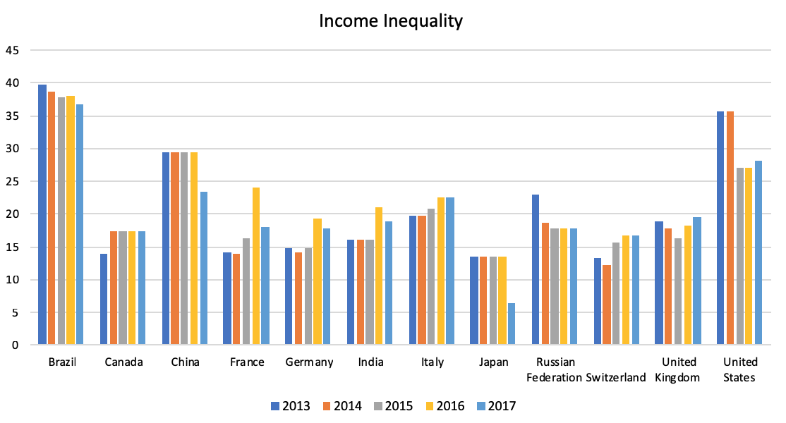
Figure 7 Atkinson Ratio to Measure Inequality in Income Distribution (source: UNDP)
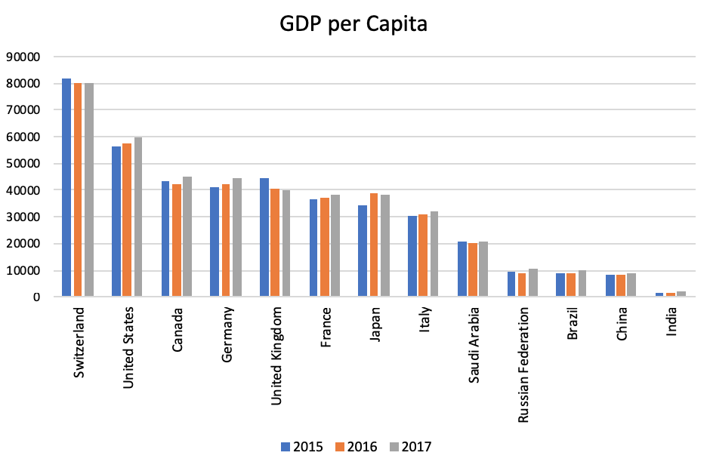
Figure 8 GDP per Capita Across Countries (Source: World Bank)
It is important to note that higher Atkinson index scores correspond to worsening income equality. According to Figure 4 above, among all countries, Brazil obtained the highest score of the Atkinson index in 2017, which implies that this country is faced with the worst inequality problem, followed by the United States and China. On the other hand, Japan is recorded as the country with most equally distributed income, which is followed by Switzerland and Canada. With comparison to GDP per capita of all countries (Figure 5), we find that higher GDP per capita does not guarantee lower income inequality. The United States is one example that bucks this trend; despite the fact that its GDP per capita is the second best after Switzerland, its income inequality is found to be the second worst after Brazil.
Even when we focus on a single country, the coexistence between GDP per capita and income inequality is not guaranteed. In the two figures above, France is an example where the increase in GDP per capita during 2015-2017 is followed by a worsening Atkinson index, rather than an improving metric. Another good example is Italy. During the period 2015 – 2017, Italy achieved improvement on its GDP per capita, but the rise of the Atkinson index was still notable during this period, rather than a decline, as would be desirable. Thus, assessing countries’ success in terms of income inequality cannot be interpreted from their GDP per capita. Likewise, considering that a happy country should promote high income equality, the GDP per capita is deficient in capturing any country’s true happiness.

Democracy Index
Another measure of success for a country is democracy, namely the freedom to speak, and the freedom to contribute in determining the future path of the country. One of the sources of strengths for a country to achieve success is a strong bonding of all components within the country itself, including government, citizenry and its natural environment. In measuring democracy, the Economists Intelligence Unit designed a composite indicator of democracy, which was composed of five main determinants - electoral process and pluralism, the functioning of government, political participation, political culture, and civil liberties (The Economists Intelligence Unit, 2018). Figure 6 below illustrates the democracy index for the countries under this sector of the unit.
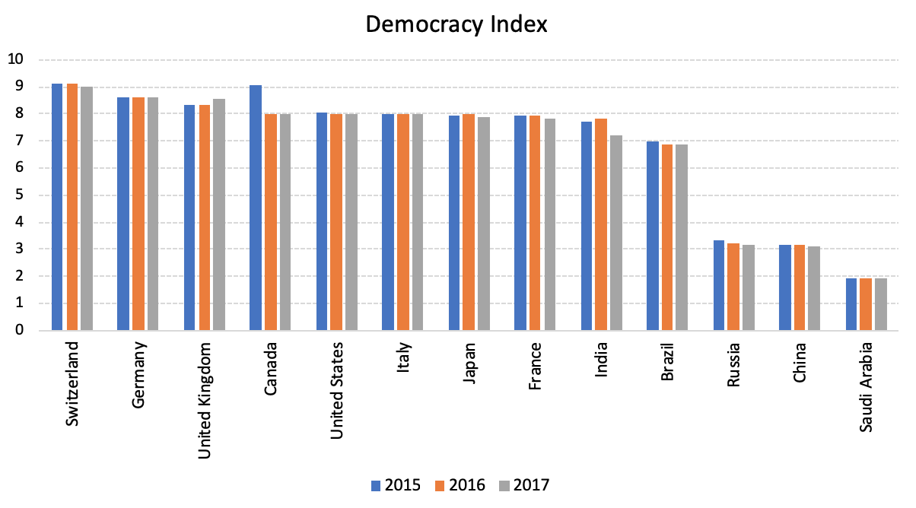
Figure 9 Democracy Index Across Countries (Source: The Economists)
As shown in Figure 6, across all countries, Switzerland surpasses other nations with its score in the democracy index of 9.00 in 2017, followed by Germany and the United Kingdom. Conversely, Saudi Arabia posts the lowest score of the democracy index with a score of less than 2, which can be easily understood, as this country is a conservative and autocratic kingdom. However, across all countries, it is interesting to note that the democracy index slightly decreased during period 2015-207, except in the United Kingdom. However, in comparison to GDP per capita, as shown in Figure 5, only Switzerland has a perfect match between GDP per capita and its democracy index, while the rest of the countries represent weak relationships between GDP per capita and democracy. For example, even the UK, which has lower GDP per capita than the US, can exceed the position of the US in terms of the democracy index. This result also confirms how GDP per capita lacks relevance in representing the country’s success in terms of democracy.

Job Creation
Job creation is another measure of success for any country. Theoretically, with strong employment opportunities, people can earn more income, and increase their consumption. Eventually, when consumption rises, people can enjoy better social welfare. Thus, a successful country is ideally able to present vast job opportunities. In part, job creation is approximated by a macroeconomic measure referred to simply as 'employment', which is the percentage of labor forces to total population. Figure 7 illustrates the employment rate in a sample of countries.
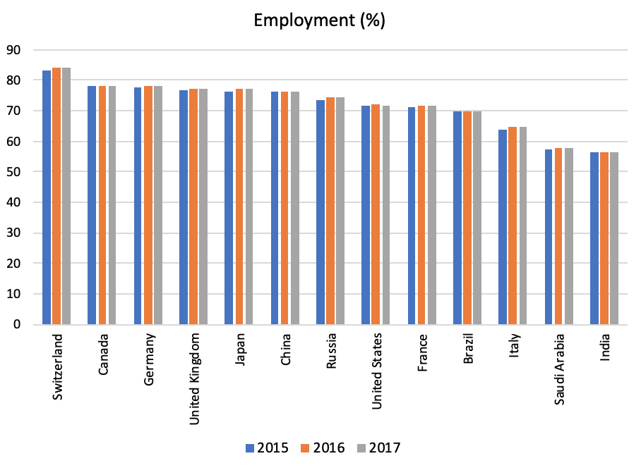
Figure 10 Employment Rate (Source: World Bank)
Again, as shown in Figure 7 above, Switzerland remains at the top of the list of successful countries in terms of employment rate. In 2017, Switzerland recorded an employment rate of 83.9%, even surpassing the United States, which remained in the bottom half of nations compared. The employment rate in Switzerland is even showing an increasing trend since 2015. Second place in the list is Canada, which recorded an employment rate of 78.19% in 2017, and which has remained relatively constant since 2015. Conversely, India is the worst performer in this list, suffering with an employment rate of less than 50%. GDP per capita also points to Switzerland and India being the best and worst performers in terms of job creation. However, the indicator is not able to correspond entirely accurately to the job creation rate in other countries. For example, based on GDP per capita, the United States is the second best country, while it lies at eighth in terms of job creation. Thus, although GDP per capita is able to approximate the best and worst performer, its ability to represent the country’s happiness in terms of job creation remains weak.

Stock Market Return
For some, the success of a country can be defined as any nation that can offer high returns for investors. The theoretical foundation behind the interest on stock market return is that when a country is attractive, internationally competitive, and gains confidence as a result, the country should ideally be able to offer a high return for its stock investors.

Figure 11 Stock Market Return in USD during period 1998 -2015. Index 2008=100 (Source: Datastream)
Furthermore, by providing higher rates of return to investors, host countries can harness the liquidity received to develop their economy, and then enhance social welfare. Thus, by setting stock returns as the bar of success, those countries which offer high stock market return on average are more successful than those offering less. However, if we stick to the conservative view that GDP per capita is the best indicator to measure welfare, then the best performer based on stock market return should be identical to that, based on stock market performance.
Figure 11 illustrates the stock market return measured in US dollars from the examined countries during the period 1998-2018. Due to high stock market return volatility, the performance of the stock market is measured by the linear regression method during the period. If classified by stock market performance, China is the best country - USD100 invested in Chinese stock markets in 2008 yield USD1,081 by the end of 2018. However, USD100 invested in Italy would have returned only USD181 ten years later.

Foreign Direct Investment
The final indicator we would like to compare is the net flow of foreign direct investment (FDI), which represents the ingoing and outgoing investment of a country at a certain period of time. The idea behind this indicator is that a successful country should attract more investment from international investors, which generate income and help the country to achieve higher social welfare. Thus, if we agree that GDP is an ideal indicator to measure the success of a country, then the most successful countries from the perspective of GDP per capita should be identical to this measure from the perspective of net FDI. Figure 9 illustrates the net flow FDI in some countries during period 2015-2017.
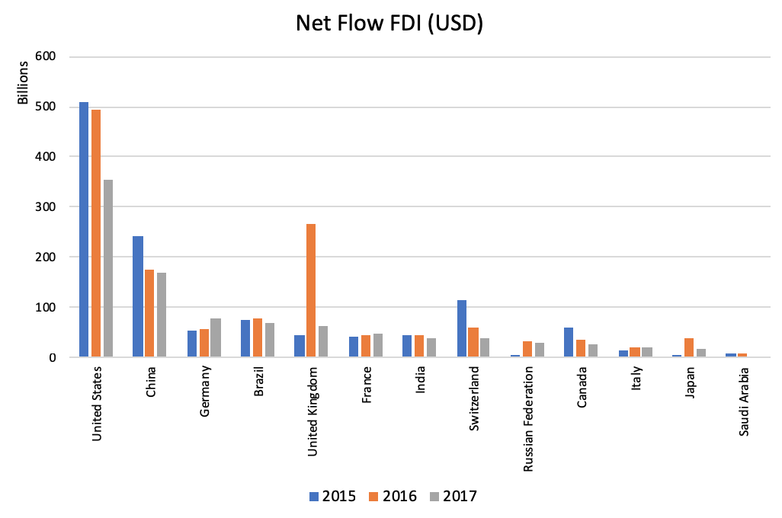
Figure 12 Net Flow Foreign Direct Investment (Source: World Bank)
Among all the countries above, the US is ranked as the most attractive investment destination, with a level of net FDI way more significant than the others. In 2017, the US recorded $354 billion in this measure; around two times higher than that of second-placed China in the same year. Conversely, the least net FDI is achieved by Saudi Arabia, which recorded only $1.4 billion in 2017. Therefore, the US is the most successful country from the perspective of net FDI. However, this result is not valid when we measure success from a GDP perspective. As shown in figure 5, the highest GDP per capita is achieved by Switzerland, in which the country lies in the bottom half of the list based on net FDI. Furthermore, the net FDI in Switzerland during the period 2015-2017 showed a trend of decreasing. Hence, if GDP per capita is indeed comprehensive in capturing the total success of a country, Switzerland should also be at the top of the list. Or at least its GDP per capita should also decline when the net FDI is performing less well, everything else being equal.

Suicide rate
Contradicting the GNH index, the Scandinavian, and some European and eastern European countries, have the highest suicide rate. Sweden was rated the 10th happiest country in the world this year according to the Gross National Happiness Index; however, it had one of the highest suicide rates in 2015, with 17.8 suicide deaths per 100,000 people. Switzerland is the fourth happiest country in the world, and yet has a suicide rate of 15.5 per 100 000 people. In a country as small as Switzerland that is a huge proportion of the local population committing suicide.
This raises the question...if a country has a high suicide rate, how exactly can it be ranked among the happiest countries in the world? Arguably, this is because the GNH mainly uses GDP and GDP per capita, meaning that even though these countries have high suicide rates, it does not mean that they will score lower in this index. If the general population is at least somewhat happy, the fraction which are not do not cause a great difference in standing within the GNH index.
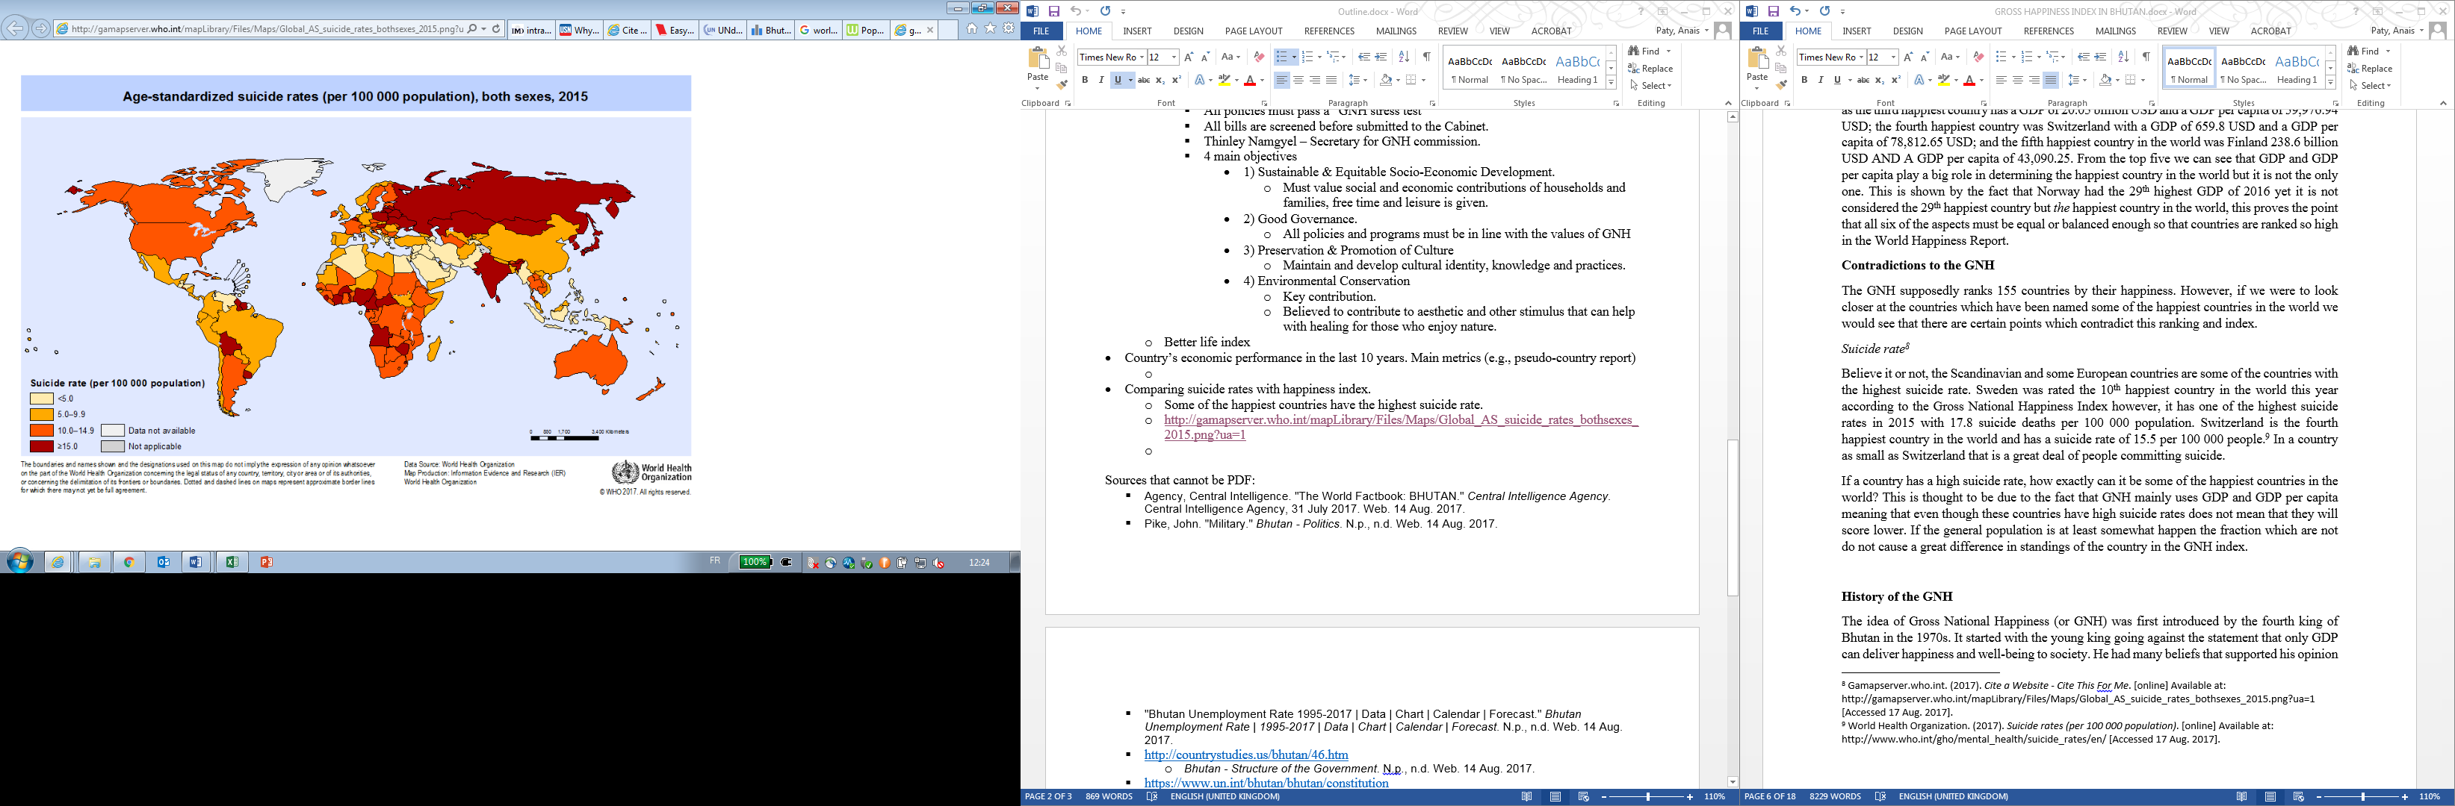
Figure 13. Suicide Rate in the World. Source: World Health Organization

The map above shows the suicide rates of different countries. Captivatingly, those which scored high in the GNH have some of the highest suicide rates. One example is Russia, which is ranked 49 out of 155 in the GNH index, yet has a suicide rate of 15.4 per 100,000 citizens; a high rate, that still represents the lowest it has ever posted. However, worldwide Russia is ranked number 17 in the number of suicide deaths per 100,000 citizens. This further proves that the GNH looks at mental health and physical health, yet it does not possess appropriate weighting.
…
In conclusion, the success of countries can be measured by many different indicators. The presence of many alternative indicators of GDP simply demonstrates that prosperity represents much more than production and consumption. Some other dimensions that we should be concerned about are the environment, education, housing, income, politics, etc. However, although scholars and policymakers are intensively providing various alternatives to GDP, it is also important to note that those indicators are not immune from criticism. All in all, the concept of competitiveness embraces most of the advantages of such indicators, but very few of their problems. Competitiveness is measurable, and can be managed. In the next section, we will demonstrate how it compares to its best known alternative in recent years - happiness.

? Siggel (2005)
? Porter (1990)
? Nadal-Belda, Alberto (2005), “La Competitividad de la Economía Española”, Revista del Instituto de Comercio Exterior, 438-452.
? Martín, César (2014), “¿Qué es la Competitividad de un País?”, Revista índice, 6-8.
? Porter et al. (2008)
? Global Competitiveness Report, http://www3.weforum.org/docs/GCR2017-2018/05FullReport/TheGlobalCompetitivenessReport2017%E2%80%932018.pdf, last accessed January 7th, 2019.
? Porter (1990)
? Paul Krugman (1994)
? OECD (1992)
? CIA Factbook
? However bleak North Korea’s future looks, one thing that’s for sure is that China will play a key role in determining it. If and only if China decides that DPRK is not sustainable, it will not be. Reform, domestically-driven change, or a social revolution, all currently seem unthinkable. The experience in Europe with West and East Germany, and the dissolution of the USSR are not applicable to the two Koreas. The two countries have evolved too far apart, and their political systems are incompatible. North Koreans live like South Koreans did fifty years ago while South Korea has become one of the world's most developed nations. North Korea has stagnated into nothingness. Consequently, only through a gradual, slow and cautions re-establishment of the relationships between the two Koreas will we see an improvement in the quality of life of North Koreans. A glimmer of hope has been sparked by two sides’ expressed wishes to form a type of confederation. In the foreseeable future we could see the border between the two countries being re-opened for people and goods. And the dream in two or three generations is that, as China Mainland and Hong Kong did, we end up with "one country, two systems".
? https://www.cnbc.com/2016/05/18/i-got-2-out-of-4-countries-right-mr-bric-jim-oneill-says.html, last accessed February 5th, 2019
? In 2010 there are only 58 economies in our ranking, and we can obtain stock prices from Datastream for only 47 of these.
? Khanna (2008)
? World Atlas, https://www.worldatlas.com/articles/countries-with-the-most-natural-resources.html, last consulted on December 10th, 2018.
? OPEC, https://www.opec.org/opec_web/en/data_graphs/330.htm, last consulted on December 10th, 2018.
? World Atlas, https://www.worldatlas.com/articles/countries-with-the-most-natural-resources.html, last consulted on December 10th, 2018.
? Swali Arica, http://blog.swaliafrica.com/dr-congo-richest-in-resources-yet-poorest-country-in-the-world/, last consulted on December 10th, 2018.
? (Morton, 2016)
? Source: World Bank Development Indicators
? Arabian Business, July 23rd, 2017.
? Studwell (2013), p. 63.
? https://www.bbc.com/news/business-32028693, last consulted on December 8th, 2018.
? Maddison, 2017.
? Ibid.
? Ibid. and World Bank Development Indicators
? https://positivemoney.org/2016/03/bis-warns-of-a-global-debt-crisis-and-a-lack-of-policy-response-options-time-to-update-the-boes-policy-toolkit/, last accessed February 13th, 2019.
? Reinhart and Rogoff (2009a), Reinhart and Rogoff (2009b)
? Bank of England (2014)
? Gopinath et al. (2017)
? Riley et al. (2005), Barnett et al. (2014a), Barnett et al. (2014b)
? https://www.technology.org/2017/09/18/cell-phone-cost-comparison-timeline/, last checked January 7th, 2019.
? McKinsey Global Institute (2018)
? Bank of England (2014)
? Comin and Hobijn (2010)
? The relationship between wages and productivity has been part of economic theory from a long time ago. The Scottish philosopher Adam Smith thought in his book the Wealth of Nations (1776) that wages were determined naturally by two forces of supply and demand. In practice, this simple definition implies that wages are a legal agreement between workers and employers. Thus, wages also reflect the level of payment representing workers’ willingness to give up their leisure for work instead. As economic research is developing, wage is defined as the marginal productivity of labor. In the ideal world of an economy where no government intervention, no frictions, and no external shocks, the level of wage should equal the marginal productivity of labor..
? Stansbury, Anna, and Lawrence H. Summers (2018). “Productivity and Pay: Is the link broken?”, Forthcoming Peterson Institute for International Economics.
? Other academic work has documented the same phenomenon for other countries. Sharpe, Arsenault, and Horrison (2008) from the Centre for the Study of Living Standard find the same pattern in Canada. They argue that in period 1980-2005, real wages of Canadian workers are stagnant while labor productivity increased by 37%. See Schwellnus, Kappeler, and Pionnier (2017), Vaisburd et al. (2016), Tamasauskiene and Stankaityte (2013) for the UK and OECD countries. Other interesting studies are Bosworth and Perry. (1994), Fisher and Hostland (2002), Blanchard and Giavazzi (2003) and Passimeni (2008).
? Stansbury and Summers (2018)
? See references in Stansbury and Summers (2018)
? Snap Inc.’s preliminary prospectus, available at https://www.sec.gov/Archives/edgar/data/1564408/000119312517029199/d270216ds1.htm#rom270216_6.
? Ibid.
? New York Times, February 3rd, 2017.
? Source: Council of Institutional Investors
? Graetz and Michales (2018)
? OECD (2017)
? There are other studies that also provide some evidence regarding the positive impact of automation on labor employment. For example, the study from Zierahn et al. (2016) reveals that automation has created over ten million jobs in European countries during 1999 – 2010.
? International Federation of Robotics. (2017). “Key Messages: The Impact of Robots on Productivity, Employment, and Jobs”, available at https://ifr.org/img/office/Robots_and_Jobs_Key_Messages.pdf, last accessed February 1st, 2019.
? McKinsey Global Institute (2017)
? Ibid.
? Graeber (2018)
? Pilling (2018)
? Slovenia ranked #48 in the 2018 IMD World Competitiveness Rankings. Belarus is not included in either the IMD and WEF rankings because the low quality of their statistical data.
? http://www.slovenia.si/slovenia/history/the-state-of-slovenes-croats-and-serbs/, last accessed January 2nd, 2019.
? https://www.ljubljana.si/en/about-ljubljana/history-of-ljubljana/restless-20th-century/ , last accessed January 2nd, 2019.
? https://www.elitepropertyslovenia.com/a-history-of-slovenia, last accessed January 2nd, 2019.
? https://www.britannica.com/place/Slovenia
? A fantastic tool to explore the history of Belarus is http://map.letapis.by/en/#1295
? https://www.economist.com/europe/2005/06/16/bordering-on-madness , last accessed January 2nd, 2019.
? http://map.letapis.by/en/#19210318, last accessed January 2nd, 2019.
? https://www.everyculture.com/A-Bo/Belarus.html , last accessed January 2nd, 2019.
? https://www.britannica.com/place/Belarus
? https://mfa.gov.pl/en/p/msz_en/foreign_policy/europe/european_union/poland_ineu/centre_of_europe/?channel=www , last accessed January 2nd, 2019.
?http://www.themeditelegraph.com/en/markets/finance-and-politics/2018/04/21/germany-and-austria-pull-slovenian-economy-itZvllXMJpA8i4VUTgqvkN/index.html, last accessed January 2nd, 2019.
? https://doc-research.org/2018/03/rise-fall-market-socialism-yugoslavia/ , last accessed January 3rd, 2019.
? http://mfa.gov.by/en/courtiers/russia/, last checked January 15th, 2019.
? https://www.globalsecurity.org/military/world/belarus/union.htm, last checked January 15th, 2019.
? Nordhaus, W.D. and Tobin, J. (1972), “Is Economic Growth Obsolete?” In: Economic Growth, Fiftieth Anniversary Colloquium, V, National Bureau of Economic Research, New York.
? Bergheim and Schneider (2006)
? Giannetti (2015); Schepelmann (2010)
? Giannetti (2015)
? Schepelmann, 2010
? Cobb (1998)
? Schepelmann (2010)
? World Bank (1997); Constanza (2009); Schepelmann et al. (2010); Hamilton, Ruta et al. (2006)
? Schepelmann et al. (2010); Constanza et al. (2015)
? IPCC (2000); Schepelmann et al. (2010).
? Wackernagel and Rees, (1996)
? Schepelmann et al. (2010).
? Constanza et al. (2015); Schepelmann et al. (2010).
? According to Marks, Abdallah et al. (2006), as cited in Constanza et al. (2015), countries can have similar life satisfaction measures but with different overall results.
? UNDP, 2018
? Schepelmann et al. (2010)
? Esty et al. (2005)
? Schepelmann et al. (2010)
? The Economist (2005)
? Data is obtained from the Economists Intelligence Unit – Democracy Index, compilation period 2015-2017. Available at: http://www.eiu.com/topic/democracy-index
? Gamapserver.who.int. (2017). Cite a Website - Cite This For Me. [online] Available at: http://gamapserver.who.int/mapLibrary/Files/Maps/Global_AS_suicide_rates_bothsexes_2015.png?ua=1 [Accessed 17 Aug. 2017].
? World Health Organization. (2017). Suicide rates (per 100 000 population). [online] Available at: http://www.who.int/gho/mental_health/suicide_rates/en/ [Accessed 17 Aug. 2017].
? World Health Organization. N.p., n.d. Web. 18 Aug. 2017. <http://gamapserver.who.int/mapLibrary/Files/Maps/Global_AS_suicide_rates_bothsexes_2015.png?ua=1>.

