Privacy Policy for TW12 Physio and Pilates

TW12 Physio and Pilates provides physiotherapy services and Physiotherapy led Pilates instruction.

This Privacy Policy relates to the collection, storage and use of your personal information by TW12 Physio and Pilates.
The information used is that which you provide in person, via email, letter, text message or telephone. The storage and processing of information will be in line with current GDPR and professional registration standards.

Named Data Protection Officer and Data controller: Nicole Pitman
Mobile: 0745 336 5211
Email: tw12physioandpilates@gmail.com

WHAT INFORMATION DO WE COLLECT?
- Name, date of birth, physical and email addresses, telephone numbers and current GP details will be recorded within the initial consultation.
- Information regarding the condition you are contacting TW12 Physio and Pilates about, general health, previous medial history, medication and social history will be asked and recorded.
- All physical examinations and treatments completed during the course of your care will be recorded.

WHY DO WE NEED TO STORE INFORMATION?
- Current and accurate health information and contact details are required, throughout the duration of your care, in order for TW12 Physio and Pilates to provide safe and effective health care.
- Communication using the information you provide ensures continuity of care i.e. booking of appointments, provision of exercises, invoices and letters.
- Physiotherapists have a professional and legal obligation to keep accurate recordings of all interaction with patients in accordance with the Health Care and Professions Council (HCPC) and Charted Society of Physiotherapy (CSP) standards.
HOW LONG WE STORE DATA?
In accordance with CSP guidelines information will be retained for the minimum period outlined below:

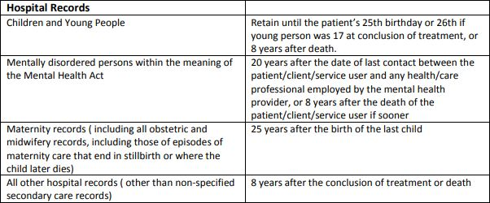
Once the retention period has expired all records will be securely destroy and disposed of.

RIGHT TO DELETE AND RECTIFY:
- You are entitled to have any discrepancies rectified. Requests for rectification must be received by TW12 Physio and Pilates in writing.
- Physiotherapists have a professional and legal obligation to keep accurate records of all interaction with patients in accordance with the Health Care and Professions Council and Charted Society of Physiotherapy standards. Records are required to be retained for a minimum of the above stated period.

HOW WE STORE INFORMATION?
- Health information, date of birth, telephone numbers, physical and email addresses, provided by you, will be stored securely within a locked metal filing cabinet, to which Nicole Pitman is the sole key holder, and/or an encrypted practice management software system.
- Invoices, which are sent electronically, will be stored on a password protected computer and/or within an encrypted practice management software system.
- The exercise prescription software used requires name, date of birth and email address to be stored for patient identification. The software database is password protected and fully encrypted.
- Telephone numbers will be stored on a password protected mobile phone.

WHEN WOULD WE SHARE INFORMATION?
- Your information may be shared with other medical professionals if required for health reasons. This is to ensure that all your health needs are met during different stages of your care pathway.
- You are entitled to object to the sharing of health records but please be aware that this may impact on the ability of TW12 Physio and Pilates to provide safe and effective care.
- If your records are requested by a solicitor or an insurance company, written consent will be required from you before a copy of the records will be provided.
- Your information will not be shared with any third party for marketing purposes.

CAN YOU ACCESS THE INFORMATION STORED?
- You are entitled, under GDPR, to request a copy of your health records.
- Requests for health records must be done so in writing and will be processed within 1 month of receipt of written request.

WHAT HAPPENS IF THERE IS AN INFORMATION BREACH?
- TW12 Physio and Pilates will notify you as soon as we are aware of an information breach. We will inform you about what was lost, how it was lost, and what we are doing to rectify the situation.
- TW12 Physio and Pilates will contact the Information Commissioner and report the information loss.

WHAT HAPPENS IF INFORMATION IS DAMAGED?
- If records are damaged, such as by fire or flood, the original record will be retained as far as is practicable.
- If records are totally irretrievable, every attempt will be made to recreate it. A statement will be included, in the new records, that “original notes destroyed by (e.g. flood) on (date). Notes recompiled from memory on (date)”

CHANGES TO TW12 PHYSIO AND PILATES PRIVACY POLICY:
All changes and updates to the privacy policy will be on the website – www.tw12physioandpilates.co.uk.

Version: 7 (amended November 2020)
Created: 7/8/18 by Nicole Pitman
Review date: September 2021

