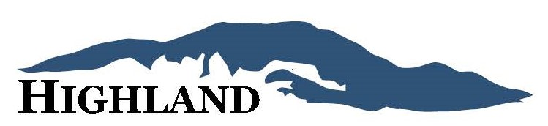

2025 April Newsletter

Spring is here! Information and reminders as we prepare for warmer weather.
Safety Concerns
It was recently reported that some neighborhood children had climbed over the pool fence and were walking atop the pool cover to retrieve a ball. Parents, please let your children know that not only is this not permitted, but it is also extremely dangerous.
Additionally, please encourage your children to remain on bike paths in common areas when riding to maintain landscaped areas and to refrain from riding on private property.
Exterior Maintenance
With summer approaching, we would like to remind you of some of the HOA expectations regarding exterior maintenance. You can find the the complete CC&Rs at therosemanagement.com/emmett-highland-hoa
- Yard Maintenance (Per CCR Article 2.3), “No improvements, including landscaping, shall be permitted to fall into disrepair, and each improvement shall at all times be kept in good condition and repair. Owner’s shall be responsible for regular weed removal, irrigation, and maintenance. Owner shall be responsible for maintenance of any sidewalk that Owner’s Lot fronts.
- Decorations (Per CCR Article 2.19), “No unsightly articles shall be permitted to remain on any Lot as to be visible from any other portion of the Property.” This includes any prolonged holiday decor, toys, and excessive ornamentation.

- Boats, Campers, and Other Vehicles. (Per CCR 2.15) No boats, trailers, tractors, recreational vehicles, (i.e., any trailers, campers, motor homes, automobile campers or similar vehicle or equipment) dilapidated, un-repaired, broken-down or unsightly vehicles, or similar equipment, off-road vehicles (ATVs or side-by-sides), motorcycles, snowmobiles, personal watercraft, commercial vehicles or trucks (working or non-working) greater than one ton in size shall regularly or as a matter of practice be parked or stored on any portion of the Property (including streets and driveways) for more than forty-eight (48) consecutive hours unless enclosed by a structure or screened from view in a manner approved, in writing, by the Committee. None of the previously identified items and no cars or trucks shall be parked on lawns or landscaped areas of the Property for any period of time.
Pool Access
We do not have a specific date yet for the pool opening but we will keep you informed. It should be prior to Memorial Day. Some things to keep in mind prior to the pool opening:
- If you have not signed a pool waiver since December 2023, you will need to sign another before obtaining pool access for this season.
- Residents who are behind on HOA dues will need to pay their balance prior to obtaining pool access.
- Residents who incur CCR violations may have their pool privileges revoked until such violations are rectified.
- Parking at the pool is only for those who are currently using the pool.
Dogs
There have been a few reports of dogs barking incessantly throughout the day (and sometimes into the night!). Homes where barking continues to be a problem will not only draw the attention of the HOA but will be reported to the police/animal control. We all know that sometimes dogs act up but there are also dogs who cannot be left alone without becoming a nuisance. Please be sure to take the steps necessary for the neighborhood and for the dogs sake.
Check out therosemanagement.com/emmett-highland-hoa.
You can find the CCR’s, irrigation, information regarding pool access, and more.

Owner Information Questionnaire
If you have not completed the owner info questionnaire within the last 6 months, please be sure to do so at https://tinyurl.com/EmmetHOAInfo
If you have any questions or concerns, please don’t hesitate to contact us either by completing the online form found at therosemanagement.com/emmett-highland-hoa or via email at emmetthighland.hoa@gmail.com

