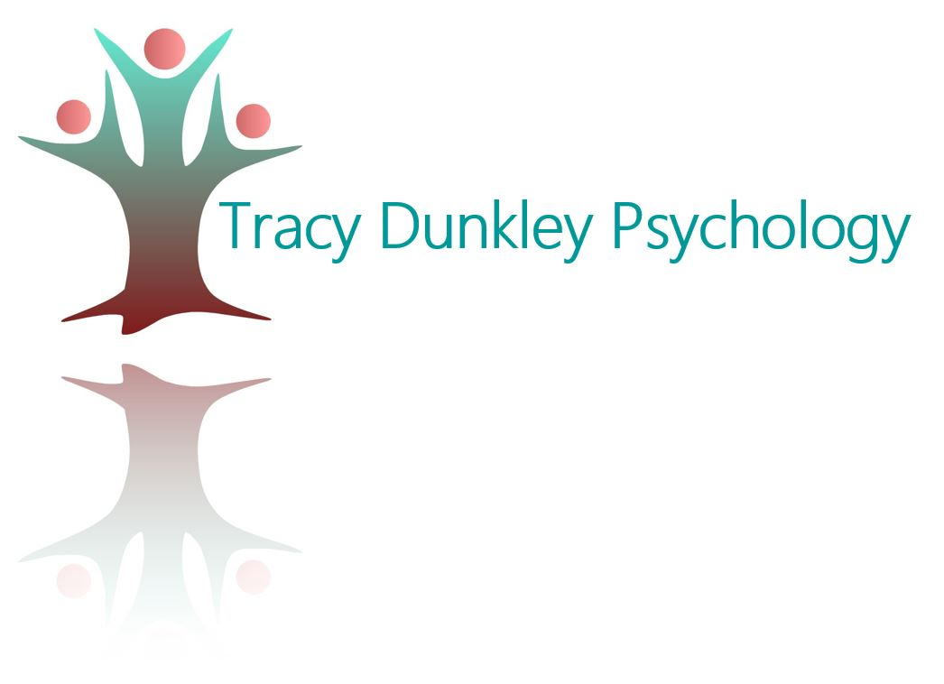 | 

Grow Together
Parent Support Group

Grow Together is a warm and supportive online parent group for those raising children aged 2–12. Grounded in the Circle of Security model and attachment theory, the group helps parents better understand their children’s emotional needs and strengthen their relationships.
Each monthly 1-hour Zoom session (Wednesday afternoons) combines practical psychoeducation on topics chosen by the group—such as emotional regulation, anxiety, friendship development, screen time, self-care, or parenting neurodivergent children—with open discussion and shared support for current parenting challenges.
Facilitated by Tracy Dunkley, Clinical Psychologist with over 20 years’ experience in child and parenting work and trained COS-P and COS-I facilitator, Grow Together offers a safe space to learn, connect, and feel understood. Small group size ensures meaningful connection.
Billing is available through NDIS plans or privately.
Enquiries: GV Developmental Clinic admin on 5858 1757

