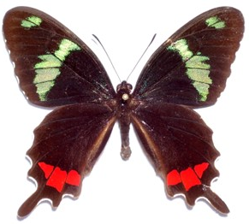
Southern Lepidopterists’ Society
and
ASSOCIATION FOR TROPICAL
LEPIDOPTERA
2026 Annual Meeting
The 2026 SLS-ATL Annual Meeting will be held at the Cuscowilla Nature and Retreat Center in Micanopy, Florida, 10 miles south of Gainesville. There will be an evening reception and collecting on Friday, 17 April. Presentations will be held on Saturday morning and afternoon (18 April), with a Friday afternoon option (17 April) depending on demand. Sunday morning (19 April) will be left open. A catered banquet will be held on Saturday evening at Cuscowilla, with a SlideFest open to all (5 first-choice & 5 second-choice images per participant; second-choice may be omitted depending on number of presenters) following dinner. Please be selective with your best images! (CAUTION to presenters: Rural area, internet access to cloud service may be unreliable.) Door prizes are solicited for our after-dinner drawings following the SlideFest.
REGISTRATION

Last name: _______________________________, First name and initial:__________________
Other registered family/group members:______________________________________________________________________
Street address or P.O. Box:________________________________________________________
City: _____________________________________ State/Province: _______________________
Zip Code:_________________Country:_____________________________________________
Email:___________________________________Phone:_______________________________
Institution or affiliation (optional, for name tag): ______________________________________
Registration fee (includes breaks, program, and registration materials). $50/individual;
$25/ student.
Total Number of Individuals………....…………………...........................………………..______
Total for Registration ………………...........................………………………………….$______
Saturday Banquet $40.00 …............…………………………………..........….........…..$______
Total enclosed $______
Please use one of these preferred methods of payment. 1) Click on <https://troplep.org/annual-meeting-2026>, follow the links and pay via PayPal (also accepts credit card payments). /OR/ 2) Kindly make your registration check payable to Association for Tropical Lepidoptera (which will handle SLS registration as well) and mail it, along with the form, to: Keith R. Willmott, McGuire Center for Lepidoptera and Biodiversity, Florida Museum of Natural History, University of Florida, P.O. Box 112710, Gainesville, FL 32611-2710, Email <kwillmott@flmnh.ufl.edu>. If paying by PayPal, please email the form to <marccminno@gmail.com>.
The registration deadline is March 21, 2026.

