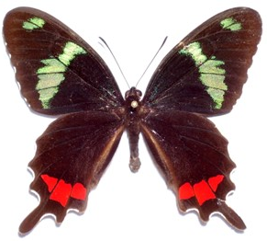
Southern Lepidopterists’ Society
and
ASSOCIATION FOR TROPICAL
LEPIDOPTERA
2026 Annual Meeting

The Combined Annual Meeting of SLS-ATL will be held at the Cuscowilla Nature and Retreat Center, located 10 miles south of Gainesville, Florida, from Friday to Sunday, 17-19 April 2026. Modified schedule: Presentations will be held on Saturday morning and afternoon (18 April), with a Friday afternoon option (17 April) depending on demand.

Call for Contributed Papers

This is a fillable form – just enter the following information and Save as a Microsoft WORD file.
Author(s): ____________________________________________________________________________

Mailing address:_______________________________________________________________________

e-mail: ________________________________ Phone: ________________________________________

Please check: _____ Oral Presentation _____ Poster ______ Student

Please type both your title and abstract below. Abstracts should be 125 words or less.

Title:

Abstract:

Title and abstract must be received by March 15th, 2026, for inclusion in the printed program.
Please send your completed form (WORD file) by e-mail to
Marc Minno (MarcCMinno@gmail.com).
Oral presentations may be displayed in PowerPoint, or a high-resolution PDF file may be used if software version compatibility problems are anticipated. In-person speakers will need to bring talks on a USB drive to be loaded onto the presentation computer.
Presentations should be 15 minutes long with an additional 5 minutes available for questions.

*Parides gundlachianus (Papilionidae), the proposed National Butterfly of Cuba, specimen and photo by Douglas Manuel Fernández-Hernández, Camagüey, Cuba.

