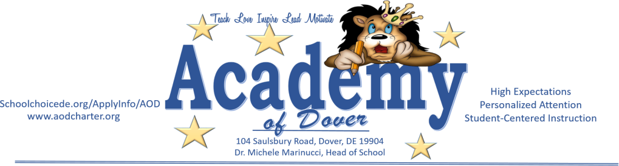

AGENDA: Citizens Budget Oversight Committee Meeting
Date | time 12/17/2020 5:30 PM | Meeting called by Bishop Thomas

Board Members

Bishop W. James Thomas, Treasurer Mr. Kimeu W. Boynton, Board President Dr. Michele Marinucci, Head of School
Mrs. Ronda Bacu, School Representative
Mrs. Michelle Hudson, HR & Financial Specialist Ms. Deborah Postles, Curriculum and Instruction Mr. Richard Riggs, DOE Representative
Dr. Esosa Iriowen, Parent Representative
Wafa Hozien, DOE Representative

Time | Item | Owner
5:30 | Call to Order | Thomas
5:32 | Review minutes— | All
5:37 | Vote to accept minutes | Members
5:40 | Review of Finances | Marinucci
5:50 | Vote to accept Finances | Members
5:55 | Member Update | Thomas
6:00 | Adjournment | Thomas
5:30 | Call to Order | Thomas
Note:
Pursuant to 29 Del. C. § 10004e(2), the agenda is subject to change to include additional items including executive sessions that arise at the time of the Board’s meeting. The times designated on the agenda are approximate and are listed for administrative purposes only. The Board reserves the right to hear any matter out of its order during the meeting. The Board may take breaks during the meeting.

