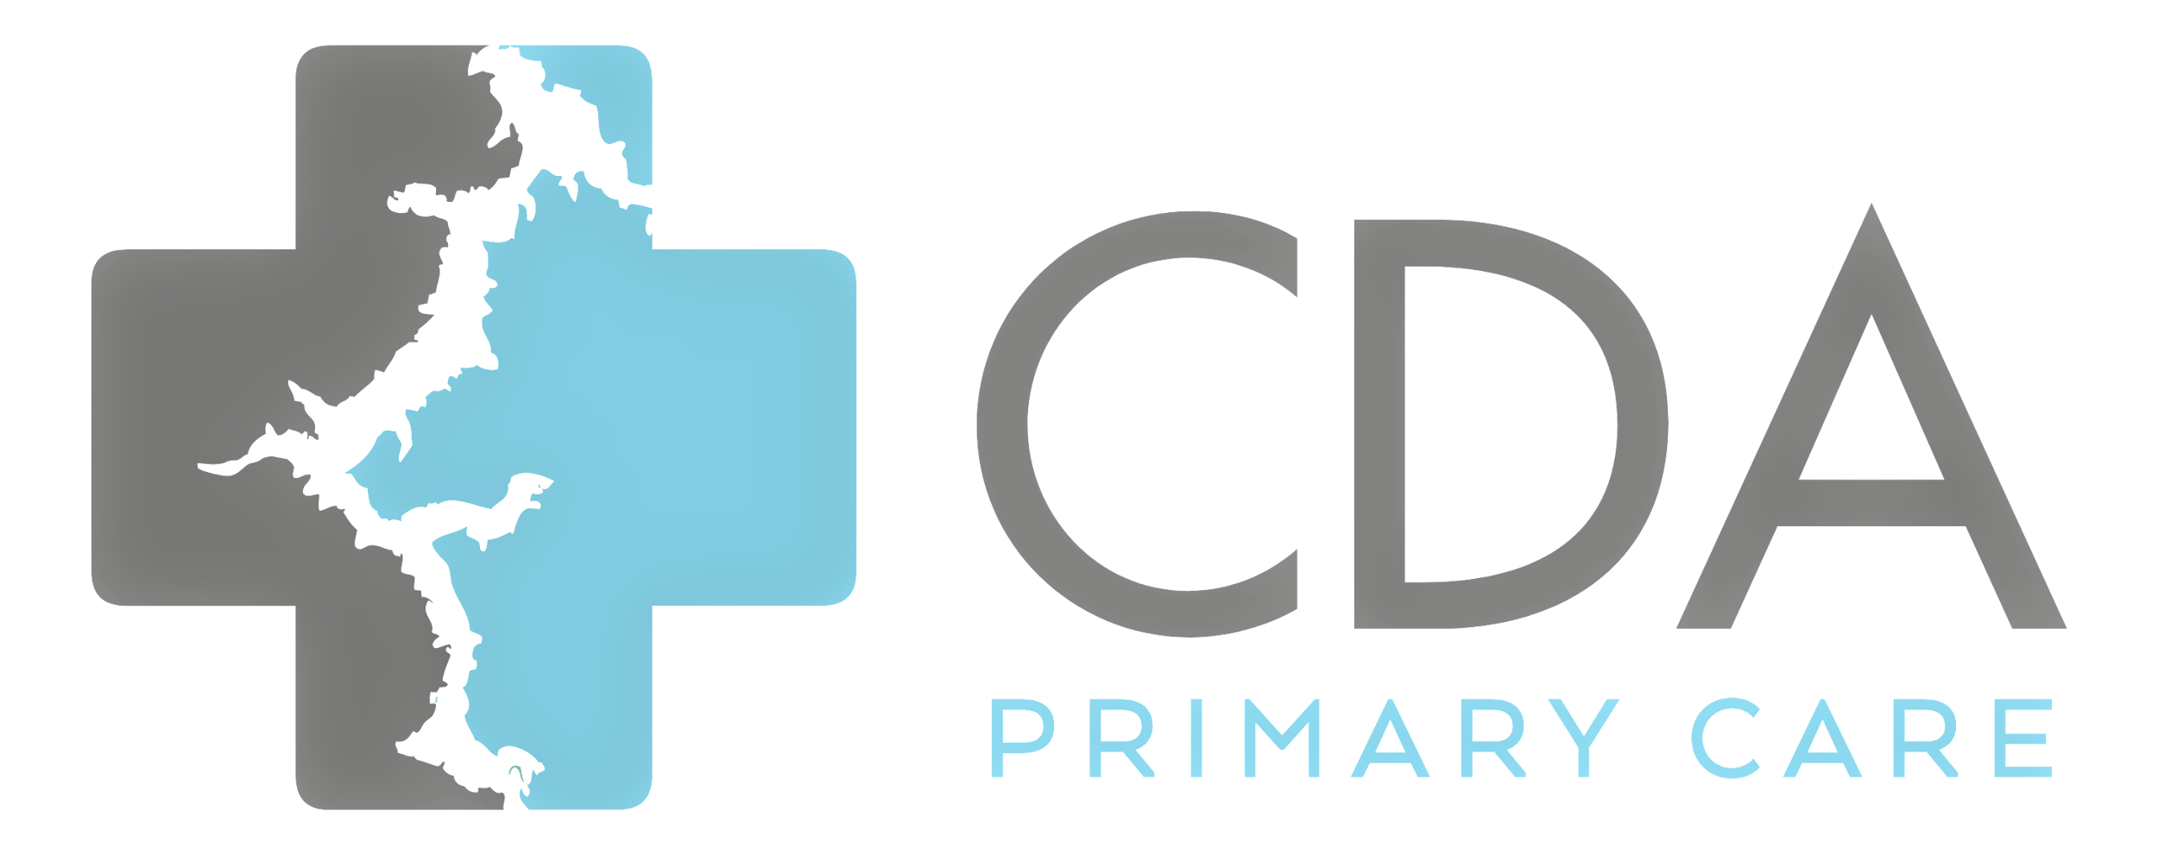

To Our Valued Patients,

We would like to start by thanking you for the support we’ve received over the years. We’ve grown tremendously as a practice and we couldn’t have done it without our community.

Coeur d’ Alene Primary Care has always made it a priority to provide the highest quality of care at affordable rates. As we settle into the new year there will be a change to several of our policies and service fees. Please take a moment to review the following changes.

**Cancellation Policy:**

Please be aware that our office requires a 24 hour notice for cancellations. Anything later than a 24 hour notice will be subject to the following policies.  
After a combination of three Late Cancellations or No Shows, our practice may decide to terminate its relationship with you.

* **Late Cancellation Policy:**

Effective 4/01/2025 - there will be a "Late Cancellation" fee of $75 if the office has not been notified at least 12 hours prior to cancellation of appointment.

* **No Show Policy:**

Effective 4/01/2025 - there will be a "No Show" fee of $100 if the office is notified an hour or less prior to cancellation of appointment OR if appointment is missed entirely.

**Psychiatric Service Fees (cash pay patients only):**

* Establishing Care: $250.00 due at time of service
* 1 hour medication review/therapy: $200.00 due at time of service
* 30 minute medication review/therapy: $175.00 due at time of service

Please communicate with our office staff if there are any questions regarding these changes.

Thank you,

CDA Primary Care