Edge – 2 – Edge Quilting Selections:
Design Sizing Notice: The largest stitch out for each pattern is shown in the box to the right of each design as shown here. These can be resized smaller but not larger.
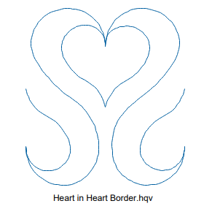
1. Heart in Heart Border (1-PS Designs cont. line)
4.49” W
4.99” H

The stitch out will need to be dense enough to secure all sides of each pieced element in the quilt top. This is important so the quilt will withstand washing and regular usage.

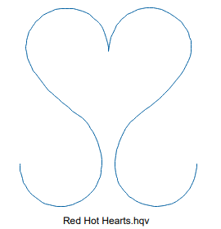
2. Red Hot Hearts ((1-PS Designs continuous line)
3.58” W
4.00” H

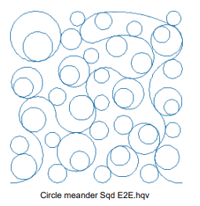
3. Circle Meander Squared E2E (Nancy Haacke Designs)
10.01” W
10.00” H

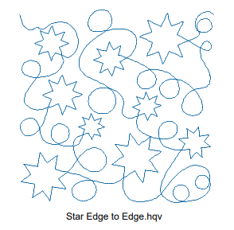
4. Star Edge to Edge (1-PS Designs continuous line)
10.06” W
10.00” H

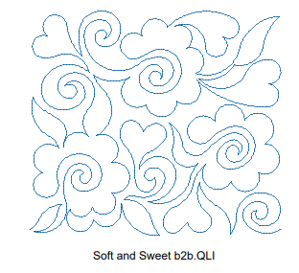
5. Soft and Sweet b2b.QLI (Anne Bright)
13.99” W
12.50” H

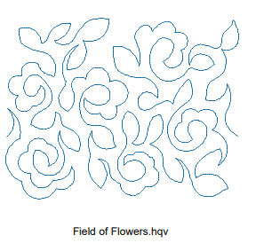
6. Field of Flowers (1-PS Designs continuous line)
11.60” W
9.00” H

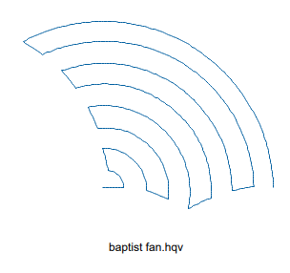
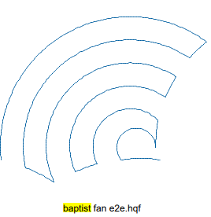
7. Baptist Fan (2-PS Tutorials) 7b*. Baptist Fan (Nancy Haacke Designs)
10.74” W
8.03” H

5.36” W
4.30” H
Smaller & reversed

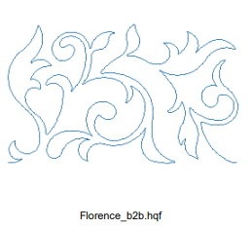
8. Florence_b2b (Anne Bright)
10.01” W
6.01” H

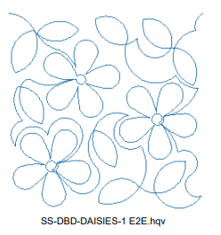
9. SS-DBD-Daisies_1 E2E (Deb Geissler)
12.00” W
12.01” H

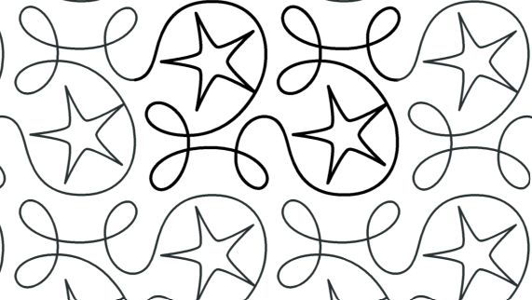
10. AM-Ginger Star 8”h x 10.75”w (Apricot Moon)
10.85” W
7.98” H

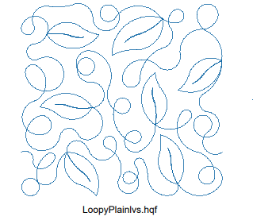
11. Loopy Plain Vines (T.J. Speiser Stitch Happy)
11.36” W
10.83” H

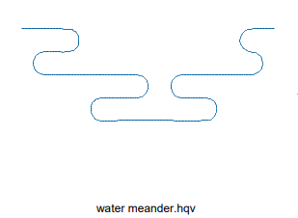
12. Water Meander – (1 PS Designs continuous line)
11.00” W
4.01” H

13. Blustery Breeze (2-PS Tutorials)
24.20” W
9.49” H

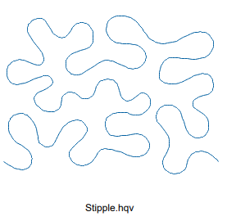
14. Stipple – (1-PS Designs continuous line)
5.50” W
4.06” H

OR
4.63” W
3.97” H
Stipple2

Larger E2E Designs available:
L1: Maze 2014 (Nancy Haacke Designs) L2: LT 2212 TT Ribbon Candy (LindaVTaylor_iPatternStudio)
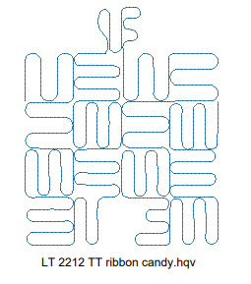
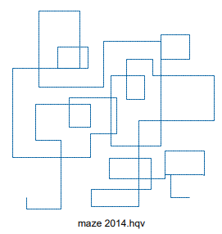
12.03” W
14.86” H

14.82” W
14.62” H

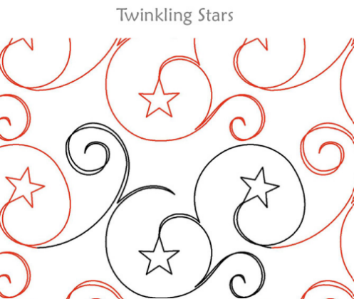
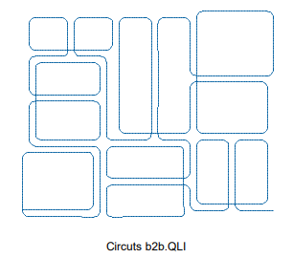
L3: Circuits b2b (Anne Bright) L4: Twinkling Stars (Dawn Sanders IntelligentSpc Quilting)
18.51” W
12.13” H

13.00” W
10.68” H

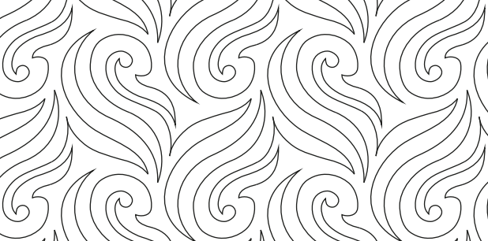
L5: Tigres (© Hermione Agee 2015) L6: e2e_easycombo (Linda V Taylor – iPattern Studio
14.96” W
14.00” H

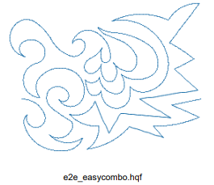
14.17” W
10.95” H

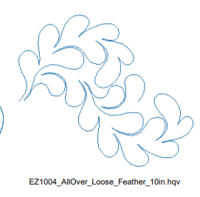
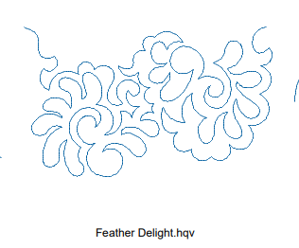
L7: Feather Delight (1-PS Designs Continuous line) L8: EZ1004_AllOver_Loose_Feather_10in (Ellen Munich)
11.52” W
10.00” H

12.49” W
7.53” H

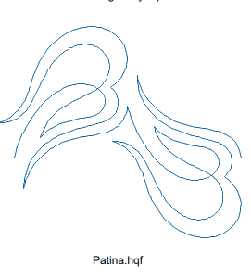
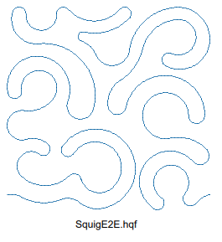
L9: Squig E2E (T.J. Speiser Stitch Happy) L10: Patina (Urban Elementz)
17.28” W
15.00” H

8.00” W
8.00” H

L11: Floral (elements) e2e (Linda Mateotti)
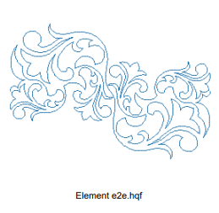
11.99” W
8.11” H

SPECIAL OCCASION E2E Selections:
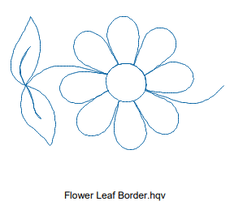
SPC1: Flower Leaf Border (1-PS Designs continuous line) SPC5: Simply Sunflowers (Crystal Smythe Intelligent Quilting)
12.24” W
9.56” H

7.96” W
5.00” H
Can use as e2e if skewed/offset

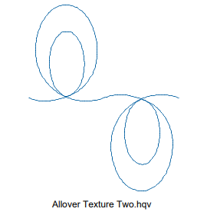
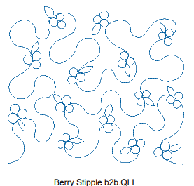
SPC2: Berry Stipple b2b (Anne Bright) SPC6: Allover Texture Two (Darene Epps)
7.31” W
9.00” H

13.99” W
12.01” H

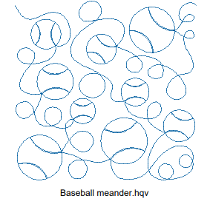
SPC3: Baseball Meander (Mary Beth Krapil cont line)
16.01” W
15.89” H

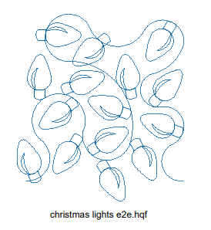
SPC4: Christmas Lights e2e (Nancy Haake Designs)
8.44” W
9.43” H

NOTE: For additional themed & special occasion edge-2-edge stitching such as: patriotic, wedding, baby, holidays, hobbies, etc. – please be sure to ask.

