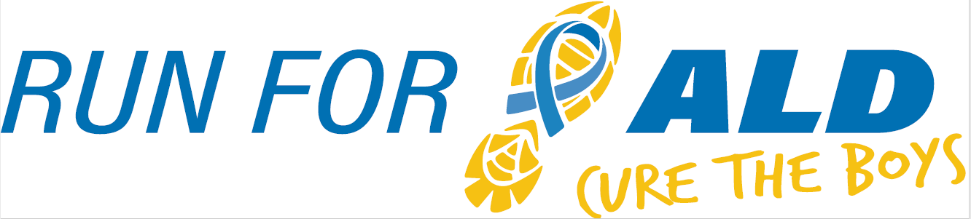
5K & 1 Mile | November 17th, 2018

The 2nd Annual Run for ALD, Cure the Boys will raise awareness and provide research funds for Adrenoleukodystrophy (ALD), a genetic neurological brain disease. Our event is inspired by the vision of our son Nicholas who had a successful bone marrow transplant to treat his cerebral ALD at the University of Minnesota Children’s Hospital in 2016. ALD is very progressive and affects 1 in 17,000 boys, many of whom suffer severe neurological symptoms and often death if undiagnosed and not treated very early. All funds raised from Run for ALD will benefit the University of Minnesota ALD Research Fund to support efforts for early identification, treatment options, and hopefully one day a cure for this devastating disease.
Last year our event raised over $11,000.
The money raised is going to support ALD research projects at the University of Minnesota. One of the projects needing funding is the development of an international family-centered database. The database will provide a unified mechanism to gather the data on boys diagnosed with ALD either through the Newborn Screening process or through secondary diagnoses.
We would like to invite you to consider sponsoring our run. Sponsorships are a vital aspect to Run for ALD’s success and are available at any level. Last year over 300 people registered for the run and a greater turnout is expected this year. Sponsorship at any level will be recognized at the event. A $250 donation will secure advertisement on the race shirt.
Knockout ALD, Inc. is our nonprofit organization established to raise awareness and funds for Adrenoleukodystrophy research. Sponsorships will be collected through the Knockout ALD organization. Information about Knockout ALD can be found at KnockoutALD.com.
Knockout ALD, Inc’s Federal ID number is #83-0754642
For additional information, please contact Dave Purschke at (314)-520-3376 or RunforALD@yahoo.com. We thank you in advance for your consideration and look forward to your response.

Contact Name:
Address:
Phone: |  | E-mail:

Sponsorship level:
$250 |  | $1,000 |  | $2,000
$500 |  | $1,500 |  | Other

Sponsor
Name Appearing on Sign / Shirt:
If you have a logo to be used on the shirt, please email it as a JPG attachment to:
Dave Purschke (RunforALD@yahoo.com)

Make checks payable to Knockout ALD, Inc.
Mail to: Knockout ALD, Inc., 841 Gardenway Dr, Ballwin, MO 63011

