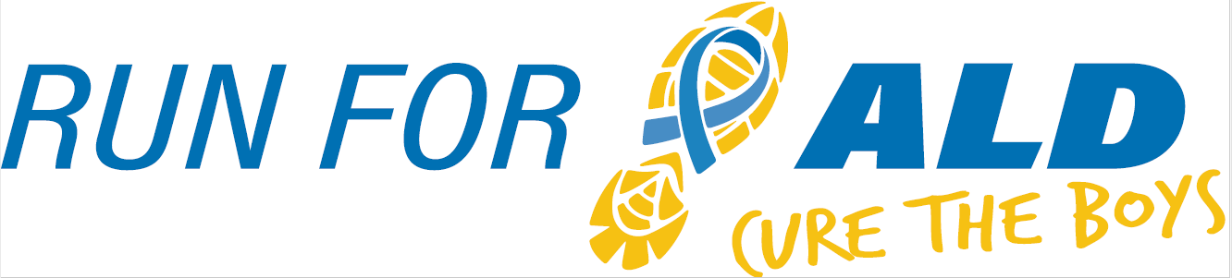
5K & 1 Mile | November 16th, 2019

The 3rd Annual Run for ALD, Cure the Boys will once again raise awareness and provide research funds for Adrenoleukodystrophy (ALD), a genetic neurological brain disease. Our event is inspired by the vision of our son Nicholas who had a successful bone marrow transplant to treat his cerebral ALD at the University of Minnesota Children’s Hospital in 2016. ALD is very progressive and affects about 1 in 18,000 boys, many of whom suffer severe neurological symptoms and death if undiagnosed and not treated very early. All funds raised from Run for ALD will benefit the University of Minnesota ALD Research Fund to support efforts for early identification, treatment options, and hopefully one day a cure for this devastating disease. Dr. Troy Lund, one of Nicholas’s doctors, heads up much of the ALD research being done at the U of M, and attended our event last year to share its impact on their research for ALD boys. Last year our event raised over $12,000, bringing our total donated to $23,000 over the past two years of our event!

We would like to invite you to consider sponsoring our run. Sponsorships are a vital aspect to Run for ALD’s success and are available at any level. Last year over 300 people registered for the run and we hope for an even greater turnout this year. Sponsorship at any level will be recognized at the event. A $250 donation will secure advertisement on the race shirt.
Knockout ALD, Inc. is our nonprofit 501 (c) (3) organization established to raise awareness and funds for Adrenoleukodystrophy research. Sponsorships will be collected through the Knockout ALD organization. Information about Knockout ALD can be found at KnockoutALD.com and information about Run for ALD can be found on our race website fleetfeetstlouis.com/racing/run-for-ALD.
Knockout ALD, Inc’s Federal ID number is #83-0754642.
For additional information, please contact Dave Purschke at (314)-520-3376, Julie Purschke at (314) 570-2058 or RunforALD@yahoo.com. We thank you in advance for your consideration and look forward to your response.

Contact Name:
Address:
Phone: |  | E-mail:

Sponsorship level:
$250 |  | $1,000 |  | $2,000
$500 |  | $1,500 |  | Other

Sponsor
Name Appearing on Sign / Shirt:
If you have a logo to be used on the shirt, please email it as a JPG attachment to:
Dave or Julie Purschke (RunforALD@yahoo.com)
Make checks payable to Knockout ALD, Inc.
Mail to: Knockout ALD, Inc., 1551 Timberlake Manor Pkwy, Chesterfield, MO 63017
Thank you!

