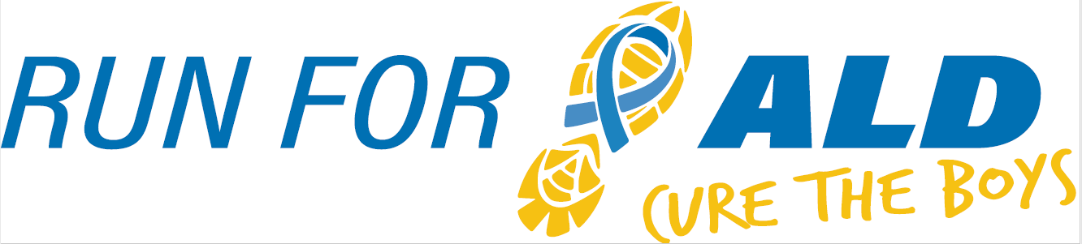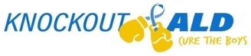
5K & 1 Mile | November 20th, 2021

The 5th Annual Run for ALD, Cure the Boys will once again raise awareness and provide research funds for adrenoleukodystrophy (ALD), a genetic neurological brain disease. Our event is inspired by the vision of our son Nicholas who had a successful bone marrow transplant to treat his cerebral ALD at the University of Minnesota Children’s Hospital in 2016. ALD is very progressive and affects about 1 in 17,000 boys, many of whom suffer severe neurological symptoms and death if undiagnosed and not treated very early. All funds raised from Run for ALD will benefit the University of Minnesota ALD Research Fund to support much-needed efforts that otherwise wouldn’t make it to the lab including early identification, better treatment options, and hopefully one day a cure for this devastating disease. The U of MN is a world leader in bone marrow transplant and ALD research. Support from ALD families and fundraisers like ours is vital to their work. Knockout ALD has raised $75,000 over the past four years for University of Minnesota ALD Research!

We would like to invite you to consider sponsoring our event. Sponsorships are key to Run for ALD’s success and are available at any level. Last year over 330 people participated virtually and we were able to expand our fundraising nationwide (and Canada!). This year we will host a live AND virtual run/walk. A $250 donation will secure advertisement on the race shirt, our race registration page, our website, and our Instagram feed.
Knockout ALD, Inc. is our nonprofit 501 (c) (3) organization established to raise awareness and funds for adrenoleukodystrophy research. Sponsorships will be collected through the Knockout ALD organization. Information about Knockout ALD can be found at KnockoutALD.com and information about Run for ALD can be found on our race website: https://raceroster.com/events/2021/48934/run-for-ald-cure-the-boys .
Knockout ALD, Inc’s Federal ID number is #83-0754642.
For additional information, please contact Dave Purschke at (314)-520-3376, Julie Purschke at (314) 570-2058 or RunforALD@yahoo.com. We thank you in advance for your consideration and look forward to your response.

Contact Name:
Address:
Phone: |  | E-mail:

Sponsorship level:
$250 |  | $1,000 |  | $2,000
$500 |  | $1,500 |  | Other

Sponsor
Name Appearing on Shirt & Event Website:
*Please email your logo for shirts and our website as a JPG attachment to:
Dave or Julie Purschke (RunforALD@yahoo.com)
Make checks payable to Knockout ALD, Inc. Thank you!
Mail to: Knockout ALD, Inc., 1551 Timberlake Manor Pkwy, Chesterfield, MO 63017

