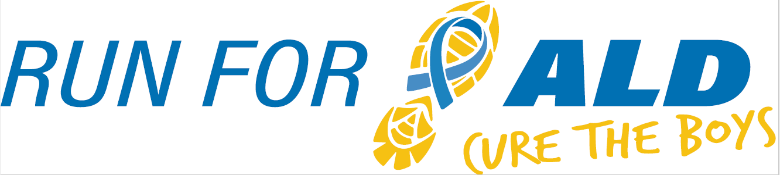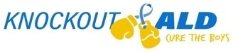
5K & 1 Mile | November 19th, 2022

The 6th Annual Run for ALD, Cure the Boys will once again raise awareness and provide research funds for adrenoleukodystrophy (ALD), a genetic neurological disease. Our event is inspired by the vision of our son Nicholas who had a successful bone marrow transplant to treat his cerebral ALD at the University of Minnesota Children’s Hospital. ALD is very progressive and affects about 1 in 17,000 boys, many of whom suffer severe neurological symptoms and death if undiagnosed and not treated very early. All funds raised from Run for ALD will benefit the University of Minnesota Leukodystrophy Center for ALD Research to support much-needed efforts that otherwise wouldn’t make it to the lab including early identification, better treatment options, and hopefully one day a cure for this devastating disease. The U of MN is a world leader in bone marrow transplant and ALD research. Support from ALD families and fundraisers like ours is vital to their work. This past year, Knockout ALD’s total funds donated to the University of Minnesota for ALD Research reached $128,500!

We would like to invite you to consider sponsoring our event. Sponsorships are key to Run for ALD’s success and are available at any level. We had our largest event last year with 537 participants and 30 teams! This year we will again host a live AND virtual run/walk. A $250 donation will secure advertisement on the race shirt, our race registration page, our website, and our Instagram feed.
Knockout ALD, Inc. is our nonprofit 501 (c) (3) organization established to raise awareness and funds for adrenoleukodystrophy research. Information about Knockout ALD can be found at KnockoutALD.com and information about Run for ALD can be found on our race website: https://raceroster.com/events/2022/61701/run-for-ald-cure-the-boys.
For additional information, please contact Dave Purschke at (314)-520-3376, Julie Purschke at (314) 570-2058 or RunforALD@yahoo.com. We thank you in advance for your consideration and look forward to your response. Knockout ALD, Inc’s Federal ID number is #83-0754642.

Contact Name:
Address:
Phone: |  | E-mail:

Sponsorship level:
Friend $250 + |  | ALD Hero $1,000+ |  | Yellow Star $2,000+
Knockout $500+ |  | Blue Heart $1,500+ |  | Other

Sponsor
Name Appearing on Shirt & Event Website:
*Please email your logo for shirts and our website as a JPG attachment to:
Dave or Julie Purschke (RunforALD@yahoo.com)
Make checks payable to Knockout ALD, Inc. Thank you!
Mail to: Knockout ALD, Inc., 1551 Timberlake Manor Pkwy, Chesterfield, MO 63017

