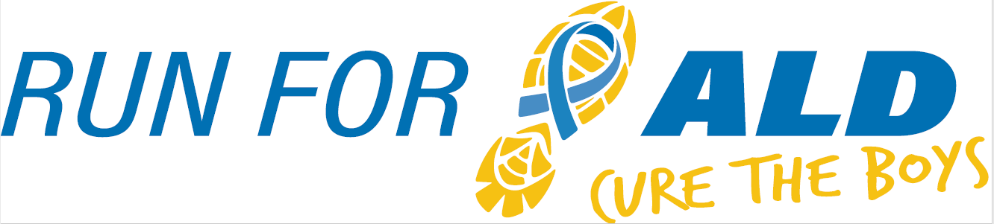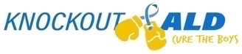

**5K & 1 Mile |** November 22nd, 2025

The **9th Annual Run for ALD: Cure the Boys** continues our mission to raise awareness and fund research for **adrenoleukodystrophy (ALD)**—a rare genetic neurological disease that affects approximately 1 in 17,000 boys. Many boys with ALD suffer severe neurological symptoms and face early death if the condition is not diagnosed and treated in time. This event is inspired by the vision of our son, Nicholas, who received a life-saving bone marrow transplant at the University of Minnesota Children’s Hospital to treat his cerebral ALD. His journey motivates us to help other families fighting this devastating disease. All proceeds from Run for ALD go directly to **ALD research at the University of Minnesota’s Leukodystrophy Center**, where scientists are working on early detection, improved treatment options, and—most importantly—a cure. These efforts often lack sufficient funding without grassroots support from families and community events like ours. Thanks to supporters like you, **Knockout ALD has contributed over $300,000** to ALD research. With your partnership, we can continue to fund the breakthroughs that offer real hope to boys with ALD and their families.

We would like to invite you to consider sponsoring our event.  **Sponsorships** are key to Run for ALD’s success, are available at a variety of levels, and will reach a large number of participants (we had over 500 last year!).  A $250 donation will secure advertisement on the race shirt, our race registration page, our website, and our Instagram feed.

Knockout ALD, Inc. is our nonprofit 501 (c) (3) organization established to raise awareness and funds for adrenoleukodystrophy research.  Information about Knockout ALD can be found at **KnockoutALD.com** and information about Run for ALD can be found on our race website: https://raceroster.com/events/2025/106710/run-for-ald-cure-the-boys

For additional information, please contact Julie Purschke at (314) 570-2058, Dave Purschke at (314)-520-3376 or RunforALD@yahoo.com.  We thank you in advance for your consideration and look forward to your response.  Knockout ALD, Inc’s Federal ID number is #83-0754642.

|  |  |  |  |
| --- | --- | --- | --- |
| Contact Name: |  | | |
| Address: |  | | |
| Phone: |  | E-mail: |  |

Sponsorship level:

|  |  |  |  |  |  |
| --- | --- | --- | --- | --- | --- |
| Friend $250 + |  | ALD Hero $1,000+ |  | Other |  |
| Knockout $500+ |  | Yellow Star $2,000+ |  |  |  |

**Sponsor**

|  |  |
| --- | --- |
| Name Appearing on Shirt & Event Website: |  |

*Please email your logo for shirts and our website as a JPG and AI, PDF, or EPS (per our shirt vendor) attachment to:

Dave or Julie Purschke ([RunforALD@yahoo.com](mailto:RunforALD@yahoo.com))

**Make checks payable to Knockout ALD, Inc. Thank you!**

**Mail to: Knockout ALD, Inc., 1551 Timberlake Manor Pkwy, Chesterfield, MO 63017**