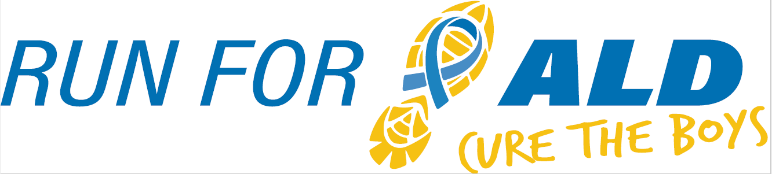 5K & 1 Mile
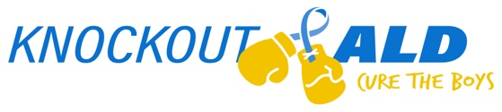
November 19th, 2022
Proceeds to benefit ALD Research

Location and Time: Creve Coeur Park, Tremayne Shelter, 13725 Marine Ave., Maryland Heights, MO 63146
In-person Event: 5K Run / 1 Mile Walk: 9:00 AM OR Virtual (run/walk wherever you are!)
Entry Details: Register by October 18th, 2022: - $25
Register after October 18th, 2022: - $35
Register via paper form below or online (you can also join a team or make a donation):
https://raceroster.com/events/2022/61701/run-for-ald-cure-the-boys
All checks should be made payable to Knockout ALD, Inc.

T-Shirts: All participants receive a short sleeve tech T-shirt
Awards: In-person 5K: Male and Female: 10 and Under; 11-15; 16-19; 20-29; 30-39; 40-49; 50+
Packet Pick Up: Friday November 18th from 3:30 PM to 6:30 PM
Knockout ALD Office, 1551 Timberlake Manor Pkwy, Chesterfield, MO 63017
Race morning at Creve Coeur Park, Tremayne Shelter from 7:30 AM to 8:30 AM
Event Contact: For additional information, contact Julie/Dave Purschke at RunforALD@yahoo.com ______________________________________________________________________________________________
Checks should be made payable to Knockout ALD, Inc.
Please mail to Knockout ALD, 1551 Timberlake Manor Pkwy, Chesterfield, MO 63017.

First Name: _____________________________ Last Name: ____________________________________________

Address: _________________________________City: _______________________ State: ________ Zip:_________

DOB: _________________ Age on Race Day: ______ Team Name (if applicable): ___________________________

Phone: __________________________ E-Mail: ______________________________Additional donation: ________
Gender:  Male  Female Race:  5K Run / Walk  1 Mile Run / Walk
Shirt Size:  Youth S  Youth M  Youth L  Youth XL  Adult S  Adult M  Adult L  Adult XL

Waiver: In consideration of your accepting this entry, I, intending to be legally bound, hereby for myself, my heirs, my executors, and administrators, waive, and release any and all rights and claims or damages I may have against David and Julie Purschke, Knockout ALD, Inc., University of Minnesota Foundation, University of Minnesota Leukodystrophy Center, Fleet Feet Sports, Red Iguana Racing, and St. Louis County Parks and Recreation, their affiliates, subsidiaries, officials, representatives, employees, successors, volunteers, and assigns for any and all injuries suffered by me in these events. I attest and verify that I am physically fit and have sufficiently trained for the completion of these events. Further, I hereby grant full permission for the free use of my name and/or photographs, videotapes, motion pictures, recordings, or any other record of this event for any legitimate purpose. My submission of this form shall act as my legal signature.

Signature: _______________________________________________________ Date: _________________________
(Parent or Guardian must sign if under 18 years old)

