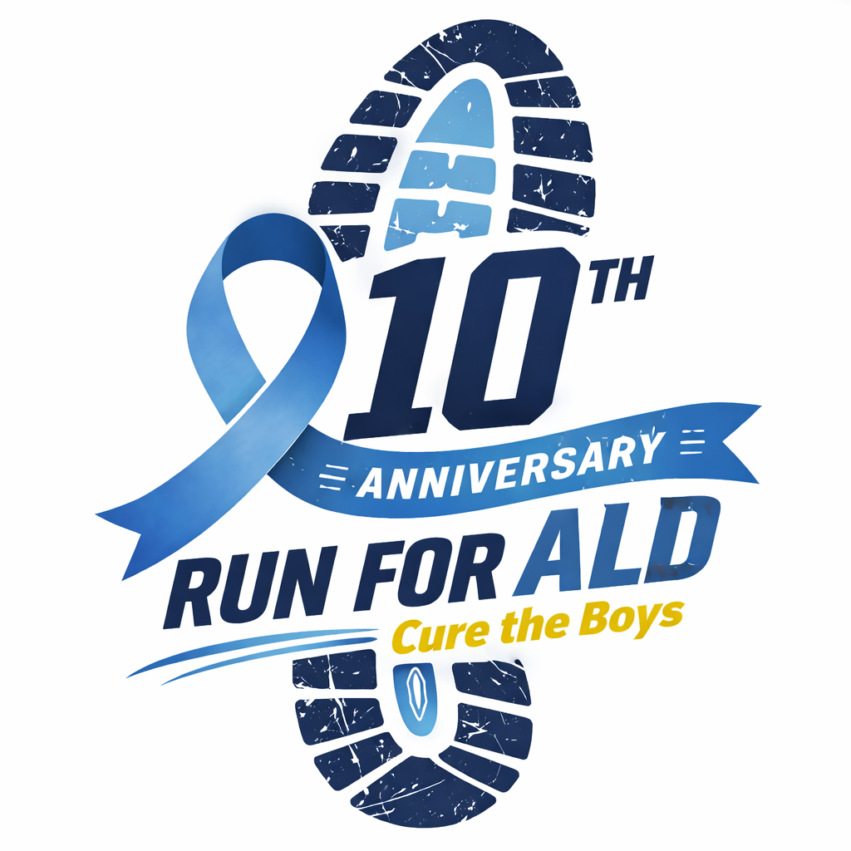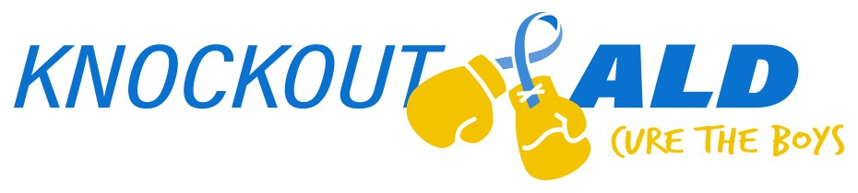

5K & 1 Mile | November 21st, 2026

Sponsorship Form

The 10th Anniversary Run for ALD, Cure the Boys supports awareness and research for adrenoleukodystrophy (ALD), a rare genetic neurological disease affecting approximately 1 in 17,000 boys. Without early diagnosis and treatment, ALD can cause severe neurological decline and can be fatal. This event is inspired by our son, Nicholas, whose life-saving bone marrow transplant at the University of Minnesota Children’s Hospital successfully halted his cerebral ALD. His journey fuels our commitment to helping other families facing this devastating disease.
All proceeds benefit ALD research at the University of Minnesota Leukodystrophy Center, where scientists are advancing early detection, better treatments, and the search for a cure. Thanks to the generosity of supporters, Knockout ALD has contributed more than $360,000 to ALD research. Together, we can continue funding breakthroughs that bring hope to boys with ALD and their families.
We would like to invite you to consider sponsoring our event. Sponsorships are key to Run for ALD’s success, are available at a variety of levels, and will reach many participants (nearly 700 last year!). Sponsors will secure advertisement on the race shirt, our race registration page, our website, and our Instagram feed.
Knockout ALD, Inc. is our nonprofit 501(c)(3) organization established to raise awareness and funds for adrenoleukodystrophy research. Information about Knockout ALD can be found at KnockoutALD.com and information about Run for ALD can be found on our race website (opens July 1st):
https://raceroster.com/events/2026/130599/run-for-ald-cure-the-boys

For additional information, please contact Julie Purschke at (314) 570-2058, Dave Purschke at (314)-520-3376 or RunforALD@yahoo.com. We thank you in advance for your consideration and look forward to your response. Knockout ALD, Inc’s Federal ID number is #83-0754642.
Please complete back side of form. Thank you!
Page 1

Contact Name:
Address:
Phone: |  | E-mail:

Sponsorship level:
Friend $250 + |  | ALD Hero $1,000+
Knockout $500+ |  | Yellow Star $2,000+ |  | Other

Sponsor
Name Appearing on Shirt & Event Website:

*Please email your logo both as JPEG and AI, PDF, or EPS per our shirt vendor to: Dave or Julie Purschke (RunforALD@yahoo.com)

Please make checks payable to Knockout ALD, Inc.
Mail to: Knockout ALD, Inc., 1551 Timberlake Manor Pkwy, Chesterfield, MO 63017

Thank you!
.

Page 2

