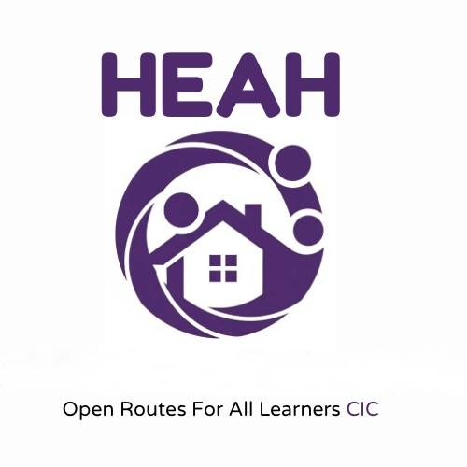

HEAH: Learning Hub – Referral Form

Operated by HEAH: Open Routes CIC  
Email: hello@heah-openroutes.co.uk | Phone: 07513 249727

# 1. Referrer Details

Full Name:  
Role/Title:  
Organisation:  
Email:  
Phone:  
Relationship to Learner:  
Date of Referral:

# 2. Learner Information

Full Name:  
Date of Birth:  
Gender:  
Address:  
Ethnicity:  
Current or Last School:  
Education Status (e.g. EHE, excluded, awaiting placement):  
EHCP Status:  
Social Worker Involved (Yes/No): If Yes, provide name & contact:

# 3. Needs and Concerns

Please describe the learner’s current situation and presenting needs. Include academic, behavioural, emotional, and safeguarding concerns as appropriate.

# 4. Desired Outcomes

What are the key goals for this placement? (e.g. re-engagement, catch-up learning, wellbeing support, transition support, etc.)

# 5. Support History

Summary of past or current services/interventions (e.g. CAMHS, tutoring, SEND services, etc.):

# 6. Placement Preferences

Preferred days/times:  
Preferred delivery format (In-home / Community / Online / Hybrid):  
Any known risks or safety considerations for staff:  
Other considerations (e.g. travel, funding availability):

# 7. Declaration

I confirm that the information provided is accurate and that parental/carer consent has been obtained for this referral.  
Referrer Signature:  
Date:  
Please return this form to: hello@heah-openroutes.co.uk